|  |  |  |  |  |
| --- | --- | --- | --- | --- |
| 1. [taxonomy]   ALL | [protein]  ALL | [nonmembrane]  ALL | [membrane]  ALL | [evidence]  ALL |

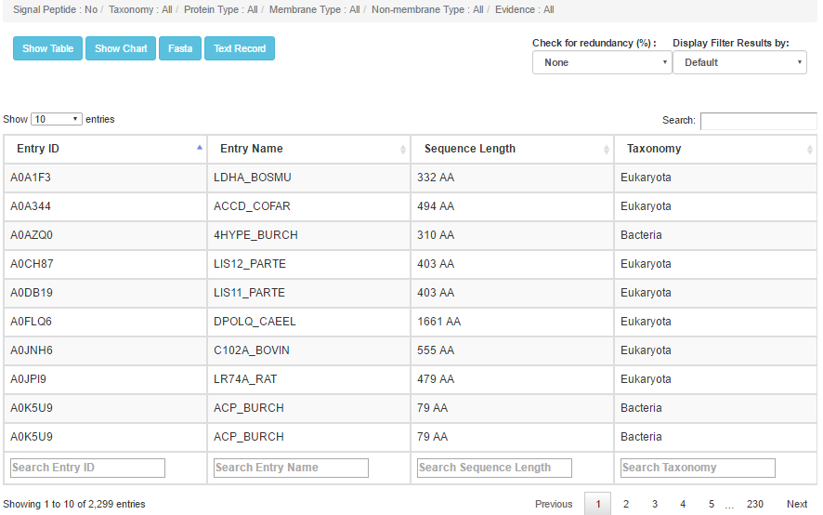#number of entries =2299

|  |  |  |  |  |
| --- | --- | --- | --- | --- |
| 1. [taxonomy]   ALL | [protein]  ALL | [nonmembrane]  ALL | [membrane]  ALL | [evidence]  Experimental |

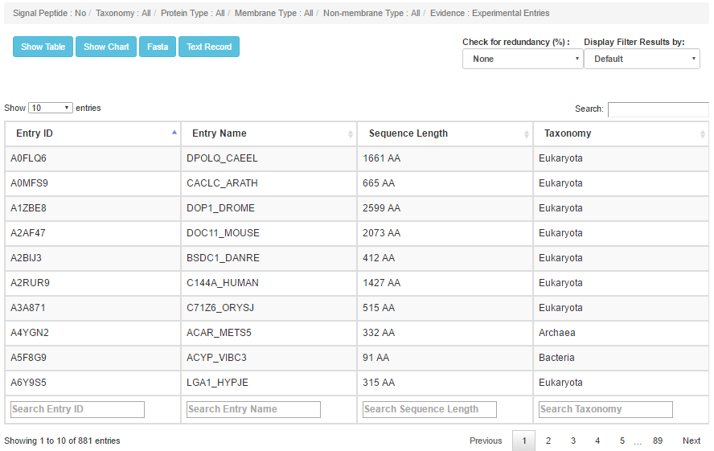#number of entries =881

|  |  |  |  |  |
| --- | --- | --- | --- | --- |
| 1. [taxonomy]   ALL | [protein]  ALL | [nonmembrane]  ALL | [membrane]  ALL | [evidence]  Nonexperimental |

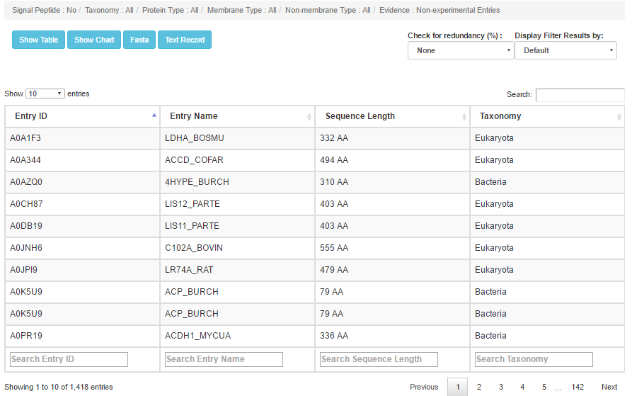#number of entries =1418

|  |  |  |  |  |
| --- | --- | --- | --- | --- |
| 1. [taxonomy]   ALL | [protein]  ALL | [nonmembrane]  ALL | [membrane]  ALL | [evidence]  Nonexperimental |

|  |  |  |  |  |
| --- | --- | --- | --- | --- |
| 1. [taxonomy]   ALL | [protein]  Transmembrane | [nonmembrane]  ALL | [membrane]  ALL | [evidence]  All |

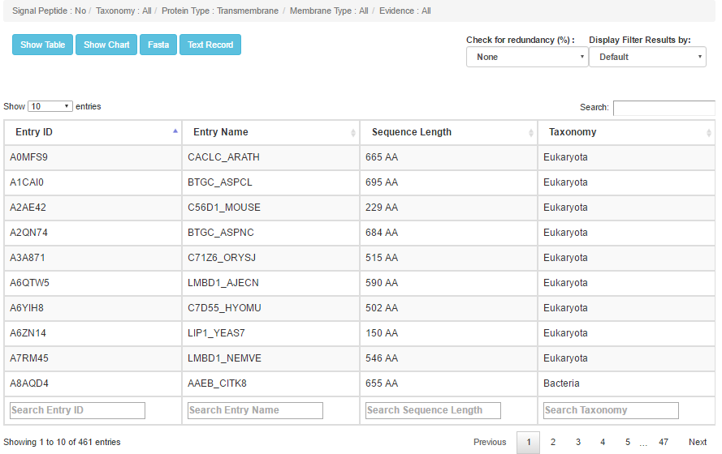#number of entries =461

|  |  |  |  |  |
| --- | --- | --- | --- | --- |
| 1. [taxonomy]   ALL | [protein]  Transmembrane | [nonmembrane]  ALL | [membrane]  ALL | [evidence]  Experimental |

#number of entries =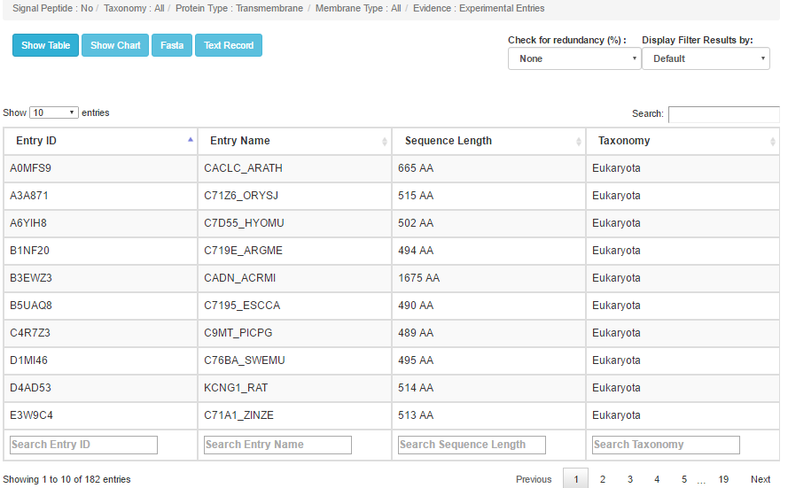182

|  |  |  |  |  |
| --- | --- | --- | --- | --- |
| 1. [taxonomy]   ALL | [protein]  Transmembrane | [nonmembrane]  ALL | [membrane]  ALL | [evidence]  NonExperimental |

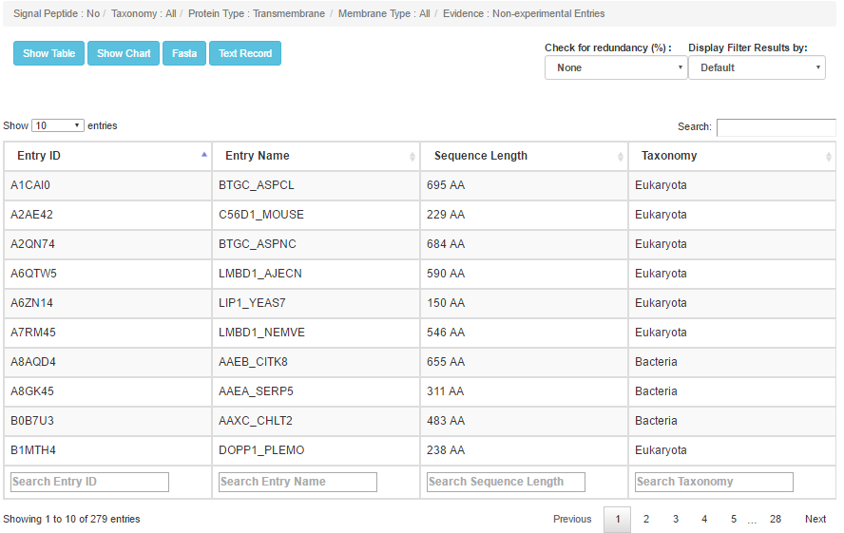

|  |  |  |  |  |
| --- | --- | --- | --- | --- |
| 1. [taxonomy]   ALL | [protein]  Transmembrane | [nonmembrane]  Single-spanning | [membrane]  ALL | [evidence]  All |

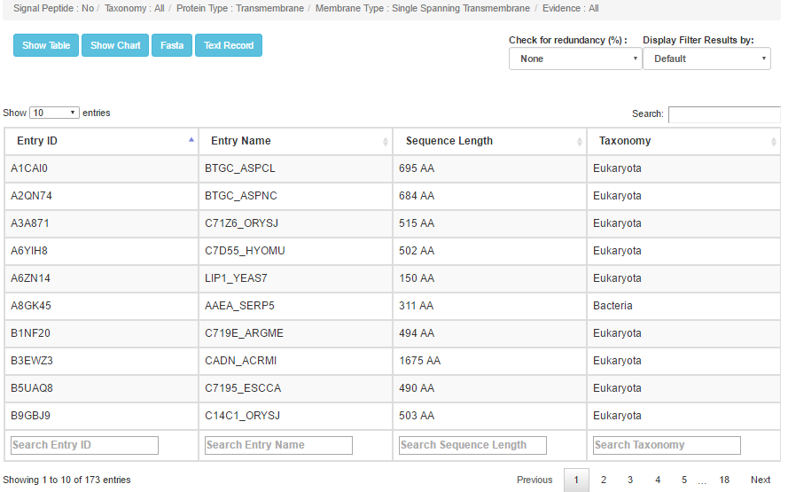

|  |  |  |  |  |
| --- | --- | --- | --- | --- |
| 1. [taxonomy]   ALL | [protein]  Transmembrane | [nonmembrane]  Single-spanning | [membrane]  ALL | [evidence]  Experimental |

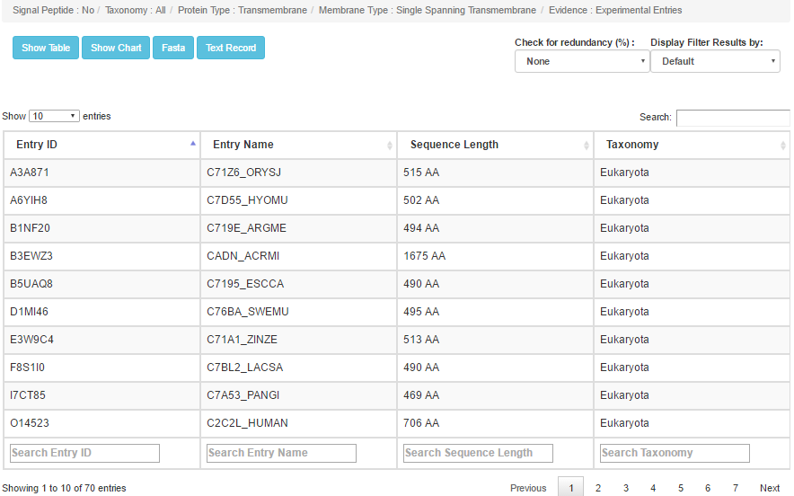

|  |  |  |  |  |
| --- | --- | --- | --- | --- |
| 1. [taxonomy]   ALL | [protein]  Transmembrane | [nonmembrane]  Single-spanning | [membrane]  ALL | [evidence]  Nonexperimental |

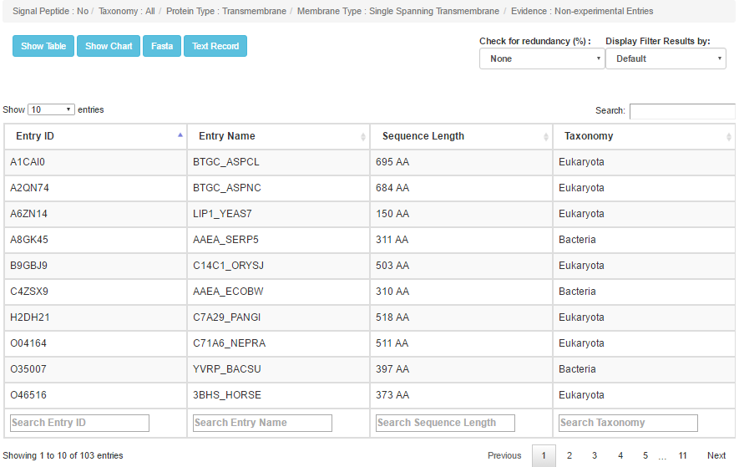

|  |  |  |  |  |
| --- | --- | --- | --- | --- |
| 1. [taxonomy]   ALL | [protein]  Transmembrane | [nonmembrane]  Multi-spanning | [membrane]  ALL | [evidence]  All |

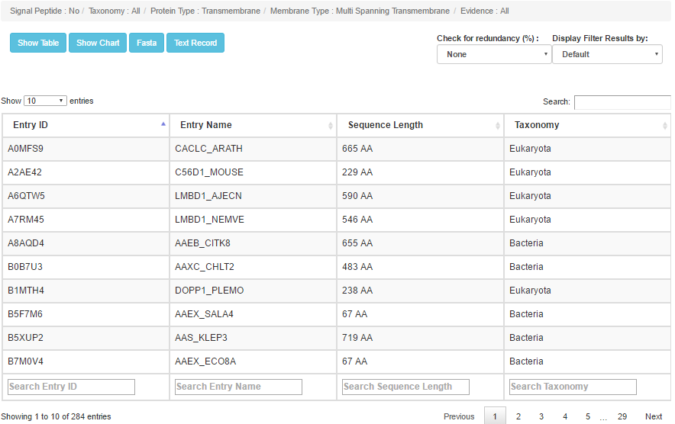

|  |  |  |  |  |
| --- | --- | --- | --- | --- |
| 1. [taxonomy]   ALL | [protein]  Transmembrane | [nonmembrane]  Single-spanning | [membrane]  ALL | [evidence]  All |

|  |  |  |  |  |
| --- | --- | --- | --- | --- |
| 1. [taxonomy]   ALL | [protein]  Transmembrane | [nonmembrane]  Single-spanning | [membrane]  ALL | [evidence]  All |

|  |  |  |  |  |
| --- | --- | --- | --- | --- |
| 1. [taxonomy]   ALL | [protein]  Transmembrane | [nonmembrane]  Single-spanning | [membrane]  ALL | [evidence]  All |

|  |  |  |  |  |
| --- | --- | --- | --- | --- |
| 1. [taxonomy]   ALL | [protein]  Transmembrane | [nonmembrane]  Single-spanning | [membrane]  ALL | [evidence]  All |

|  |  |  |  |  |
| --- | --- | --- | --- | --- |
| 1. [taxonomy]   ALL | [protein]  Transmembrane | [nonmembrane]  Single-spanning | [membrane]  ALL | [evidence]  All |

|  |  |  |  |  |
| --- | --- | --- | --- | --- |
| 1. [taxonomy]   ALL | [protein]  Transmembrane | [nonmembrane]  Single-spanning | [membrane]  ALL | [evidence]  All |

|  |  |  |  |  |
| --- | --- | --- | --- | --- |
| 1. [taxonomy]   ALL | [protein]  Transmembrane | [nonmembrane]  Single-spanning | [membrane]  ALL | [evidence]  All |

|  |  |  |  |  |
| --- | --- | --- | --- | --- |
| 1. [taxonomy]   ALL | [protein]  Transmembrane | [nonmembrane]  Single-spanning | [membrane]  ALL | [evidence]  All |

|  |  |  |  |  |
| --- | --- | --- | --- | --- |
| 1. [taxonomy]   ALL | [protein]  Transmembrane | [nonmembrane]  Single-spanning | [membrane]  ALL | [evidence]  All |

|  |  |  |  |  |
| --- | --- | --- | --- | --- |
| 1. [taxonomy]   ALL | [protein]  Transmembrane | [nonmembrane]  Single-spanning | [membrane]  ALL | [evidence]  All |

|  |  |  |  |  |
| --- | --- | --- | --- | --- |
| 1. [taxonomy]   ALL | [protein]  Transmembrane | [nonmembrane]  Single-spanning | [membrane]  ALL | [evidence]  All |

|  |  |  |  |  |
| --- | --- | --- | --- | --- |
| 1. [taxonomy]   ALL | [protein]  Transmembrane | [nonmembrane]  Single-spanning | [membrane]  ALL | [evidence]  All |