FRANCISCO, Jacob Angelo

SANCHEZ, Jeck Danielle

**MP2**

**Screenshot of the spec:**

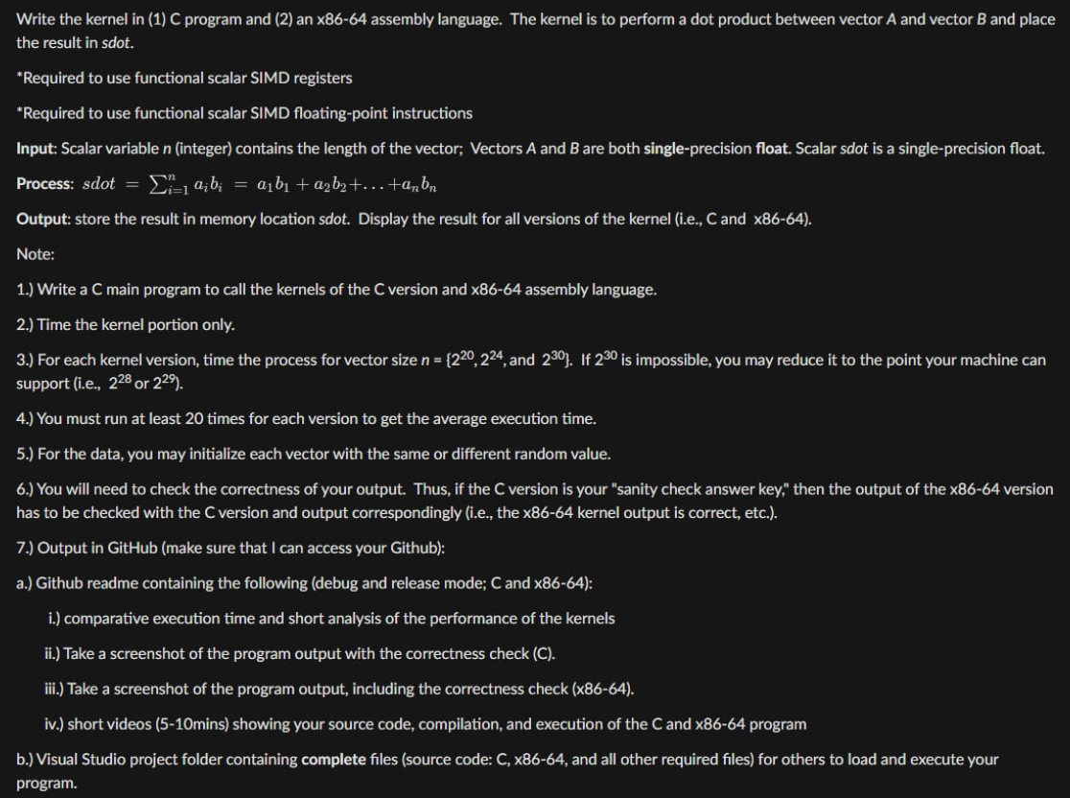

**Screenshot of a test case:**

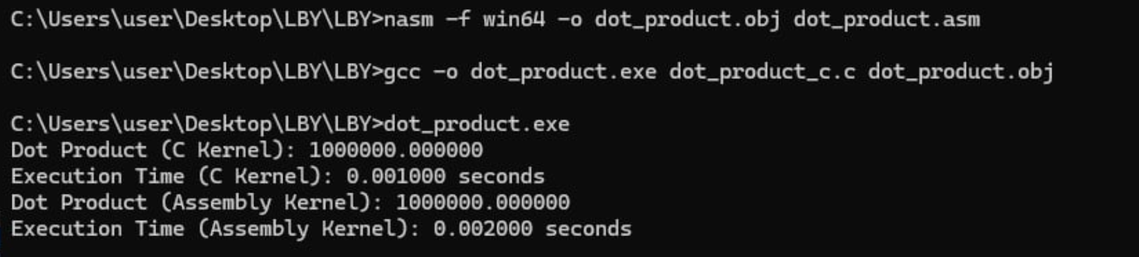

**Github link:** <https://github.com/jeckerschan/LBY>