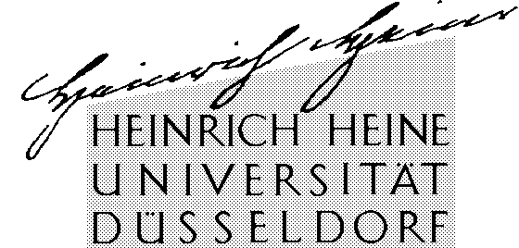

Eckhart Arnold, M.A.
Philosophisches Institut,
Lehrstuhl für Theoretische Philosophie
Universitätsstr. 1, Gebäude 23.21
D-40225 Düsseldorf, Deutschland (Germany)

Tel.:  Fax: | +49-(0)211-811-473  +49-(0)211-811-5764
E-Mail:  Internet: | arnold@phil.uni-duesseldorf.de  http://www.phil-fak.uni-duesseldorf.de/thphil

Heinrich-Heine-Universität Düsseldorf
Philosophisches Institut ∙ Lehrstuhl für Theoretische Philosophie
Universitätsstrasse 1, Gebäude 23.21 ∙ D-40225 Düsseldorf

Publication of a Voegelin-Critique from Hans Kelsen

Dear Madam or Sir,

Your publishing house has released a whole series of excellent books about the philosopher of history “Eric Voegelin”. Not long ago I have found in the “Eric Veogelin Archiv” in Munich a typoscript written by the philosopher of law and teacher of Eric Voegelin Hans Kelsen, which contains a lengthy (125 pages) commentary of Eric Voegelins “New Science of Politics”. Since this typoscript is as yet unpublished, but contains what appears to me to be one of the deepest and most comprehensive discussions of Voegelins “New Science”, I am planning to publish it. For this purpose, I am looking for a …

Mit freundlichen Grüßen

Eckhart Arnold

