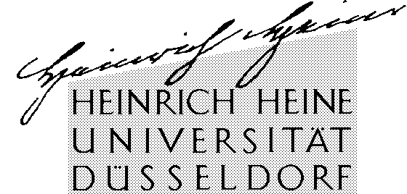

Eckhart Arnold, M.A.
Philosophisches Institut,
Lehrstuhl für Theoretische Philosophie
Universitätsstr. 1, Gebäude 23.21
D-40225 Düsseldorf, Deutschland (Germany)

Tel.:  Fax: | +49-(0)211-811-473  +49-(0)211-811-5764
E-Mail:  Internet: | arnold@phil.uni-duesseldorf.de  http://www.phil-fak.uni-duesseldorf.de/thphil

Heinrich-Heine-Universität Düsseldorf
Philosophisches Institut ∙ Lehrstuhl für Theoretische Philosophie
Universitätsstrasse 1, Gebäude 23.21 ∙ D-40225 Düsseldorf

Paul Caringella
1420 La Playa Street
San Francisco, CA 94122
USA

Publication of the Hans Kelsen - Eric Voegelin correspondence

Dear Paul Caringella,

As I have already mentioned in my E-Mail (which you hopefully have received by the time you get this letter), I am planning to publish Hans Kelsens review of Eric Voegelins “New Science of Politics”. This review is mentioned in Eric Voegelins autobiography, but so far it has not been published in any form.

For a better understanding to the reader I have decided to publish the correspondence between Eric Voegelin and Hans Kelsen along with the review. The correspondence comprises four letters, two of which have been written by Eric Voegelin. To my E-Mail from May 25th I have attached the full draft of the planned publication including the correspondence.

As you are the literary executer of Eric Voegelin, I would kindly like to ask you for the permission to reprint the two letters of Eric Voegelin to Hans Kelsen from February 10th 1954 and March 7th 1954.

If you have further questions regarding this publication or if you need more detailed information, I will be happy to answer you any question.

Yours sincerely,

Eckhart Arnold

