Visual SQL Guide

Written By Jeffrey Clendening

Select Statements

View all tables
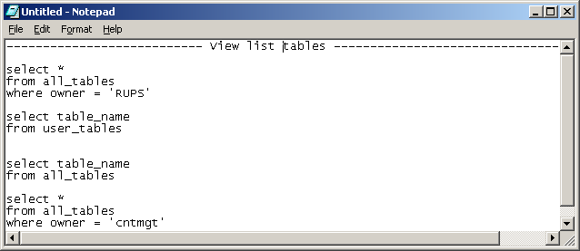Distinct
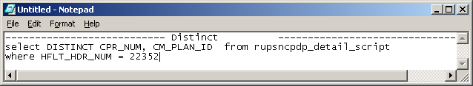IN
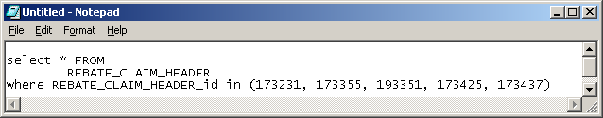Select all
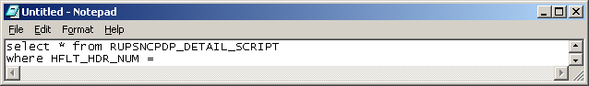

Converting to number
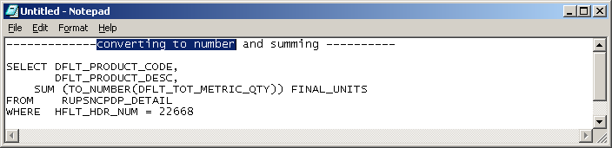
Count
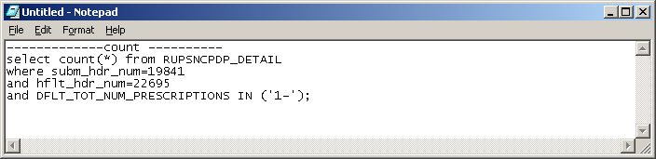
Order by
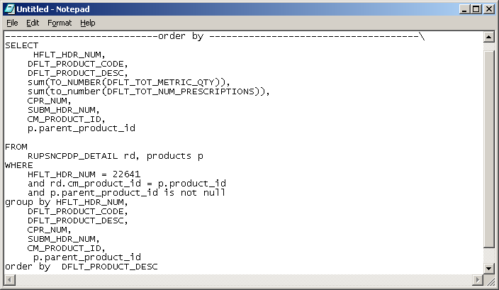
Decode
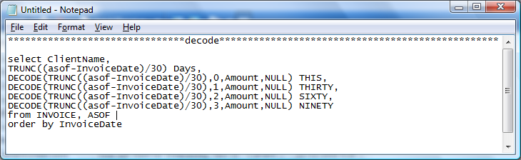
Results for decode
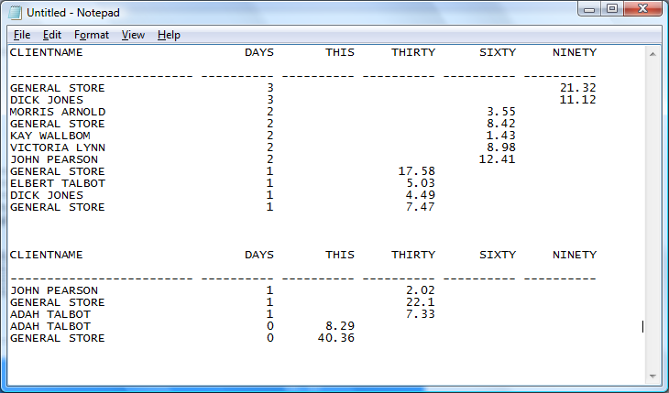
Roll up
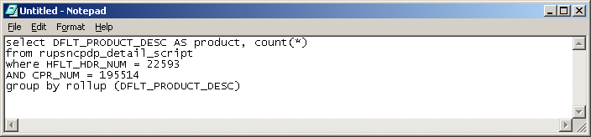
Like
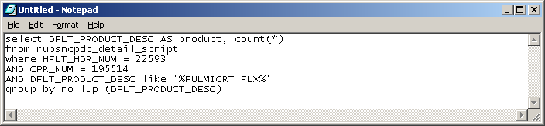
Between - Select all
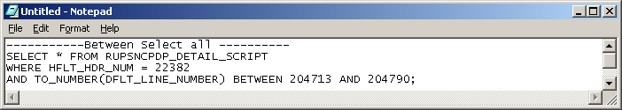
Order by Substring
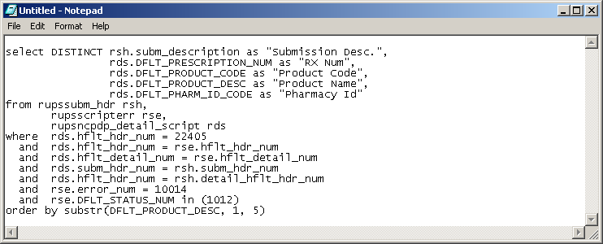

Joins
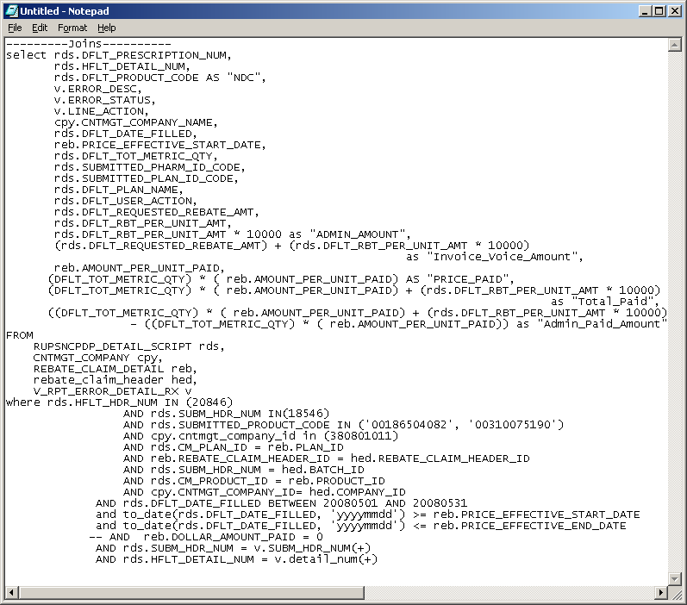
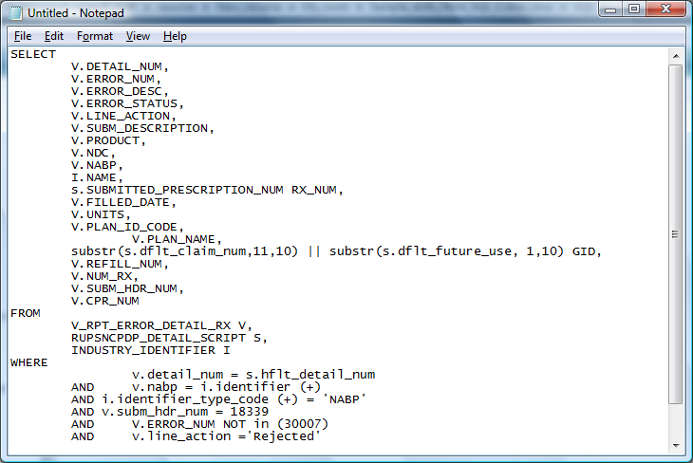

Ltrim select
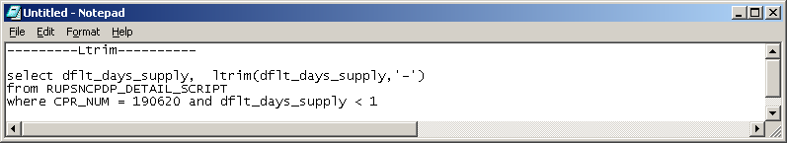
Lpad
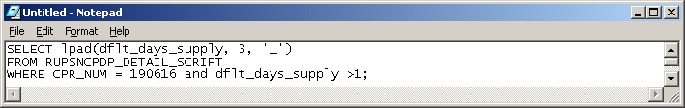
Select Count
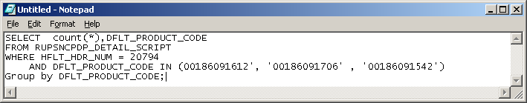
Select group by - count
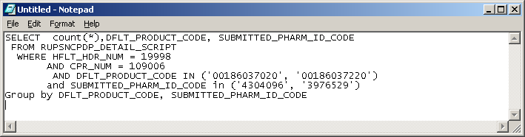

Update statements

Nested where
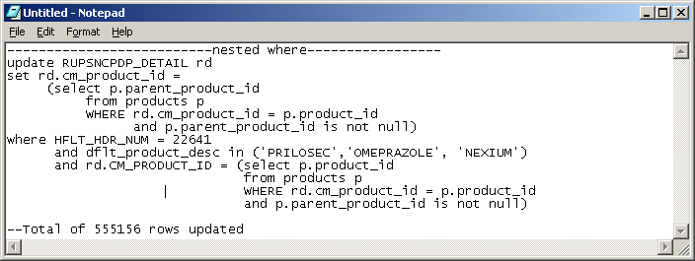
Between Update
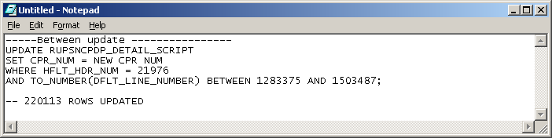
In Update
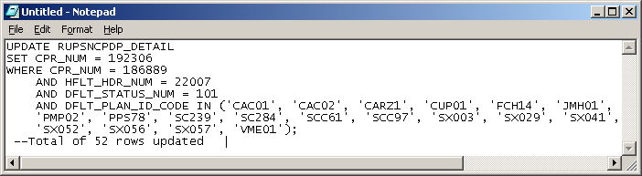
Nested select in an update
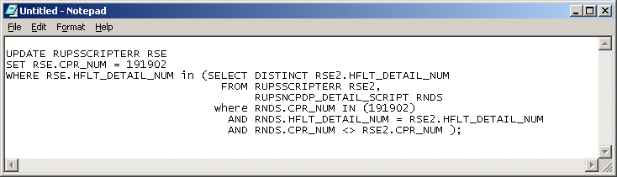
Concatenation
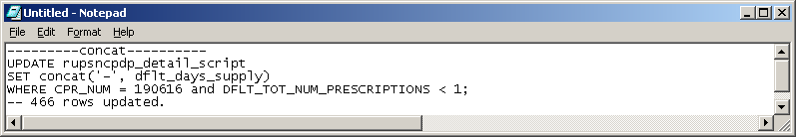

Not in – Update
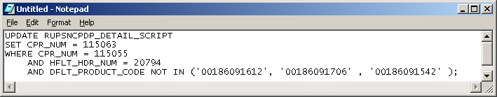
Translate
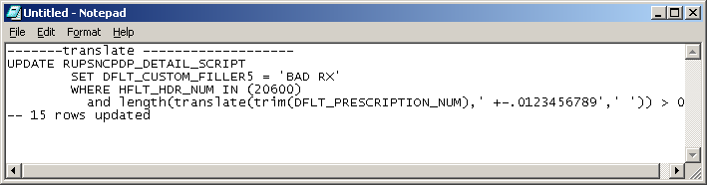
Ltrim update
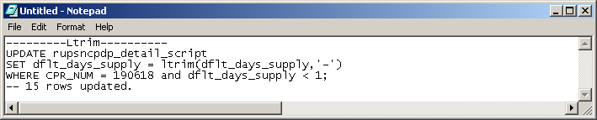

Insert
Insert into table
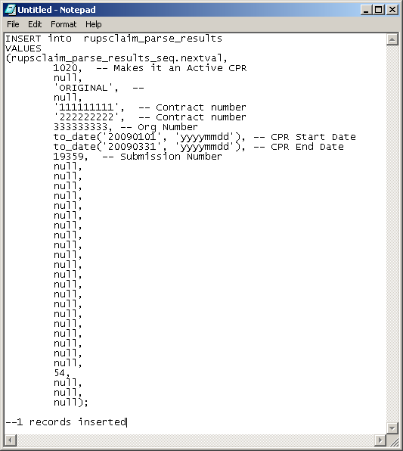

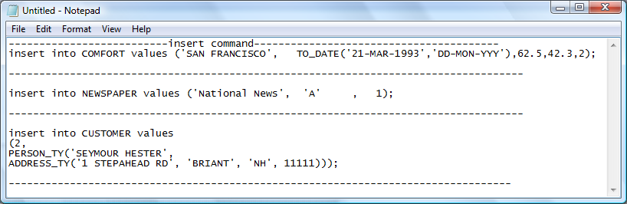

Views
Create view
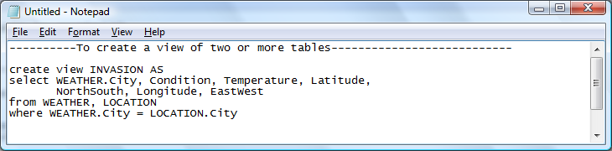
Replace View
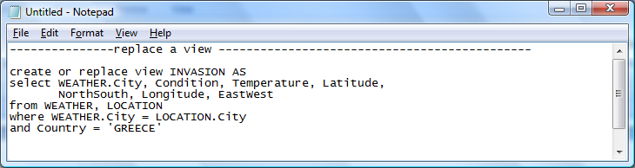
Create tables
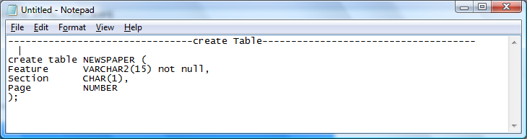
Alter
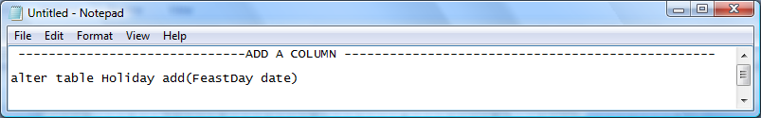
Results
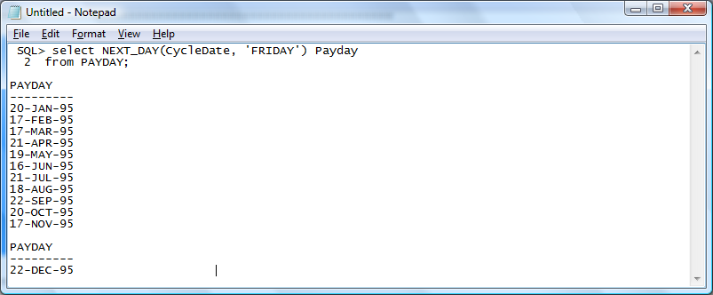
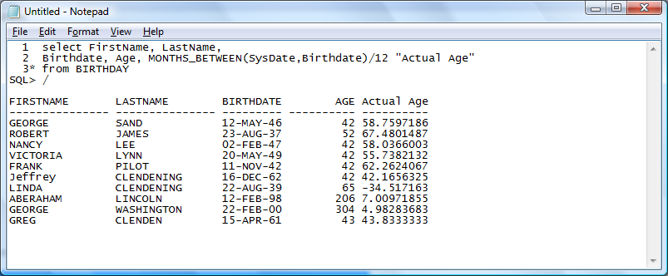

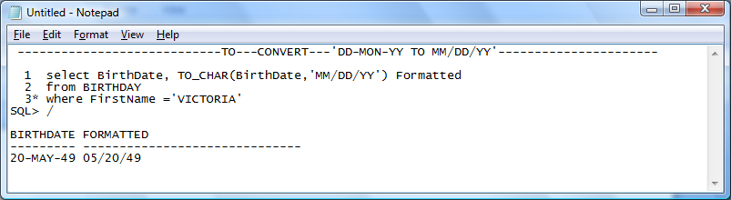

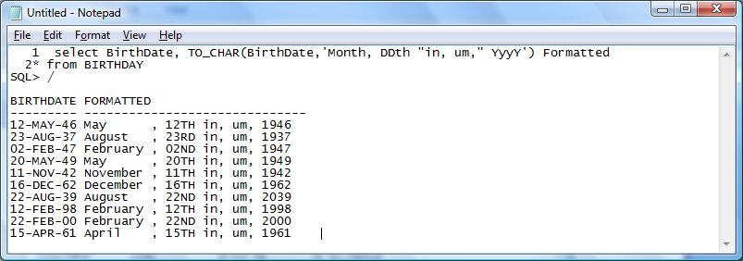
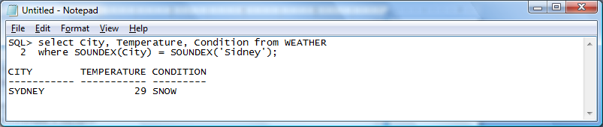

SQL Scripts

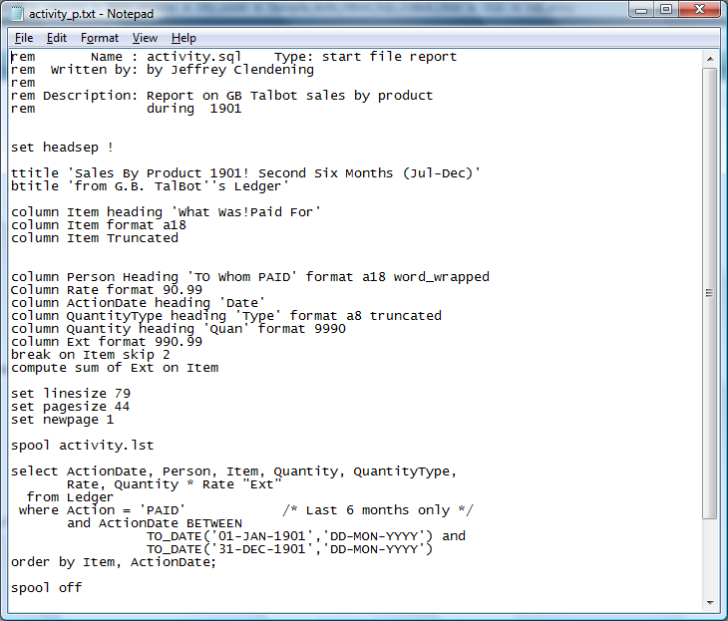
Update Script 1
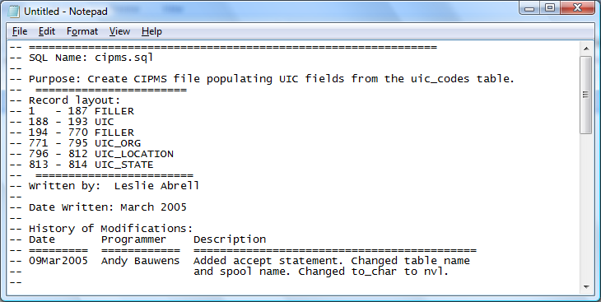
Update Script 1 continued – Update table and create sequential file
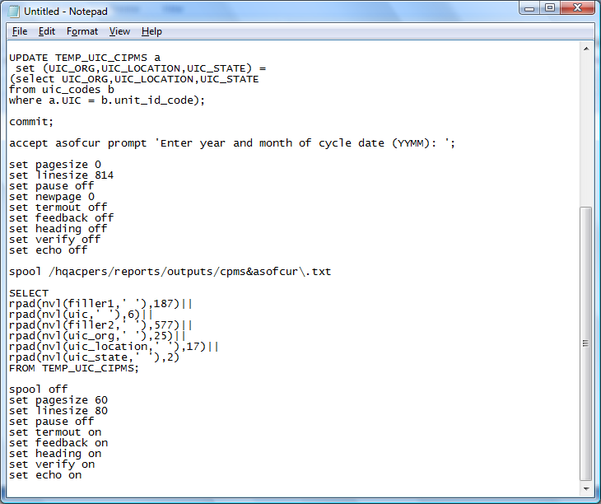
Create a sequential file 2
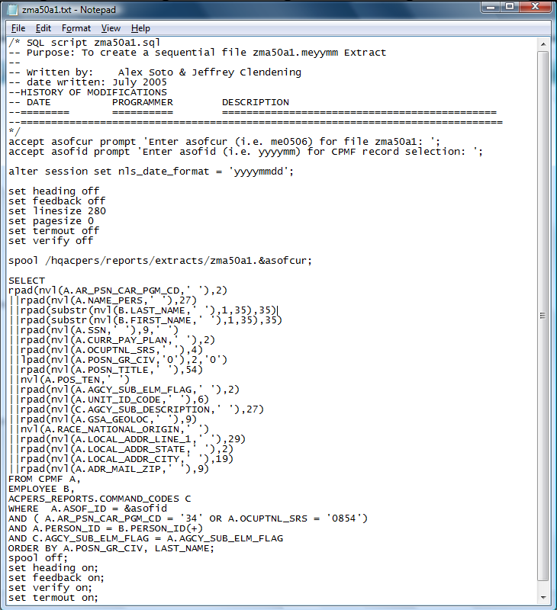

Create table with a select statement 3
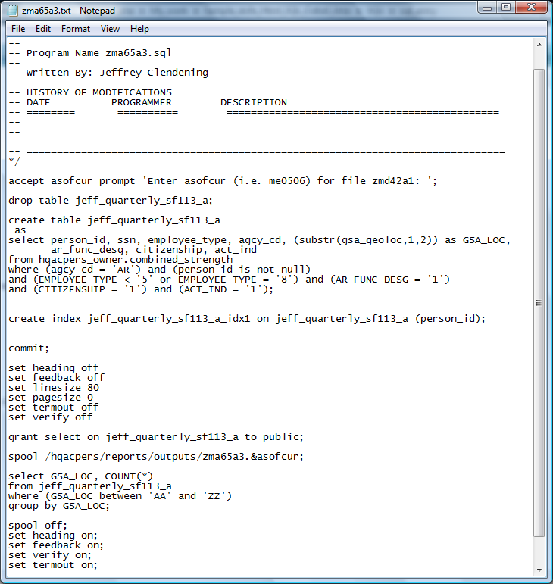
Create Creates sequential file 4
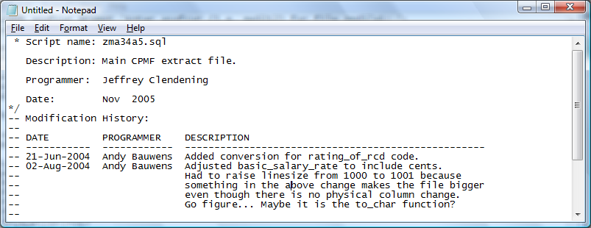
Creates sequential file 4 continued
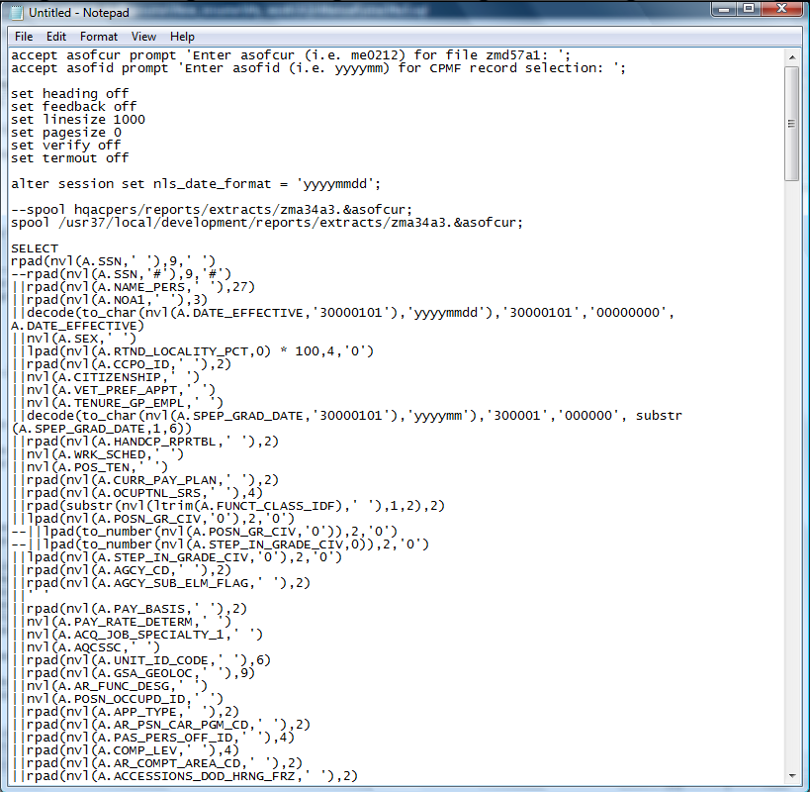

Creates sequential file 4 continued
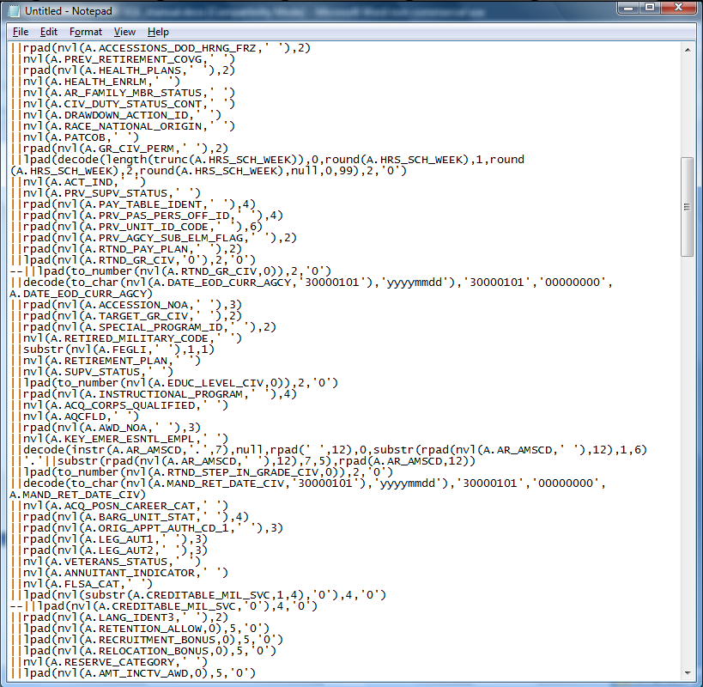
Creates sequential file 4 continued
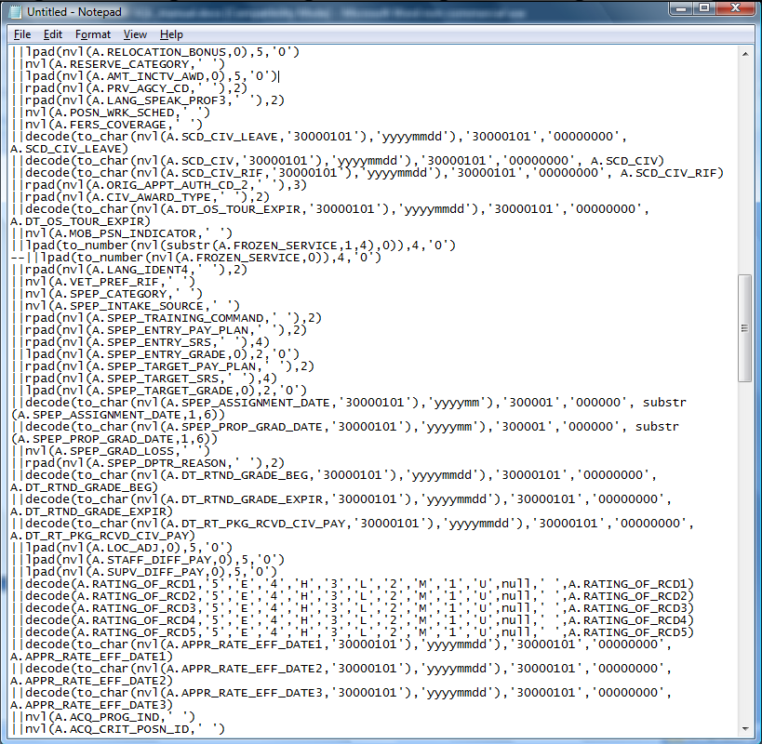

Creates sequential file 4 continued
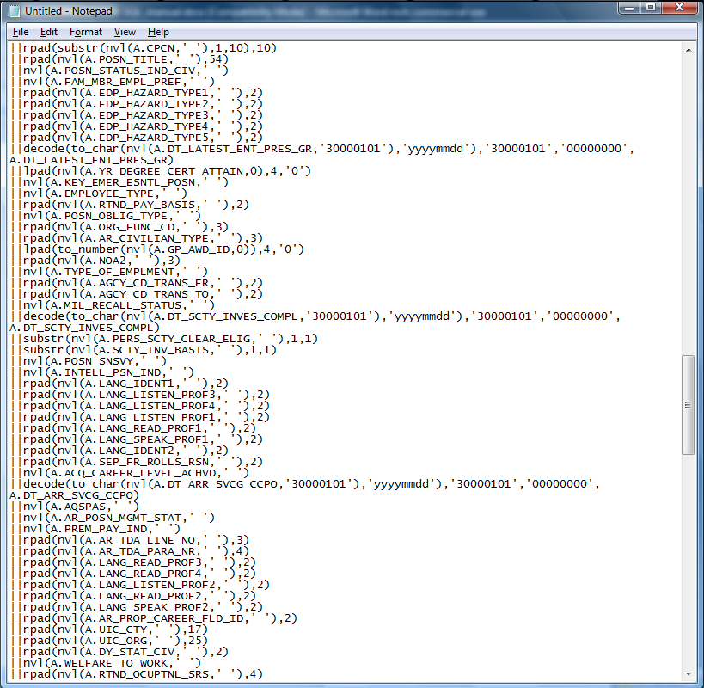

Creates sequential file 4 continued
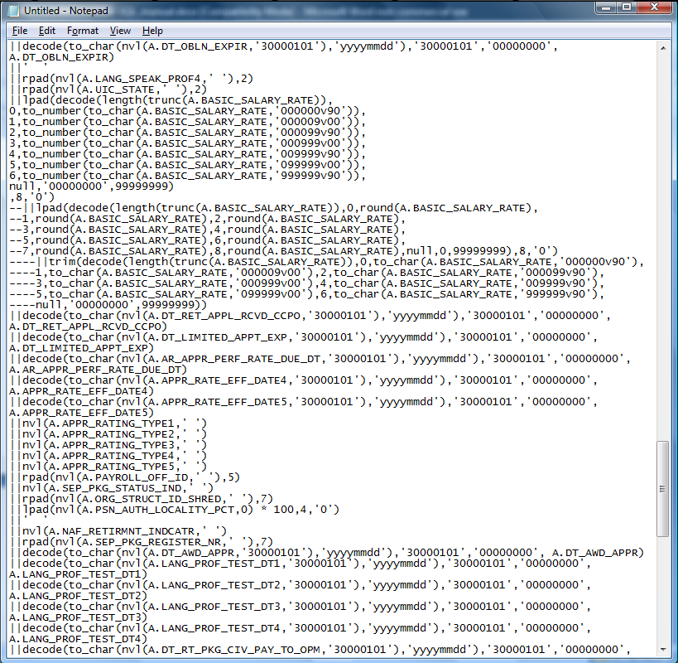

Creates sequential file 4 continued
