Social app actions .

I chose to create a backend using firbase ,we have one collection in the db called “users”

Here is the list of action .

* 1 – register
* 2 – log in
* 3 – send friend request
  + 3.1 – accept friend request
  + 3.2 – reject friend request
* 4 – add post
* 5 – show friend post

***1 – register***

User registration , each child of user collection will present a registered user in the social app

The child key is user id that firebase provide it “unique id ”.under the first child of user id

We will save user email and name .

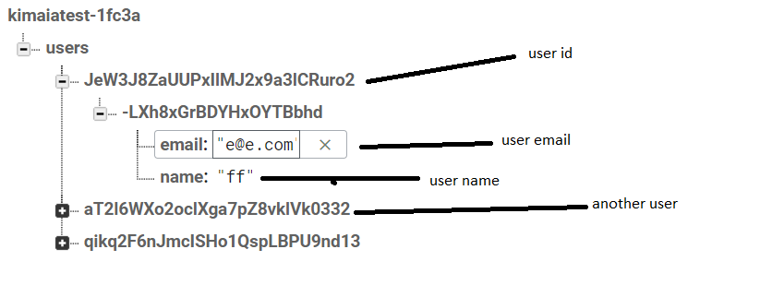

***2 – Log in***

User can login to the app by providing email and password,

the authenticated is done by firebase using signInWithEmailAndPassword method .

***3 – Send friend request***

User can send a friend request to other users in the app “not her friends ”.

User [e@e.com](mailto:e@e.com) send friend request [w@w.com](mailto:w@w.com) user .

The db schema before sending request look like that 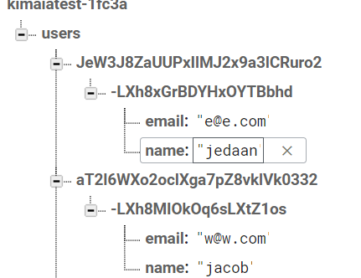

After sending request

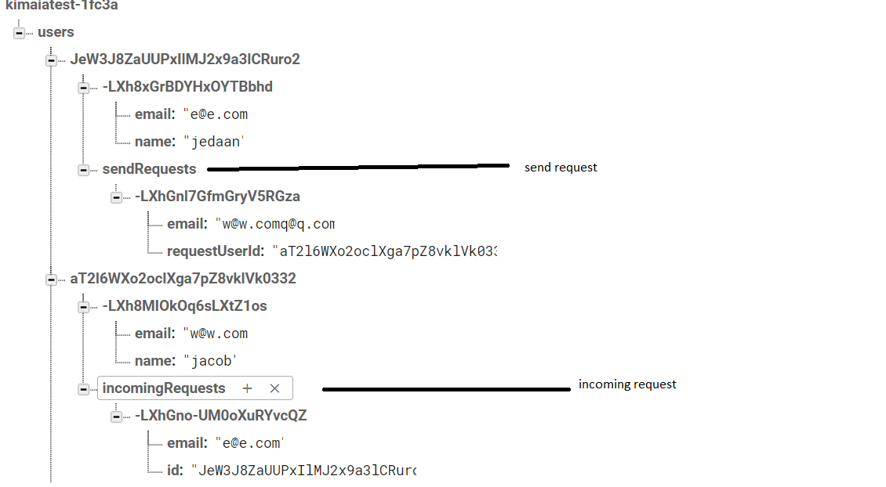

***3.1 – accept friend request***

In case the user accept the friend request, we will remove the user request from incommingRequests and add it to myFriends , also we move the user from the sendRequests

The schema will look like that .

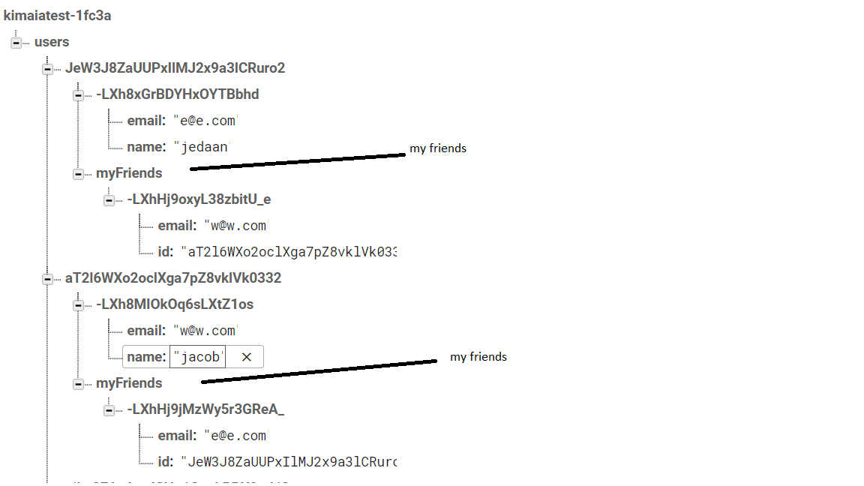

***3.2 – reject friend request***

Just remove the user data from incommingRequests and sendRequests.



***4 – add post***

User can add post, we will save users posts under myPosts in the collection .

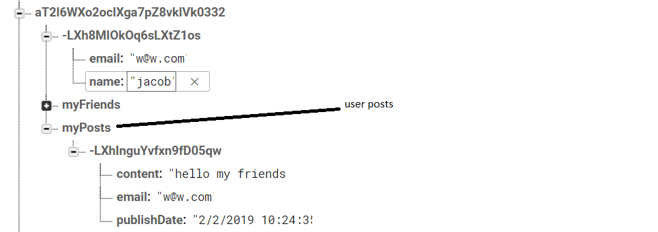

***5 – show friends posts***

we can fetch all friends posts by iterating for myFriends is specific user, extract the friends id

with the each user id I can get the user pots from her myPosts .