Cleaning Agent 🡪 Solution used to clean the equipment

For Example: AQUANOX® A4625B - Aqueous Batch Cleaning Solution

Equipment Log must have below fields

User should never be permitted to enter value for fields highlighted in green. Auto populate the values for the selected Equipment # or Batch #

* Equipment #
* Equipment Name (dropdown list)
* Calibration Due date
* Preventive Maintenance Due date
* Model #
* Start date & time
* End date & time
* Dept. assigned to (equipment currently installed or used)
* Cleaning Agent
* Batch # (dropdown list)
* Product Name
* Part #
* Batch #
* Approver Signature
* Comments (if any)
* Attachment



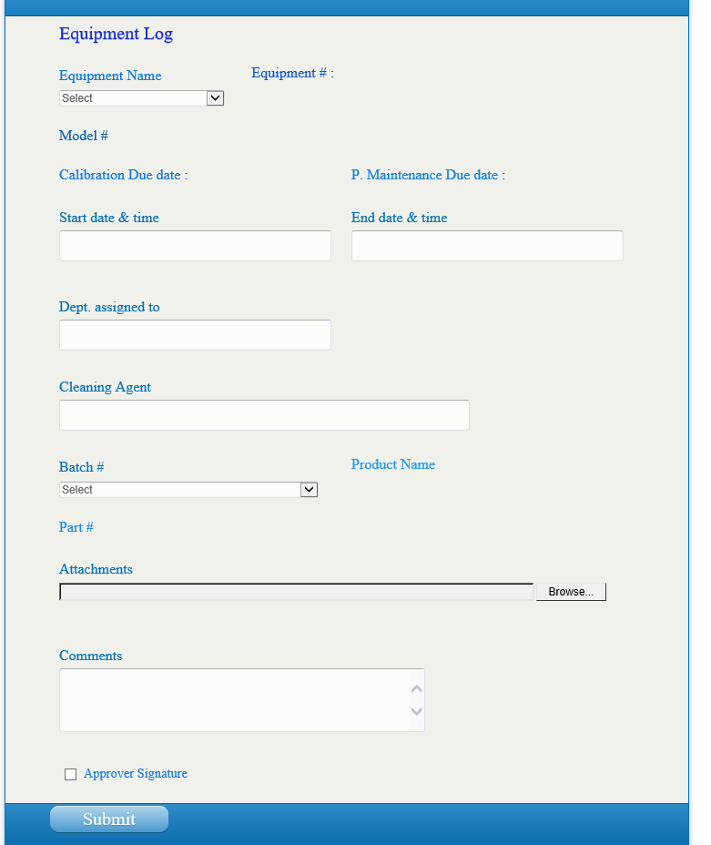

* When the user selects the Equipment name dropdown list, system must display Equipment #, Model #, Calibration date & PM due date for the selected Equipment.
* Batch # must be drop down list, auto populate Part # & product name for the selected batch #.
* If user selects Approver signature , system must display Pop up window that prompts the user to enter User ID & Password to authenticate the record