Responsibility Description | Type | Concept Name
Print the login menu when users open the software to let users enter their own username and password. | D | Interactor
Ensure the user’s account is recorded in the database and whether or not the user logged in by the password is right. | D | KeyChecker
Container for all the collection of information of the registered account especially the usernames and the passwords. | K | KeyStorage
Register a new account and log in automatically when the user who have been and then logged in WeChat, and choose “log in as a WeChat user” | D | InstantRegister
Block the input to deny more attempts if too many unsuccessful attempts | D | Controller
Container for user’s authentication data,such as pass-code ,state and routine.,etc | K | Key

System Sequence Diagram
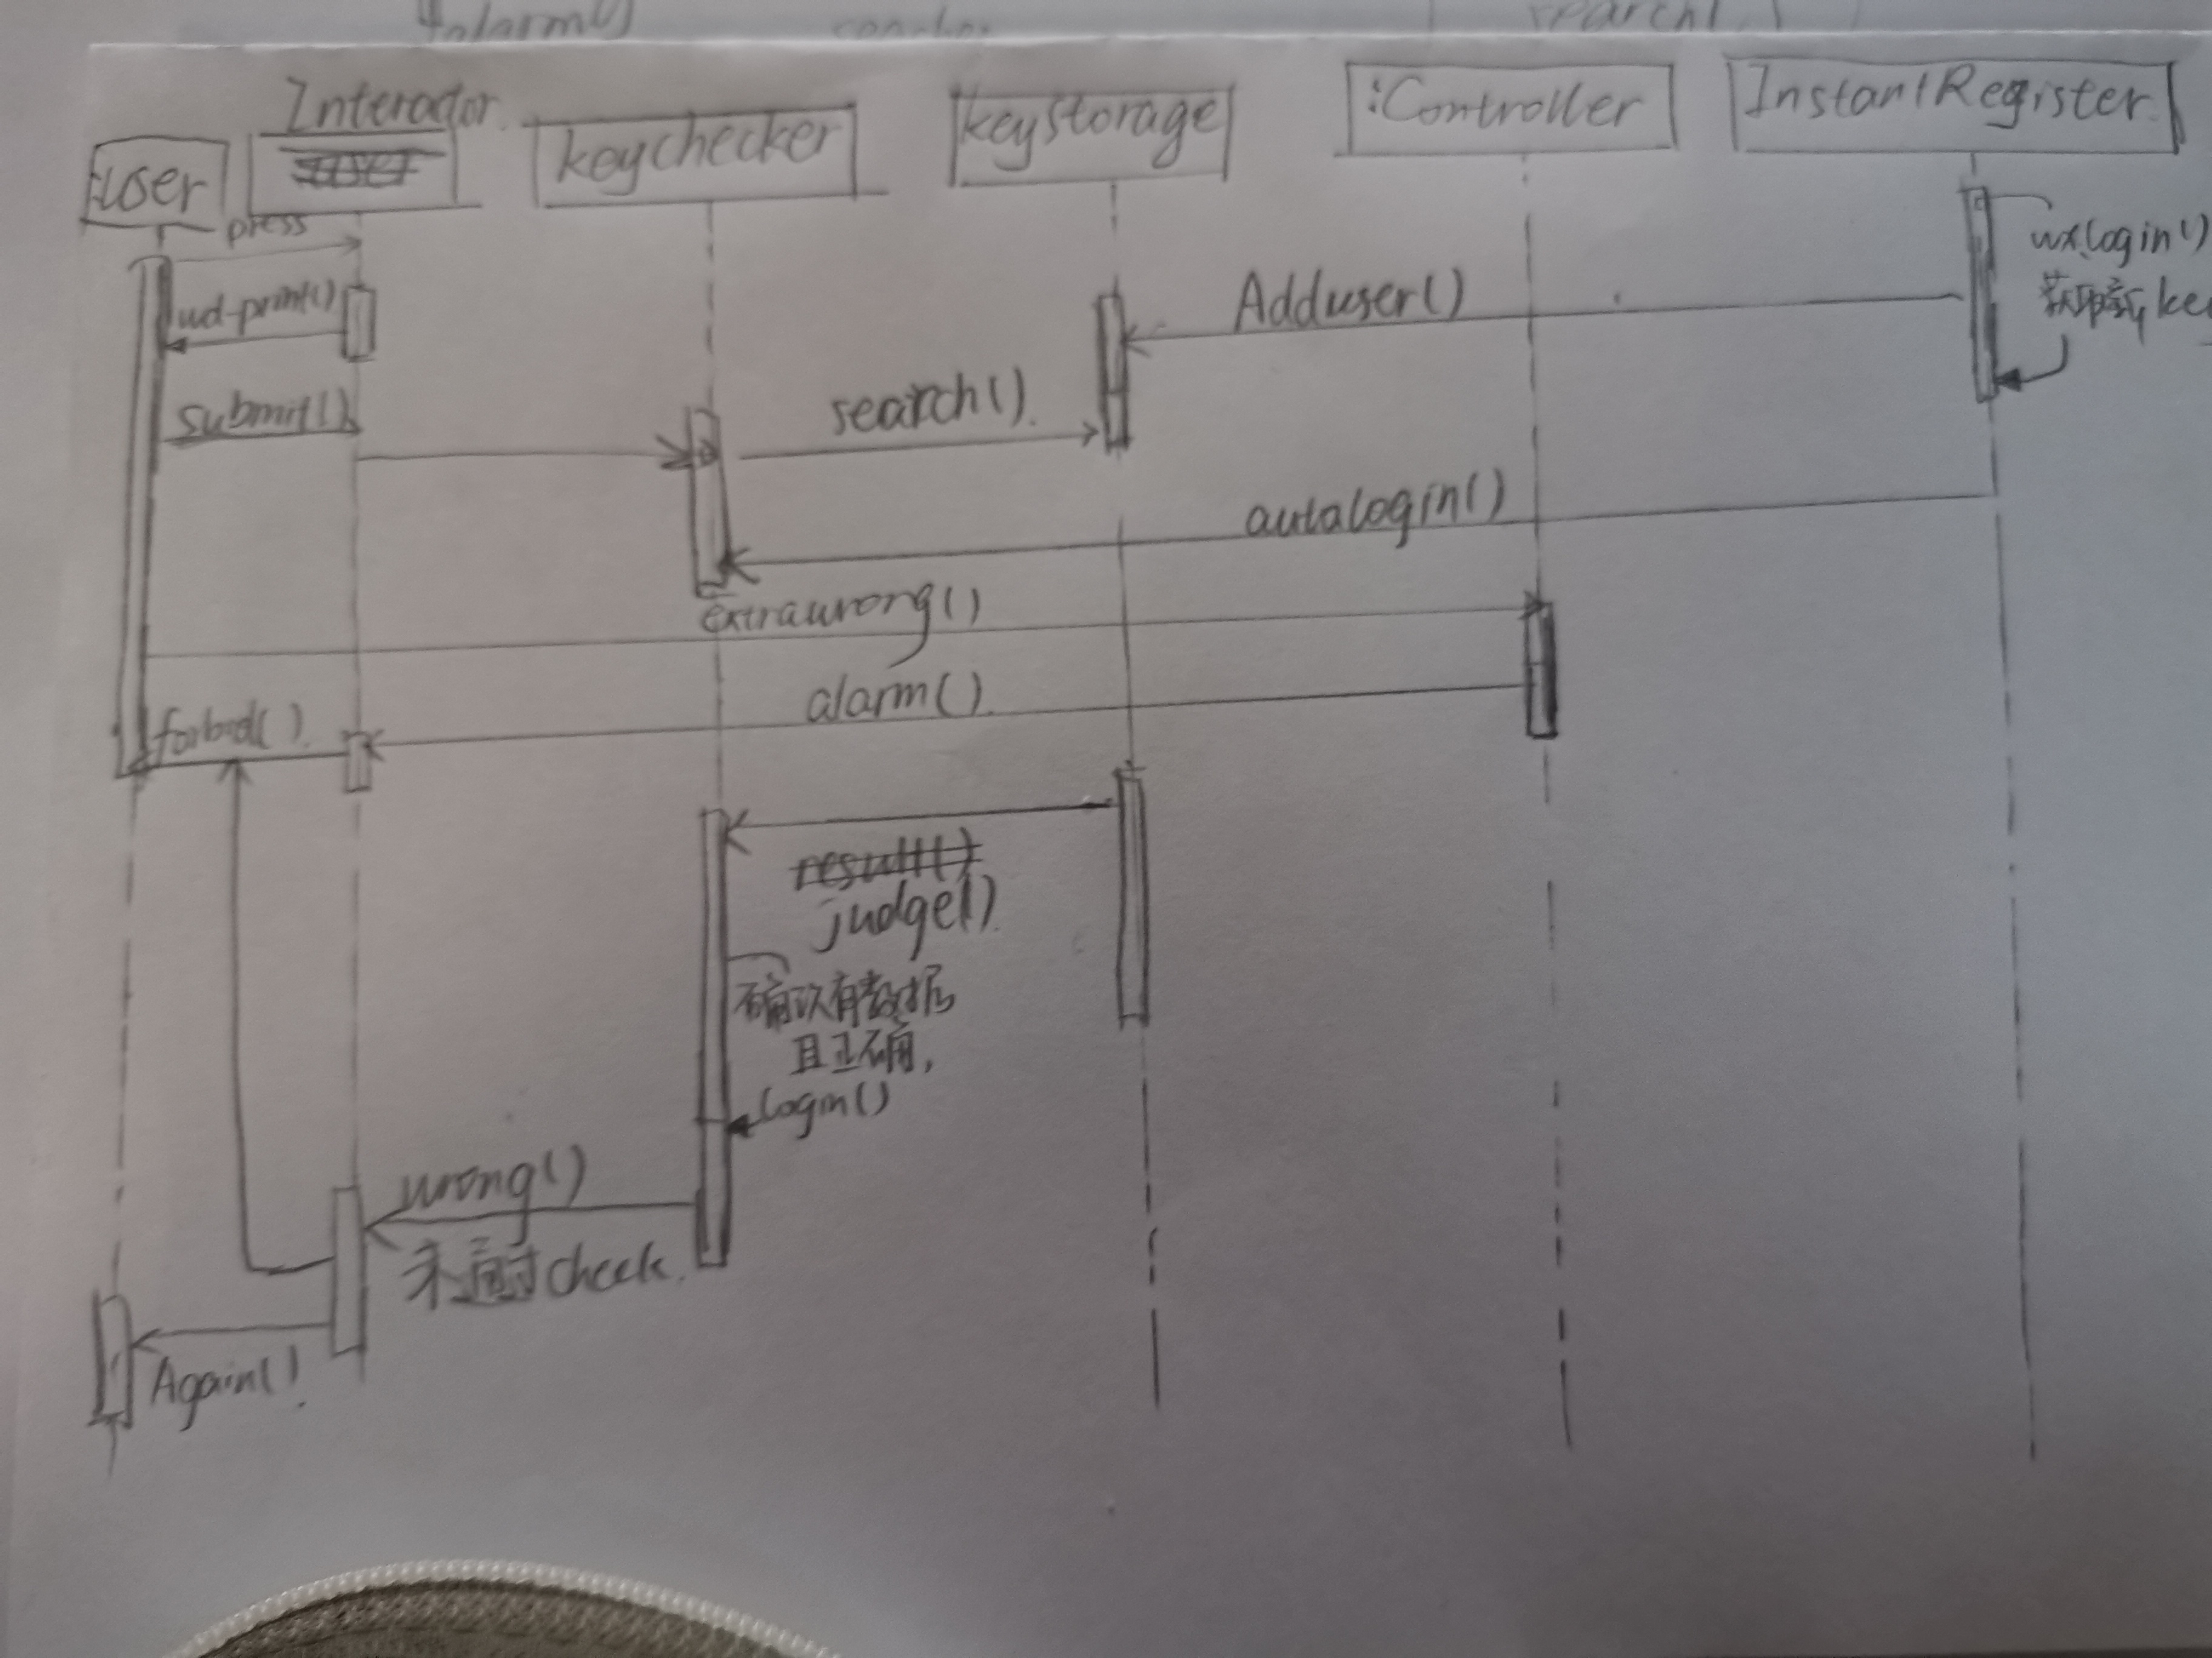

class diagram
