|  |  |  |
| --- | --- | --- |
| Responsibility Description | Type | Concept Name |
| Execute the reminder function at the specified time | D | Time-Checker |
| Select routines that users want to set a reminder from database for them. | K | Datastore |
| List all matters which need to be reminded.Each of them match their own time.(对应各自的提醒时间) | K | Timestore |

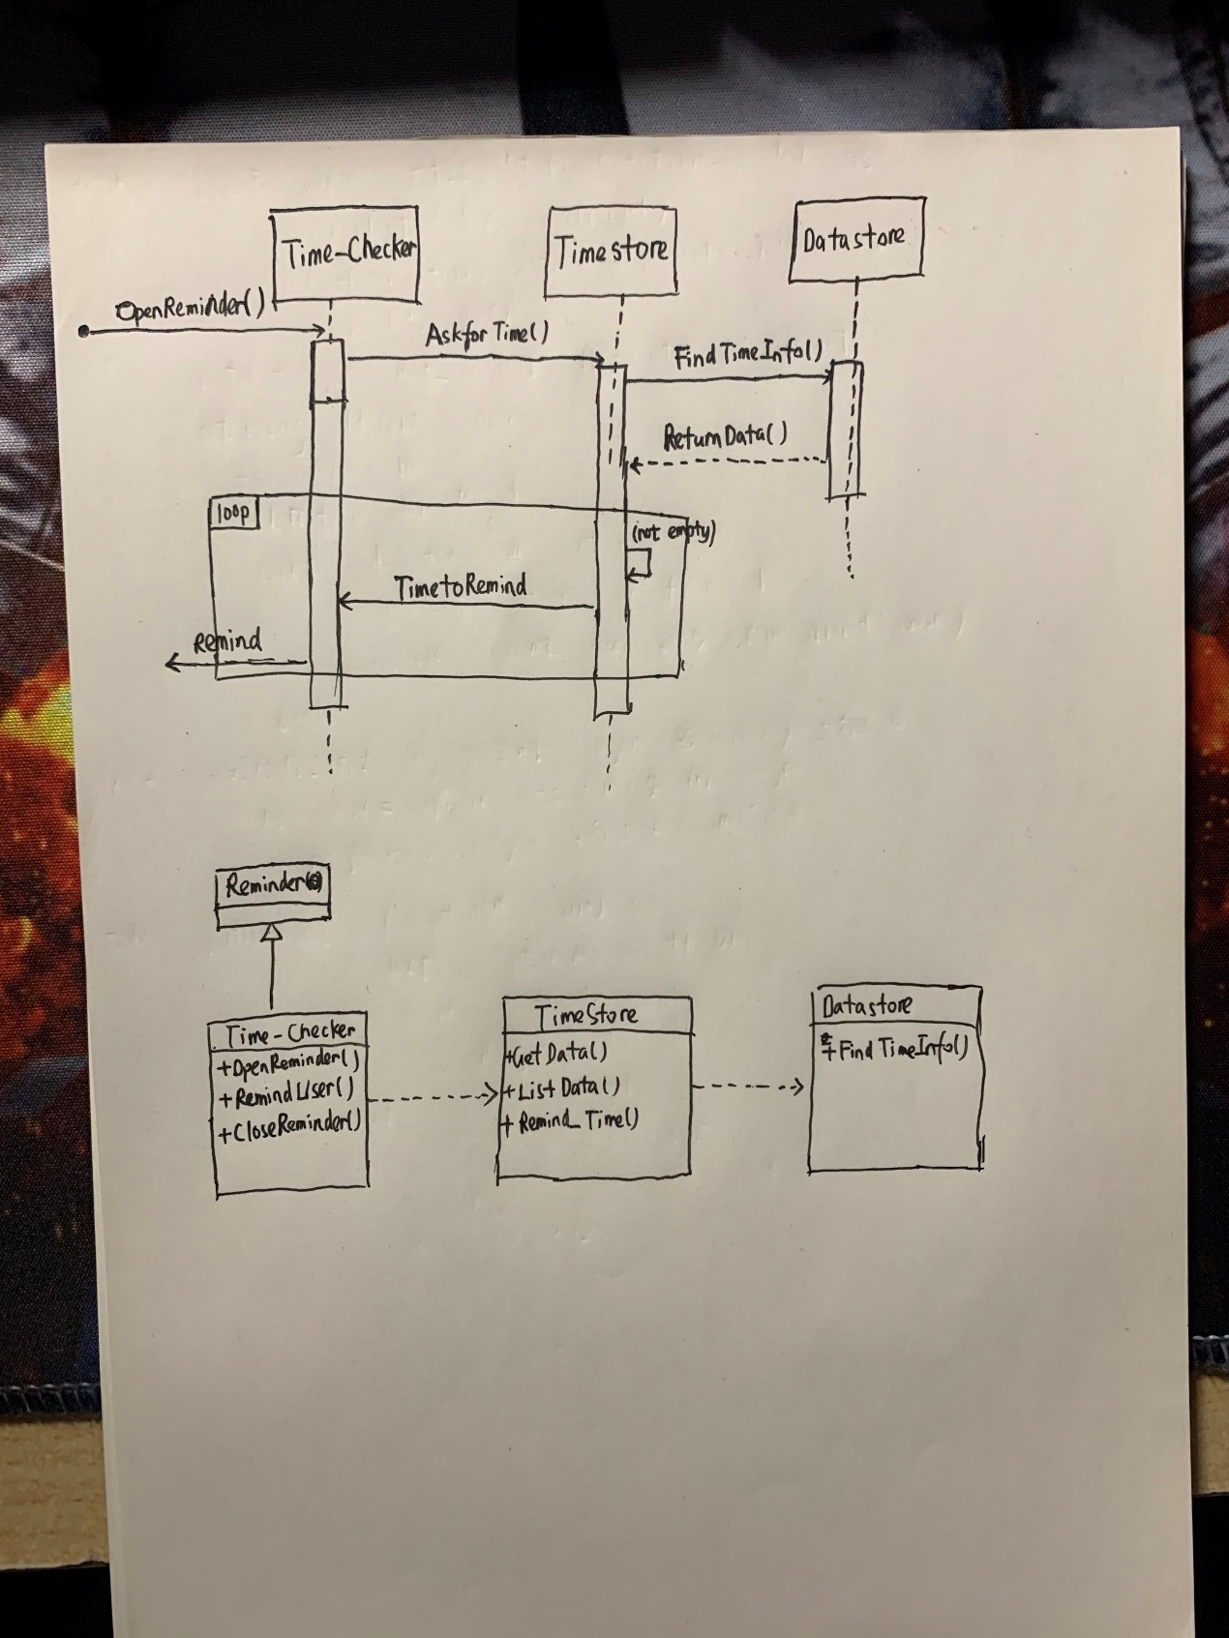

设计思路：

对于Reminder，当用户开启该功能后，系统会在指定时间提醒，不同事项的提醒日期不同，TimeStore应从库中将这些日期提取出来，然后反馈给TimeChecker，告知其应在什么时间提醒用户。