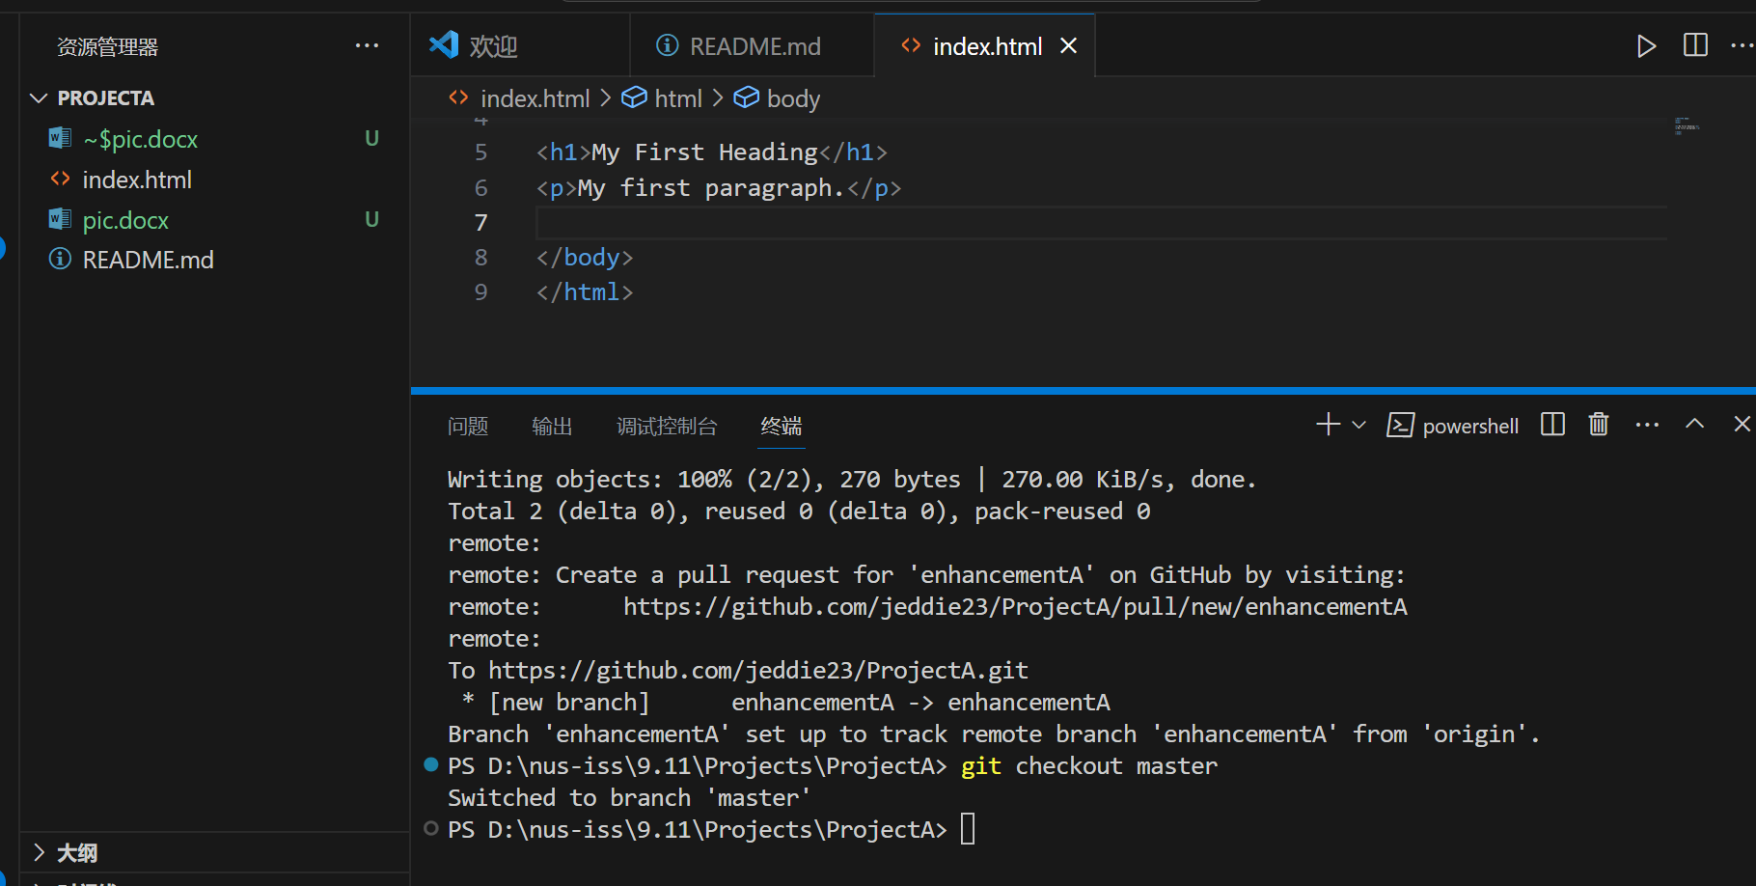

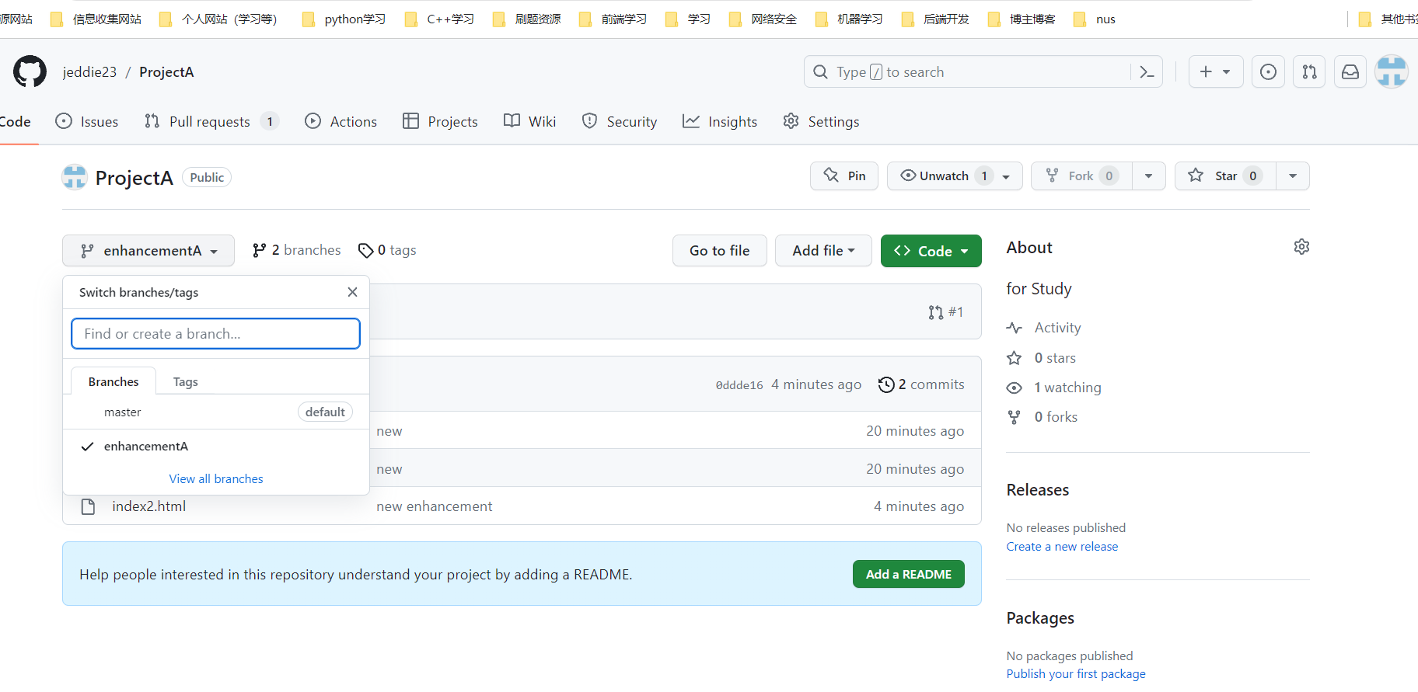

I once created a blog website using Git functionality, you can refer to https://jeddie23.github.io/"