GreenHouseWatch — Phase 1 Design and Phase 2 Simulation Delivery
Course: CTEC 651 – Internet Technologies Discovery
Instructor: Prof. F. Njeh
Student / Team: IPMC BIT
Submission focus: Phase 1 Design (Due 7 Sep 2026) and Phase 2 Simulation (Due 14 Sep 2026)

1. Project overview
GreenHouseWatch is a local IoT digital repository designed for greenhouse monitoring in a low-cost, free-to-use environment. The system captures temperature, humidity, soil moisture, and light readings from a virtual greenhouse sensor, publishes them through MQTT, records them in a local SQLite database, and supports analysis and visualisation without relying on paid cloud services.

2. Problem statement and use case
Small greenhouse and urban-farm operators lose plants when temperature, humidity, or soil moisture drift outside a safe operating band, often while no one is actively monitoring a thermometer or dashboard. Commercial IoT platforms are usually paid, cloud-locked, and too heavy for a class-scale system. GreenHouseWatch addresses this by focusing on local capture, storage, and inspection of greenhouse sensor data using free tools and simple automation.
The use case simulates a single greenhouse node, GH-SENSOR-01, that emits a JSON reading every two seconds. Each reading contains device metadata and environmental values, and the system stores the historical stream for later interpretation and alerting.

3. Design specification
The system follows a standard IoT flow: sensor simulator → MQTT broker → subscriber → SQLite storage → visualisation/export. The design uses the public HiveMQ broker and stores readings in a local repository to enable later charting and review.
Architecture diagram:
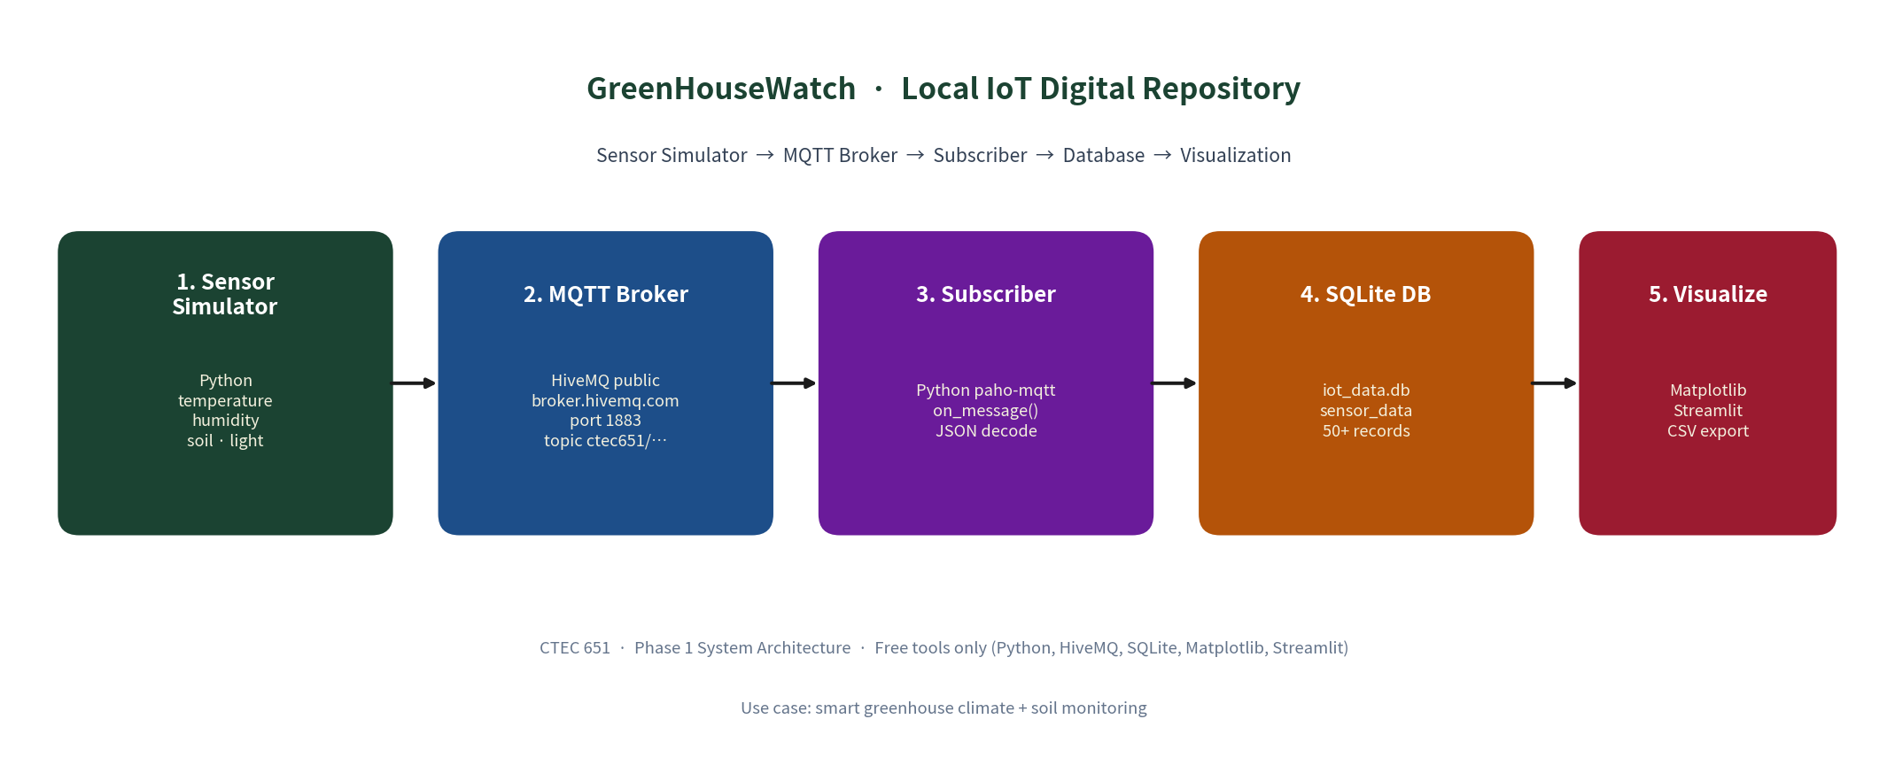
Data fields used in the project include timestamp, ISO timestamp, device ID, temperature_c, humidity_pct, soil_moisture_pct, light_lux, alert_flag, and alert_reason. The alert logic flags readings that breach the safe bands: temperature 16–32 °C, humidity 40–80 %, and soil moisture ≥ 30 %.

4. Implementation summary
The design is implemented in the repository with the following components: docs/PHASE1_Project_Proposal.md, diagrams/architecture.png, src/simulator.py, and supporting source modules for MQTT, SQLite, and visualization. The project uses Python, paho-mqtt, SQLite, Matplotlib, and optional Streamlit for dashboarding.

5. Simulation deliverable
The Phase 2 simulation is implemented in src/simulator.py. It generates realistic greenhouse readings with day/night dynamics, light and temperature variation, humidity inversions, soil moisture decay, and injected anomaly conditions. This provides a credible time-series stream suitable for later database storage and alert interpretation.
# GreenHouseWatch simulator — 20 records, interval=0.0s
# Fields: timestamp, iso_time, device_id, temperature_c, humidity_pct, soil_moisture_pct, light_lux, alert_flag, alert_reason
{"timestamp": 1788813086.599, "iso_time": "2026-09-07T20:31:26.598819+00:00", "device_id": "GH-SENSOR-01", "temperature_c": 16.85, "humidity_pct": 75.82, "soil_moisture_pct": 54.34, "light_lux": 20.9, "alert_flag": 0, "alert_reason": null}
{"timestamp": 1788813086.599, "iso_time": "2026-09-07T20:31:26.598981+00:00", "device_id": "GH-SENSOR-01", "temperature_c": 17.07, "humidity_pct": 77.08, "soil_moisture_pct": 54.75, "light_lux": 7.6, "alert_flag": 0, "alert_reason": null}
{"timestamp": 1788813086.599, "iso_time": "2026-09-07T20:31:26.599083+00:00", "device_id": "GH-SENSOR-01", "temperature_c": 18.2, "humidity_pct": 78.68, "soil_moisture_pct": 55.19, "light_lux": 46.4, "alert_flag": 0, "alert_reason": null}
{"timestamp": 1788813086.599, "iso_time": "2026-09-07T20:31:26.599178+00:00", "device_id": "GH-SENSOR-01", "temperature_c": 17.82, "humidity_pct": 78.16, "soil_moisture_pct": 54.92, "light_lux": 0.0, "alert_flag": 0, "alert_reason": null}
{"timestamp": 1788813086.599, "iso_time": "2026-09-07T20:31:26.599270+00:00", "device_id": "GH-SENSOR-01", "temperature_c": 17.93, "humidity_pct": 79.47, "soil_moisture_pct": 54.62, "light_lux": 18.5, "alert_flag": 0, "alert_reason": null}
{"timestamp": 1788813086.599, "iso_time": "2026-09-07T20:31:26.599362+00:00", "device_id": "GH-SENSOR-01", "temperature_c": 17.6, "humidity_pct": 77.87, "soil_moisture_pct": 55.14, "light_lux": 56.5, "alert_flag": 0, "alert_reason": null}
The sample output confirms the expected data format: timestamp, iso_time, device_id, temperature_c, humidity_pct, soil_moisture_pct, light_lux, alert_flag, and alert_reason. The simulator also demonstrates alert conditions such as high humidity and other threshold breaches in the generated readings.

6. Submission checklist
Phase 1 Design — Due 7 Sep 2026 — Submit docs/PHASE1_Project_Proposal.md (or .docx) and diagrams/architecture.png
Phase 2 Simulation — Due 14 Sep 2026 — Submit src/simulator.py and samples/phase2_sample_output.txt

7. Conclusion
GreenHouseWatch demonstrates a practical local IoT repository pattern for smart greenhouse monitoring. The project balances a clear architectural design with a realistic simulation that can later feed live MQTT transmission, SQLite storage, and dashboard analysis without requiring paid cloud services.

