BOWIE STATE UNIVERSITY

DEPARTMENT OF COMPUTER SCIENCE

INTERNET TECHNOLOGY DISCOVERY

INTERNET OF THINGS (IOT) DIGITAL
REPOSITORY PROJECT
GREENHOUSEWATCH

INSTRUCTOR
DR. FELIX NJEH

BY

JERRY DIABOR
SEPTEMBER 14, 2026

1. Project overview
GreenHouseWatch is a local IoT digital repository for greenhouse monitoring demonstrations. The simulator and MQTT publisher produce temperature, humidity, soil-moisture, light, nutrient-level and pH readings for crop-specific zones. The subscriber stores accepted messages in SQLite, while the Streamlit dashboard provides Overview, Zones, Analytics, Forecast, Controls and Data pages.

Problem statement and use case
The design addresses the need to retain environmental observations and identify out-of-range conditions without requiring a paid IoT platform. The current use case is a multi-zone virtual greenhouse with crop-specific thresholds and device-health metadata. This educational prototype demonstrates monitoring and analysis; it does not claim physical greenhouse coverage or authorize irrigation hardware.

Delivery scope and assessment
The repository now includes the design proposal, architecture diagram, simulator, MQTT pipeline, SQLite storage, visualizations and a live Streamlit dashboard. The dashboard reads the repository every five seconds, distinguishes fresh, stale, demo and simulated data, and exposes crop-specific targets. Input validation, alert normalization, forecast handling and page-level rendering are covered by the local test suite.
Phase deadlines: design 7 September; simulation 14 September; MQTT 21 September; storage, visualization and presentation 28 September 2026. The PDF title says 21 September while its Due Date field and final-phase sections say 28 September. This report follows the explicit phase dates and does not certify timely submission.
Requirement source: Digital Repository Project 1 due 28 September 2026.pdf, pp. 1-7.

2. Design specification
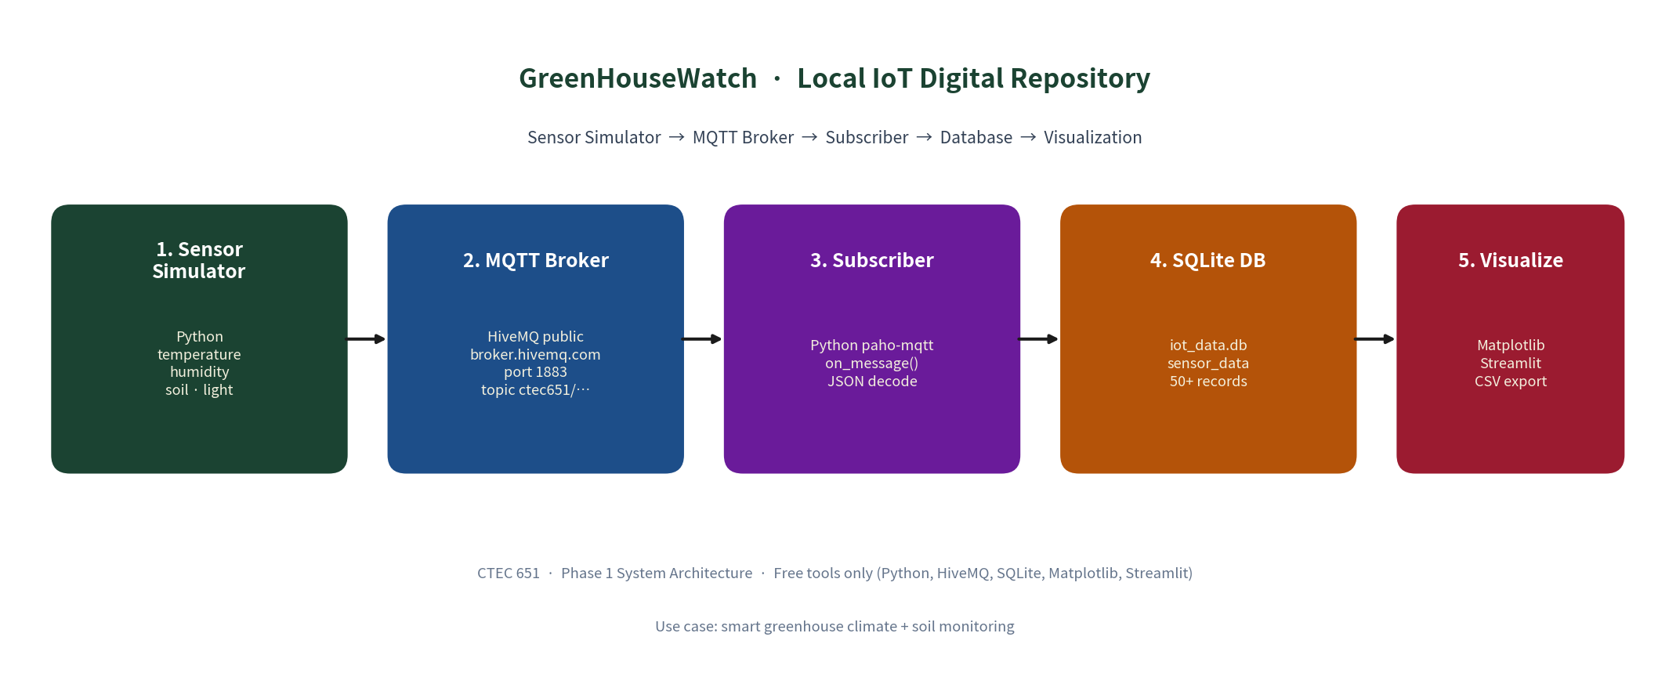
Figure 1. Repository architecture.
The publisher imports the simulator; the subscriber receives the same JSON schema and commits each accepted message. The repository remains local even though message transport uses an external public broker. Configuration is centralized in src/config.py.
Field | SQLite type | Purpose
id | INTEGER | Auto-increment primary key
timestamp | REAL | Unix timestamp; indexed for time queries
iso_time | TEXT | Human-readable UTC timestamp
device_id | TEXT | Originating virtual sensor node
temperature_c | REAL | Air temperature in degrees Celsius
humidity_pct | REAL | Relative humidity percentage
soil_moisture_pct | REAL | Soil moisture percentage
light_lux | REAL | Ambient illumination
alert_flag | INTEGER | 1 when any configured limit is breached
alert_reason | TEXT | Reason(s), or NULL when normal
nutrient_level | REAL | Optional nutrient level percentage
ph_scale | REAL | Optional soil solution pH
measured_at | TEXT | Sensor measurement time in UTC for zone telemetry
received_at | TEXT | Subscriber receipt time in UTC for zone telemetry

Schema sources are src/db.py tables sensor_data and zone_telemetry. Zone telemetry includes measured_at, received_at, crop-health fields, optional nutrient_level and ph_scale, and alert metadata. SQLite type declarations alone do not enforce numeric sensor values; subscriber validation and write-time alert normalization provide the application-level checks.
Global fallback thresholds are temperature 16-32 degrees C, humidity 40-80% and soil moisture at least 30%. Zone telemetry uses crop-specific configured targets. Boundary values are accepted; light is recorded but does not trigger an alert. Nutrient level and pH are stored as optional telemetry and displayed with target bands.
Free toolchain: Python, paho-mqtt, HiveMQ public broker, SQLite, Matplotlib and optional Streamlit/pandas. CSV can be opened in a spreadsheet, but no paid spreadsheet software is needed.

3. Simulation deliverable
src/simulator.py generates JSON records with UTC timestamps, a device identifier, temperature, humidity, soil moisture, light, nutrient level, pH and alert metadata. The default live interval is two seconds. Zone publishers attach crop and device-health metadata; command-line options control count, interval and zone.

Live readings and historical simulation
generate_reading() models temperature and light with a solar curve and humidity with an inverse trend plus random variation. Live calls use soil moisture near the default 55% baseline. generate_series() adds soil dry-down, a mid-series irrigation recovery and injected anomalies. Those historical events are not automatically present in the live publisher. The implemented temperature curve does not include the two-hour lag claimed in a source comment.
Run from the repository root after dependencies are installed:
.venv\Scripts\python.exe src/simulator.py --count 20 --interval 2
.venv\Scripts\python.exe src/simulator.py --once

Saved sample output
samples/phase2_sample_output.txt contains 20 parseable JSON records, satisfying the requested 10-20 record sample. Its header explicitly uses interval=0.0s, so this artifact demonstrates the output format rather than two-second timing. One actual saved record is reproduced below.
{
"timestamp": 1788813086.599,
"iso_time": "2026-09-07T20:31:26.598819+00:00",
"device_id": "GH-SENSOR-01",
"temperature_c": 16.85,
"humidity_pct": 75.82,
"soil_moisture_pct": 54.34,
"light_lux": 20.9,
"alert_flag": 0,
"alert_reason": null
}

Simulation verification
Threshold and repository tests pass, including exact boundary cases, multi-zone telemetry, nutrient/pH fields and alert normalization. The implementation supports eight configured crop zones; active telemetry is still simulated unless a physical publisher is connected.
Phase 1 artifacts: docs/PHASE1_Project_Proposal.docx and diagrams/architecture.png. Phase 2 artifacts: src/simulator.py, src/config.py and samples/phase2_sample_output.txt.

4. MQTT transmission and SQLite storage

Transmission implementation and retained evidence
src/publisher.py sends zone-aware JSON through broker.hivemq.com:1883 on ctec651/greenhousewatch/ipmcbit. src/subscriber.py validates payloads, records received_at, preserves measured_at, normalizes crop-specific alert metadata and inserts readings through src/db.py. The publisher retries after transient broker disconnects.
The saved samples/subscriber_run.log contains 20 received payloads and storage messages. All 20 payloads were matched against current SQLite records during this review. This is retained evidence of the earlier run, not a new live broker test on 16 September. samples/phase3_mqtt_transmission.txt is explicitly an example and should not be used as primary evidence. The assignment accepts a screenshot OR output.

Current repository snapshot
Check | Verified result
Database | data/iot_data.db; PRAGMA integrity_check = ok
Stored rows | Current repository snapshot; verify row count immediately before demonstration
Composition | Historical seed records plus live/simulated zone telemetry; composition changes as publishers run
Coverage (UTC) | 7 Sep 2026 00:31:21 to 8 Sep 2026 05:56:22
Sampling | Historical rows: 15 minutes; MQTT batch: approximately 2 seconds
Gap | Approximately 9 hours 39 minutes between batches
Alerts | 7 alerts; 93 normal readings
CSV | CSV export is generated from the filtered repository snapshot
Timestamp and alert checks | All ISO/numeric times agree within 1 ms; all alerts match current threshold logic

Storage and pipeline behavior
The schema has timestamp indexes and parameterized INSERT statements. The offline pipeline initializes a database, seeds historical readings when needed, exports CSV and creates four charts. The current dashboard loads the SQLite repository, applies freshness rules, and preserves UTC storage while presenting user-facing times in Eastern time.
MQTT QoS 0 and the publisher console counter do not establish subscriber receipt. For this snapshot, the independent subscriber log and database matching provide the stronger evidence. The offline script bypasses MQTT and cannot by itself prove Phase 3 communication.

5. Visualizations and interpretation
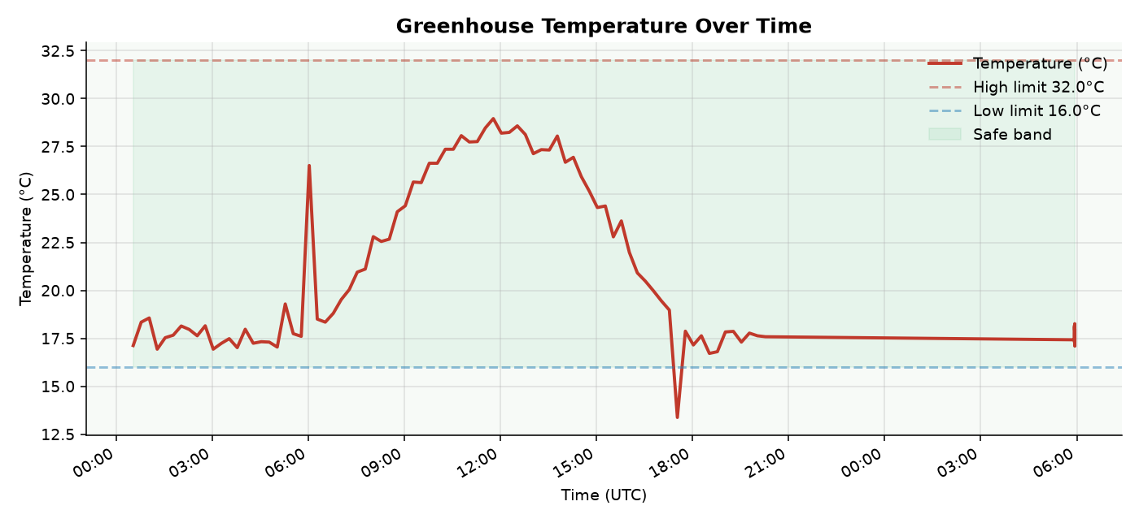
Figure 2. Temperature history from the repository; dashed lines show project limits.
In the retained 100-record sensor_data snapshot, the temperature range is 13.37-28.96 degrees C. No stored value exceeds the 32-degree upper limit. The single low-temperature alert occurs on 7 September at 17:31:21 UTC; it is an injected simulated cold event, not a measured dawn event.
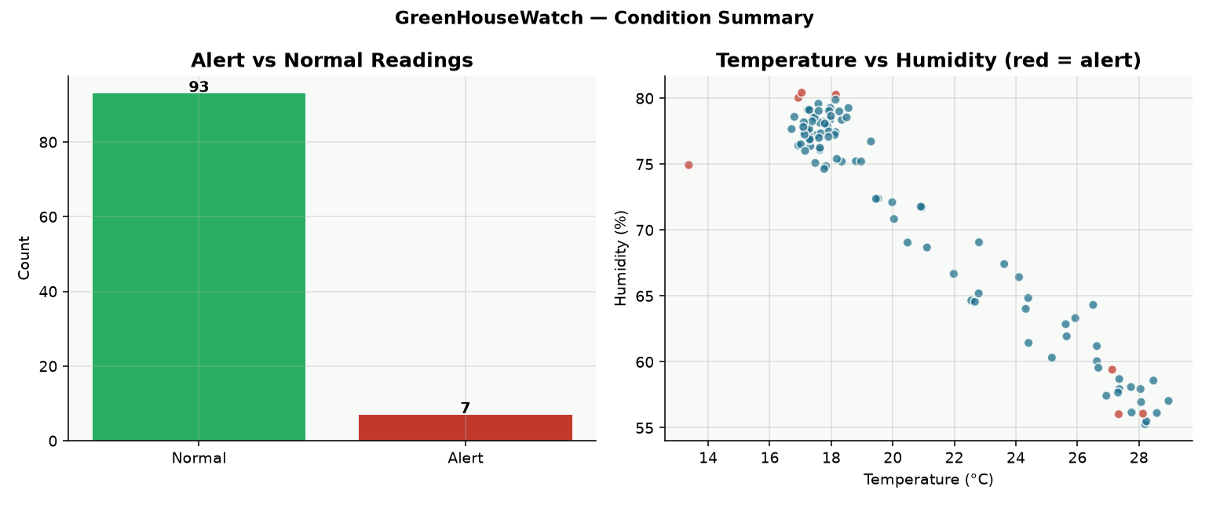
Figure 3. Current condition summary: 93 normal readings and 7 alerts.
Alerts represent 7% of 100 stored readings: three high_humidity, three dry_soil and one low_temperature. This percentage weights records, not elapsed time, because the historical and MQTT batches use different sampling intervals. The scatter reflects the programmed relationship between temperature and humidity.
Sources: outputs/01_temperature_over_time.png and outputs/04_alert_summary.png; data/iot_data.db. Additional charts: 02_humidity_over_time.png and 03_soil_and_light.png.

6. Additional insights and optional dashboard

Humidity, soil moisture and light
Humidity ranges from 55.27% to 80.42%. Three simulated records exceed 80%, at 01:16, 02:46 and 05:01 UTC on 7 September. Soil moisture ranges from 20.12% to 73.36%; dry-soil alerts occur at 12:46, 13:01 and 13:16 UTC, followed by the modeled irrigation recovery. Light ranges from 0 to 7,863.2 lux and follows the programmed solar pattern. These results illustrate how stored data makes threshold events visible; they do not independently validate a physical clock or greenhouse safety.

Dashboard and integrated demonstration
src/dashboard.py launches a multi-page Streamlit application. Overview presents primary zone health, explicit KPI averages, environmental trends and data-quality status. Zones provides a searchable crop directory and selected-zone details. Analytics provides compact filters, zone comparison, gaps, alert analysis and summaries. Forecast provides a default Bowie location, current weather, daily summaries, recommendations and indoor/outdoor comparison.
The dashboard stores UTC timestamps. Chart axes and tooltips use UTC; refresh and availability summaries explicitly use Eastern time. Analytics uses zone-specific dash patterns and gap segmentation. Overview marks bins containing recorded alerts. See Section 9 for the current chart assessment and application screenshots.

Learning-objective assessment
Objective (PDF p. 1) | Evidence and assessment
Understand IoT architecture | Five-stage design and matching implementation; met at artifact level.
Simulate sensor data | Four measurement channels, JSON and 20 saved samples; met.
Implement MQTT communication | Publisher/subscriber plus 20 retained payloads matched to storage; supported by prior-run evidence.
Store/manage time series | SQLite, time index, 100 rows and matching CSV; met for valid data.
Visualize for insight | Four PNG charts and corrected interpretation in this report; met, with display limitations.
Present an end-to-end system | Ten-slide deck and demo commands exist; final presentation/demo delivery remains unverified.
The optional dashboard/integrated-script objective is implemented. Basic AI and other bonus enhancements are optional and are not treated as missing core requirements.

7. Whole-project deliverable checklist
Phase / deadline | Artifacts and readiness
1. Design / 7 Sep | One-page proposal: docs/PHASE1_Project_Proposal.docx. Architecture: diagrams/architecture.png. Content present; identity needs confirmation.
2. Simulation / 14 Sep | src/simulator.py and samples/phase2_sample_output.txt. Verified 20 records and generator/alert checks.
3. MQTT / 21 Sep | src/publisher.py, src/subscriber.py and samples/subscriber_run.log. Retained transmission output matches 20 stored rows; no new network run in this review.
4. Storage / 28 Sep | Current repository contains multi-zone telemetry; verify counts before submission
5. Visualization / 28 Sep | Four images in outputs/. Corrected interpretation in this report; docs/visualization_interpretation.md remains stale.
6. Bonus / optional | src/dashboard.py and src/offline_pipeline.py execute on valid data. Input-validation and display limitations remain.
7. Presentation / 28 Sep | presentation/GreenHouseWatch_Slides.pptx has 10 slides, within the recommended 8-15. Counts and claims need correction. Live or recorded final demo still must be delivered.

Required corrections before final submission
Input validation is now enforced before insertion for numeric, finite and physically valid measurements. Zone alert_flag and alert_reason are recomputed from configured crop thresholds at write time. The active database was normalized and has no inconsistent alert flag/reason pairs.
Section 9 provides the current application review and screenshots. The earlier single-device counts and static figures are retained as historical evidence; they are not the current multi-zone dashboard totals. Supporting slides and interpretation files should identify their dataset and distinguish simulated from physical readings.
Identity and demonstration: the source materials use IPMC BIT and include a name-replacement note. Confirm the intended student identity. No recording is present in the repository. The student must give the required live presentation/demo or submit a recording; commands on a slide are preparation, not proof of delivery.

8. Verification record and demonstration guide
Check run on 16 September | Outcome
Source and requirement review | Read all seven PDF pages, application modules, supporting documents and slide text.
Data integrity and consistency | PASS: SQLite integrity, 100 CSV rows, timestamps and all alert metadata.
Simulation / thresholds | PASS: historical sequence spacing and 11 boundary cases.
Subscriber callback | PASS on valid JSON and missing/malformed messages; FAIL on invalid numeric values.
Isolated offline pipeline | PASS: seed/store/export/four charts; rerun preserves row count.
Dashboard execution | PASS on actual dataset; reproduced failure with mocked invalid latest temperature.
Retained MQTT evidence | 20 payloads match stored rows. A fresh HiveMQ round trip was not run.

Live demonstration sequence
From the repository root, use the existing virtual environment. Start the subscriber first, then one publisher per demonstration zone. Check the database count immediately before the demo because live publishers may continue adding rows; do not present simulated values as physical observations.
.venv\Scripts\python.exe src/db.py
# Terminal A
.venv\Scripts\python.exe src/subscriber.py
# Terminal B
.venv\Scripts\python.exe src/publisher.py --count 20 --interval 2
.venv\Scripts\python.exe src/db.py
.venv\Scripts\python.exe src/export_csv.py
.venv\Scripts\python.exe src/visualize.py
.venv\Scripts\python.exe -m streamlit run src/dashboard.py
Show the received JSON, matching inserted row and refreshed visualizations. Save actual terminal output. If the broker is unavailable, use a previously recorded MQTT demonstration plus the offline pipeline for storage and charting; the offline route alone omits transmission. Do not reset the database before preserving the chosen submission snapshot.

Conclusion
GreenHouseWatch satisfies the central educational design: simulated sensor data can be transmitted, stored locally and visualized with free tools. The first-delivery artifacts are present, and the current dataset is internally consistent. The project should be described as implemented with outstanding validation and submission corrections, rather than fully complete or error-free. This report records the checks and remaining work; it does not certify an instructor grade, submission timing or completion of the final presentation.
Verification logs and structured results are retained under tmp/delivery.

9. Current application and chart assessment
Review and screenshot capture: 22 September 2026. This section supersedes earlier dashboard descriptions and replaces the duplicate static figures with current application evidence. Screenshots show the running application and its actual repository state; counts and freshness can change while publishers are active.

Environment Trend and Analytics: corrections
- Large histories: removed the Overview crash caused by referencing a zone column after aggregation. Charts sample large display datasets while tables and CSV exports retain loaded observations.
- Meaningful averages: Overview and Analytics Overall average now compute five-minute means within each reporting zone, then weight reporting zones equally. Missing zones are excluded, not treated as zero.
- Gaps and missing values: gaps longer than 20 minutes remain disconnected, including after display sampling. Missing values in one metric no longer suppress valid values in another.
- Units and time: temperature and humidity have separate labeled axes. Chart axes and hover times explicitly use UTC; Analytics availability summaries include calendar dates and Eastern time. pH ticks retain decimal precision.
- Controls and interpretation: Analytics Reset now restores defaults without a session-state exception. Eight dash patterns distinguish configured zones. Overview explains that red triangles mean an alert in any core metric, not necessarily the metric under the marker.

Verification and limits
All 26 automated tests passed, including five chart regression tests. The six application pages were opened and captured without page exceptions. The forecast page returned live outdoor weather for Bowie, Maryland. No irrigation request was submitted during this review.
At 16:49 UTC, the loaded multi-zone snapshot contained 442 readings across eight zones: 433 simulator and nine seeded samples. Nutrient and pH values were absent in 328 readings. These are simulated observations, not evidence of physical greenhouse measurements. Display sampling may omit individual events; inspect the full filtered data for exact values.
Remaining interpretation limits: aggregate target bands show the intersection of configured zone ranges and cannot certify each zone as healthy. Overview may display last-known values when sources are stale. Analytics summary averages weight records, while Overall average charts weight reporting zones within five-minute bins. The five-day outdoor forecast is separate from indoor telemetry.

Current Overview
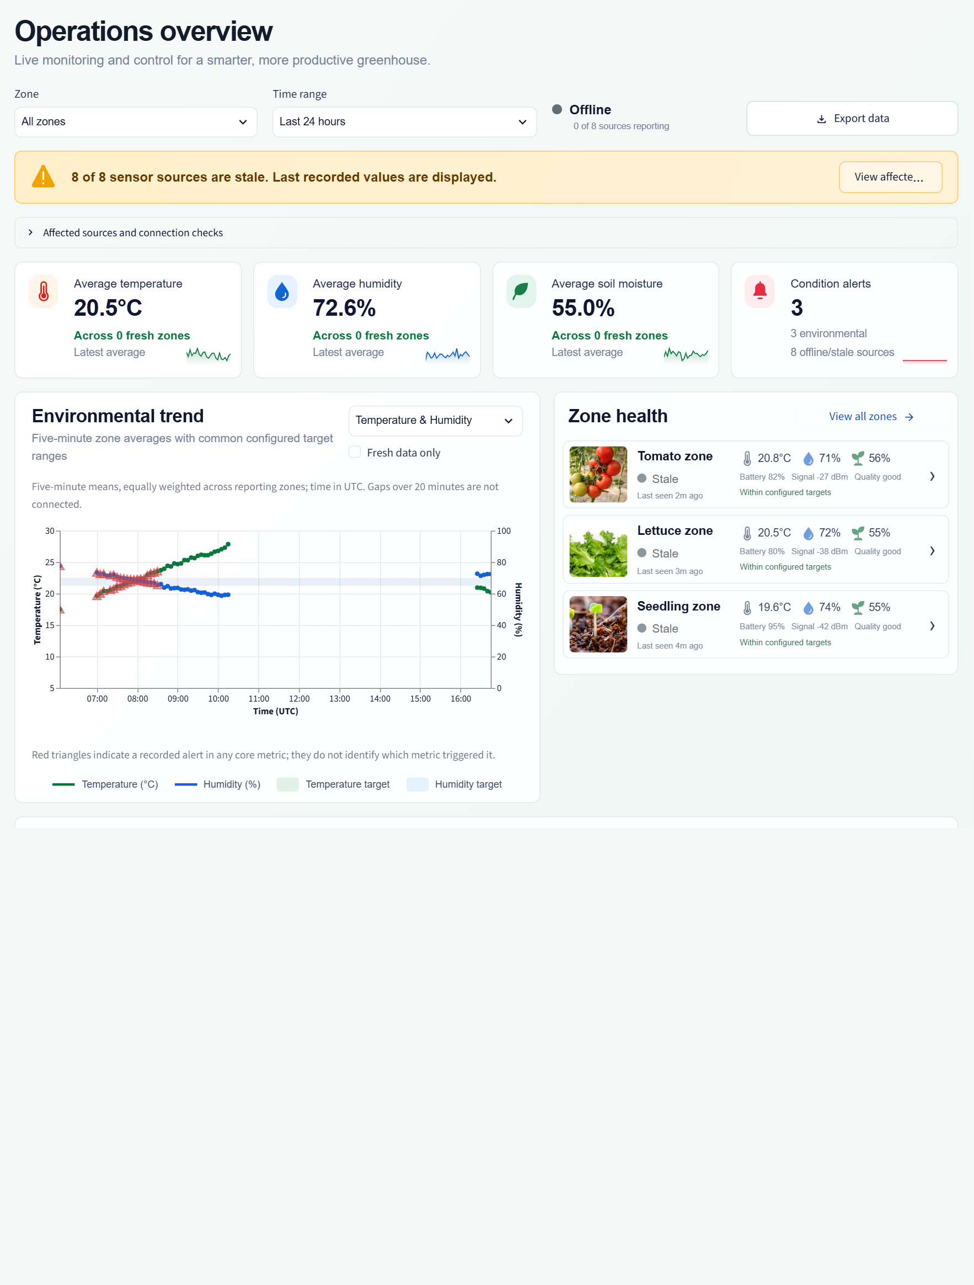
Figure 5. Operations Overview: current repository values, source freshness, environmental trend, primary zone health and simulated irrigation controls.
Freshness and source status are part of the evidence. An Offline or Degraded state indicates missing recent telemetry; it is not a failure to load the dashboard. The values shown are last-known or simulated measurements.

Environment Trend: detailed view
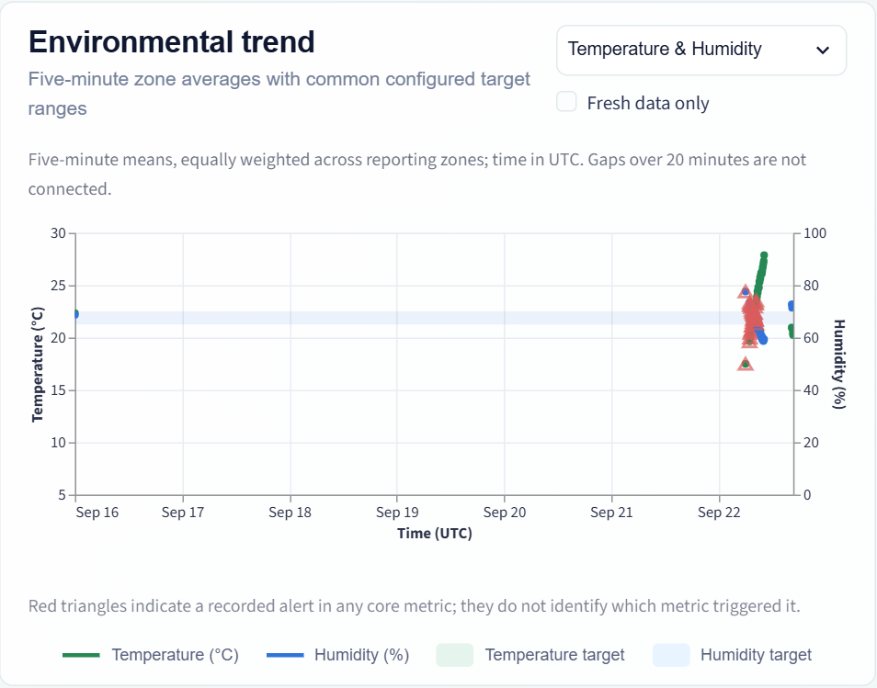
Figure 6. Corrected Environment Trend with separate temperature and humidity axes, five-minute zone means, configured target bands and visible observation gaps.
Read temperature against the left axis and humidity against the right. Blank intervals indicate a lack of observations rather than a constant environment. Red triangles indicate that at least one recorded core-metric alert occurred in the time bin. The band represents shared configured targets for the selected zones.
Soil moisture, nutrient level and pH remain selectable. Where optional measurements are absent, the application presents an explicit no-measurements message rather than inventing values.

Analytics: comparison and filtering
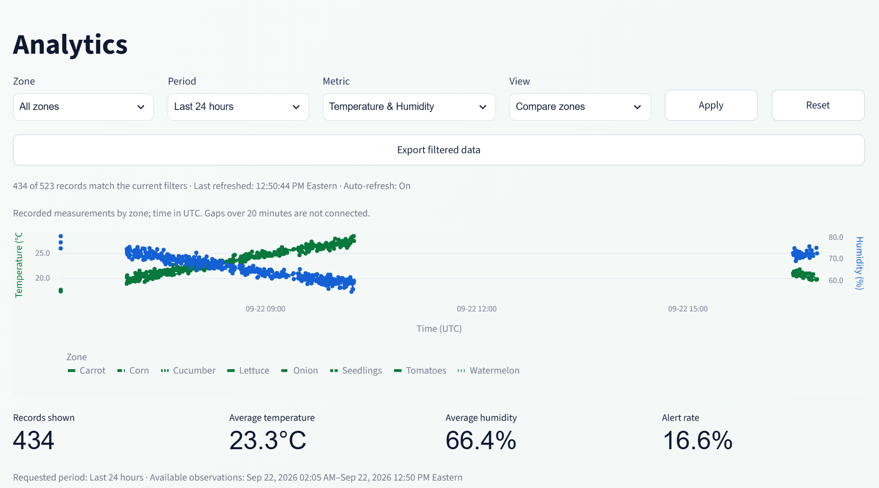
Figure 7. Analytics comparison view: period and metric filters, UTC axes, zone dash legend, summary statistics and dated Eastern availability range.
Compare zones retains each zone's observations. Overall average aligns asynchronous publishers to five-minute bins before averaging zones. Summary cards and comparison tables use all matching loaded records; they can differ from equal-zone chart means when reporting frequencies differ.
Assessment: units and gaps are now explicit, and Reset is functional. Dense overlapping series are still easier to inspect using the Zone filter or a shorter period. The chart is a monitoring aid; use the filtered CSV for exact event-level analysis.

Zones: current crop directory
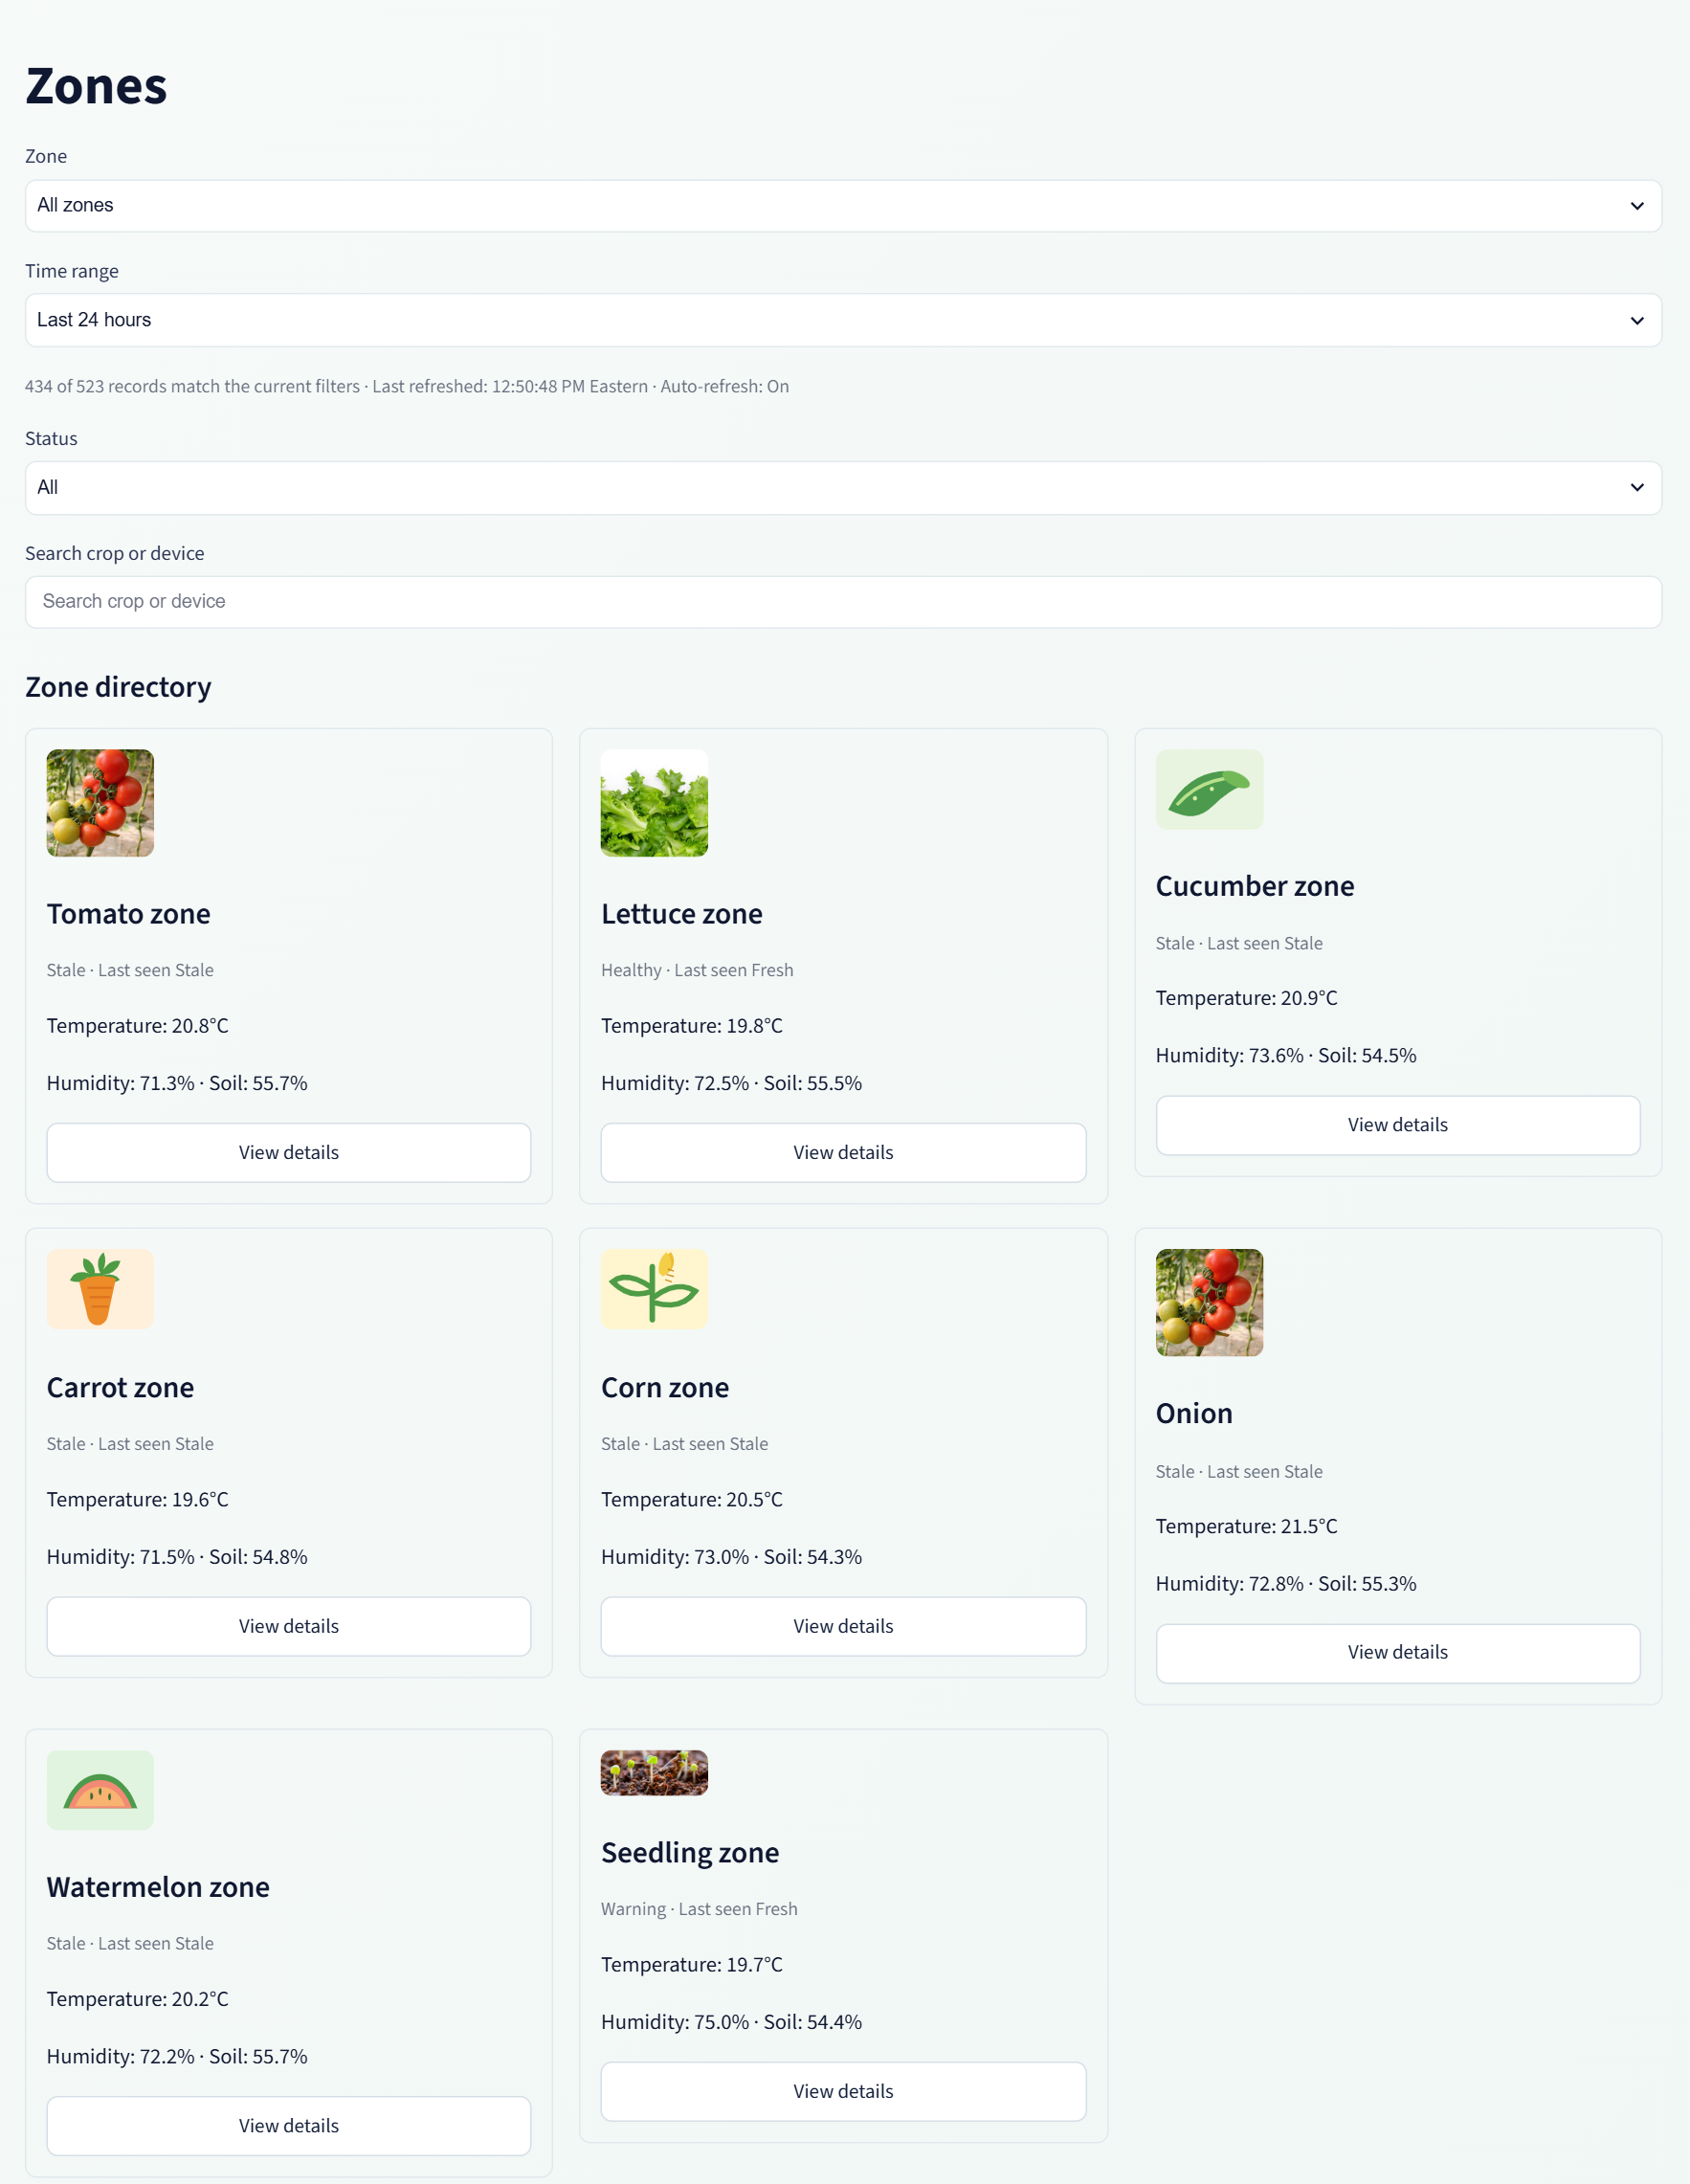
Figure 8. Current eight-zone crop directory with matching crop images, observed conditions and freshness labels.
The directory includes Tomato, Lettuce, Cucumber, Carrot, Corn, Onion, Watermelon and Seedling zones. Stale readings remain historical evidence. Optional nutrient and pH values are not available in every stored message.

Forecast: current outdoor context
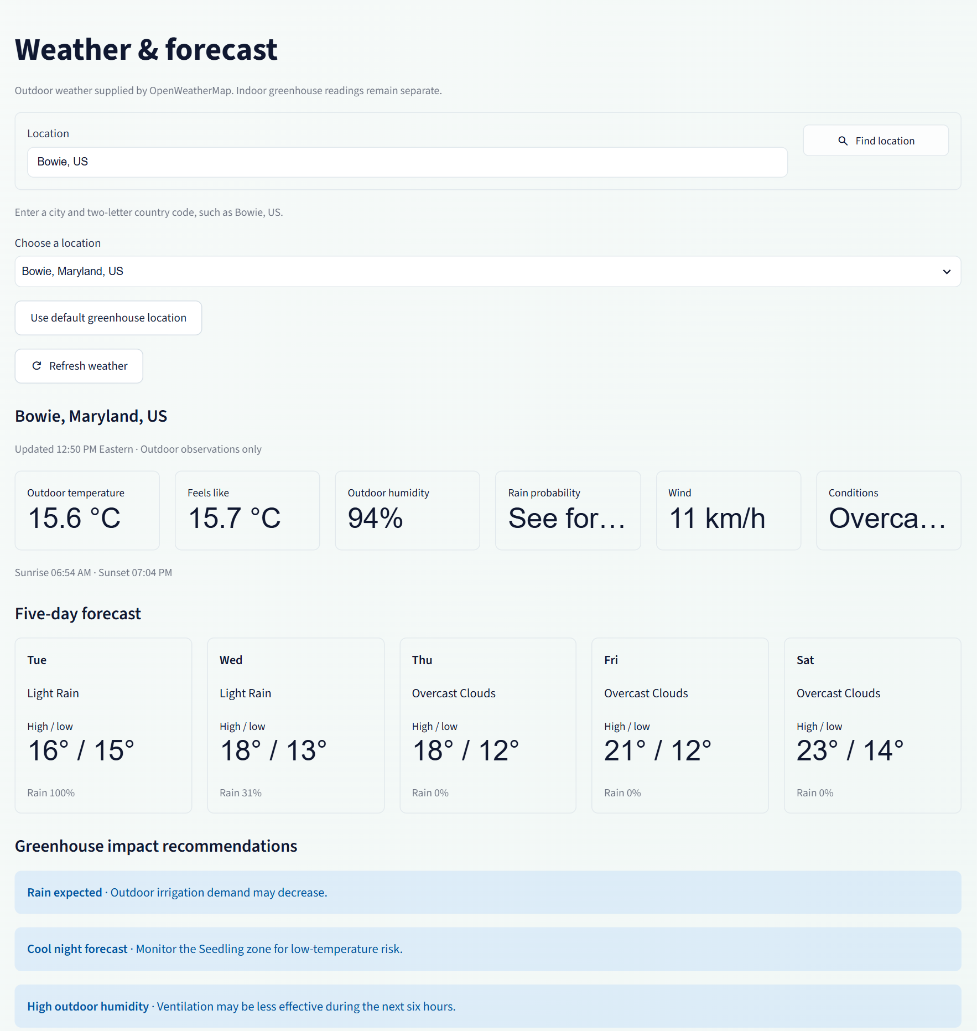
Figure 9. Current Bowie outdoor weather, five-day forecast and greenhouse impact recommendations from the running Forecast page.
Outdoor weather is provided by OpenWeatherMap. Indoor values elsewhere in this application originate from the repository and were simulated in this review. Forecast recommendations do not actuate hardware.

Controls and repository data
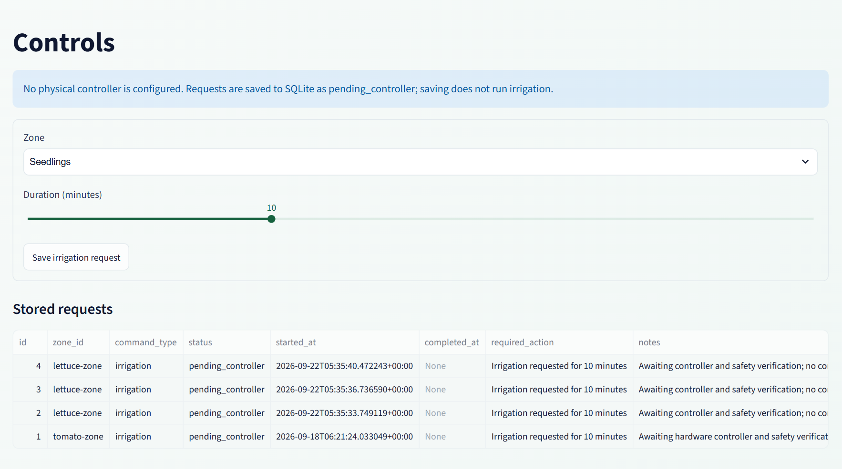
Figure 10. Controls page explicitly identifies the absence of a physical controller. No request was submitted during review.
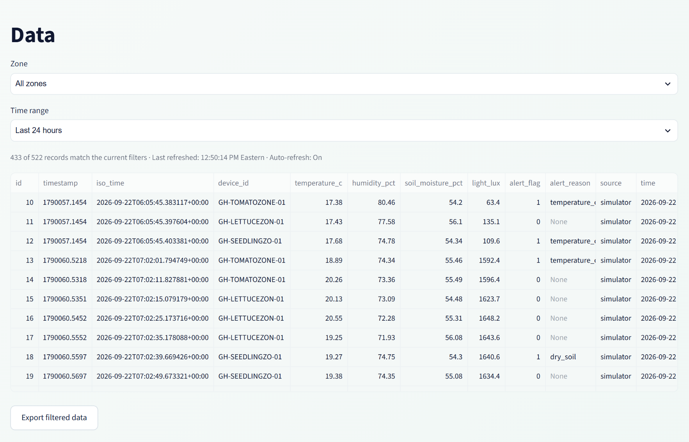
Figure 11. Data page with repository filters, timestamps, provenance fields and CSV export.
Evidence files: outputs/current-application/. Verification: tests/test_chart_review.py and the complete 26-test suite. The pre-edit report is preserved under tmp/finalProject-before-chart-review-20260922.docx.

