Student: Jedidiah
ClientID: 8876149
Target machine(server): 10.0.2.5 (UDP service)
Discovered open UDP port: 12407
Tools used: nmap, netcat/nc, crunch, hashcat, awk (Kali VM)

Description of the target and goal
The target system is a remote voucher-generation service running on a Linux host at IP 10.0.2.5. The service listens on an unknown UDP port within the range 12345–12500 and returns a voucher code when given a valid ClientID. The voucher code is a 32-character hexadecimal MD5 hash generated from the format MD5(A || ClientID || B), where A and B are short unknown strings with restricted character sets. The goal is to first discover the open UDP port, then obtain the voucher code for the given ClientID, and finally recover the original values of A and B by performing a brute-force attack using Crunch (for candidate generation) and Hashcat (for cracking), verifying the result by recomputing the MD5 hash.

A. Find the open UDP port (part a)
Command used
sudo nmap -sU -p 12345-12500 --open -v 10.0.2.5
Relevant output (captured)
Discovered open port 12407/udp on 10.0.2.5
Explanation
- -sU performs a UDP scan.
- -p 12345-12500 restricts scan to the required port range.
- --open shows only open ports.
- We identified port 12407/udp as the voucher service.

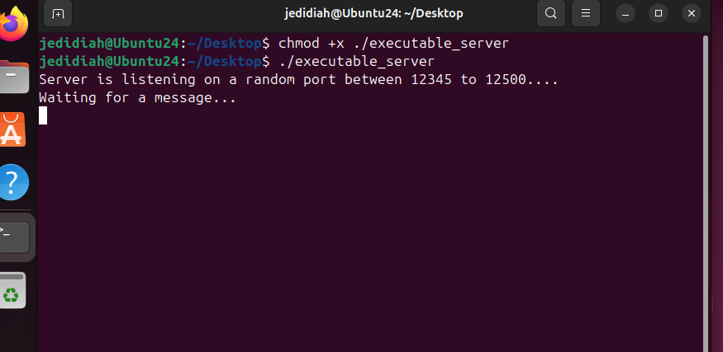
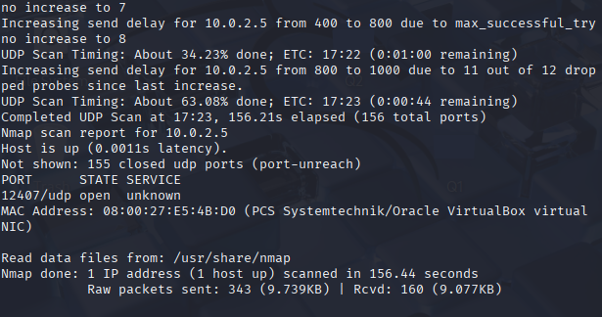

B. Request a voucher for your ClientID (part b)
Command used
echo -n "8876149" | nc -u -w1 10.0.2.5 12407
(Alternative: ncat --udp --recv-only 10.0.2.5 12407)
Server response (example captured)
Your client ID, 8876149, has been transformed into a secret! Here is your voucher code:
f3f7d40bac6f43413a66b2aff4b6ea6c
What to save
- Save the 32-hex MD5 string alone to a file for cracking:
echo -n "f3f7d40bac6f43413a66b2aff4b6ea6c" > voucher_hash.txt
Explanation
- The UDP service returns a voucher (32-hex MD5). We will bruteforce the preimage of that MD5 with Hashcat/Crunch.
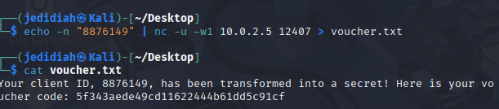
** I Took the screenshot on my first attempt, thus the result hash values is not the same as the one I used for the following steps because I recall the sever, getting different hash values each time. **

C. Recovering A and B (part c) — Crunch + Hashcat (step-by-step)
Problem statement recap
VoucherCode = MD5(A || ClientID || B) where:
- A = two lowercase letters (all combinations aa..zz, 676 items)
- ClientID = 8876149 (fixed)
- B = two symbols chosen from the assignment symbol set (example set used: !"#$%&'()*+,-./:;<=>?@[\]^_`{|}~
We use Crunch to generate A and B lists (explicit Crunch usage), combine them into candidates.txt, then run Hashcat to find the matching preimage.
Code:
mkdir -p ~/gift_crack
cd ~/gift_crack
# make sure tools exist
sudo apt update
sudo apt install -y crunch hashcat

1) Put the voucher hash into a file (exact, no trailing newline)
echo -n "f3f7d40bac6f43413a66b2aff4b6ea6c" > voucher_hash.txt

2) Generate A.txt (all two-letter lowercase combos)
crunch 2 2 abcdefghijklmnopqrstuvwxyz -o A.txt

3) Generate B.txt (all 2-symbol combos from the exact symbol set)
Create a file called symbols.txt containing !"#$%&'()*+,-./:;<=>?@[\]^_`{|}~
crunch 2 2 symbols.txt -o B.txt

4) Combine A + ClientID + B → candidates.txt
CLIENT=8876149
awk -v c="$CLIENT" 'FNR==NR{a[++n]=$0; next} { for (i=1;i<=n;i++) print a[i] c $0 }' A.txt B.txt > candidates.txt

5) Run Hashcat (dictionary attack, MD5 mode)
# dictionary attack using the generated candidate list
hashcat -m 0 -a 0 voucher_hash.txt candidates.txt
- -m 0 = MD5
- -a 0 = straight / dictionary mode
OR
hashcat -m 0 -a 3 voucher_hash.txt '?l?l8876149?1?1' -1 symbols.txt –force

6) Show the cracked result
hashcat --show -m 0 voucher_hash.txt candidates.txt
Captured output (from the lab run):
f3f7d40bac6f43413a66b2aff4b6ea6c:tp8876149~%

Interpretation
- The plaintext that produced the MD5: tp8876149~%
- Thus:
  - A = tp (two lowercase letters)
  - B = ~% (two symbol characters)

D. Manual verification (always include in report)
Take the cracked plaintext (tp8876149~%) and verify:
Command
echo -n "tp8876149~%" | md5sum
Expected output
f3f7d40bac6f43413a66b2aff4b6ea6c -
This matches the voucher MD5 obtained from the server — verification successful.

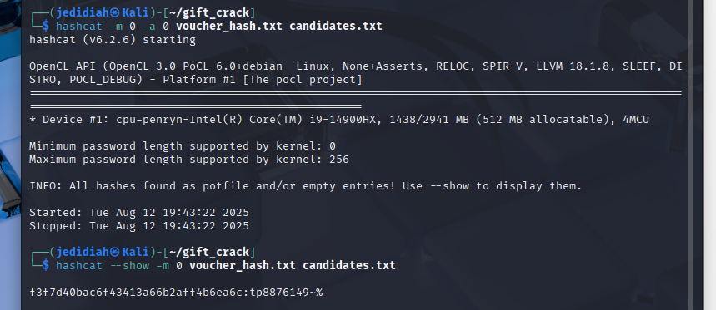

**JUST A README**
Part (a) - Port discovery
Command:
sudo nmap -sU -p 12345-12500 --open -v 10.0.2.5
Output:
Discovered open port 12407/udp on 10.0.2.5

Part (b) - Obtain voucher
Command:
echo -n "8876149" | nc -u -w1 10.0.2.5 12407
Server response:
Your client ID, 8876149, has been transformed into a secret! Here is your voucher code: f3f7d40bac6f43413a66b2aff4b6ea6c
Part (c) - Recover A and B (Crunch + Hashcat)
Commands and steps:
1) Save hash:
echo -n "f3f7d40bac6f43413a66b2aff4b6ea6c" > voucher_hash.txt

2) Generate A (2 letters):
crunch 2 2 abcdefghijklmnopqrstuvwxyz -o A.txt
3) Generate B (2 symbols; used symbol set):
crunch 2 2 '‘!"#$%&'()*+,-./:;<=>?@[\]^_`{|}~' -o B.txt

4) Combine:
CLIENT=8876149
awk -v c="$CLIENT" 'FNR==NR{a[++n]=$0; next} { for (i=1;i<=n;i++) print a[i] c $0 }' A.txt B.txt > candidates.txt
5) Crack:
hashcat -m 0 -a 0 voucher_hash.txt candidates.txt
OR
hashcat -m 0 -a 3 voucher_hash.txt '?l?l8876149?1?1' -1 symbols.txt –force

hashcat --show -m 0 voucher_hash.txt candidates.txt
Output:
f3f7d40bac6f43413a66b2aff4b6ea6c:tp8876149~%
Verification:
echo -n "tp8876149~%" | md5sum
Output:
f3f7d40bac6f43413a66b2aff4b6ea6c -

Final answer:
A = tp
B = ~%

