Problem Statement
The objectives of this project were to create a randomtree planner, to implement collision detection for a point, circle, and square robot, and to generate motion paths for two environments, and to compare the Random Tree planner to PRM, RRT, and EST planners. The Random Tree planner is similar to the RRT planner except a random configuration from the graph is selected instead of the nearest configuration to the random sample from the configuration space.

Environment Description
For both environments, the world space is a bounded box from (-1, -1) to (1, 1). In addition, the start state is in the lower-left corner of the bounded box and the goal state is in the upper-right corner of the bounded box. The first environment contains an L-shaped obstacle that blocks the direct path from the start and goal states. The second environment contains two large blocks that create a narrow in-between passage where the robot must navigate to move from the start to the goal state.
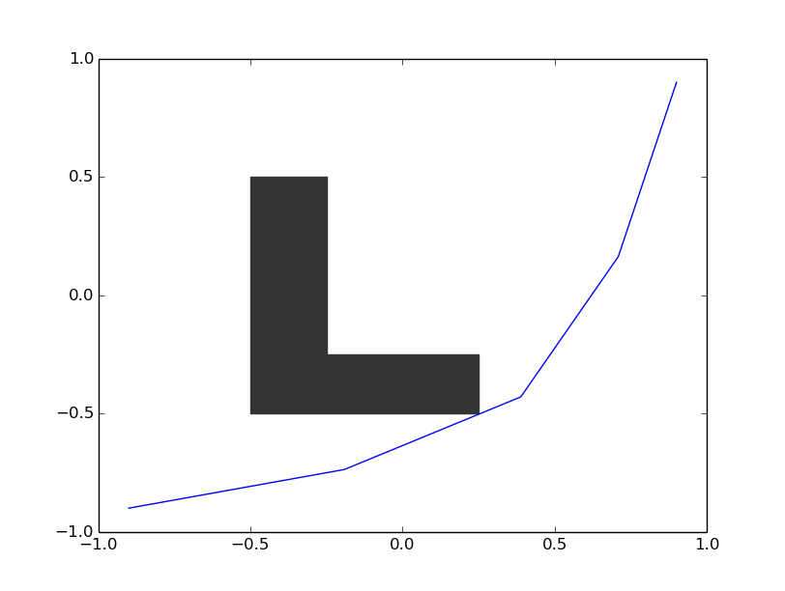
Figure 1 - A point robot navigating around an L-shaped obstacle in environment 1
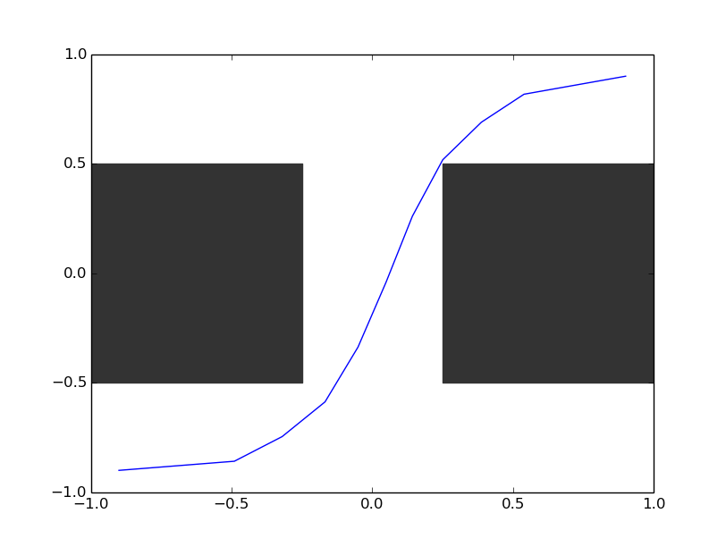
Figure 2 - A point robot navigating through a narrow passage between two obstacles in environment 2

Robot Description
There are three robot configurations for this project. The first robot is a simple point with a configuration space of R^2. The second robot is a circle with a 0.1 radius with a configuration space of R^2. The third robot is a square with a 0.25 length with a configuration space of SE(2) = R^2 X SO(2).

Benchmark Results

Point Robot / Circle Robot
The results from the point and circle robots were similar due to their similar configuration spaces. The randomtree planner typically performed worse than the PRM, EST, and RRT planners in environments 0 and 1 by every measure. On average, the solution time with the randomtree planner was 0.01 and 0.02 for environments 0 and 1 respectively, which was approximately twice as slow as the other planners. The average solution length with the randomtree planner was 4.5 and 4.2 for environments 0 and 1 respectively. This was on average longer than the other planners but was comparable to the tree-based planners and were all within about 1.0 units from each other. The mean number of states sampled by the randomtree planner was about 300 and 600 for environments 0 and 1 respectively. This was significantly greater than the states used by PRM and RRT, though EST tended to use almost half the amount of states randomtree used. Overall, although the performance was worse than the other planners, the randomtree planner was within the same order of magnitude and suffered between 2 to 3 times worse performance than the best planner.
Figure 3 Computation Time - Environment 0 - Point Robot
Figure 4 Solution Length - Environment 0 - Point Robot

Figure 5 Number of States Sampled – Environment 0 – Point Robot
Figure 6 Computation Time - Environment 1 - Point Robot

Figure 7 Solution Length - Environment 1 - Point Robot
Figure 8 Number of States Sampled - Environment 1 - Point Robot

Square Robot
The square robot clearly presents a more difficult problem for the planners overall. However, the relative performances of the planners remained largely unchanged. The randomtree planner still took longer to find a path (twice as slow in environment 0 and significantly slower in environment 1. Randomtree also took more graph states, although EST also took more graph states than PRM and RRT. Finally, the path lengths were all interestingly similar. This is probably due to the fact that all the environment obstacles constrain the robot in such a way that the solution paths are similar enough to each other.
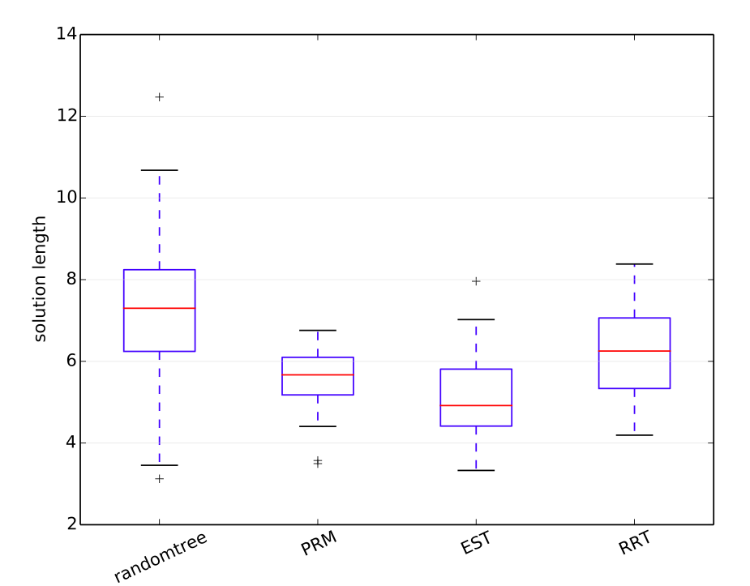
Figure 9 Solution Length - Environment 1 - Square Robot

Conclusion
The randomtree planner performed the worst because it produces a tree that diffuses the slowest through configuration space. The other tree based planners have the advantage of faster exploration by adding new states near the leaves of the tree (RRT) or sampling based on the density of the current sampled states in the configuration space (EST). PRM also typically performed better because it has coverage of the configuration space built into the algorithm.

Difficulty / Time
Ryan Spring: 4 out of 10 – 8 hours
Jayvee Abella: 4 out of 10 – 8 hours

We enjoyed the fact that this project helped us learn the specific steps necessary in building/testing planners and the care needed in collision checking.

