PROJECT IN AUTOMATA AND LANGUAGE THEORY

GENDER NEUTRAL LANGUAGE RECOGNIZER

Submitted by:
Jed Joward Edo
Jerry Olalo
Nemesis Manes
Alvin Jacob Daganato
BSCS 3B

Submitted to:

ALMA MAE B. AUXTERO
Instructor

Date submitted: October 26, 2026

Project overview
The Gender Neutral Language Checker is a desktop application that lets the user upload a plain-text (.txt) file and scans it for 16 predefined gender-specific words and phrases, such as “foreman,” “spokesman,” and “his or her.” For each detected term it shows the number of occurrences and a suggested gender-neutral alternative (for example, “supervisor,” “spokesperson,” and “their”). Its purpose is to help writers review documents and choose more inclusive wording. Main features: whole-word and case-insensitive matching, plural and variant forms (for example, “foremen”), a results table with counts and suggestions, a document preview with the detected terms highlighted, and clear messages for empty files, unsupported formats, and documents with no detected terms. The file is never modified.

2 Tools and recognition approach
Programming language and tools: Python 3 with the built-in re (regular expression) module and Tkinter for the desktop interface, written and run in Visual Studio Code. No third-party packages are used. Recognition approach: regular expressions.
- Each term has its own regular expression, and every rule is wrapped as \b(?:RULE)\b and compiled with re.IGNORECASE. Main patterns: spokes(?:man|men), fore(?:man|men), crafts(?:man|men), man[- ]hours?, ladies\s+and\s+gentlemen, his\s+or\s+her. The group (?:man|men) matches singular and plural forms, [- ] accepts a hyphen or a space, and \s+ accepts any spacing between words. IGNORECASE makes “Foreman,” “FOREMAN,” and “foreman” match the same rule. The word boundary \b at both ends makes only whole words match, so a term is not found inside a longer word (for example, “foremanship” is not flagged). Matches are found with finditer, so every occurrence is counted.
List of terms and suggested alternatives (16 terms):
Gender-specific term | Regular expression | Suggested alternative
spokesman | spokes(?:man|men) | spokesperson
cameraman | camera(?:man|men) | camera operator
mailman | mail(?:man|men) | mail carrier
housewife | house(?:wife|wives) | homemaker
headmaster | headmasters? | school head / principal
foreman | fore(?:man|men) | supervisor
layman | lay(?:man|men) | layperson
freshman | fresh(?:man|men) | first-year student
congressman | congress(?:man|men) | legislator / member of congress
craftsman | crafts(?:man|men) | artisan
repairman | repair(?:man|men) | repairer / technician
middleman | middle(?:man|men) | intermediary
man-hours | man[- ]hours? | work hours / person-hours
ladies and gentlemen | ladies\s+and\s+gentlemen | everyone / distinguished guests
he or she | he\s+or\s+she | they
his or her | his\s+or\s+her | their

Application screenshots
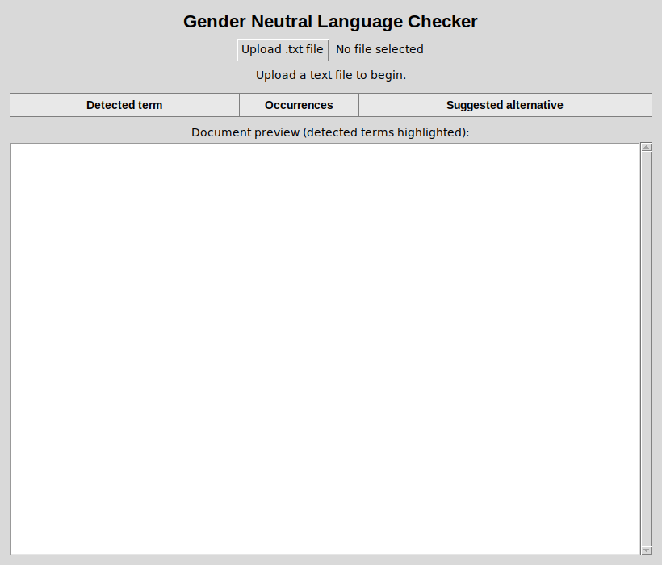
Figure 1. File selection: the Upload .txt file button on the start screen.
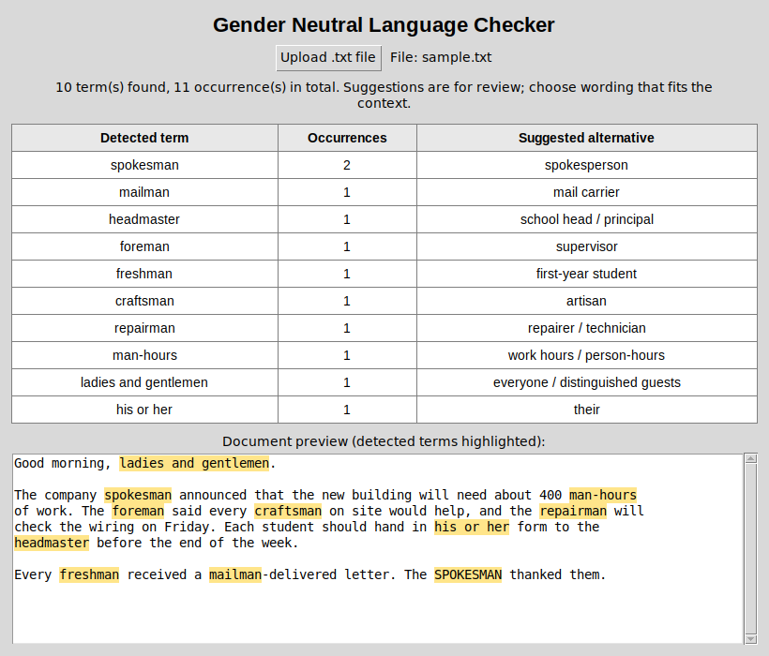
Figure 2. Detected terms with occurrence counts, suggested alternatives, and highlighted preview (sample.txt).
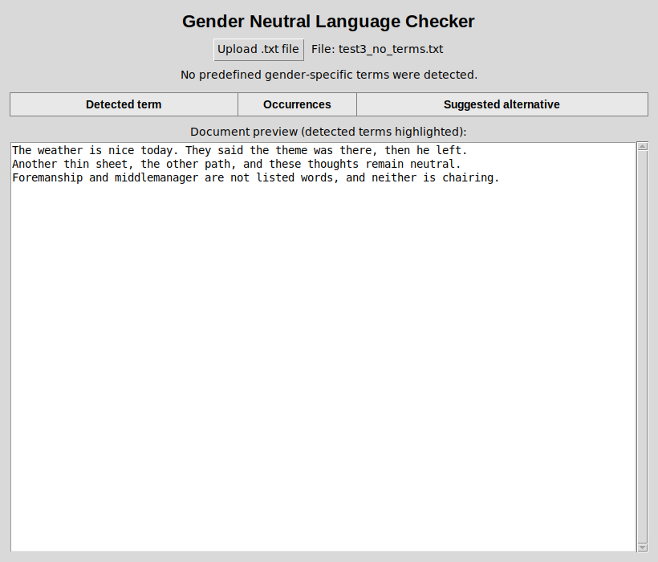
Figure 3. A document with no detected terms.
Source code / GitHub link: [Insert public GitHub link here]

Testing
Each test was run on the actual application using the files in the test_files folder. The actual results are the output of the application.
- Test 1: A document containing listed gender-specific terms.
- Test 2: Same listed term more than once and with different capitalization.
- Test 3: A document containing no listed terms, including “the.”
- Test 4: An empty .txt file.
- Test 5: A file in an unsupported format.
# | Test situation (file) | Expected result | Actual result | Pass?
1 | Document containing listed terms (sample.txt) | Listed terms detected with counts and suggestions | 10 terms detected: spokesman 2, mailman 1, headmaster 1, foreman 1, freshman 1, craftsman 1, repairman 1, man-hours 1, ladies and gentlemen 1, his or her 1 | Pass
2 | Same terms repeated with different capitalization (test2_repeated_caps.txt) | Variants counted together regardless of capitalization | spokesman 3, foreman 4, man-hours 3 (Foreman/FOREMAN/foreman/foremen; Man-Hours/MAN HOURS/man-hour all counted) | Pass
3 | No listed terms; includes “the,” “then,” “they,” “he” (test3_no_terms.txt) | No terms detected; “the” does not trigger “he” | “No predefined gender-specific terms were detected.” | Pass
4 | Empty .txt file (test4_empty.txt) | Message that the file is empty | “The selected file is empty. Please choose a file that contains text.” | Pass
5 | Unsupported format (test5_unsupported.docx) | Message rejecting the format | “Unsupported file format: .docx. Only .txt files are supported.” | Pass

Conclusion
The desktop application GenderNeutralChecker uses regular expressions to detect 16 gender-specific terms in .txt files, count their occurrences, suggest neutral alternatives, and highlight them in a preview. All five required tests passed. We learned how word boundaries, alternation groups, and the ignore-case flag work together to match whole words precisely, so “the” never triggers “he.” Known limitations: only .txt files saved as UTF-8 are supported, the term list is fixed at 16 entries, and the checker does not understand context, so suggestions are for review (for example, “freshman” may be acceptable in a quoted title).

Sources and contributions
References and libraries: Python 3 standard library (re, tkinter, pathlib, collections); Python documentation on regular expressions; Visual Studio Code. No third-party packages or borrowed code. AI assistance: Claude was used to help guide the programmer.
Member contributions:
- Jed Joward Edo: Programmer
- Jerry Olalo: Documentation
- Nemesis Manes: Documentation
- Alvin Jacob Daganato: Documentation

