ATOC7500 – Application Lab #2

Regression, Autocorrelation, Red Noise Timeseries

in class Monday/Wednesday September 21/23, 2020

Notebook #1 – Autocorrelation and Effective Sample Size using Fort Collins, Colorado weather observations

ATOC7500_applicationlab2_AR1_Nstar.ipynb

LEARNING GOALS:

1) Calculate the autocorrelation at a range of lags using two methods available in python (np.correlate, dot products)

2) Estimate the effective sample size (N*) using the lag-1 autocorrelation

3) Evaluate the influence of changing the sampling frequency and the specified weather variable on the memory/redness of the data as quantified by the autocorrelation and N*.

DATA and UNDERLYING SCIENCE:

In this notebook, you will analyze the memory (red noise) in weather observations from Fort Colins, Colorado at Christman Field. The observations are from one year, but are sampled hourly. The default settings for the notebook analyze the air temperature in degrees F sampled once daily (every midnight). But other standard weather variables and sampling frequencies can also be easily analyzed. The file containing the data is called christman_2016.csv and it is a comma-delimited text file.

Non-exhaustive Questions to guide your analysis of Notebook #1:

1) Start with the default settings in the code. In other words – Read in the data and find the air temperature every 24 hours (every midnight) over the entire year. Calculate the lag-1 autocorrelation using np.correlate and the direct method using dot products. Compare the python syntax for calculating the autocorrelation with the formulas in Barnes. Equation numbers are provided to refer you back to the Barnes Notes. What is the lag-1 autocorrelation?

The lag-1 autocorrelation is the correlation between 1 data point and the data point subsequent to it.

2) Calculate the autocorrelation at a range of lags using np.correlate and the direct method using dot products. Compare the python syntax for calculating the autocorrelation with the formulas in Barnes. Equation numbers are provided to refer you back to the Barnes Notes. How does the autocorrelation change as you vary the lag from -40 days to +40 days?

As you increase the lag (in both directions) the autocorrelation decreases. For some reason though, the lags do not decrease symmetrically in both directions.

3) Calculate the effective sample size (N*) and compare it to your original sample size (N). Equation numbers are provided to refer you back to the Barnes Notes. How much memory is there in temperature sampled every midnight?

With a lag-1 autocorrelation of 0.85, the effective sample size is 31 data points. This means that each data point has a memory of 365/31 ~= 12 days.

4) Now you are ready to tinker … i.e., make minor adjustments to the code with the parameters set in the code to see how your results change. Suggestion: Make a copy of the notebook for your tinkering so that you can refer back to your original answers and the unmodified original code. For example: Repeat steps 1-3) above with a different variable (e.g., relative humidity (RH), wind speed (wind_mph)). Repeat steps 1-3) above with a different temporal sampling frequency (e.g., every 12 hours, every 6 hours, every 4 days). How do you answers change?

If we sample air temperature measurements every 2 weeks instead of every day, we get a lag-1 autocorrelation of 0.59 and an effective sample size of 25 that is equal to the sample size. This suggests that as you temporally space out the individual measurements, the memory is reduced.

Relative humidity on the other hand (sampled every 24 hours) has a lag 1 autocorrelation of 0.3 and this reduces the effective sample size from 366 to 198 data points. If I sample every 2 hours on the other hand, I get a lag-1 autocorrelation of 0.87, which reduces my effective sample size from 4392 to 317.

Notebook #2 – Red noise time series generation, Regression, and Statistical Significance Testing While Regressing

ATOC7500_applicationlab2_AR1_regression_AO.ipynb

LEARNING GOALS:

1) Calculate and analyze the autocorrelation at a range of lags using output from an EOF analysis (the Arctic Oscillation Index).

2) Generate a red noise time series with equivalent memory as an observed time series (i.e., given lag-1 autocorrelation).

3) Correlate two time series and calculate the statistical significance.

4) Evaluate the statistical significance obtained in the context of the number of chances provided for success. What happens when you go “fishing” for correlations and give yourself lots of opportunity for success? Can you critically evaluate the chances that your regression is statistically different than 0 just by chance?

DATA and UNDERLYING SCIENCE:

In this notebook, you will analyze the monthly Arctic Oscillation (AO) timeseries from January 1950 to present. The AO timeseries comes from an Empirical Orthogonal Function (EOF) analysis. We will implement EOFs in the next application lab so in this lab we are actually using multiple analysis methods introduced in this class, some that you have learned and some that you are still yet to learn ☺.

How do you find the AO value each month? To identify the atmospheric circulation patterns that explain the most variance, NOAA regularly applies EOF analysis to the monthly mean 1000-hPa height anomalies poleward of 20° latitude for the Northern Hemisphere. The AO spatial pattern (Figure 1 below) emerges as the first EOF (explaining the most variance, 19%). The AO timeseries we will analyze is a measure of the amplitude of the pattern in Figure 1 in a given month. In other words – the AO timeseries is the first principal component (a timeseries) associated with the first EOF (a spatial structure). More information on the EOF analysis here:

http://www.cpc.ncep.noaa.gov/products/precip/CWlink/daily_ao_index/history/method.shtml

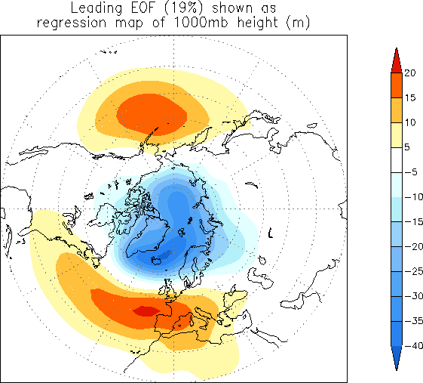

Figure 1. The loading pattern of the Arctic Oscillation (AO), i.e., the structure explaining the most variance of monthly mean 1000mb height during 1979-2000 period. In other words – this is the first EOF.

The data are available and regularly updated here:

<http://www.cpc.ncep.noaa.gov/products/precip/CWlink/pna/norm.nao.monthly.b5001.current.ascii>

You can work with the data directly on the web (assuming you have an internet connection). I have also downloaded the data and made them available – The name of the data file is “monthly.ao.index.b50.current.ascii”.

Questions to guide your analysis of Notebook #2:

1) Start with the default settings in the code. First read in the Arctic Oscillation (AO) data. Look at your data!! Plot it as a timeseries. Save the timeseries plot as a postscript file and put it in this document.

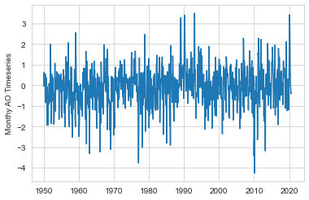

2) Calculate the lag-one autocorrelation (AR1) of the AO data and record it here. Use two methods (np.correlate, dot products). Check that they give you the same result. Interpret the value. How much memory (red noise) is there in the AO from month to month?

The lag one autocorrelation is 0.32. This suggests that there is a small but non-negligible amount of red noise in the time series as each point explains 10% of the variability of the next point.

3) Calculate and plot the autocorrelation of the AO data at all lags. Describe your results. How red are the data at lags other than lag=1? Is there any interesting behavior of the autocorrelation as a function of lag? What would you expect for red noise timeseries with an AR1=value reported in 2)?

The autocorrelation falls off extremely quickly in both directions almost reaching 0 after 5 months in either direction. Interestingly, the autocorrelation begins to increase again as lag magnitude increases, especially between 5 and 7.5 months. Despite this interesting pattern, after one month, the dataset is approximately 90% white noise and only 10% red noise (or even less).

4) Generate a synthetic red noise time series with the same lag-1 autocorrelation as the AO data. Your synthetic dataset should have different time evolution but the same memory as the AO. Plot the AO timeseries and the synthetic red noise time series. Put the plot below.

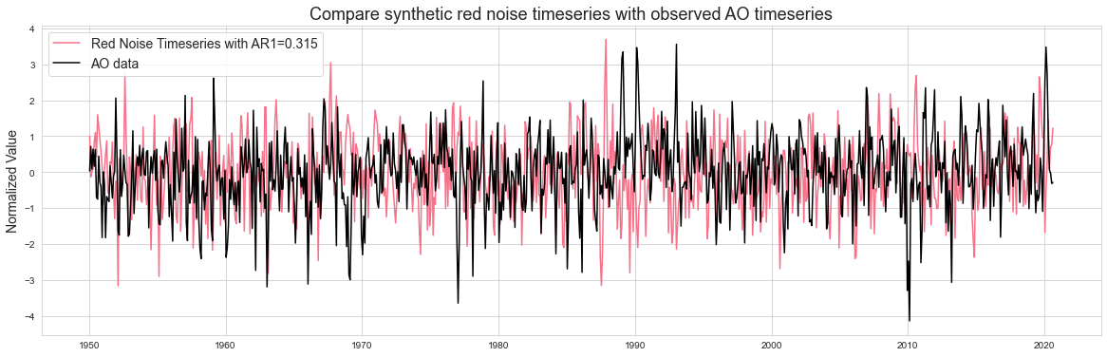

5) Do you expect to find any correlation between the two datasets, i.e., the synthetic red noise and the actual AO data? What is the correlation between the synthetic red noise and the actual AO data? Calculate a regression coefficient and other associated regression statistics.

Regression statistics:

|  |  |
| --- | --- |
| Regression coefficient | 0.05 |
| Explained variance | 0.21% |
| P­-value | 0.18 |

6) Next -- Have some fun and go “fishing for correlations”. What happens if you try correlating subsets of the two datasets many times? When you try 200 times -- what is the maximum correlation/variance explained you can obtain between the synthetic red noise and the actual data? Note: you are effectively searching for a high correlation with no a priori reason to do so.... THIS IS NOT good practice for science but we are doing it here because it is instructive to see what happens :)

7) Calculate the correlation statistics for the highest correlation obtained in question 6). Two methods are provided - they should give you the same answers. Place a confidence interval on your correlation. Because you have found a correlation that is not equal to 0, use the Fisher-Z Transformation. Did your "fishing" for a statistically significant correlation work? Is your highest correlation statistically significant (i.e., can you reject the null hypothesis that the correlation is zero)? Write out the steps for hypothesis testing and use the values you calculate to formally assess.

The 5 steps for hypothesis testing are:

1. State the significance level: **95%**
2. State the null hypothesis: **There is a statistical connection between our red noise time series and AO time series**
3. State the statistic to be used (t or z) and necessary assumptions: **We are using the Fisher z statistic because our dataset is larger than 30 and our null hypothesis is not 0**
4. State the critical region: **The critical region is |rhomin| > 0**
5. Evaluate the statistic and state the conclusion: **|rhomin| > 0, therefore, we have failed to reject the null hypothesis that there is a statistical connection between the AO and red noise time series**

Fishing for a statistically significant correlation worked!

8) You went searching for correlations, you searched long and hard (200 times!) You should have been concerned that the largest correlation you found would be a false positive. Do you think you found a false positive? Explain what you found and potentially why you think it is important statistically but not physically. What lessons did you learn by “fishing for correlations”?

This was almost definitely a false positive because the whole idea significant levels are that there is a 95% chance that the relationship you are seeing isn’t random. But this also means there is a 5% chance that there will be a significant correlation even if there is no true connection between the variables. By trying out 200 red noise time series, we are almost guaranteeing that we will find at least one significant correlation. In fact, the probability of not finding any significant correlations 0.0035%.