**ATOC7500 – Application Lab #4**

**Spectral Analysis of Timeseries**

**in class Monday October 19 and Wednesday October 21**

ASK IF YOU HAVE QUESTIONS ☺

**Notebook #1 – Spectral analysis of hourly surface air temperatures from Fort Collins, Colorado at Christman Field**

**ATOC7500_applicationlab4_fft_christman.ipynb**

**LEARNING GOALS:**

1) Complete a spectral analysis using two different functions in Python (direct FFT from numpy and using scipy which has more options). Describe the results including an interpretation of the spectral peaks and an assessment of their statistical significance.

2) Contrast applying a Boxcar and a Hanning Window when calculating the power spectra. What are the advantages/disadvantages of these two window types? What are the implications for the resulting power spectra?

**DATA and UNDERLYING SCIENCE:**

In this notebook, you analyze two years (January 1, 2013 thorugh December 31, 2014) of hourly surface temperature observations from Christman Field in Fort Collins, Colorado. Missing data have been already treated. The data are in .csv format and are called Christman_data_nomissing.csv.

**Questions to guide your analysis of Notebook #1:**

1) Look at your data. What are the autocorrelation and e-folding time of your data? What spectral peaks do you expect to find in your analysis and how much power do you think they will have?

Temperature lag-1 autocorrelation = 0.99 and e-folding time scale = 100.92 hours

I expect to see three spectral peaks, one at the diurnal cycle, one at the seasonal cycle, and one for synoptic weather variability (3-5 days).

2) Calculate the power spectra using the Numpy method, which assumes a Boxcar window that is the length of your entire dataset. Graph the power spectra, the red noise fit to the data, and the 99% confidence interval. What statistically significant spectral peaks did you find? What do they represent? How did you assess the statistical significance (what is the null hypothesis that you are trying to reject)? Compare back to Barnes and Hartman notes to make sure all of the equations and functions in the notebook are working as you expect them too.

There are 3 statistically significant spectral peaks. Statistical significance is determined by peaks that exceed the 99% confidence interval of the red noise fit. One at the yearly frequency, one at the daily frequency, and one at the 12 hour frequency. The first two are obvious, but it is unclear what physical mechanisms are behind the 12 hour peak.

3) Calculate the power spectra using the scipy method. Check that you get the same result as you got using the Numpy method. Next – compare the power spectra obtained using both a Boxcar window and a Hanning window. Assume a window length that is the entire length of the dataset. Do you get the same statistically significant peaks when applying the Hanning window and the Boxcar window? How do they differ? Can you explain why?

Using the Hanning window, you get the same statistically significant spectral peaks, but they are lower than peaks from the boxcar window. They peaks are also smoother, showing less noise. This makes sense because one of the downsides of the Hanning window is the way in which it smooths the data.

*4) If time – take a look at other surface meteorological variables in the dataset. Do you obtain similar spectral peaks?*

**Notebook #2 – FFT analysis using Dome-C Ice Core Data**

**ATOC7500_applicationlab4_fft_EPICA.ipynb**

**LEARNING GOALS:**

1) Calculate power spectra of a dataset available on a non-uniform temporal grid. Describe the results including an interpretation of the spectral peaks and an assessment of their statistical significance.

2) Contrast applying a Boxcar and a Hanning Window when calculating the power spectra. What are the advantages/disadvantages of these two window types? What are the implications for the resulting power spectra?

3) Apply a Hanning Window with various window lengths - What are the advantages/disadvantages of changing the window length and the implications for the resulting power spectra in terms of their statistical significance and temporal precision?

4) Apply a Hanning Window with various window lengths and use Welch’s method (Welch’s Overlapping Segment Analysis, WOSA). How does WOSA change the results and why?

**DATA and UNDERLYING SCIENCE:**

In this notebook, you will perform a power spectral analysis of the temperature record from the Dome-C Ice Core, taken at 75 South and 123 East (Jouzel et al. 2007). The temperature data go back ~800,000 years before present. They are unevenly spaced in time. The data are available on-line here, courtesy of the NOAA Paleoclimatology Program and World Data Center for Paleoclimatology:

ftp://ftp.ncdc.noaa.gov/pub/data/paleo/icecore/antarctica/epica_domec/edc3deuttemp2007.txt More information on the data is available at:

https://www.ncdc.noaa.gov/paleo-search/study/6080

**Questions to guide your analysis of Notebook #2:**

1) Look at your data and pre-process for FFT analysis: Power spectra analysis assumes that input data are on an evenly spaced grid. The Dome-C temperature data are not uniformly sampled in time. Regrid the Dome-C temperature data to a uniform temporal grid in time. Plot the data before and after re-gridding to make sure the re-gridding worked as expected.

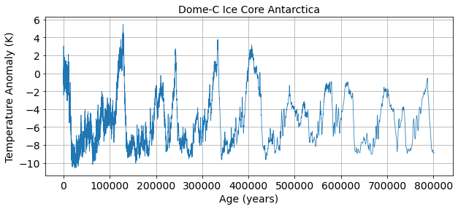

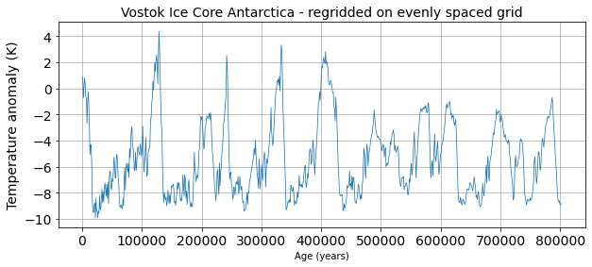

2) Signal and Noise: What is the autocorrelation and e-folding time of your data? What spectral peaks do you expect to find in your analysis and how much power do you think they will have? *Hint: Think back to the Petit 1999 Vostok ice core dataset discussed in class.*

Temp lag-1 autocorrelation = 0.96 and the e-folding timescale = 25.0

3) Use Boxcar Window to calculate power spectra: Calculate the power spectra using the Numpy method, which assumes a Boxcar window that is the length of your entire dataset. Graph the power spectrum, the red noise fit to the data, and the 99% confidence interval. What statistically significant spectral peaks did you find? What do they represent?

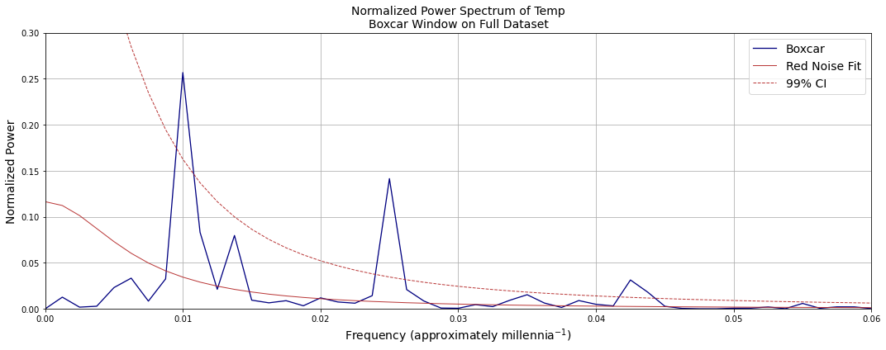

We see statistically significant spectral peaks at frequencies of 100k (eccentricity), 40k (obliquity), and ~23k (precession) years. These correspond to the Milankovitch cycles.

4) Compare Boxcar Window vs. Hanning Window: Calculate the power spectra using the SciPy method. Compare the results obtained using a Boxcar window that is the length of your entire dataset to those obtained using a Hanning window that is the length of your entire dataset. Graph the power spectrum, the red noise fit to the data, and the 99% confidence interval. What statistically significant spectral peaks did you find? What do they represent? What are the differences between the results obtained using the Boxcar window and the Hanning window? Is the intuition that you gained by looking at Fort Collins temperatures the same as what you are seeing here with Dome-C temperature records? Why or Why not?

For the most part, we see the same spectral peaks with both hanning and boxcar windows. The hanning window smooths the spectral peaks to the point that precession can barely be identified. It also creates two distinct low frequency peaks when with the boxcar window there was only 1. The hanning window had a similar smoothing effect on the fort collins temperatures as well.

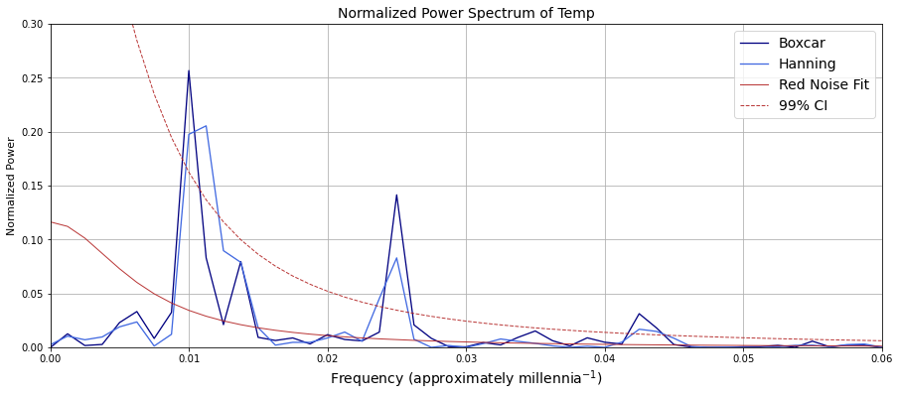

5) Hanning Window with different window lengths: Using the SciPy method, compare the power spectra obtained using Hanning window with different window lengths. Graph the power spectra, the red noise fit to the data, and the 99% confidence interval. Did you find any statistically significant spectral peaks? How does decreasing the window length affect the temporal precision of the spectral peaks and their statistical significance? Did you find the classic tradeoff between 1) high spectral/temporal resolution but low quality statistics, and 2) high quality statistics but low spectral/temporal resolution?

With smaller window lengths, we lose the low frequency spectral peak, but retain the others. This is because, when using larger window lengths, you are decreasing the statistical robustness of the data, but you are increasing the temporal resolution, allowing you to view spectral peaks at low frequencies. On the other hand, decreasing the window size increases the degrees of freedom and the statistical strength of your findings. As a result, low window lengths work really well if you are primarily interested in high frequency powers, but don’t work well if you are interested in data variability at lower frequencies.

5) Add WOSA (Welch Overlapping Segment Averaging): Having found what you think is a good balance between precision in the identification of the spectral peaks and statistical significance – Try applying WOSA (Welch Overlapping Segment Averaging) in addition to using the Hanning Window with different window lengths. How does this change your results?

With WOSA, the moving window allows for statistical robustness (with smaller window lengths) to still capture lower frequency data. In other words, it helps to compensate for the loss of information at lower frequencies as window size decreases.