Patryk Jedlikowski 08.02.2018

1. What is the nationality of clients?

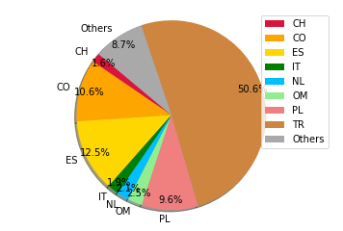

The half of our clients are Turkish. On the next places are Spanish, Polish and Columbian citizens. 91.3% clients descend from only 8 nations, the rest 80 countries.
Why the Turkish represent half of our clients?
We should look at this more closely. Maybe marketing campain is more efficient there. If something is special there we should consider use this at another campain.

At our next charts we will look only at these the biggest 8 nations.

2. Let’s look at students witch teaches per country.
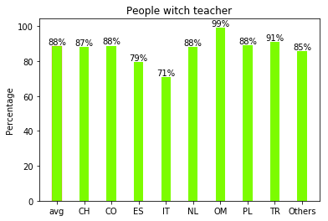

Most of the biggest countries are near the average ratio.
Spanish and Italish clients more rarely use teacher help. We should look at this more closely.

3.The ratio of started units. 100% means all uniqe learner id.
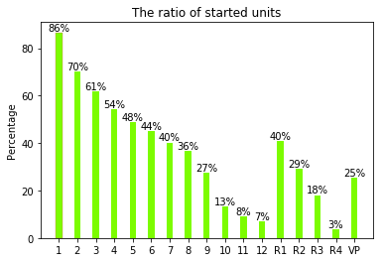

We can see that open unit ratio linearly desend to 9 unit where it collapse. The difference between 10th and 8th unit is 3 times smaller. The cause of these phenomenon should be explore.
Only 86% of students start the first unit. For another 14% this unit is to easy.

The average score per unit analisys give us information which chapter is to easy or to hard.
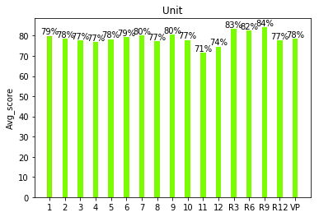

The chart shows that most of the units have result close to average, but 11th and 12th unit has a bit less average score.

Let’s look at completition per unit.
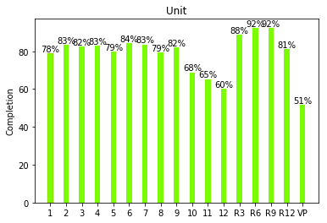

We can see that the first unit has less completition ratio than next few units. People which open the course can end their journey at 1st unit, that can the reason why completition ratio and ratio of starter units are different that the next chapters.
Also here we see the collapse at 9/10th unit.
Units 10th, 11th and 12th are not only more rarely started but also the completition ratio are smaller there.

Inverse rate chart show that average rate are approximately the same at all units exept for 12th unit where is 50% biggest.
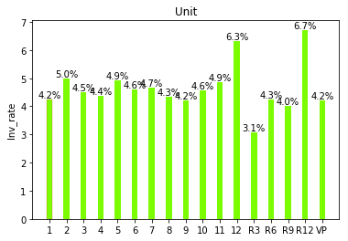

4. Average score depending on teacher presence.
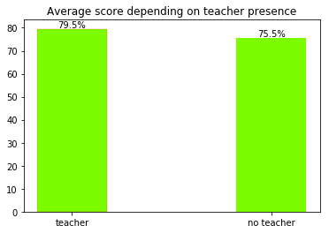

We can see that studends results with teacher are biggest than study without him.
We can use these information during marketing campain.

