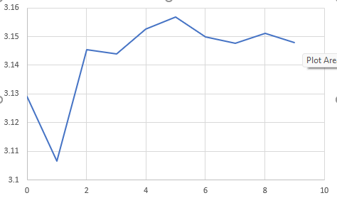

The above graph above represents the data that was created from the Monte Carlo program. Each thread creates 500 random points and will add the total points and total number of points within the circle and calculate pi. As the threads increase, the graph gets closer to pi, 3.141… If the number of random points is increased by a more drastic amount each thread, the points are much closer to the actual number of pi.