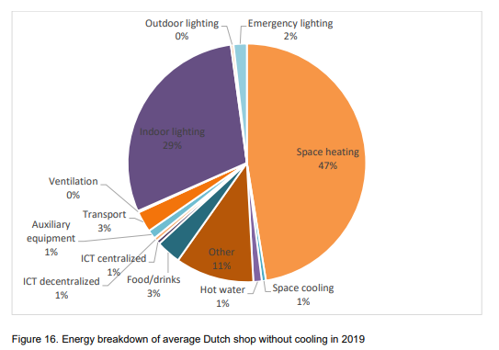

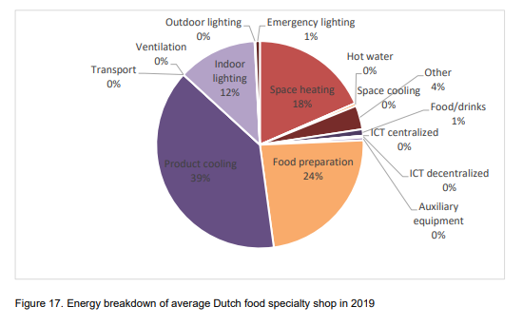

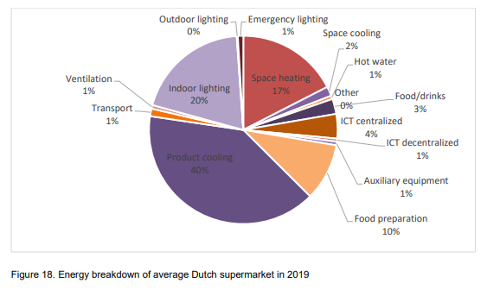

TRADE
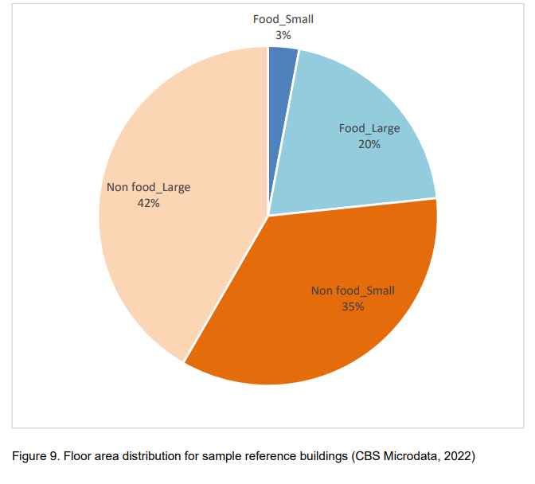
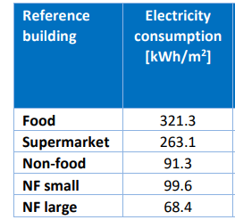

HORECA
No specific data on consumption.

INFORMATION AND COMMUNICATION
Small surface

FINANCIAL SERVICES
Small surface

REAL ESTATE RENTAL AND TRADE
Small surface

EDUCATION
Take mean from dataset
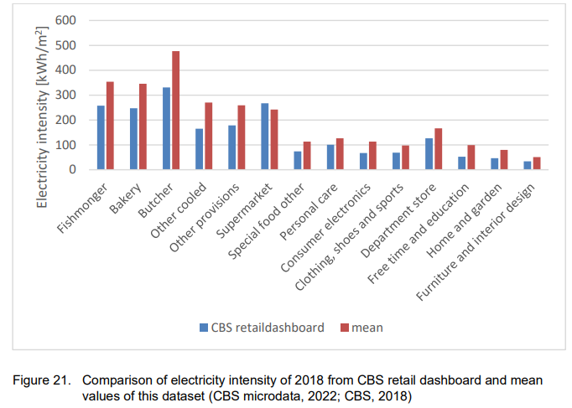

HEALTHCARE
Small surface

CULTURE SPORTS AND RECREATION
Small surface

