Former Teachers: Barriers, Incentives and Policy Lessons for Re-entry
Directorate for Education and Skills
WORKING DRAFT

Abstract

Résumé

Acknowledgements

Table of contents
Abstract 1
Résumé 1
Acknowledgements 1
Table of contents 1
1. Introduction 1
2. Teacher leaving: patterns, determinants and destinations 1
2.1 The teacher leaving rate and its evolution 1
2.2 Determinants of teachers leaving 1
2.3 Stated and revealed preferences 1
2.4 Destinations after leaving 1
3. The policies 1
4. Conclusions 1
References 1

1. Introduction
Pendiente de escribir (al final de todo). Yo creo que aquí es clave resaltar los aprendizajes y que alguien que lea esto se quede con todo lo importante. Si alguien quiere detalles de research, que pueda pasar a la sección 2, y si quieren solo policy que pasen a 3.

2. Teacher leaving: rates, determinants and implications for re-entry
To design and evaluate the impact of policies that aim to bring former teachers back to the classroom it is fundamental to have a thorough understanding of the reasons why teachers leave. Moreover, it is crucial to identify the experiences and added value that former teachers can bring back to educational systems if they are successfully reintegrated. This debate is of central importance for governments that are making a wide range of efforts to retain and re-attract former teachers in response to the pressing challenges of an ageing teaching workforce, serious teacher shortages and the rising concerns over teachers' burnout and lack of mentorship (OECD, 2025a; UNESCO, 2024; Madigan and Kim, 2021; OECD, 2025b). This section therefore reviews what is known about why teachers leave, before the paper turns to the policies that have tried to bring them back.
First, we distinguish three main profiles of former teachers: (1) switchers, those who resign from teaching to take up other part-time or full-time employment, (2) leavers, those who withdraw from the labour market, and (3) retired teachers who have reached the end of their working lives. The determinants of leaving and the opportunity cost that each group faces when considering whether to re-enter vary significantly across these profiles. In general terms, for switchers, salary, job satisfaction and working conditions appear to be the central margins; for leavers, household arrangements and flexibility; while for retired teachers, pension rules and re-employment possibilities. However, these institutional factors are highly country-dependent, and a comprehensive description would require a paper of its own. Here we instead develop a general framework that classifies the most common motives for leaving and illustrates them with selected country examples.

2.1 The teacher leaving rate and its evolution
The average teachers leaving rate among the OECD countries was 6.5% in 2023 (OECD, 2025a), with considerable heterogeneities among countries with data availability (see Figure 1). In countries with a low leaving rate, close to 2%, such as Israel, Ireland, France and Greece the workforce renews itself through retirement alone, while other countries with a higher proportion of leavers like Lithuania, Denmark or Estonia signal educational systems with a higher number of leavers and swtichers, raising potential issues with working conditions and teacher retention that forces the system to replace a substantial share of its stock every year.
The evolution of the leaving rate across time tends to be stable in most of the observed countries. The OECD average leaving rate moved from 6.9% in 2015 to 6.5% in 2023 and most systems present in both years moved by less than a percentage point (OECD, 2025a). Moreover, studies developed in countries with the longest available series confirm this stable trend. In USA, which holds one of the longest-running national series, the rate has oscillated between 5% and 8.5% across three and a half decades of survey waves, has sat near 8% for the last twenty years, and carries no lasting mark from the pandemic increase (NCES, 2024), and similar patterns hold in England, New Zealand, Sweden, Israel, Iceland, Norway and Flanders (Department for Education, 2024a; Education Counts, 2025; Adermon and Laun, 2018; CBS Israel, 2023; Björnsdóttir and Hansen, 2024; Statistics Norway, 2025; Vansteenkiste, 2025).

Figure 1. The teacher leaving rate and its composition, 2022/23
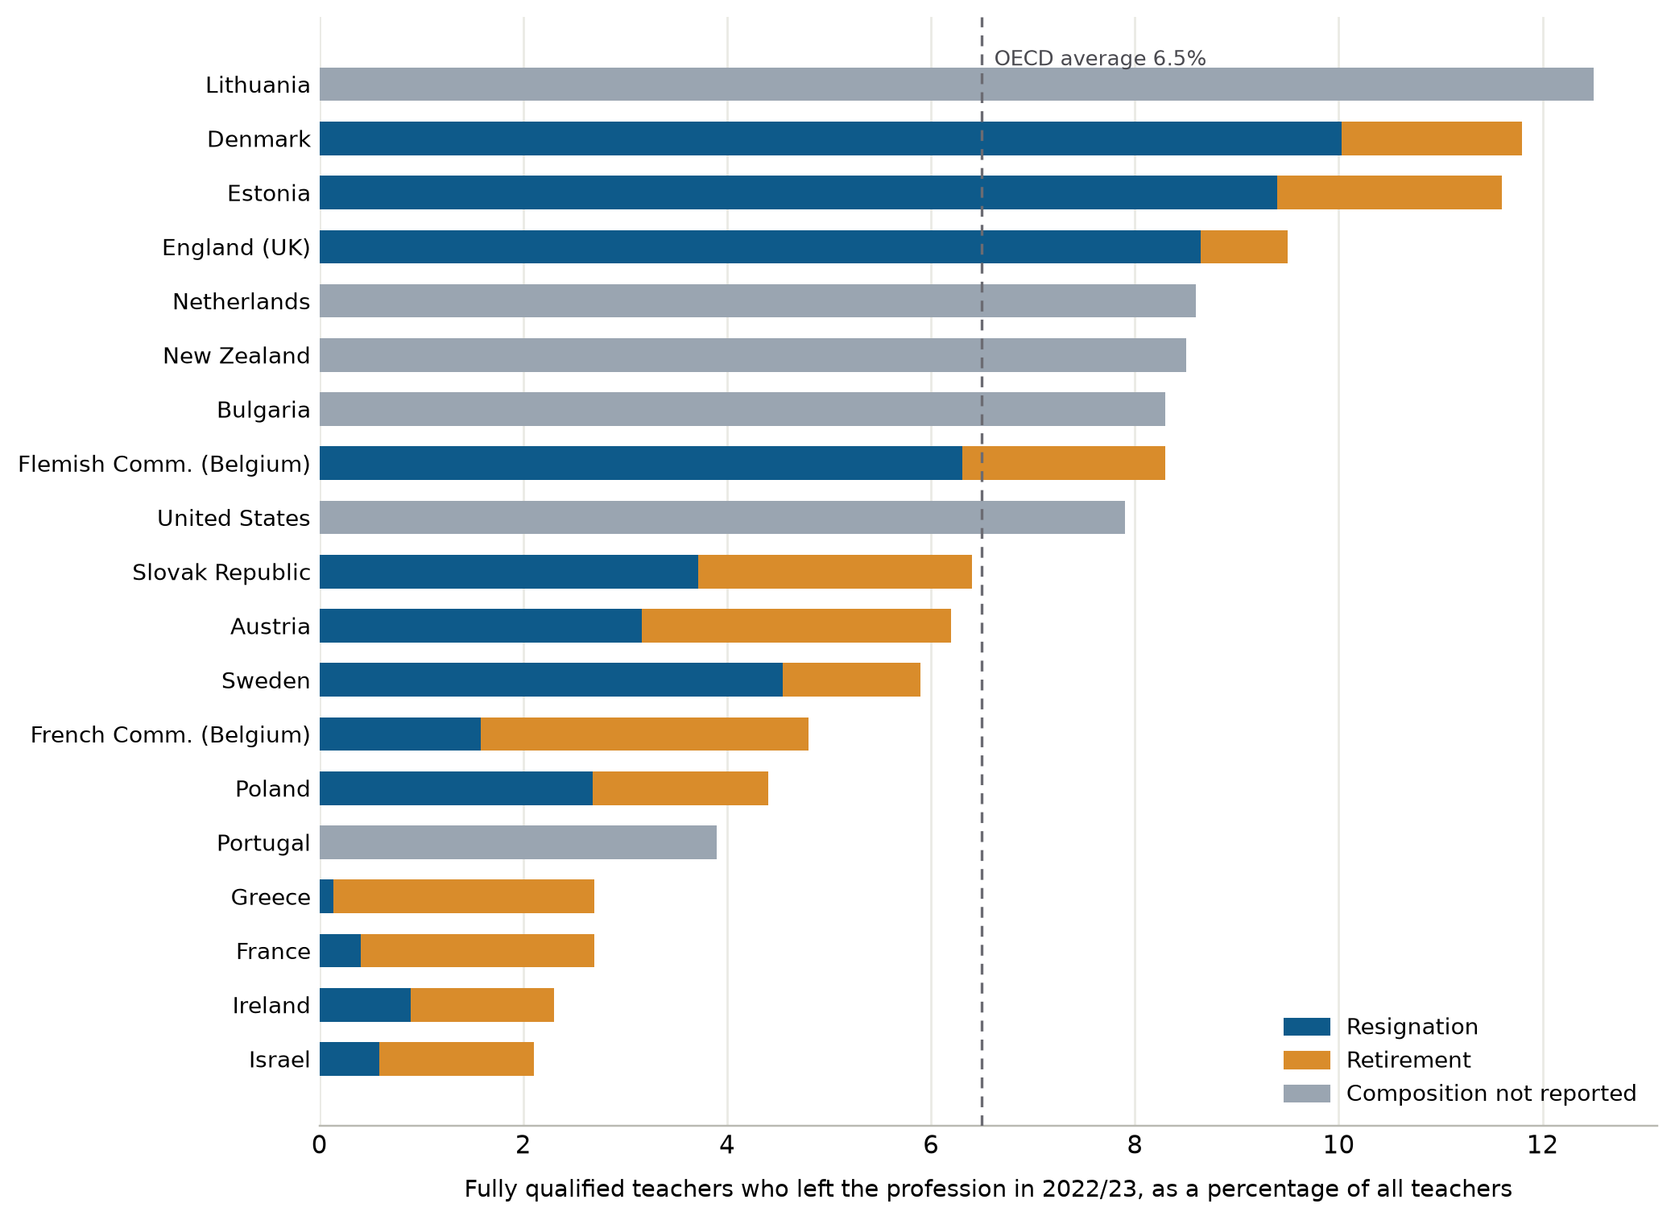
Note: Share of fully qualified teachers, full-time and part-time in public institutions, who left the profession during the reference year, from pre-primary to upper secondary education. The split into resignations and retirements is shown where reported; grey bars report the total rate only. The OECD average refers to the 19 countries and economies with available data. The reference year differs from 2022/23 for Denmark, France, New Zealand and England (2021/22). Data refer to primary and lower secondary education combined and exclude upper secondary education in Denmark, exclude upper secondary education in Israel and upper secondary vocational education in the Netherlands, and include non-fully qualified teachers in the Netherlands, New Zealand and the Flemish Community of Belgium. For the United States, leavers include teachers appointed to other positions in the education sector.
Source: OECD (2025a), Education at a Glance 2025, Table D8.4.
It is worth noticing that the phenomenon of leaving is not worrying in itself, as a continuous outflow is a common feature of any profession in a dynamic labour market. In fact, even though no comparable benchmark has been published for most OECD countries, the leaving rate of teachers tends to be lower than, or comparable to, that of similar professions where it has been studied. For example, in USA, in the last twenty years the leaving rate for teachers was about the rate at which nurses leave nursing, close to that of accountants and below that of social workers (Aldeman and Yi, 2025), an ordering already visible in the 1990s (Harris and Adams, 2007); in Australia, a study using administrative records finds that the teacher leaving rate was the lowest among 97 occupation groups (Buckley and Griselda, 2025) and in Sweden, register data show that annual exits among teachers, preschool teachers, nurses and police are alike (Adermon and Laun, 2018).
Nevertheless, re-attracting former teachers has become one of the policy margins through which governments are trying to alleviate the current problem of teacher shortages. Although not sufficient to close the gap on its own, it can help reduce and fill vacancies in the short run, especially in the disadvantaged and rural schools where shortages tend to concentrate (UNESCO, 2024; Carver-Thomas and Darling-Hammond, 2019; Nguyen, Lam and Bruno, 2024). The magnitude of this policy margin depends on the baseline leaving and retirement rates, since in countries such as France, Greece, Ireland or Israel, whose low leaving rates are almost solely explained by retirement, its potential is scarce (OECD, 2025a). Beyond short-run relief to shortages, returners and retired teachers can bring benefits of their own, such as positive experience spillovers to colleagues, mentorship for beginning teachers and tutoring roles with experimental backing (Papay et al., 2020; DeCesare et al., 2017; Nickow, Oreopoulos and Quan, 2024).

2.2 Determinants of teachers leaving
The reasons why teachers leave the profession have been extensively studied, through self-reported surveys, interviews and, more recently, through administrative records of observed departures. Despite this abundance of evidence, ranking the identified reasons remains difficult, since studies differ in the populations they follow, in the outcomes they measure, in their external validity and in the way motives are grouped. Building on a comprehensive review of this literature and on recent meta-analyses (Nguyen et al., 2020; Gundlach, Slemp and Hattie, 2024), this paper classifies the reasons into six areas (see Table 1).
Table 1. Reasons for leaving teaching, by area
Area | Reasons
Professional factors | Loss of professional purpose; limited autonomy over the work; professional standing; exposure to parental complaint and legal risk
Working conditions | Hours and total workload; pupil behaviour and classroom discipline; administrative and documentation demands; limited access to reduced hours; burnout and exhaustion
Organisational factors | School leadership; collegial support and team structure
Accountability and regulation | External inspection and its consequences; certification and licensing requirements
Financial factors | Salary relative to outside options; pension design and its timing incentives; contract insecurity
Personal and life-course factors | Family formation and care; childbirth; health and incapacity; relocation and a partner's circumstances; retirement and career stage
Source: Authors' elaboration on the literature reviewed in this section.
First, professional factors group the motives related to the purpose, autonomy and standing of the teaching work. This area covers teachers who decide to leave because they no longer find meaning in teaching, who feel they have lost control over how to exercise it, or who perceive a deterioration in the standing of the profession, often due to the exposure to parental complaint and legal action. The evidence on this area comes mainly from surveys and focus groups where teachers declare their intention to leave and the reasons associated with it, that that despite being an imperfect proxy of actual leaving, reaches motives that administrative records cannot register.
A great example is Finland, where a longitudinal survey that followed teachers over five years found a lack of professional commitment named persistently over workload and interpersonal relation difficulties among those declaring an intention to leave (Räsänen et al., 2020). Similarly, in England, teachers with the intention of leaving declared that their views are not considered by policymakers, giving this concern more importance than salary and economic incentives (Department for Education, 2024b). When the question turns to actual leavers, this pattern remains consistent, in the United States, most switchers rate their new job above teaching in autonomy, influence and professional prestige, although not always in salary (NCES, 2014). Similar findings are found in the leaver surveys of the Netherlands and Sweden, where the lack of professional challenge and the limited control over one's own work rank among the leading motives, only behind working conditions (Van Casteren et al., 2023; Statistics Sweden, 2023).
Moreover, the apparent decline in the perception of professional purpose of the teaching profession is not only a problem for those deciding to leave. The TALIS survey, which asks teachers across more than fifty countries about their work and its conditions, shows that across the OECD only 26% of teachers felt their profession was valued in society, and those who do feel valued are over 10% less likely to intend leaving within five years (OECD, 2020; OECD, 2025c). Taken together the evidence points to recognition and professional purpose as decisive in the decision to leave, consistent with teaching remaining as one of the most vocational career choices. This matters for policies that seek to bring former teachers back and highlight the importance of the recognition of their previous service, roles that make use of their experience and initiatives that increase their participation in decisions about their own work.
Secondly, complaints about working conditions are the most frequently declared factor associated with intention to leave in international surveys. In this area we group motives such as working hours and total workload, pupil behavior and classroom discipline, class size, administrative demands and the burnout that accumulates when these run together. According to TALIS 2024, one in four teachers across the OECD declare an intention to leave the profession within the next five years, and teachers who report high levels of stress are almost twice as likely to declare that intention. That stress comes mainly from too much administrative work and marking, from keeping up with constant changes in government requirements and from maintaining classroom discipline (OECD, 2020; OECD, 2025c).
In the same line, when actual leavers declare their motives, workload, understood as an excessive number of hours both in the school and in preparation outside it, emerges as the most cited reason among those related to working conditions. In the Netherlands, workload, stress and burden were named ahead of every other category, by 47% of recent leavers, complaining about intense working days, little rest within them and recurrent overtime (Van Casteren et al., 2023). Among these leavers, 80% declared that they could have been retained, most often with less workload or a smaller class, and a quarter with more supportive school leadership. In Sweden the most important motives where workload and parental expectations first and administrative tasks and the lack of control over one's own work following (Statistics Sweden, 2023), and in Australia, the intensification of workload ranked second, only behind dissatisfaction with school leadership, which is examined later in this section (Brandenburg et al., 2024).
However, the workload teachers declare goes beyond the number of hours of work stipulated by contract and mainly reflects the burden they perceive in the classroom. This can be observed in England, where TALIS responses were linked to administrative registers of the school workforce, so actual departures could be observed. Teachers in schools with worse discipline were more likely to leave the profession, specifically an improvement of one standard deviation in the school's discipline climate halves a teacher's annual probability of leaving the profession. In the same study, the amount of hours teachers worked did not predict their departure (Sims and Jerrim, 2020). This is relevant for policies that aim to re-attract former teachers, because teacher shortages tend to concentrate in disadvantaged or rural schools where the classroom climate is worst (Simon and Johnson, 2015; UNESCO, 2024). It also points to what such policies should attend to, the discipline climate of the school where a returner is placed and the teaching load they are offered (Sims and Jerrim, 2020; Van Casteren et al., 2023).
Thirdly, closely linked to the daily pressures of teaching, organisational factors play a decisive role in retention, as the quality of institutional support influences a teacher’s decision to stay. This area includes the quality of school leadership, the structuring of collaborative time, and the degree of collegial support within the institution. Among these, dissatisfaction with school leadership emerges as one of the most frequently cited predictors of teacher departure in the literature (Boyd et al., 2011; Ladd, 2011; Simon and Johnson, 2015). However, isolating the causal effect of school administration on retention is methodologically challenging as schools with highly effective principals tend to be the ones that already benefit from greater resources, more experienced staff, and a higher socio-economic student composition, making it difficult to disentangle the impact of leadership from favorable student and school characteristics.
Nonetheless, when studies account for these sorting dynamics, the direct effect of leadership remains substantial. Using comprehensive survey data matched to administrative records in New York, Boyd et al. (2011) found that teachers' perceptions of school administration was the central factor to retain staff in schools, outweighing other working conditions and student demographics. Moreover, studies tracking the same schools over time demonstrate that when a school's leadership improves -specifically in supportiveness, trust, and communication- its teacher turnover falls (Kraft, Marinell and Shen-Wei Yee, 2016).
Additionally, mentorship is also a relevant organisational lever as it accelerates the pedagogical development of novice educators and mitigates the professional isolation common in early-career teaching. The results from TALIS indicate that across the OECD only 22% of novice teachers report having an assigned mentor in their current school (OECD, 2020). Furthermore, in a meta-analysis pooling 120 observational studies, Nguyen et al. (2020) find that novice teachers who receive induction support are less likely to experience professional turnover. A particular example of this policy margin is England's Early Career Framework, which entitles every new teacher to two years of mentoring increasing teacher retention within their original school (Walker et al., 2024). More broadly, strong collegial support and collaborative school environments consistently correlate with lower attrition intentions (Johnson, Kraft and Papay, 2012; Simon and Johnson, 2015).
Thus, organisational factors matter in two ways for the re-entry policies examined in this paper. The first is where returners are placed, since leadership and collegial support are what the evidence above identifies as decisive, and a teacher who returns to a school with weak leadership meets the conditions that produced the first departure (Boyd et al., 2011; Kraft, Marinell and Shen-Wei Yee, 2016). The second is the potential for retired teachers to re-enter the profession as dedicated mentors, addressing the mentoring shortages identified by TALIS and contributing to the peer collaboration and professional interaction that directly improve instructional quality (Papay et al., 2020).
Fourth, accountability and regulation group the motives related to external teacher evaluation and to statutory licensing rules. In general, the evaluation of teachers can be divided into internal evaluations, carried out by the school's own leadership, and external evaluation, carried out by a public body, usually a national or regional inspection regulated by education ministries or equivalent authorities. The internal revisions are common, since 64% of teachers across the OECD work in schools where the principal evaluates every teacher at least once a year and 51% in schools where other members of the management team do so, most often on the basis of classroom observation (OECD, 2020). Additionally, beyond evaluation, maintaining a valid teaching license requires meeting specific regulatory obligations that vary by country, typically taking the form of mandatory periodic training or documented evidence of continued classroom practice.
However, what matters for leavers is the additional time and work these obligations imply, since nearly half report that evaluation in their school is carried out merely to fulfil administrative requirements, without producing feedback they can use, and 54% that their mandatory training competes with their working schedule (OECD, 2020). The importance of accountability and regulation motives is nonetheless minor compared to other determinants of leaving, since even if test-based accountability does elevate stress and turnover intentions (Ryan et al., 2017) ranks below affective commitment, burnout and job satisfaction (Gundlach, Slemp and Hattie, 2024). For policies aiming to re-attract teachers, this suggests that the cost of recertification is worth attention, as higher costs and the isolation teachers face in navigating the process affect the decision to leave, deter re-entry, and reduces retention once back, which argues for keeping such burdens as low as regulatory purposes allow.
Fifth, economic incentives represent the most extensively studied determinant of teacher retention, including the salary relative to outside options, the design of pensions and the insecurity of contracts. From an economic perspective, a relevant margin for retention depends on comparing teaching wages against the best alternative available in the outside labor market. Because outside options vary by subject, qualification, and local labor market characteristics, uniform pay scales generate highly heterogeneous exit rates across disciplines and regions. For most teachers this comparison is unfavorable, since actual primary teacher salaries average 83% of the earnings of tertiary-educated workers across the OECD, with considerable heterogeneity across countries (see Figure 2). Only four systems pay at or above parity, led by Portugal at 128% of the benchmark, whereas the United States registers the lowest relative compensation at 63%. Where pay has been tested causally, money retains, with targeted payments cutting departures by 9% to 23% in Norway, England and North Carolina (Falch, 2011; Sims and Benhenda, 2022; Clotfelter et al., 2008), though the effect has lasted only as long as the payment itself (See et al., 2020).
Figure 2. Teachers’ salary compared to other tertiary-educated workers earnings
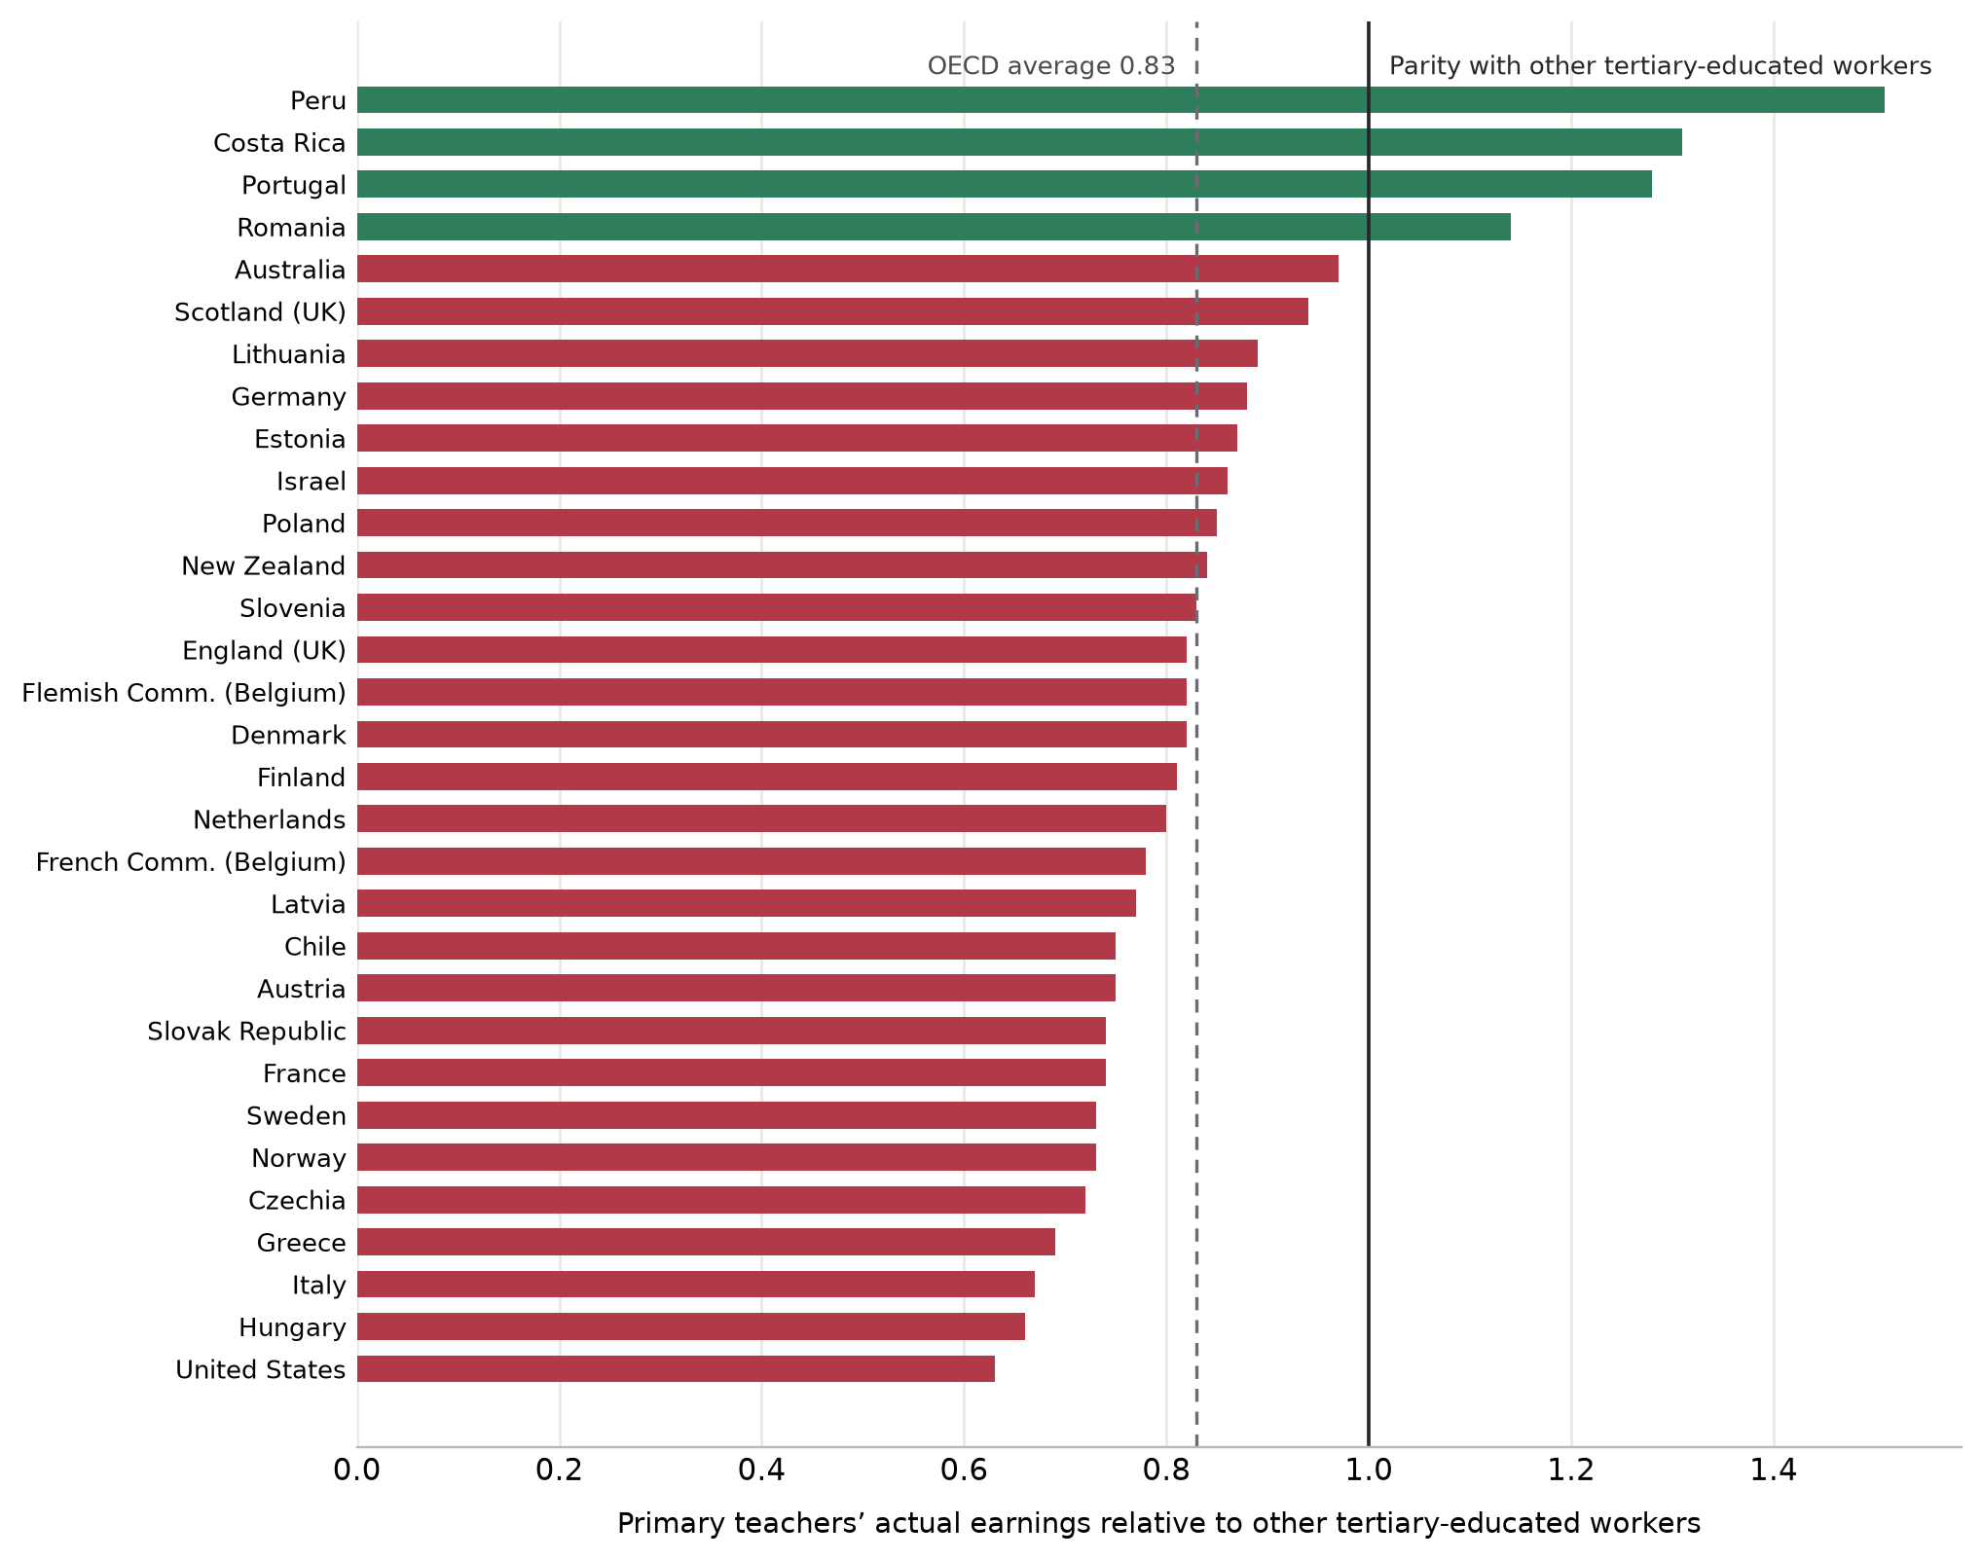
Note: Ratio of the average actual salary of full-time primary teachers in public institutions to the earnings of full-time tertiary-educated workers aged 25 to 64. Data refer to 2024 or the nearest available year.
Source: OECD (2025d), Education at a Glance 2025, Table D3.2.
Moreover, pension rules also affect the decision to leave, since they set the retirement age and, along the teaching career, create incentives for retention depending on the pension system’s rigidity. In most schemes covering teachers, retiring before the age stipulated by law reduces the pension and retiring later marginally increases it, so retirement concentrates around that age. This phenomenon is closely related to the way pensions funds growth and accumulate. In defined-benefit schemes, most of the pension is earned in the final years before the full-pension age and little accrues after it, so one more year of work carries a substantial pension gain at 54 and almost nothing at 60 (Costrell and Podgursky, 2009). This is mostly the case across the civil-service teacher schemes of Europe and North America, while defined-contribution systems, as in Sweden or Australia, are close to actuarially neutral and spread retirements accordingly (OECD, 2025e). The available estimates of how much teachers value that deferred income present mixed results, with estimates running from about 20 cents per dollar of present value to near parity (Fitzpatrick, 2015; Ni, Podgursky and Wang, 2022).
Finally, personal and life-course factors drive a substantial share of departures. Unlike the preceding dimensions, these causes originate entirely outside the school environment, placing them as the least predictable from an institutional perspective and the least responsive to standard administrative levers. Along the teaching career, the leaving rate exhibits a pronounced U-shape, concentrated among novice teachers during early-career sorting and late-career workers approaching retirement but with a stable middle lifecycle phase (Nguyen et al., 2020). The early peak reflects the exits of novice teachers who leave for further study, family formation or alternative employment while the quality of their match with the profession is still being revealed (Guarino, Santibañez and Daley, 2006), while the late peak responds to the retirement incentives just examined (Costrell and Podgursky, 2009).
The teaching workforce is predominantly female, so the events of family life weigh on it with particular force, and the birth of a child is the best documented of these motives. In England, where the workforce census follows teachers after maternity leave, between 17% and 20% of those who return leave the profession within a year, double the rate of comparable teachers, and women aged 30 to 39 form the largest group among leavers (Department for Education, 2023). In the United States and Sweden the same event has long driven female exits, and personal life reasons, covering health, childcare and the care of relatives, remain as the most non-retirement motive among voluntary leavers, (Stinebrickner, 2002; NCES, 2024; Statistics Sweden, 2023). Family circumstances beyond childbirth weight in the same direction, since personal life reasons, covering health, childcare and the care of family members, form the most important non-retirement motive among American voluntary leavers, at 15% (NCES, 2024), and the difficulty of combining work and family is named by 15% of Swedish leavers (Statistics Sweden, 2023).
This matters for policies that seek to bring former teachers back, since those who left over a birth or a family obligation did not leave over the conditions of the school, and the constraint behind the exit can ease with time. However, there is evidence suggesting that re-entry after a period of childcare or other family responsibilities, once predicted by gender and child-rearing, no longer follows on its own. An example of this is the United States, where among teachers who left between 2000 and 2019 that association has disappeared and only about one in five returned (Grissom and Reininger, 2012; Moyer, 2022). Thus, policies that aim to recover teaching leavers should focus on flexibility, the margin to which this group is most responsive, through part-time and phased returns, predictable timetables and placements compatible with care responsibilities.
Finally, not all the motives listed in the table have been studied with the same intensity, nor can their relative importance be compared perfectly across studies. The best available basis for doing so comes from recent meta-analyses of teacher turnover, which pool hundreds of estimates accumulated by the literature (Nguyen et al., 2020; Gundlach, Slemp and Hattie, 2024). Taken together, they point to working conditions and organisational features of the school as the most consistently important determinants of leaving, above financial incentives, accountability and personal characteristics. Teachers exposed to high workload, stress and weak organisational support are substantially more likely to leave, while salary and regulatory factors, although relevant, tend to have smaller effects when compared across determinants (Nguyen et al., 2020; Gundlach, Slemp and Hattie, 2024). This does not mean that personal or life-course motives are secondary for every teacher, but rather that the conditions under which teaching takes place appear to be the main institutional margin through which systems can influence retention.
This distinction is particularly important for policies aiming to re-attract former teachers. The evidence suggests that bringing a teacher back without changing the conditions under which they previously left risks reproducing the same decision further down the line. Re-entry policies should therefore be understood not only as a mechanism to reduce the cost of returning, but also as an opportunity to improve the quality of the match between teachers and schools: reducing workload, ensuring supportive leadership and collegial environments, offering adequate classroom conditions and, where the original exit was driven by personal circumstances, providing the flexibility required to combine teaching with family responsibilities. In this sense, what the literature teaches us is that the relevant question is not simply how to make former teachers return, but whether the system can offer them a different set of conditions once they do

3. The policies
My proposed labeling/characterization of initiatives and policies is the following:
- Regulatory / legal
- Financial incentives
- Information & nudges
- Support & training
- Flexible positions
- Flexible re-certification

4. Conclusions

References
Adermon, A., & Laun, L. (2018). Bristyrken i offentlig verksamhet [Shortage occupations in the public sector] (IFAU Rapport 2018:19). Institutet för arbetsmarknads- och utbildningspolitisk utvärdering. https://www.ifau.se/globalassets/pdf/se/2018/r-2018-19-bristyrken-i-offentlig-verksamhet.pdf
AE. (2024). Mange nye folkeskolelærere forlader folkeskolen på få år [Many new primary school teachers leave the primary school within a few years]. Arbejderbevægelsens Erhvervsråd. https://www.ae.dk/analyse/2024-06-mange-nye-folkeskolelaerere-forlader-folkeskolen-paa-faa-aar
Aldeman, C., & Yi, S. (2025, December 18). Are teachers abandoning teaching? Data show teacher turnover remains low. Education Next. https://www.educationnext.org/are-teachers-abandoning-teaching-data-show-teacher-turnover-remains-low/
Björnsdóttir, A., & Hansen, B. (2024). Starfsmannavelta meðal kennara í grunnskólum árin 1998 til 2020 [Staff turnover among compulsory school teachers 1998 to 2020]. Netla — Veftímarit um uppeldi og menntun, Sérrit 2024 — Menntakvika. https://doi.org/10.24270/serritnetla.2024.6
Boyd, D., Grossman, P., Ing, M., Lankford, H., Loeb, S., & Wyckoff, J. (2011). The influence of school administrators on teacher retention decisions. American Educational Research Journal, 48(2), 303–333. https://doi.org/10.3102/0002831210380788
Brandenburg, R., Larsen, E., Simpson, A., Sallis, R., & Tran, D. (2024). ‘I left the teaching profession... and this is what I am doing now’: A national study of teacher attrition. The Australian Educational Researcher, 51(5), 2381–2400. https://doi.org/10.1007/s13384-024-00697-1
Buckley, J., & Griselda, S. (2025). Who stays, who goes? A new look at teacher attrition using administrative data (e61 Institute Research Note). e61 Institute. https://e61.in/who-stays-who-goes-a-new-look-at-teacher-attrition-using-administrative-data/
Carver-Thomas, D., & Darling-Hammond, L. (2019). The trouble with teacher turnover: How teacher attrition affects students and schools. Education Policy Analysis Archives, 27(36). https://doi.org/10.14507/epaa.27.3699
CBS Israel. (2023). Teaching staff leaving the education system. Central Bureau of Statistics. https://www.cbs.gov.il/ [Full bibliographic details to be completed before publication.]
CIAE. (2025). Abandono docente en el sistema educativo chileno 2015–2024 (Informe OFD No. 12, by J. P. Valenzuela and F. Meneses). Observatorio de Formación Docente, Universidad de Chile. https://ciae.uchile.cl/noticia/abandono-docente-en-la-educacion-publica-llega-solo-a-4-anual-y-profesores-se-mantendrian-25-anos-en-ejercicio
Clotfelter, C., Glennie, E., Ladd, H., & Vigdor, J. (2008). Would higher salaries keep teachers in high-poverty schools? Evidence from a policy intervention in North Carolina. Journal of Public Economics, 92(5–6), 1352–1370. https://doi.org/10.1016/j.jpubeco.2007.07.003
Costrell, R. M., & Podgursky, M. (2009). Peaks, cliffs, and valleys: The peculiar incentives in teacher retirement systems and their consequences for school staffing. Education Finance and Policy, 4(2), 175–211. https://doi.org/10.1162/edfp.2009.4.2.175
DeCesare, D., McClelland, A., & Randel, B. (2017). Impacts of the Retired Mentors for New Teachers program (REL 2017-225). Regional Educational Laboratory Central, Institute of Education Sciences, U.S. Department of Education. https://ies.ed.gov/ncee/edlabs
Department for Education. (2023). School workforce in England: Ad hoc statistics on maternity leave and returns. [Release to be verified before publication.]
Department for Education. (2024a). School workforce in England: Reporting year 2023. https://explore-education-statistics.service.gov.uk/find-statistics/school-workforce-in-england
Department for Education. (2024b). Working lives of teachers and leaders: Wave 3 and wave 4 reports. https://www.gov.uk/government/publications/working-lives-of-teachers-and-leaders
Education Counts. (2025). Teacher turnover. New Zealand Ministry of Education. https://www.educationcounts.govt.nz/statistics/teacher-turnover
European Commission/EACEA/Eurydice. (2021). Teachers in Europe: Careers, development and well-being (Eurydice report). Publications Office of the European Union.
Falch, T. (2011). Teacher mobility responses to wage changes: Evidence from a quasi-natural experiment. American Economic Review, 101(3), 460–465. https://doi.org/10.1257/aer.101.3.460
Feng, L., & Sass, T. R. (2018). The impact of incentives to recruit and retain teachers in “hard-to-staff” subjects. Journal of Policy Analysis and Management, 37(1), 112–135. https://doi.org/10.1002/pam.22037
Fitzpatrick, M. D. (2015). How much are public school teachers willing to pay for their retirement benefits? American Economic Journal: Economic Policy, 7(4), 165–188. https://doi.org/10.1257/pol.20140087
Government of Spain. (2015). Real Decreto Legislativo 5/2015, de 30 de octubre, por el que se aprueba el texto refundido de la Ley del Estatuto Básico del Empleado Público, Articles 49 and 89. Boletín Oficial del Estado. https://www.boe.es/eli/es/rdlg/2015/10/30/5/con
Grissom, J. A., & Reininger, M. (2012). Who comes back? A longitudinal analysis of the reentry behavior of exiting teachers. Education Finance and Policy, 7(4), 425–454. https://doi.org/10.1162/EDFP_a_00075
Guarino, C. M., Santibañez, L., & Daley, G. A. (2006). Teacher recruitment and retention: A review of the recent empirical literature. Review of Educational Research, 76(2), 173–208. https://doi.org/10.3102/00346543076002173
Gundlach, H. A. D., Slemp, G. R., & Hattie, J. (2024). A meta-analysis of the antecedents of teacher turnover and retention. Educational Research Review, 44, Article 100606. https://doi.org/10.1016/j.edurev.2024.100606
Harris, D. N., & Adams, S. J. (2007). Understanding the level and causes of teacher turnover: A comparison with other professions. Economics of Education Review, 26(3), 325–337. https://doi.org/10.1016/j.econedurev.2005.09.007
Johnson, S. M., Kraft, M. A., & Papay, J. P. (2012). How context matters in high-need schools: The effects of teachers’ working conditions on their professional satisfaction and their students’ achievement. Teachers College Record, 114(10), 1–39. https://doi.org/10.1177/016146811211401004
Kindsiko, E. (2023). [Analysis of teacher attrition in Estonia using EHIS register data 2005/06–2021/22]. Arenguseire Keskus. [Full bibliographic details to be completed before publication.]
Kraft, M. A., Marinell, W. H., & Shen-Wei Yee, D. (2016). School organizational contexts, teacher turnover, and student achievement: Evidence from panel data. American Educational Research Journal, 53(5), 1411–1449. https://doi.org/10.3102/0002831216667478
Ladd, H. F. (2011). Teachers’ perceptions of their working conditions: How predictive of planned and actual teacher movement? Educational Evaluation and Policy Analysis, 33(2), 235–261. https://doi.org/10.3102/0162373711398128
Madigan, D. J., & Kim, L. E. (2021). Towards an understanding of teacher attrition: A meta-analysis of burnout, job satisfaction, and teachers’ intentions to quit. Teaching and Teacher Education, 105, Article 103425. https://doi.org/10.1016/j.tate.2021.103425
Ministère de l’Éducation nationale. (2023). La retraite des personnels de l’Éducation nationale. https://www.education.gouv.fr/la-retraite-des-personnels-de-l-education-nationale-41489
Ministry of Education Korea. (2023). [Statistics on mid-career teacher separations 2019–2023]. Ministry of Education, Sejong. [Full bibliographic details to be completed before publication.]
Moyer, A. (2022). Has “who comes back” changed? Teacher reentry 2000–2019. Educational Researcher, 51(8), 544–546. https://doi.org/10.3102/0013189X221122746
NCES. (2014). Teacher attrition and mobility: Results from the 2012–13 Teacher Follow-up Survey (NCES 2014-077). National Center for Education Statistics, U.S. Department of Education. https://nces.ed.gov/pubs2014/2014077.pdf
NCES. (2024). Teacher attrition and mobility: Results from the 2021–22 Teacher Follow-up Survey. National Center for Education Statistics, U.S. Department of Education. https://nces.ed.gov/pubsearch/pubsinfo.asp?pubid=2024039
Nguyen, T. D., Lam, C. D., & Bruno, P. (2024). What do we know about the extent of teacher shortages nationwide? A systematic examination of reports of U.S. teacher shortages. AERA Open, 10. https://doi.org/10.1177/23328584241276512
Nguyen, T. D., Pham, L. D., Crouch, M., & Springer, M. G. (2020). The correlates of teacher turnover: An updated and expanded meta-analysis of the literature. Educational Research Review, 31, Article 100355. https://doi.org/10.1016/j.edurev.2020.100355
Ni, S., Podgursky, M., & Wang, F. (2022). How much are public school teachers willing to pay for their retirement benefits? Comment. American Economic Journal: Economic Policy, 14(3), 478–493. https://doi.org/10.1257/pol.20200763
Nickow, A., Oreopoulos, P., & Quan, V. (2024). The promise of tutoring for PreK-12 learning: A systematic review and meta-analysis of the experimental evidence. American Educational Research Journal, 61(1), 74–107. https://doi.org/10.3102/00028312231208687
NŠA. (2025). [Teacher demand and supply forecast]. Nacionalinė švietimo agentūra. [Full bibliographic details to be completed before publication.]
OECD. (2020). TALIS 2018 results (Volume II): Teachers and school leaders as valued professionals. OECD Publishing. https://doi.org/10.1787/19cf08df-en
OECD. (2025a). What is the profile of the teaching workforce and how has it evolved? In Education at a glance 2025: OECD indicators (Indicator D8, Table D8.4). OECD Publishing. https://doi.org/10.1787/f7b0b326-en
OECD. (2025b). Results from TALIS 2024. OECD Publishing. https://doi.org/10.1787/90df6235-en
OECD. (2025c). Results from TALIS 2024, country notes: Japan, France and the Netherlands. OECD Publishing. https://doi.org/10.1787/e127f9e2-en
OECD. (2025d). How much are teachers and school heads paid? In Education at a glance 2025: OECD indicators (Indicator D3, Table D3.2). OECD Publishing. https://doi.org/10.1787/1c0d9c79-en
OECD. (2025e). Pensions at a glance 2025: OECD and G20 indicators. OECD Publishing.
Papay, J. P., Taylor, E. S., Tyler, J. H., & Laski, M. E. (2020). Learning job skills from colleagues at work: Evidence from a field experiment using teacher performance data. American Economic Journal: Economic Policy, 12(1), 359–388. https://doi.org/10.1257/pol.20170709
Räsänen, K., Pietarinen, J., Pyhältö, K., Soini, T., & Väisänen, P. (2020). Why leave the teaching profession? A longitudinal approach to the prevalence and persistence of teacher turnover intentions. Social Psychology of Education, 23(4), 837–859. https://doi.org/10.1007/s11218-020-09567-x
Ryan, S. V., von der Embse, N. P., Pendergast, L. L., Saeki, E., Segool, N., & Schwing, S. (2017). Leaving the teaching profession: The role of teacher stress and educational accountability policies on turnover intent. Teaching and Teacher Education, 66, 1–11. https://doi.org/10.1016/j.tate.2017.03.016
See, B. H., Morris, R., Gorard, S., & El Soufi, N. (2020). Teacher recruitment and retention: A critical review of international evidence of most promising interventions. Education Sciences, 10(10), Article 262. https://doi.org/10.3390/educsci10100262
Simon, N. S., & Johnson, S. M. (2015). Teacher turnover in high-poverty schools: What we know and can do. Teachers College Record, 117(3), 1–36. https://doi.org/10.1177/016146811511700305
Sims, S., & Benhenda, A. (2022). The effect of financial incentives on the retention of shortage-subject teachers: Evidence from England (CEPEO Working Paper No. 22-04). UCL Centre for Education Policy and Equalising Opportunities. https://repec-cepeo.ucl.ac.uk/cepeow/cepeowp22-04.pdf
Sims, S., & Jerrim, J. (2020). TALIS 2018: Teacher working conditions, turnover and attrition (Statistical working paper). Department for Education. https://www.gov.uk/government/publications/talis-2018-teacher-working-conditions-turnover-and-attrition
Springer, M. G., Swain, W. A., & Rodriguez, L. A. (2016). Effective teacher retention bonuses: Evidence from Tennessee. Educational Evaluation and Policy Analysis, 38(2), 199–221. https://doi.org/10.3102/0162373715609687
Statistics Norway. (2025). [Articles on the labour-market attachment of trained teachers]. Statistisk sentralbyrå. https://www.ssb.no/ [Full bibliographic details to be completed before publication.]
Statistics Sweden. (2023). Lärare utanför yrket 2022/2023 [Teachers outside the profession 2022/2023]. Statistiska centralbyrån. https://www.scb.se/
Stinebrickner, T. R. (2002). An analysis of occupational change and departure from the labor force: Evidence of the reasons that teachers leave. Journal of Human Resources, 37(1), 192–216. https://doi.org/10.2307/3069608
Teaching Council of Aotearoa New Zealand. (2016). Teaching Council Rules 2016 (LI 2016/122). New Zealand Legislation. https://www.legislation.govt.nz/regulation/public/2016/0122/latest/whole.html
UNESCO. (2024). Global report on teachers: Addressing teacher shortages and transforming the profession. UNESCO and the International Task Force on Teachers for Education 2030. https://doi.org/10.54675/FIGU8035
Van Casteren, W., Lodewick, J., Lommertzen, J., Luyten, E., & van Mensvoort, C. (2023). Vertrekredenen leraren en docenten in het po, vo en mbo [Reasons for leaving among teachers in primary, secondary and vocational education]. ResearchNed. https://www.voion.nl/publicaties/vertrekredenen-leraren-en-docenten-in-het-po-vo-en-mbo/
Vansteenkiste, S. (2025). De in- en uitstroom in het lerarenberoep vanuit vergelijkend perspectief [Inflow into and outflow from the teaching profession in comparative perspective]. Steunpunt Onderwijsonderzoek.
Victorian Institute of Teaching. (2025). Professional practice and learning requirements. https://www.vit.vic.edu.au/maintain/requirements
Walker, M., Worth, J., Liht, J., Classick, R., Tang, S., Rutt, S., & Straw, S. (2024). Evaluation of the early roll-out of the Early Career Framework: Evaluation report. National Foundation for Educational Research for the Education Endowment Foundation. https://d2tic4wvo1iusb.cloudfront.net/production/documents/projects/ECF_early_year_rollout_evaluation_report.pdf

The two only exceptions are Austria and Estonia, whose rate nearly doubled during the same interval (OECD, 2025a).
The American figures come from the Teacher Follow-up Survey (TFS), which re-interviews one year later a sample of teachers drawn from the Schools and Staffing Survey (SASS) and its successor the National Teacher and Principal Survey (NTPS); the waves are three to five years apart, so the series is discontinuous but covers 1988 to 2022 under one definition. A continuous annual measure built from the Current Population Survey (CPS) gives consistent results (Harris and Adams, 2007; Aldeman and Yi, 2025).
For most countries no historical data exists, as such series require longitudinally linked teacher registers. Shorter series move both ways, upward in Denmark, Estonia, Lithuania and Korea and downward in Australia and Chile (AE, 2024; Kindsiko, 2023; NŠA, 2025; Ministry of Education Korea, 2023; Buckley and Griselda, 2025; CIAE, 2025).
See table A1 in the Appendix to observe the comparison of our area definitions and the most used in the main meta-analysis of teaching turnover (por construir!)
Declared intentions to leave are an imperfect proxy for departure. One of the largest meta-analyses of the field, which pools 3430 coefficients from 186 studies of teacher turnover, found that the antecedents of intended departure are not the ones that weigh most to predict the actual leaving decision (Gundlach, Slemp and Hattie, 2024).
In the 2018 round of TALIS, 73% of surveyed English teachers consented to linkage with the School Workforce Census, the administrative register of state-school staff, yielding 2 684 linked records at an 84% match rate (Sims and Jerrim, 2020).
The discipline climate was measured as an standardized index built from teachers' reports on how far they can control disruptive behavior, how consistently their school enforces rules and how much stress pupil behavior causes them. The magnitude is large for this literature, where one standard deviation in a school leadership index lowers annual departures from the school by around 10% in North Carolina primary schools (Ladd, 2011), and one in each of four indices covering leadership, academic expectations, teacher relationships and safety lowers them by 25% in New York middle schools (Kraft, Marinell and Shen-Wei Yee, 2016).
The obligation consists either of completing training, which ranges from 8 hours a year in Luxembourg to 35 in Scotland and from three to five days in Belgium, Finland, Cyprus, Lithuania and Slovenia (European Commission/EACEA/Eurydice, 2021), or of a minimum amount of teaching, such as 20 days a year in Australia or two years of classroom practice in New Zealand (Victorian Institute of Teaching, 2025; Teaching Council of Aotearoa New Zealand, 2016).
The causal evidence rests on a small number of studies exploiting policy discontinuities, with three main conclusions. Financial incentives are effective when the payment is large and teachers are aware of their eligibility (Falch, 2011; Clotfelter et al., 2008). Their effect is confined to the teachers they target and is negligible for the rest (Springer, Swain and Rodriguez, 2016). One-off bonuses produce larger short-run effects than permanent increases, which indicates that the retention gain does not persist beyond the payment period (Feng and Sass, 2018).
The retirement age generally falls between 62 and 67, averaging 64.7 for men and 63.9 for women across the OECD. It stands at 62 in Greece and Slovenia, at 67 in Australia, Denmark, Iceland, Israel, the Netherlands and Norway, and in between everywhere else (OECD, 2025f). The systems with the lowest ages for teachers are France and Spain, where retirement is possible from 59 for the former primary corps and from 60 for civil-servant teachers with thirty years of service (Ministère de l'Éducation nationale, 2023; Government of Spain, 2015).
Women make up around seven in ten lower secondary teachers across the OECD in ANO. The proportion is highest in Latvia, Lithuania and Estonia, at 84% to 86%, and among OECD members it falls below half only in Japan, at 41% (OECD, 2025c)
Both studies synthesize the broader literature on teacher turnover, which counts every departure from the school and therefore combines teachers who leave the profession with teachers who move between schools. Nguyen et al. (2020) pool 120 studies of observed turnover in the United States, while Gundlach, Slemp and Hattie (2024) pool 3 430 coefficients on close to 70 antecedents and estimate attrition, migration and retention separately, for intentions as well as for observed behaviour.

