**Assignment 1 : Questions and answers**

1. Install Jupyter notebook and run the first program and share the screenshot of the output.

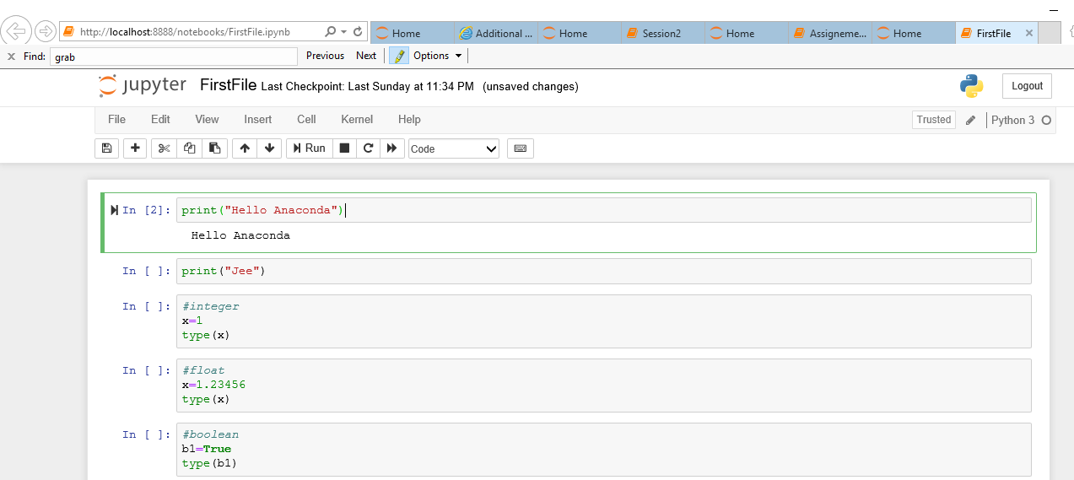

2. Write a program which will find all such numbers which are divisible by 7 but are not a

multiple of 5, between 2000 and 3200 (both included). The numbers obtained should be printed

in a comma-separated sequence on a single line.

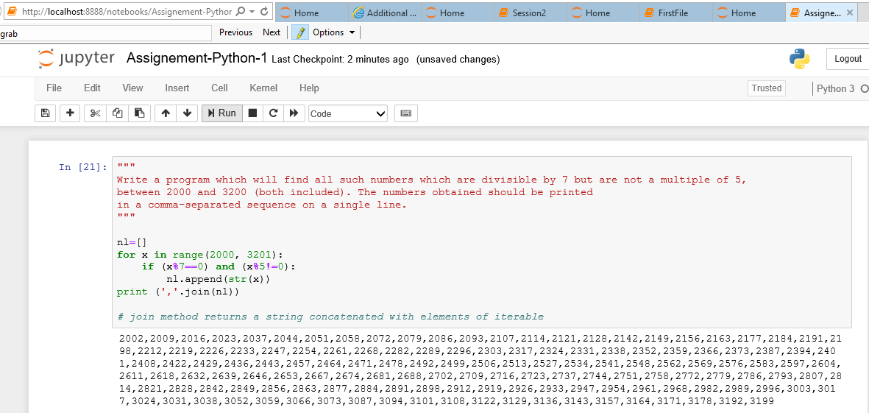

3. Write a Python program to accept the user's first and last name and then getting them printed

in the the reverse order with a space between first name and last name.

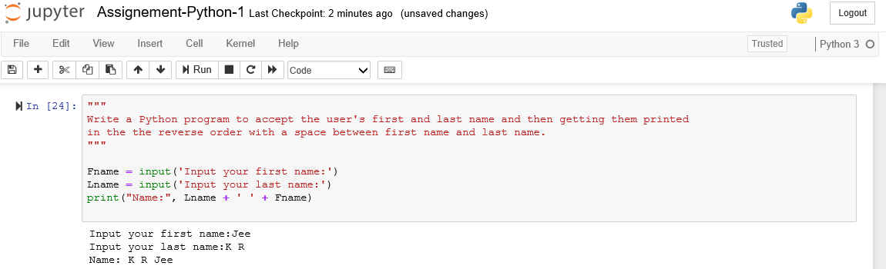

4. Write a Python program to find the volume of a sphere with diameter 12 cm.

Formula: V=4/3 * π * r3

