Assignment 4 : Answers with screen shots

1.1 Write a Python Program(with class concepts) to find the area of the triangle using the below

formula.

area = (s*(s-a)*(s-b)*(s-c)) ** 0.5

Function to take the length of the sides of triangle from user should be defined in the parent

class and function to calculate the area should be defined in subclass.

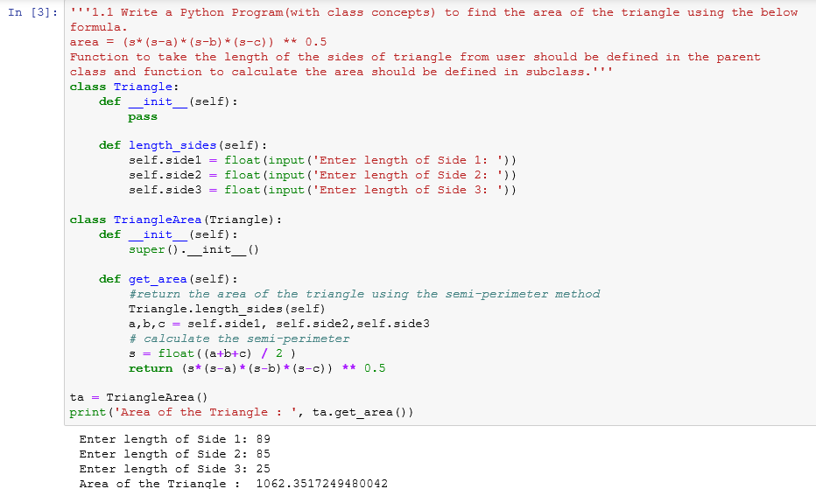

1.2 Write a function filter_long_words() that takes a list of words and an integer n and returns

the list of words that are longer than n.

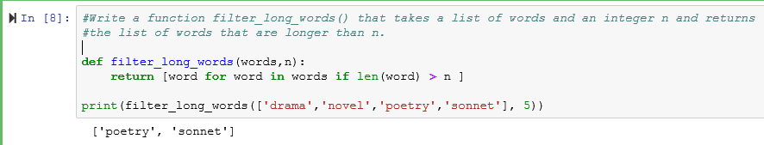

2.1 Write a Python program using function concept that maps list of words into a list of integers

representing the lengths of the corresponding words .

**Hint:** If a list [ ab,cde,erty] is passed on to the python function output should come as [2,3,4]

Here 2,3 and 4 are the lengths of the words in the list.

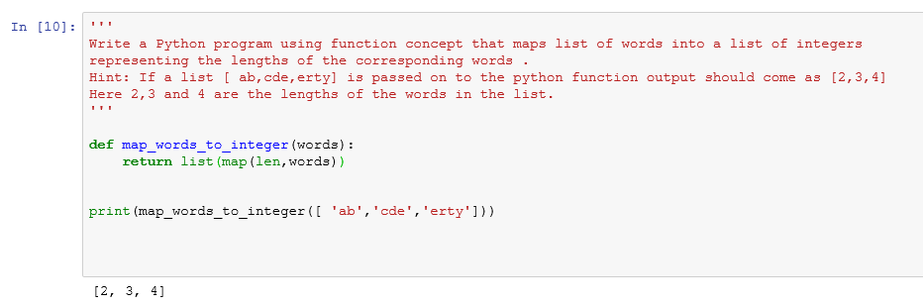

2.2 Write a Python function which takes a character (i.e. a string of length 1) and returns True if

it is a vowel, False otherwise.

