Assignment_6

Jeevan

16/07/2019

data <- read.table(file = "clipboard",header = TRUE)  
str(data)

## 'data.frame': 36 obs. of 3 variables:  
## $ treatment: int 1 2 3 4 5 6 7 8 9 1 ...  
## $ block : int 1 1 1 1 1 1 1 1 1 2 ...  
## $ yield : num 144.4 113.5 60.9 163.4 110.1 ...

attach(data)  
treatment <- as.factor(data$treatment)  
block <- as.factor(data$block)  
str(data)

## 'data.frame': 36 obs. of 3 variables:  
## $ treatment: int 1 2 3 4 5 6 7 8 9 1 ...  
## $ block : int 1 1 1 1 1 1 1 1 1 2 ...  
## $ yield : num 144.4 113.5 60.9 163.4 110.1 ...

boxplot(data$yield ~ data$treatment, xlab = "Treatment", ylab = "Yield",  
 col = c("#00AFBB", "#E7B800"))

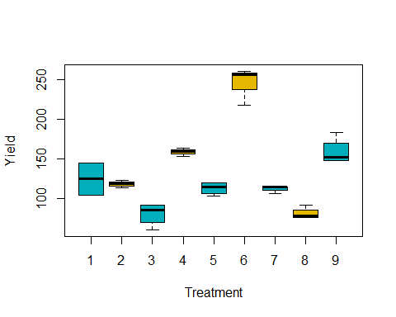

m1 <- aov(data$yield ~ data$treatment + data$block)  
summary(m1)

## Df Sum Sq Mean Sq F value Pr(>F)  
## data$treatment 1 2094 2094.0 0.803 0.377  
## data$block 1 232 232.2 0.089 0.767  
## Residuals 33 86110 2609.4

lm1 <- lm(yield~treatment+block)  
library(lsmeans)

## Warning: package 'lsmeans' was built under R version 3.5.3

## Loading required package: emmeans

## Warning: package 'emmeans' was built under R version 3.5.3

## The 'lsmeans' package is now basically a front end for 'emmeans'.  
## Users are encouraged to switch the rest of the way.  
## See help('transition') for more information, including how to  
## convert old 'lsmeans' objects and scripts to work with 'emmeans'.

lsm1 <- lsmeans(lm1,"treatment")  
pairs(lsm1)

## contrast estimate SE df t.ratio p.value  
## 1 - 2 6.317 9.61 24 0.658 0.9989   
## 1 - 3 43.710 9.61 24 4.549 0.0035   
## 1 - 4 -33.830 9.61 24 -3.521 0.0383   
## 1 - 5 11.585 9.61 24 1.206 0.9474   
## 1 - 6 -122.825 9.61 24 -12.783 <.0001   
## 1 - 7 12.225 9.61 24 1.272 0.9299   
## 1 - 8 43.472 9.61 24 4.525 0.0037   
## 1 - 9 -34.182 9.61 24 -3.558 0.0353   
## 2 - 3 37.392 9.61 24 3.892 0.0166   
## 2 - 4 -40.148 9.61 24 -4.179 0.0085   
## 2 - 5 5.268 9.61 24 0.548 0.9997   
## 2 - 6 -129.143 9.61 24 -13.441 <.0001   
## 2 - 7 5.907 9.61 24 0.615 0.9993   
## 2 - 8 37.155 9.61 24 3.867 0.0175   
## 2 - 9 -40.500 9.61 24 -4.215 0.0078   
## 3 - 4 -77.540 9.61 24 -8.070 <.0001   
## 3 - 5 -32.125 9.61 24 -3.344 0.0563   
## 3 - 6 -166.535 9.61 24 -17.333 <.0001   
## 3 - 7 -31.485 9.61 24 -3.277 0.0649   
## 3 - 8 -0.237 9.61 24 -0.025 1.0000   
## 3 - 9 -77.892 9.61 24 -8.107 <.0001   
## 4 - 5 45.415 9.61 24 4.727 0.0023   
## 4 - 6 -88.995 9.61 24 -9.263 <.0001   
## 4 - 7 46.055 9.61 24 4.793 0.0019   
## 4 - 8 77.302 9.61 24 8.046 <.0001   
## 4 - 9 -0.352 9.61 24 -0.037 1.0000   
## 5 - 6 -134.410 9.61 24 -13.989 <.0001   
## 5 - 7 0.640 9.61 24 0.067 1.0000   
## 5 - 8 31.887 9.61 24 3.319 0.0594   
## 5 - 9 -45.767 9.61 24 -4.763 0.0021   
## 6 - 7 135.050 9.61 24 14.056 <.0001   
## 6 - 8 166.298 9.61 24 17.308 <.0001   
## 6 - 9 88.642 9.61 24 9.226 <.0001   
## 7 - 8 31.247 9.61 24 3.252 0.0683   
## 7 - 9 -46.407 9.61 24 -4.830 0.0018   
## 8 - 9 -77.655 9.61 24 -8.082 <.0001   
##   
## Results are averaged over the levels of: block   
## P value adjustment: tukey method for comparing a family of 9 estimates