DOE Practical End Sem

Jeevan ~ 1740256

01/10/2019

**AIM:**

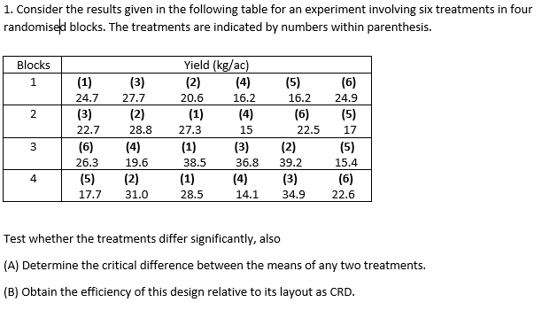

**ANALYSIS:**

library(readxl)

## Warning: package '

readxl' was built under R version 3.5.2

library(lsmeans)

## Warning: package 'lsmeans' was built under R version 3.5.3

## Loading required package: emmeans

## Warning: package 'emmeans' was built under R version 3.5.3

## The 'lsmeans' package is now basically a front end for 'emmeans'.  
## Users are encouraged to switch the rest of the way.  
## See help('transition') for more information, including how to  
## convert old 'lsmeans' objects and scripts to work with 'emmeans'.

ESEQ1_data <- read_excel("ESEQ1_data.xlsx")  
#View(ESEQ1_data)  
attach(ESEQ1_data)  
model <- aov(Yield~Blocks,data = ESEQ1_data)  
plot(model)

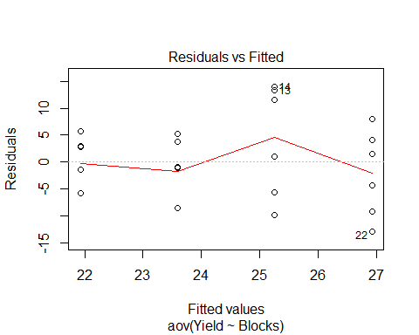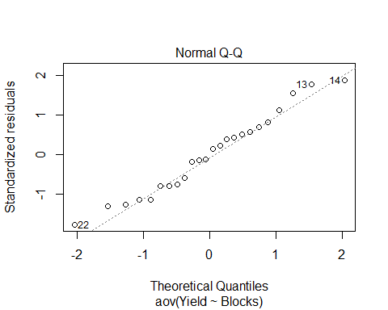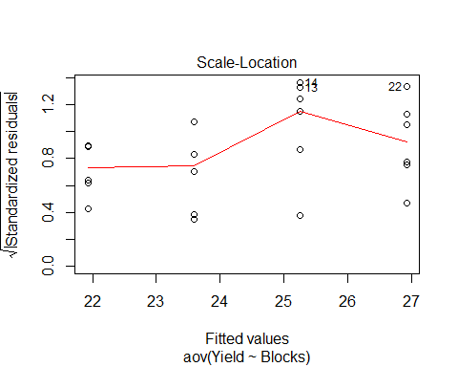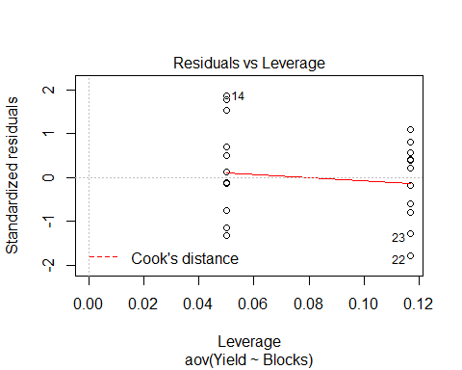

linear <- lm(Yield~Blocks,data = ESEQ1_data)  
summary(linear)

##   
## Call:  
## lm(formula = Yield ~ Blocks, data = ESEQ1_data)  
##   
## Residuals:  
## Min 1Q Median 3Q Max   
## -12.825 -5.725 0.075 4.358 13.942   
##   
## Coefficients:  
## Estimate Std. Error t value Pr(>|t|)   
## (Intercept) 20.258 3.832 5.287 2.64e-05 ***  
## Blocks 1.667 1.399 1.191 0.246   
## ---  
## Signif. codes: 0 '***' 0.001 '**' 0.01 '*' 0.05 '.' 0.1 ' ' 1  
##   
## Residual standard error: 7.663 on 22 degrees of freedom  
## Multiple R-squared: 0.0606, Adjusted R-squared: 0.0179   
## F-statistic: 1.419 on 1 and 22 DF, p-value: 0.2462

lsm <- lsmeans(linear,"Blocks")  
lsm

## Blocks lsmean SE df lower.CL upper.CL  
## 2.5 24.4 1.56 22 21.2 27.7  
##   
## Confidence level used: 0.95

pairs(lsm)

## contrast estimate SE df z.ratio p.value  
## (nothing) nonEst NA NA NA NA

summary(model)

## Df Sum Sq Mean Sq F value Pr(>F)  
## Blocks 1 83.3 83.33 1.419 0.246  
## Residuals 22 1291.9 58.72

**AIM:**

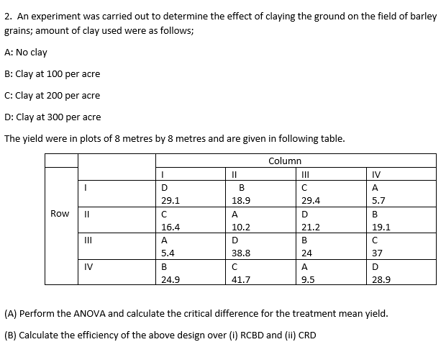

**ANALYSIS:**

ESEQ2_data <- read_excel("ESEQ2_data.xlsx")  
# View(ESEQ2_data)  
attach(ESEQ2_data)  
model1 <- aov(Clay~Column+Row,data = ESEQ2_data)  
summary(model1)

## Df Sum Sq Mean Sq F value Pr(>F)   
## Column 3 1372.1 457.4 11.546 0.00101 **  
## Row 1 135.2 135.2 3.413 0.09174 .   
## Residuals 11 435.8 39.6   
## ---  
## Signif. codes: 0 '***' 0.001 '**' 0.01 '*' 0.05 '.' 0.1 ' ' 1

plot(model1)

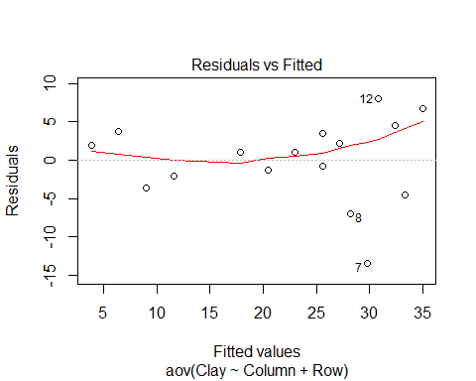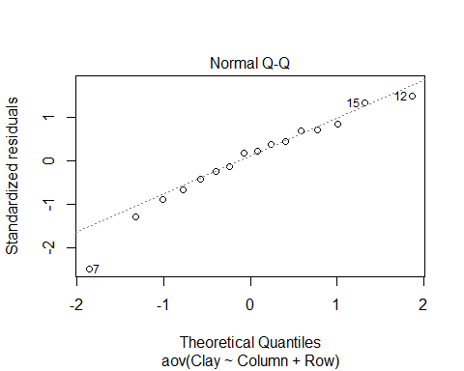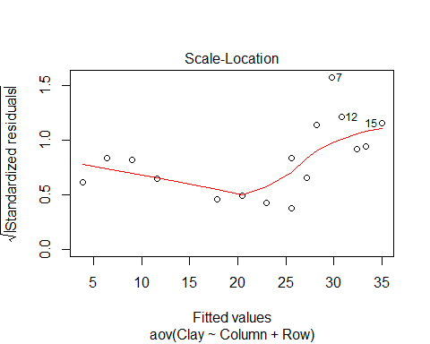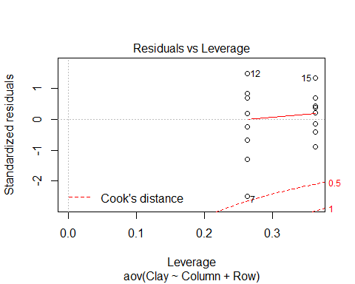

linear2 <- lm(Clay~Column+Row,data = ESEQ2_data)  
summary(linear2)

##   
## Call:  
## lm(formula = Clay ~ Column + Row, data = ESEQ2_data)  
##   
## Residuals:  
## Min 1Q Median 3Q Max   
## -13.425 -2.475 1.025 3.575 8.000   
##   
## Coefficients:  
## Estimate Std. Error t value Pr(>|t|)   
## (Intercept) 1.200 4.720 0.254 0.804022   
## ColumnB 14.025 4.451 3.151 0.009220 **   
## ColumnC 23.425 4.451 5.263 0.000267 ***  
## ColumnD 21.800 4.451 4.898 0.000473 ***  
## Row 2.600 1.407 1.847 0.091736 .   
## ---  
## Signif. codes: 0 '***' 0.001 '**' 0.01 '*' 0.05 '.' 0.1 ' ' 1  
##   
## Residual standard error: 6.294 on 11 degrees of freedom  
## Multiple R-squared: 0.7757, Adjusted R-squared: 0.6942   
## F-statistic: 9.513 on 4 and 11 DF, p-value: 0.001415

lsm1 <- lsmeans(linear2,"Column")  
lsm1

## Column lsmean SE df lower.CL upper.CL  
## A 7.7 3.15 11 0.774 14.6  
## B 21.7 3.15 11 14.799 28.7  
## C 31.1 3.15 11 24.199 38.1  
## D 29.5 3.15 11 22.574 36.4  
##   
## Confidence level used: 0.95

pairs(lsm1)

## contrast estimate SE df t.ratio p.value  
## A - B -14.03 4.45 11 -3.151 0.0395   
## A - C -23.43 4.45 11 -5.263 0.0013   
## A - D -21.80 4.45 11 -4.898 0.0023   
## B - C -9.40 4.45 11 -2.112 0.2086   
## B - D -7.78 4.45 11 -1.747 0.3470   
## C - D 1.62 4.45 11 0.365 0.9825   
##   
## P value adjustment: tukey method for comparing a family of 4 estimates

lsm2 <- lsmeans(linear2,"Row")  
lsm2

## Row lsmean SE df lower.CL upper.CL  
## 2.5 22.5 1.57 11 19 26  
##   
## Results are averaged over the levels of: Column   
## Confidence level used: 0.95

When we compare the pairs using the lsmeans package, here we are comparing the critical differences between each of the factors. The tukey test method is used to compare it.

**---------------------------------------------------------------------------------------------------**

**AIM:**

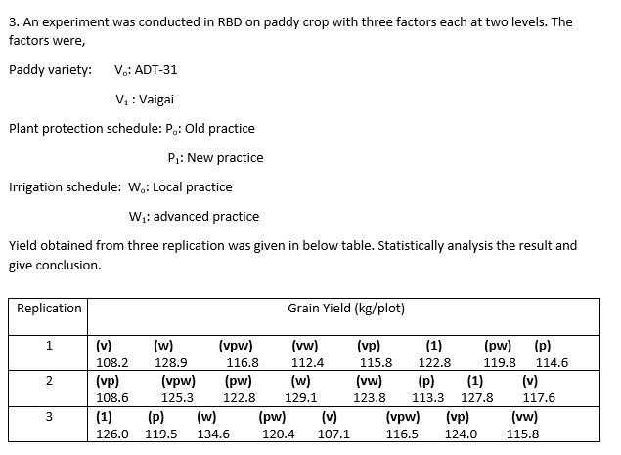

**ANALYSIS:**

ESEQ3_data <- read_excel("ESEQ3_data.xlsx")  
# View(ESEQ3_data)  
attach(ESEQ3_data)

## The following object is masked from ESEQ1_data:  
##   
## Yield

model2 <- aov(Yield~Factorp+Factorv+Factorw+Factorp*Factorv+Factorp*Factorw+Factorv*Factorw+Factorp*Factorv*Factorw,data = ESEQ3_data)  
summary(model2)

## Df Sum Sq Mean Sq F value Pr(>F)   
## Factorp 1 55.5 55.5 2.435 0.13818   
## Factorv 1 319.0 319.0 13.996 0.00178 **  
## Factorw 1 153.5 153.5 6.735 0.01953 *   
## Factorp:Factorv 1 271.4 271.4 11.905 0.00329 **  
## Factorp:Factorw 1 3.5 3.5 0.151 0.70235   
## Factorv:Factorw 1 0.2 0.2 0.008 0.92957   
## Factorp:Factorv:Factorw 1 3.2 3.2 0.138 0.71479   
## Residuals 16 364.7 22.8   
## ---  
## Signif. codes: 0 '***' 0.001 '**' 0.01 '*' 0.05 '.' 0.1 ' ' 1

# Factor v, w and vp are less than 0.05 from the model  
boxplot(Yield~Factorp,col = c("#00AFBB","#E7B800"))

From the above ANOVA table, we can see that Factor v, factor w and the interaction between p and v are significant.

Therefore, we reject the null hypothesis and fail to reject the alternative hypothesis and thus we can say that there is a significant difference between these factors and the yield.

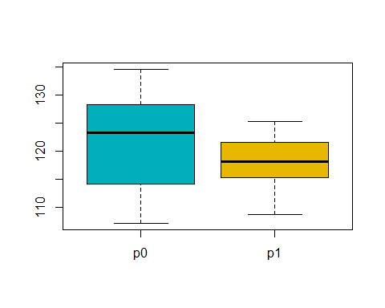

boxplot(Yield~Factorv,col = c("#00AFBB","#E7B800"))

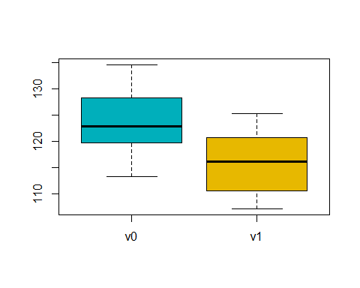

boxplot(Yield~Factorw,col = c("#00AFBB","#E7B800"))

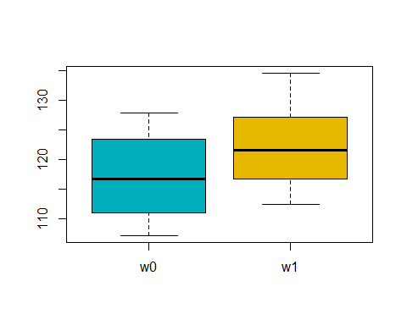

boxplot(Yield~Factorp*Factorv,col = c("#00AFBB","#E7B800"))

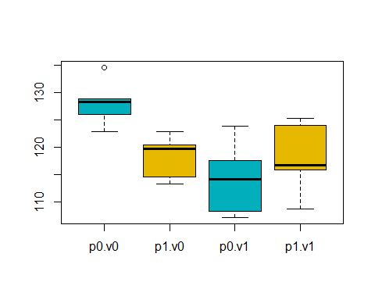

boxplot(Yield~Factorp*Factorw,col = c("#00AFBB","#E7B800"))

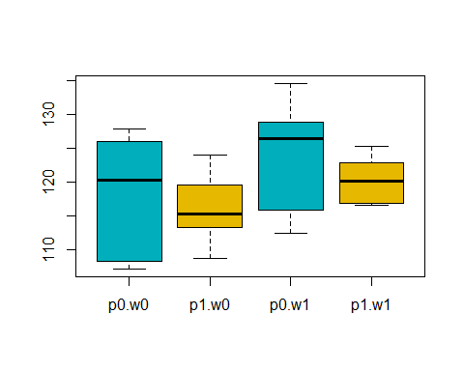

boxplot(Yield~Factorv*Factorw,col = c("#00AFBB","#E7B800"))

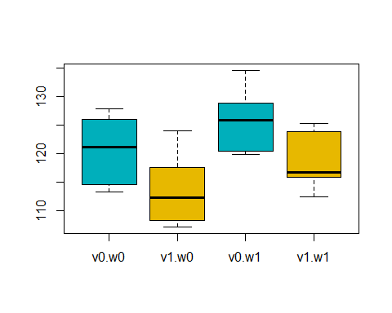

boxplot(Yield~Factorp*Factorv*Factorw,col = c("#00AFBB","#E7B800"))

