Lab 8

Jeevan ~ 1740256

24/09/2019

Analyse the following 2^3 factorial experiment.

library(readxl)

## Warning: package 'readxl' was built under R version 3.5.2

Lab8_Data_56 <- read_excel("C:/Users/Jeevan/Desktop/Christ University/Statistics/DOE/Lab8_Data_56.xlsx")  
View(Lab8_Data_56)  
attach(Lab8_Data_56)  
boxplot(Yield~Factor1,data = Lab8_Data_56,xlab = "A",ylab = "Yield",col = c("#00AFBB","#E7B800"))

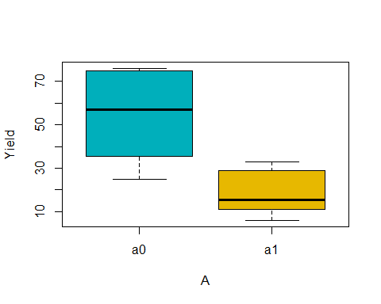

boxplot(Yield~Factor2,data = Lab8_Data_56,xlab = "B",ylab = "Yield",col = c("#00AFBB","#E7B800"))

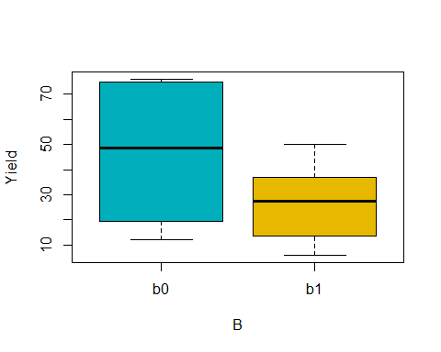

boxplot(Yield~Interaction,data = Lab8_Data_56,xlab = "AB",ylab = "Yield",col = c("#00AFBB","#E7B800"))

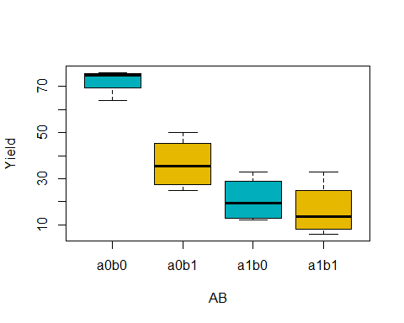

model <- aov(Yield~Factor1+Factor2+Factor1*Factor2,data = Lab8_Data_56)  
summary(model)

## Df Sum Sq Mean Sq F value Pr(>F)   
## Factor1 1 5112 5112 51.59 1.11e-05 ***  
## Factor2 1 1640 1640 16.55 0.00156 **   
## Factor1:Factor2 1 992 992 10.01 0.00815 **   
## Residuals 12 1189 99   
## ---  
## Signif. codes: 0 '***' 0.001 '**' 0.01 '*' 0.05 '.' 0.1 ' ' 1