Assignment-3

Jeevan

25/06/2019

Milk <- read.csv("C:/Users/Jeevan/Desktop/Christ University/Statistics/DOE/Milk.csv")  
View(Milk)  
library(agricolae)

## Warning: package 'agricolae' was built under R version 3.5.3

str(Milk)

## 'data.frame': 17 obs. of 2 variables:  
## $ Machine: Factor w/ 4 levels "A","B","C","D": 1 1 1 1 2 2 2 2 2 3 ...  
## $ Level : num 11.9 12.1 12.1 12.3 12.6 ...

attach(Milk)  
boxplot(Level~Machine)

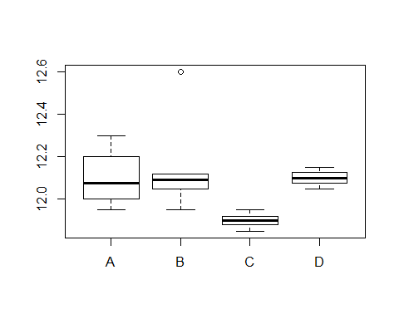

model <- aov(Level~Machine)  
summary(model)

## Df Sum Sq Mean Sq F value Pr(>F)  
## Machine 3 0.1912 0.06374 2.495 0.106  
## Residuals 13 0.3321 0.02554

out <- LSD.test(model,"Level",p.adj = "bonferroni",alpha=0.01)   
out

## $statistics  
## MSerror Df Mean CV  
## 0.02554462 13 12.05941 1.325329  
##   
## $parameters  
## test p.ajusted name.t ntr alpha  
## Fisher-LSD bonferroni Level 12 0.01  
##   
## $means  
## Level std r LCL UCL Min Max Q25 Q50 Q75  
## 11.85 11.85 NA 1 11.36856 12.33144 11.85 11.85 11.85 11.85 11.85  
## 11.88 11.88 NA 1 11.39856 12.36144 11.88 11.88 11.88 11.88 11.88  
## 11.9 11.90 NA 1 11.41856 12.38144 11.90 11.90 11.90 11.90 11.90  
## 11.92 11.92 NA 1 11.43856 12.40144 11.92 11.92 11.92 11.92 11.92  
## 11.95 11.95 0 3 11.67204 12.22796 11.95 11.95 11.95 11.95 11.95  
## 12.05 12.05 0 3 11.77204 12.32796 12.05 12.05 12.05 12.05 12.05  
## 12.09 12.09 NA 1 11.60856 12.57144 12.09 12.09 12.09 12.09 12.09  
## 12.1 12.10 0 2 11.75957 12.44043 12.10 12.10 12.10 12.10 12.10  
## 12.12 12.12 NA 1 11.63856 12.60144 12.12 12.12 12.12 12.12 12.12  
## 12.15 12.15 NA 1 11.66856 12.63144 12.15 12.15 12.15 12.15 12.15  
## 12.3 12.30 NA 1 11.81856 12.78144 12.30 12.30 12.30 12.30 12.30  
## 12.6 12.60 NA 1 12.11856 13.08144 12.60 12.60 12.60 12.60 12.60  
##   
## $comparison  
## NULL  
##   
## $groups  
## Level groups  
## 12.6 12.60 a  
## 12.3 12.30 a  
## 12.15 12.15 a  
## 12.12 12.12 a  
## 12.1 12.10 a  
## 12.09 12.09 a  
## 12.05 12.05 a  
## 11.95 11.95 a  
## 11.92 11.92 a  
## 11.9 11.90 a  
## 11.88 11.88 a  
## 11.85 11.85 a  
##   
## attr(,"class")  
## [1] "group"

Paneer <- read.csv("C:/Users/Jeevan/Desktop/Christ University/Statistics/DOE/Paneer.csv")  
View(Paneer)  
str(Paneer)

## 'data.frame': 12 obs. of 3 variables:  
## $ Fat : int 1 2 3 1 2 3 1 2 3 1 ...  
## $ Batch : int 1 1 1 2 2 2 3 3 3 4 ...  
## $ Values: num 66.8 77.9 71.7 68.1 78.7 ...

Paneer$Batch = as.factor(Paneer$Batch)  
Paneer$Fat = as.factor(Paneer$Fat)  
str(Paneer)

## 'data.frame': 12 obs. of 3 variables:  
## $ Fat : Factor w/ 3 levels "1","2","3": 1 2 3 1 2 3 1 2 3 1 ...  
## $ Batch : Factor w/ 4 levels "1","2","3","4": 1 1 1 2 2 2 3 3 3 4 ...  
## $ Values: num 66.8 77.9 71.7 68.1 78.7 ...

attach(Paneer)  
boxplot(Values~Fat,data = Paneer,xlab = "Fat",ylab = "Values",col = c("#00AFBB","#E7B800"))

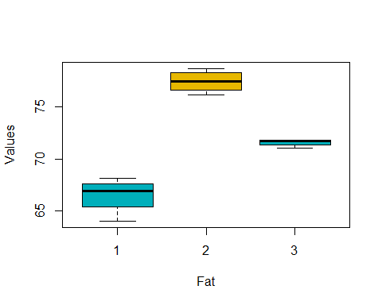

boxplot(Values~Batch,data = Paneer,xlab = "Batch",ylab = "Values",col = c("#00AFBB","#E7B800"))

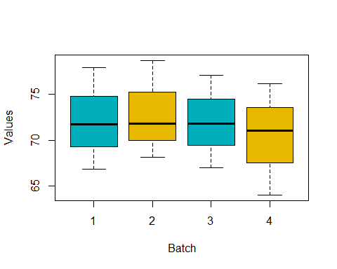

model <- aov(Values ~ Batch + Fat, data = Paneer)  
summary(model)

## Df Sum Sq Mean Sq F value Pr(>F)   
## Batch 3 9.73 3.24 5.762 0.0336 *   
## Fat 2 242.21 121.11 215.138 2.6e-06 ***  
## Residuals 6 3.38 0.56   
## ---  
## Signif. codes: 0 '***' 0.001 '**' 0.01 '*' 0.05 '.' 0.1 ' ' 1

library(lsmeans)

## Warning: package 'lsmeans' was built under R version 3.5.3

## Loading required package: emmeans

## Warning: package 'emmeans' was built under R version 3.5.3

## The 'lsmeans' package is now basically a front end for 'emmeans'.  
## Users are encouraged to switch the rest of the way.  
## See help('transition') for more information, including how to  
## convert old 'lsmeans' objects and scripts to work with 'emmeans'.

lml = lm(Values ~ Batch+Fat, data = Paneer)  
lsm1 = lsmeans(lml, "Fat")  
lsm1

## Fat lsmean SE df lower.CL upper.CL  
## 1 66.5 0.375 6 65.6 67.4  
## 2 77.5 0.375 6 76.6 78.4  
## 3 71.6 0.375 6 70.7 72.5  
##   
## Results are averaged over the levels of: Batch   
## Confidence level used: 0.95

pairs(lsm1)

## contrast estimate SE df t.ratio p.value  
## 1 - 2 -10.99 0.531 6 -20.725 <.0001   
## 1 - 3 -5.09 0.531 6 -9.604 0.0002   
## 2 - 3 5.90 0.531 6 11.121 0.0001   
##   
## Results are averaged over the levels of: Batch   
## P value adjustment: tukey method for comparing a family of 3 estimates

library(multcompView)

## Warning: package 'multcompView' was built under R version 3.5.3

CLD(lsm1,Letters = "abc")

## Warning: 'CLD' will be deprecated. Its use is discouraged.  
## See '? CLD' for an explanation. Use 'pwpp' or 'multcomp::cld' instead.

## Fat lsmean SE df lower.CL upper.CL .group  
## 1 66.5 0.375 6 65.6 67.4 a   
## 3 71.6 0.375 6 70.7 72.5 b   
## 2 77.5 0.375 6 76.6 78.4 ca   
##   
## Results are averaged over the levels of: Batch   
## Confidence level used: 0.95   
## P value adjustment: tukey method for comparing a family of 3 estimates   
## significance level used: alpha = 0.05

lsm2 = lsmeans(lml, "Batch")  
lsm2

## Batch lsmean SE df lower.CL upper.CL  
## 1 72.1 0.433 6 71.1 73.2  
## 2 72.9 0.433 6 71.8 73.9  
## 3 72.0 0.433 6 70.9 73.0  
## 4 70.4 0.433 6 69.3 71.5  
##   
## Results are averaged over the levels of: Fat   
## Confidence level used: 0.95

pairs(lsm2)

## contrast estimate SE df t.ratio p.value  
## 1 - 2 -0.740 0.613 6 -1.208 0.6444   
## 1 - 3 0.167 0.613 6 0.272 0.9922   
## 1 - 4 1.733 0.613 6 2.829 0.1056   
## 2 - 3 0.907 0.613 6 1.480 0.5018   
## 2 - 4 2.473 0.613 6 4.037 0.0262   
## 3 - 4 1.567 0.613 6 2.557 0.1466   
##   
## Results are averaged over the levels of: Fat   
## P value adjustment: tukey method for comparing a family of 4 estimates