**REVISION QUESTIONS**

1. *Design a circuit that captures temperature and light intensity from the environment and if the temp is above a particular threshold and the light intensity value is 1, a series of 5 LED's should glow alternatively.*

**Code:**

#include <DHTesp.h>

DHTesp dht;

#define dht_apin D3

int sensorPin = 0;

int led1 = D0;

int led2 = D2;

int led3 = D4;

int led4 = D6;

int led5 = D8;

float sensorValue = 0;

void setup() {

Serial.begin(9600);

Serial.println("DHT11 Humidity and Temperature Sensor");

delay(1000);

dht.setup(dht_apin, DHTesp::DHT11);

pinMode(led1,OUTPUT);

pinMode(led2,OUTPUT);

pinMode(led3,OUTPUT);

pinMode(led4,OUTPUT);

pinMode(led5,OUTPUT);

}

void loop() {

float temp=dht.getTemperature();

Serial.print("Current Temperature = ");

Serial.print(temp);

Serial.println(" C");

sensorValue = analogRead(A0);

float value = sensorValue/(1024.0);

Serial.println(value);

delay(1000);

if(value==1 && temp>26) {

digitalWrite(led1,HIGH);

digitalWrite(led2,HIGH);

digitalWrite(led3,HIGH);

digitalWrite(led4,HIGH);

digitalWrite(led5,HIGH);

}

else {

digitalWrite(led1,LOW);

digitalWrite(led2,LOW);

digitalWrite(led3,LOW);

digitalWrite(led4,LOW);

digitalWrite(led5,LOW);

}

}

--------------------------------------------------------------------------------------------------------------------------------------

1. *Design a circuit that captures humidity and temperature based on threshold values assigned. The RGB led should be high or low.*

**Code:**

int RED = D0;

int GREEN = D2;

int BLUE = D4;

void setup() {

// put your setup code here, to run once:

pinMode(RED,OUTPUT);

pinMode(GREEN,OUTPUT);

pinMode(BLUE,OUTPUT);

}

void loop() {

digitalWrite(RED,LOW);

digitalWrite(GREEN,HIGH);

digitalWrite(BLUE,HIGH);

delay (1000);

digitalWrite(RED,HIGH);

digitalWrite(GREEN,LOW);

digitalWrite(BLUE,HIGH);

delay (1000);

digitalWrite(RED,HIGH);

digitalWrite(GREEN,HIGH);

digitalWrite(BLUE,LOW);

delay (1000);

}

--------------------------------------------------------------------------------------------------------------------------------------

1. *Capture temperature and give a 3 bit counter or a 2 bit counter.*

**Code:**

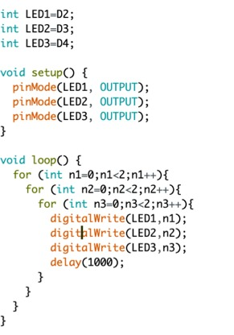

--------------------------------------------------------------------------------------------------------------------------------------

1. *Design a traffic light system in which after*

*Red ~ 2s*

*Green ~ 3s*

*Yellow ~ 4s*

**Code:**

int RED = D0;

int BLUE = D4;

int GREEN = D2;

void setup() {

// put your setup code here, to run once:

pinMode(RED,OUTPUT);

pinMode(GREEN,OUTPUT);

pinMode(BLUE,OUTPUT);

}

void loop() {

digitalWrite(RED,LOW);

digitalWrite(GREEN,HIGH);

digitalWrite(BLUE,HIGH);

delay (2000);

digitalWrite(RED,HIGH);

digitalWrite(GREEN,LOW);

digitalWrite(BLUE,HIGH);

delay (4000);

digitalWrite(RED,HIGH);

digitalWrite(GREEN,HIGH);

digitalWrite(BLUE,LOW);

delay (6000);

}

--------------------------------------------------------------------------------------------------------------------------------------