Lab2_1740256

Jeevan

19/06/2019

**AIM-**

Fit a simple linear regression to the data that involving the following steps by using R.

1. Plot the scatter diagram for the data .
2. Estimate the parameters of a simple linear regression model.
3. Obtain the fitted values of the model.
4. Test the significance of the model parameters and interpret the results.
5. Obtain the coefficient of determination and interpret the results.
6. Obtain the 95 percent and 99 percent confidence interval for the slope and intercept parameters.
7. Check whether the assumptions of the residuals are satisfied or not by using a suitable statistical test.

**ANALYSIS–**

library(lmtest)

Spend_sales <- read.csv("C:/Users/Jeevan/Desktop/Christ University/Statistics/Spend_sales.csv")  
View(Spend_sales)  
attach(Spend_sales)

plot(Sales,Spend,main = "Scatter Plot")

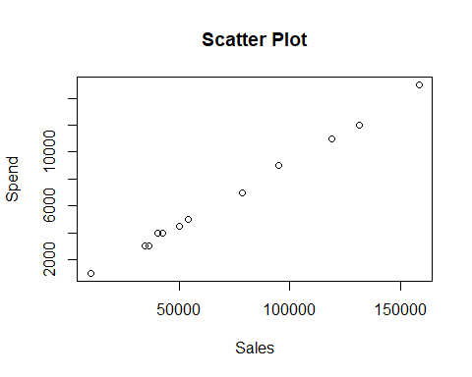

scatter.smooth(Sales,Spend)

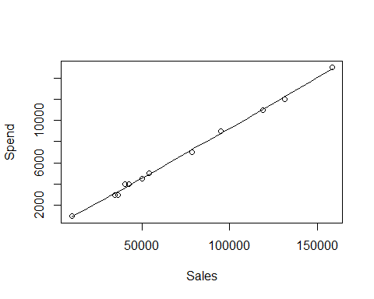

cor(Sales,Spend)

## [1] 0.9988322

model = lm(Spend~Sales)  
model

##   
## Call:  
## lm(formula = Spend ~ Sales)  
##   
## Coefficients:  
## (Intercept) Sales   
## -114.67027 0.09392

summary(model)

##   
## Call:  
## lm(formula = Spend ~ Sales)  
##   
## Residuals:  
## Min 1Q Median 3Q Max   
## -293.22 -165.15 -20.82 188.67 312.02   
##   
## Coefficients:  
## Estimate Std. Error t value Pr(>|t|)   
## (Intercept) -1.147e+02 1.196e+02 -0.959 0.36   
## Sales 9.392e-02 1.437e-03 65.378 1.71e-14 ***  
## ---  
## Signif. codes: 0 '***' 0.001 '**' 0.01 '*' 0.05 '.' 0.1 ' ' 1  
##   
## Residual standard error: 217.5 on 10 degrees of freedom  
## Multiple R-squared: 0.9977, Adjusted R-squared: 0.9974   
## F-statistic: 4274 on 1 and 10 DF, p-value: 1.707e-14

fit=fitted.values(model)  
fit

## 1 2 3 4 5 6   
## 816.4799 3687.9803 4987.5895 4585.6001 3146.2338 3881.8369   
## 7 8 9 10 11 12   
## 8795.8754 11054.0602 14770.5836 12221.8957 7258.6417 3293.2230

res=resid(model)  
sum(res)

## [1] 1.882938e-13

confint(model, level = 0.95)

## 2.5 % 97.5 %  
## (Intercept) -381.20401860 151.86346955  
## Sales 0.09072177 0.09712374

confint(model, level = 0.99)

## 0.5 % 99.5 %  
## (Intercept) -493.78404056 264.44349151  
## Sales 0.08936972 0.09847579

dwtest(Spend~Sales)

##   
## Durbin-Watson test  
##   
## data: Spend ~ Sales  
## DW = 1.1625, p-value = 0.03414  
## alternative hypothesis: true autocorrelation is greater than 0

**INTERPRETATION–**

The parameters for the simple linear regression model are –

***Coefficients:  
## (Intercept) Sales   
## -114.67027 0.09392***

The fitted values of the model are –

***## 1 2 3 4 5 6   
## 816.4799 3687.9803 4987.5895 4585.6001 3146.2338 3881.8369   
## 7 8 9 10 11 12   
## 8795.8754 11054.0602 14770.5836 12221.8957 7258.6417 3293.2230***

The significance of the model parameters –

1.71e-14 is less than 0.05 and is therefore highly significant and therefore we reject the null hypothesis.

The coefficient of determination is ***0.9974*** and this shows that the model is a good fit to the data.

The 95 percent and 99 percent confidence interval for the slope and intercept parameters are –

***## 2.5 % 97.5 %  
## (Intercept) -381.20401860 151.86346955  
## Sales 0.09072177 0.09712374***

***## 0.5 % 99.5 %  
## (Intercept) -493.78404056 264.44349151  
## Sales 0.08936972 0.09847579***

The assumptions of the residuals are satisfied by the Durbin Watson Test

***## Durbin-Watson test  
## data: Spend ~ Sales  
## DW = 1.1625, p-value = 0.03414  
## alternative hypothesis: true autocorrelation is greater than 0***

-----------------------------------------------------------------------------