Lab 8

Jeevan

04/09/2019

#Importing the dataset  
library(readxl)

## Warning: package 'readxl' was built under R version 3.5.2

data <- read_excel("C:/Users/Jeevan/Desktop/Christ University/Statistics/Linear Regression/lab-data8.xlsx")  
View(data)  
attach(data)  
#Linear Regression Model  
mlmodel=lm(DeliveryTimeY~NumberOfCasesX1+DistanceX2, data=data)  
summary(mlmodel)

##   
## Call:  
## lm(formula = DeliveryTimeY ~ NumberOfCasesX1 + DistanceX2, data = data)  
##   
## Residuals:  
## Min 1Q Median 3Q Max   
## -5.7860 -0.6649 0.4509 1.1713 7.4063   
##   
## Coefficients:  
## Estimate Std. Error t value Pr(>|t|)   
## (Intercept) 2.323473 1.095005 2.122 0.045348 *   
## NumberOfCasesX1 1.615374 0.170466 9.476 3.18e-09 ***  
## DistanceX2 0.014417 0.003607 3.997 0.000608 ***  
## ---  
## Signif. codes: 0 '***' 0.001 '**' 0.01 '*' 0.05 '.' 0.1 ' ' 1  
##   
## Residual standard error: 3.254 on 22 degrees of freedom  
## Multiple R-squared: 0.9597, Adjusted R-squared: 0.9561   
## F-statistic: 262.3 on 2 and 22 DF, p-value: 4.497e-16

#Residual Plots  
plot(mlmodel)

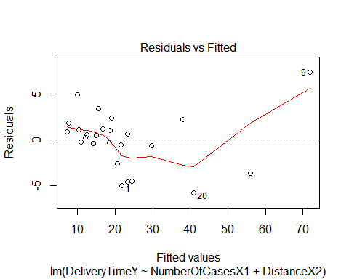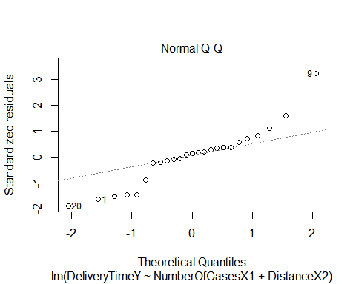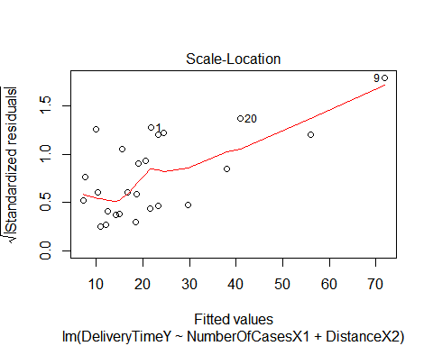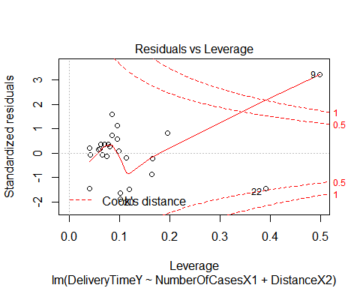

#(i) Data is deviating from normal  
#(ii) most frequency used plot to check normality of error term  
#(iii) scale location plot ~ deviation of residuals from straight line/information about influential objects  
#(iv)   
r=resid(mlmodel)   
r

## 1 2 3 4 5 6   
## -5.0246957 1.1586320 0.2285735 4.9416599 -0.4282885 -0.2787501   
## 7 8 9 10 11 12   
## 0.8598928 1.1713084 7.4062681 2.3772799 2.2415445 -0.5768987   
## 13 14 15 16 17 18   
## 0.5386578 1.0735592 0.6792781 -0.6649225 0.4508538 3.4658465   
## 19 20 21 22 23 24   
## 1.8113885 -5.7860360 -2.5956121 -3.6810862 -4.5995562 -4.5713561   
## 25   
## -0.1975409

p=fitted(mlmodel)  
p

## 1 2 3 4 5 6 7   
## 21.704696 10.341368 12.071427 9.938340 14.178288 18.388750 7.140107   
## 8 9 10 11 12 13 14   
## 16.658692 71.833732 19.122720 38.088456 21.576899 12.461342 18.676441   
## 15 16 17 18 19 20 21   
## 23.320722 29.664922 14.899146 15.534153 7.688612 40.886036 20.495612   
## 22 23 24 25   
## 56.001086 23.349556 24.401356 10.947541

qqnorm(r) # to plot the q-q plot

