Fitting A Linear Regression Model

Jeevan

12/06/2019

A rocket motor is manufactured by bonding together two types of propellants, an igniter and a sustainer. The shear strength of the bond (Y) is thought to be a linear function of the age of the propellant (X) when the motor is cast.

Fit a simple linear regression to the data that involving the following steps by using R.

a) Plot the scatter diagram for the data.

b) Estimate the parameters of a simple linear regression model.

c) Obtain the fitted values of the model.

d) Show that the sum of fitted values and sum of observed values of Y are equal.

e) Obtain the residuals and show that the sum of residuals is zero.

library(readxl)

## Warning: package 'readxl' was built under R version 3.5.2

lab1 <- read_excel("C:/Users/Jeevan/Desktop/Christ University/Statistics/Linear Regression/lab1.xlsx")  
View(lab1)  
attach(lab1)

plot(age,sheer,main="Scatter Plot")

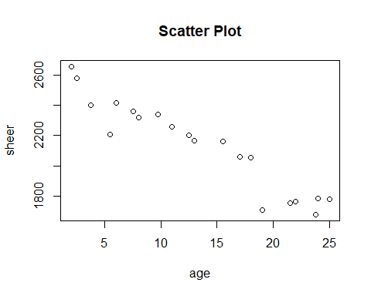

scatter.smooth(age,sheer,main = "Fitted Linear Scatter Plot")

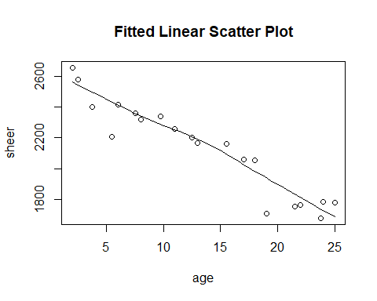

The above figure shows a scatter plot for the data with a fitted linear regression model.

model=lm(sheer~age)  
model

##   
## Call:  
## lm(formula = sheer ~ age)  
##   
## Coefficients:  
## (Intercept) age   
## 2627.82 -37.15

We fit a linear model to the variables which gives us the slope intercept.

fit = fitted.values(model)  
fit

## 1 2 3 4 5 6 7 8   
## 2051.942 1745.425 2330.594 1996.211 2423.478 1921.904 1736.136 2534.938   
## 9 10 11 12 13 14 15 16   
## 2349.170 2219.133 2144.826 2488.496 1698.983 2265.575 1810.443 1959.058   
## 17 18 19 20   
## 2404.901 2163.402 2553.515 1829.020

These are the fitted values of the model.

res=resid(model)  
sum(res)

## [1] -1.367795e-13

sum(fit)

## [1] 42627.15

sum(sheer)

## [1] 42627.15

Here we see that the sum of residuals in nearly zero.

Also the sum of fitted values and sum of observed values of Y are equal.