Lab 9: Detection of Multicollinearity in R

Jeevan Koshy ~ 1740256

September 18, 2019

**Aim**

To check the multicollinearity of the given data and analyze the data using R package.

**Procedure**

#install.packages("GGally")  
# install.packages("mctest")  
library(GGally)

## Warning: package 'GGally' was built under R version 3.5.3

## Loading required package: ggplot2

## Warning: package 'ggplot2' was built under R version 3.5.2

library(readxl)

## Warning: package 'readxl' was built under R version 3.5.2

library(mctest)

## Warning: package 'mctest' was built under R version 3.5.2

multicollinearitydata <- read_excel("C:/Users/Jeevan/Desktop/Christ University/Statistics/Linear Regression/multicollinearitydata.xlsx")  
# View(multicollinearitydata)  
attach(multicollinearitydata)  
fit = lm(y~.,data = multicollinearitydata)  
formula(fit)

## y ~ x1 + x2 + x3 + x4 + x5 + x6 + x7 + x8 + x9 + x10

plot(fit)

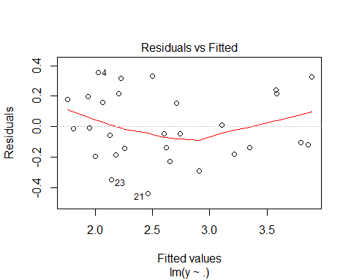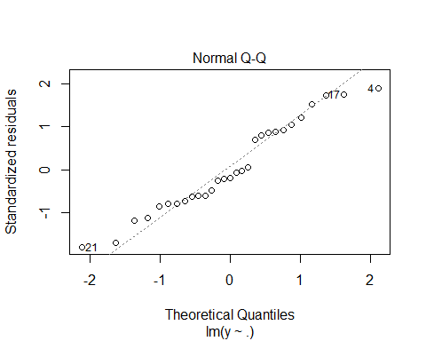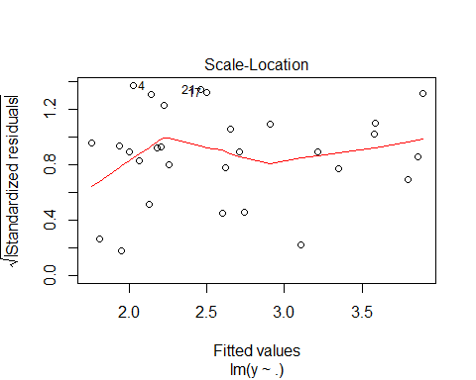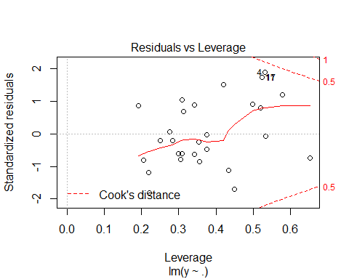

ggpairs(multicollinearitydata)

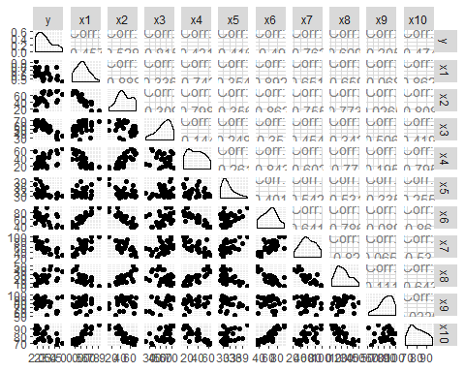

x = multicollinearitydata[,2:10]  
x

## # A tibble: 29 x 9  
## x1 x2 x3 x4 x5 x6 x7 x8 x9  
## <dbl> <dbl> <dbl> <dbl> <dbl> <dbl> <dbl> <dbl> <dbl>  
## 1 0.789 39.8 66.9 23.4 33.4 77.3 79.2 15.3 92.1  
## 2 0.644 41.7 63.4 41.4 30.4 60.4 42.1 27.7 95.6  
## 3 0.681 36.1 72.6 14.4 29.9 79.5 66 10.1 88.4  
## 4 0.601 44.7 52.6 16.1 32 53.9 77.2 14.4 80.8  
## 5 0.679 41.7 63.3 21.6 29.7 68.7 56.1 25.3 99.5  
## 6 0.537 65.3 47.2 58.4 30.2 36.2 33.9 49.2 81.8  
## 7 0.628 41.9 59.3 26 32.4 64.6 47.9 18.8 87.4  
## 8 0.516 70.8 53.2 50.5 33 44.9 41.8 39.9 77.9  
## 9 0.488 69.5 55.9 52.6 29.2 44.4 32.6 40.7 74.2  
## 10 0.49 72.7 43.6 52.2 29.8 44.8 22.5 40.5 93.7  
## # ... with 19 more rows

omcdiag(x,multicollinearitydata$y,data = multicollinearitydata)

## Warning in omcdiag(x, multicollinearitydata$y, data =  
## multicollinearitydata): Extra argument 'data' is ignored

##   
## Call:  
## omcdiag(x = x, y = multicollinearitydata$y, data = multicollinearitydata)  
##   
##   
## Overall Multicollinearity Diagnostics  
##   
## MC Results detection  
## Determinant |X'X|: 0.0001 1  
## Farrar Chi-Square: 230.3103 1  
## Red Indicator: 0.5562 1  
## Sum of Lambda Inverse: 52.4495 1  
## Theil's Method: -0.3339 0  
## Condition Number: 101.8065 1  
##   
## 1 --> COLLINEARITY is detected by the test   
## 0 --> COLLINEARITY is not detected by the test

imcdiag(x,multicollinearitydata$y)

##   
## Call:  
## imcdiag(x = x, y = multicollinearitydata$y)  
##   
##   
## All Individual Multicollinearity Diagnostics Result  
##   
## VIF TOL Wi Fi Leamer CVIF Klein  
## x1 8.5152 0.1174 18.7879 22.5455 0.3427 -0.4908 0  
## x2 8.7085 0.1148 19.2714 23.1256 0.3389 -0.5019 0  
## x3 2.5346 0.3945 3.8364 4.6037 0.6281 -0.1461 0  
## x4 5.2636 0.1900 10.6589 12.7907 0.4359 -0.3034 0  
## x5 2.1149 0.4728 2.7872 3.3446 0.6876 -0.1219 0  
## x6 11.0201 0.0907 25.0503 30.0603 0.3012 -0.6352 1  
## x7 5.2569 0.1902 10.6424 12.7708 0.4361 -0.3030 0  
## x8 6.7809 0.1475 14.4524 17.3428 0.3840 -0.3908 0  
## x9 2.2548 0.4435 3.1369 3.7643 0.6660 -0.1300 0  
##   
## 1 --> COLLINEARITY is detected by the test   
## 0 --> COLLINEARITY is not detected by the test  
##   
## x1 , x2 , x5 , x6 , x8 , x9 , coefficient(s) are non-significant may be due to multicollinearity  
##   
## R-square of y on all x: 0.8965   
##   
## * use method argument to check which regressors may be the reason of collinearity  
## ===================================

summary(fit)

##   
## Call:  
## lm(formula = y ~ ., data = multicollinearitydata)  
##   
## Residuals:  
## Min 1Q Median 3Q Max   
## -0.43837 -0.14250 -0.04833 0.19676 0.35463   
##   
## Coefficients:  
## Estimate Std. Error t value Pr(>|t|)   
## (Intercept) 4.686737 1.970421 2.379 0.028660 *   
## x1 0.613751 1.488450 0.412 0.684958   
## x2 -0.001258 0.009745 -0.129 0.898732   
## x3 -0.033710 0.007148 -4.716 0.000172 ***  
## x4 0.019574 0.008449 2.317 0.032514 *   
## x5 -0.024824 0.024090 -1.030 0.316427   
## x6 0.005273 0.011015 0.479 0.637931   
## x7 -0.017476 0.006283 -2.782 0.012310 *   
## x8 -0.007767 0.011157 -0.696 0.495198   
## x9 -0.006798 0.006318 -1.076 0.296125   
## x10 0.012862 0.018141 0.709 0.487409   
## ---  
## Signif. codes: 0 '***' 0.001 '**' 0.01 '*' 0.05 '.' 0.1 ' ' 1  
##   
## Residual standard error: 0.2751 on 18 degrees of freedom  
## Multiple R-squared: 0.8994, Adjusted R-squared: 0.8434   
## F-statistic: 16.08 on 10 and 18 DF, p-value: 5.185e-07

new = multicollinearitydata[,-7]  
new

## # A tibble: 29 x 10  
## y x1 x2 x3 x4 x5 x7 x8 x9 x10  
## <dbl> <dbl> <dbl> <dbl> <dbl> <dbl> <dbl> <dbl> <dbl> <dbl>  
## 1 2.13 0.789 39.8 66.9 23.4 33.4 79.2 15.3 92.1 90.2  
## 2 2.69 0.644 41.7 63.4 41.4 30.4 42.1 27.7 95.6 83.4  
## 3 1.94 0.681 36.1 72.6 14.4 29.9 66 10.1 88.4 94   
## 4 2.38 0.601 44.7 52.6 16.1 32 77.2 14.4 80.8 78.1  
## 5 1.99 0.679 41.7 63.3 21.6 29.7 56.1 25.3 99.5 82.9  
## 6 3.21 0.537 65.3 47.2 58.4 30.2 33.9 49.2 81.8 73.9  
## 7 2.55 0.628 41.9 59.3 26 32.4 47.9 18.8 87.4 86.3  
## 8 2.62 0.516 70.8 53.2 50.5 33 41.8 39.9 77.9 74.1  
## 9 3.12 0.488 69.5 55.9 52.6 29.2 32.6 40.7 74.2 73.5  
## 10 3.82 0.49 72.7 43.6 52.2 29.8 22.5 40.5 93.7 76.2  
## # ... with 19 more rows

fit1 = lm(y~.,data = new)  
formula(fit1)

## y ~ x1 + x2 + x3 + x4 + x5 + x7 + x8 + x9 + x10

summary(fit1)

##   
## Call:  
## lm(formula = y ~ ., data = new)  
##   
## Residuals:  
## Min 1Q Median 3Q Max   
## -0.42439 -0.16256 -0.06006 0.22185 0.32720   
##   
## Coefficients:  
## Estimate Std. Error t value Pr(>|t|)   
## (Intercept) 4.876626 1.890518 2.580 0.018370 *   
## x1 0.989738 1.238412 0.799 0.434053   
## x2 -0.001715 0.009499 -0.181 0.858656   
## x3 -0.032935 0.006820 -4.829 0.000116 ***  
## x4 0.018210 0.007792 2.337 0.030529 *   
## x5 -0.023376 0.023409 -0.999 0.330540   
## x7 -0.018585 0.005720 -3.249 0.004225 **   
## x8 -0.009947 0.009976 -0.997 0.331253   
## x9 -0.006975 0.006178 -1.129 0.272942   
## x10 0.013037 0.017765 0.734 0.471996   
## ---  
## Signif. codes: 0 '***' 0.001 '**' 0.01 '*' 0.05 '.' 0.1 ' ' 1  
##   
## Residual standard error: 0.2695 on 19 degrees of freedom  
## Multiple R-squared: 0.8981, Adjusted R-squared: 0.8498   
## F-statistic: 18.6 on 9 and 19 DF, p-value: 1.277e-07

xx = new[,2:9]  
xx

## # A tibble: 29 x 8  
## x1 x2 x3 x4 x5 x7 x8 x9  
## <dbl> <dbl> <dbl> <dbl> <dbl> <dbl> <dbl> <dbl>  
## 1 0.789 39.8 66.9 23.4 33.4 79.2 15.3 92.1  
## 2 0.644 41.7 63.4 41.4 30.4 42.1 27.7 95.6  
## 3 0.681 36.1 72.6 14.4 29.9 66 10.1 88.4  
## 4 0.601 44.7 52.6 16.1 32 77.2 14.4 80.8  
## 5 0.679 41.7 63.3 21.6 29.7 56.1 25.3 99.5  
## 6 0.537 65.3 47.2 58.4 30.2 33.9 49.2 81.8  
## 7 0.628 41.9 59.3 26 32.4 47.9 18.8 87.4  
## 8 0.516 70.8 53.2 50.5 33 41.8 39.9 77.9  
## 9 0.488 69.5 55.9 52.6 29.2 32.6 40.7 74.2  
## 10 0.49 72.7 43.6 52.2 29.8 22.5 40.5 93.7  
## # ... with 19 more rows

imcdiag(xx,new$y)

##   
## Call:  
## imcdiag(x = xx, y = new$y)  
##   
##   
## All Individual Multicollinearity Diagnostics Result  
##   
## VIF TOL Wi Fi Leamer CVIF Klein  
## x1 5.5402 0.1805 13.6207 16.6476 0.4248 -0.3734 0  
## x2 8.6189 0.1160 22.8566 27.9359 0.3406 -0.5810 0  
## x3 2.3634 0.4231 4.0903 4.9992 0.6505 -0.1593 0  
## x4 4.4741 0.2235 10.4224 12.7385 0.4728 -0.3016 0  
## x5 2.0816 0.4804 3.2448 3.9658 0.6931 -0.1403 0  
## x7 4.4087 0.2268 10.2260 12.4984 0.4763 -0.2972 0  
## x8 5.6462 0.1771 13.9386 17.0361 0.4208 -0.3806 0  
## x9 2.2470 0.4450 3.7411 4.5725 0.6671 -0.1515 0  
##   
## 1 --> COLLINEARITY is detected by the test   
## 0 --> COLLINEARITY is not detected by the test  
##   
## x1 , x2 , x5 , x8 , x9 , coefficient(s) are non-significant may be due to multicollinearity  
##   
## R-square of y on all x: 0.8952   
##   
## * use method argument to check which regressors may be the reason of collinearity  
## ===================================

step(fit1,direction = "both")

## Start: AIC=-68.31  
## y ~ x1 + x2 + x3 + x4 + x5 + x7 + x8 + x9 + x10  
##   
## Df Sum of Sq RSS AIC  
## - x2 1 0.00237 1.3824 -70.261  
## - x10 1 0.03912 1.4191 -69.500  
## - x1 1 0.04639 1.4264 -69.352  
## - x8 1 0.07221 1.4522 -68.831  
## - x5 1 0.07243 1.4525 -68.827  
## - x9 1 0.09259 1.4726 -68.427  
## <none> 1.3800 -68.310  
## - x4 1 0.39675 1.7768 -62.982  
## - x7 1 0.76662 2.1467 -57.498  
## - x3 1 1.69408 3.0741 -47.084  
##   
## Step: AIC=-70.26  
## y ~ x1 + x3 + x4 + x5 + x7 + x8 + x9 + x10  
##   
## Df Sum of Sq RSS AIC  
## - x10 1 0.04245 1.4248 -71.384  
## - x5 1 0.07323 1.4556 -70.764  
## - x8 1 0.07709 1.4595 -70.687  
## - x1 1 0.08164 1.4640 -70.597  
## - x9 1 0.09143 1.4738 -70.403  
## <none> 1.3824 -70.261  
## + x2 1 0.00237 1.3800 -68.310  
## - x4 1 0.39712 1.7795 -64.938  
## - x7 1 0.86042 2.2428 -58.227  
## - x3 1 1.87671 3.2591 -47.389  
##   
## Step: AIC=-71.38  
## y ~ x1 + x3 + x4 + x5 + x7 + x8 + x9  
##   
## Df Sum of Sq RSS AIC  
## - x5 1 0.07429 1.4991 -71.910  
## - x8 1 0.08457 1.5094 -71.712  
## - x9 1 0.08776 1.5126 -71.650  
## <none> 1.4248 -71.384  
## + x10 1 0.04245 1.3824 -70.261  
## + x2 1 0.00570 1.4192 -69.500  
## - x1 1 0.35012 1.7750 -67.012  
## - x4 1 0.37385 1.7987 -66.627  
## - x7 1 1.16522 2.5901 -56.053  
## - x3 1 2.00859 3.4334 -47.878  
##   
## Step: AIC=-71.91  
## y ~ x1 + x3 + x4 + x7 + x8 + x9  
##   
## Df Sum of Sq RSS AIC  
## - x9 1 0.03540 1.5345 -73.233  
## - x8 1 0.04403 1.5432 -73.070  
## <none> 1.4991 -71.910  
## + x5 1 0.07429 1.4248 -71.384  
## + x10 1 0.04351 1.4556 -70.764  
## + x2 1 0.00696 1.4922 -70.045  
## - x4 1 0.30425 1.8034 -68.551  
## - x1 1 0.31815 1.8173 -68.329  
## - x7 1 1.23626 2.7354 -56.469  
## - x3 1 2.36467 3.8638 -46.454  
##   
## Step: AIC=-73.23  
## y ~ x1 + x3 + x4 + x7 + x8  
##   
## Df Sum of Sq RSS AIC  
## - x8 1 0.0457 1.5802 -74.382  
## <none> 1.5345 -73.233  
## + x10 1 0.0404 1.4942 -72.006  
## + x9 1 0.0354 1.4991 -71.910  
## + x5 1 0.0219 1.5126 -71.650  
## + x2 1 0.0004 1.5342 -71.240  
## - x4 1 0.2951 1.8297 -70.132  
## - x1 1 0.3247 1.8593 -69.666  
## - x7 1 1.2009 2.7354 -58.469  
## - x3 1 4.1080 5.6425 -37.472  
##   
## Step: AIC=-74.38  
## y ~ x1 + x3 + x4 + x7  
##   
## Df Sum of Sq RSS AIC  
## <none> 1.5802 -74.382  
## + x8 1 0.0457 1.5345 -73.233  
## + x10 1 0.0456 1.5346 -73.231  
## + x9 1 0.0371 1.5432 -73.070  
## + x5 1 0.0054 1.5749 -72.481  
## + x2 1 0.0021 1.5782 -72.420  
## - x4 1 0.2615 1.8417 -71.941  
## - x1 1 0.3024 1.8826 -71.305  
## - x7 1 1.5685 3.1487 -56.389  
## - x3 1 4.0640 5.6442 -39.463

##   
## Call:  
## lm(formula = y ~ x1 + x3 + x4 + x7, data = new)  
##   
## Coefficients:  
## (Intercept) x1 x3 x4 x7   
## 4.270727 1.524122 -0.034690 0.009727 -0.017116

be = lm(y~x1+x3+x4+x7,data = new)  
summary(be)

##   
## Call:  
## lm(formula = y ~ x1 + x3 + x4 + x7, data = new)  
##   
## Residuals:  
## Min 1Q Median 3Q Max   
## -0.48391 -0.17071 0.01805 0.18276 0.45733   
##   
## Coefficients:  
## Estimate Std. Error t value Pr(>|t|)   
## (Intercept) 4.270727 0.542943 7.866 4.25e-08 ***  
## x1 1.524122 0.711229 2.143 0.0425 *   
## x3 -0.034690 0.004416 -7.856 4.34e-08 ***  
## x4 0.009727 0.004881 1.993 0.0578 .   
## x7 -0.017116 0.003507 -4.881 5.63e-05 ***  
## ---  
## Signif. codes: 0 '***' 0.001 '**' 0.01 '*' 0.05 '.' 0.1 ' ' 1  
##   
## Residual standard error: 0.2566 on 24 degrees of freedom  
## Multiple R-squared: 0.8833, Adjusted R-squared: 0.8638   
## F-statistic: 45.41 on 4 and 24 DF, p-value: 7.411e-11

**Conclusion**

From the analysis performed above, it can be seen that there exists multicollinearity in the given dataset as indicated by the following methods:

MC Results detection  
1. Determinant |X'X|: 0.0001 1  
2. Farrar Chi-Square: 230.3103 1  
3. Red Indicator: 0.5562 1  
4. Sum of Lambda Inverse: 52.4495 1  
5. Condition Number: 101.8065 1

On diagnosing for Individual Multicollinearity, it is observed that *x6*, i.e., the percentage of female literacy is the cause for multicollinearity in the dataset. On removing *x6* from the dataset it can be seen that there exists no multicollinearity in the data.

Using Stepwise Elimination Method, it can be seen that *x4*, i.e., the female age at marriage is the best variable(p>0.05) that can be selected from the data since it has almost no effect on the dataset.

-----------------------------------------------------------------------------\---------------------------------------