**REPORT ON SURVEY OF THE SOUTHERN CORROBOREE FROG**

-----------------------------------------------------------------------------------------------------------------------------------------------------------

**Name**: Jeevan Koshy **Register Number**: 1740256

**Date:** 26-March-2019 **Location:** New South Wales, Australia

**INTRODUCTION:**

The data is taken from the survey to find the distribution of the Southern Corroboree frog located in the Snowy mountain area of New South Wales, Australia. This dataset contains columns consisting of –

* *Status* = 0 (if the frog is not there)  
   1 (if the frog is spotted during the survey)
* *northing =* reference points for frog searched
* *easting =* reference points for frog searched
* *altitude =* to the nearest extent population (value in meters)
* *distance =* to the nearest extent population (value in meters)
* *NoOfPools =* Number of pools for potential breeding of frogs (within 2km)
* *NoOfSites =* Number of sites for potential breeding of frogs (within 2km)
* *avrain =* Average rainfall for spring period.
* *meanmin =* Minimumtemperature for spring period
* *meanmax =* Maximum temperature for spring period

**AIM:**

The purpose of this survey was to answer the following questions –

1. Count the number of frogs spotted during the survey and find the range of Northing and Easting reference points for spotting the frogs.

2. How many frogs where spotted in reference point northing greater than 100 and easting less than 1050?

3. What is average altitude where the frogs that were not able to be spotted?

4. Visualize average rainfall for spring period where the frogs are spotted.

5 Is the average rainfall for spring period less in the places where the frogs are not spotted? Justify your answer.

6. Count the number of frogs which are spotted that have more than 50 pools and 3 sites for their potential breeding.

7. Find a relationship between average rainfall and maximum temperature for spring period.

8. Suggest the investigator on average what should be the altitude and distance to the nearest extant population should he or she can spot the frogs.

**ANALYSIS:**

The above questions can be answered with the help of writing statistical code in RStudio.



**Answer 1**

spot<-filter(Frogs,Frogs$Status=="1") #all the frogs which were spotted

# View(spot)

count(spot) # counting the number of frogs which were spotted

summary(Frogs$northing) # Finding the range for spotting the frogs

summary(Frogs$easting)

**Answer 2**

north<-filter(Frogs,Frogs$Status=="1" & Frogs$northing>100 & Frogs$easting<1050)

# View(north)

count(north)

# counting number of frogs spotted where reference point for northing > 100 & easting <1050

**Answer 3**

no_spot<-filter(Frogs,Frogs$Status=="0")

avg_no_spot<-mean(no_spot$altitude)

avg_no_spot

**Answer 4**

barplot(spot$avrain,spot$Status, #visualising average rainfall for spring period where frogs are spotted

col="maroon",

xlab = "Average Rainfall",ylab = "Frogs spotted",

main = "Average rainfall for spring period where frogs are spotted")

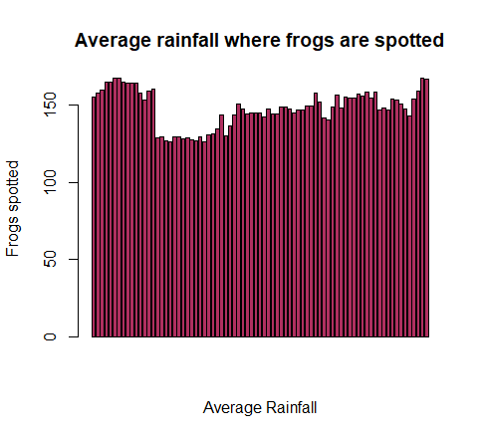

**Answer 5**

avg_spot_rain<-mean(spot$avrain)

avg_spot_rain

avg_no_spot_rain<-mean(no_spot$avrain)

avg_no_spot_rain

The average average rainfall for spring period is not less in the places where frogs are not spotted because if we look at the average rainfall in the places where the frogs are spotted – there is only a small difference and hence we can say that it is not less.

**Answer 6**

spot_fifty_three<-filter(spot,spot$NoOfPools>50 & spot$NoOfSites==3)

# View(spot_fifty_three)

count(spot_fifty_three)

# counting the number of frogs which are spotted in more than 50 pools with 3 sites for potential breeding

**Answer 7**

cor(x = Frogs$avrain,y = Frogs$meanmax)

cor.test(x = Frogs$avrain,y=Frogs$meanmax)

# Finding a relation between average rainfall & maximum spring temperature

**Answer 8**

spot_alt<-mean(spot$altitude)

spot_alt # Finding the average altitude to spot frogs

spot_dist<-mean(spot$distance)

spot_dist # Finding average distance to spot frogs

**CONCLUSION:**

> spot<-filter(Frogs,Frogs$Status=="1") #all the frogs which were spotted

> count(spot) # counting the number of frogs which were spotted

# A tibble: 1 x 1

n

<int>

1 79

> summary(Frogs$northing) # Finding the range for spotting the frogs

Min. 1st Qu. Median Mean 3rd Qu. Max.

84.0 192.0 222.5 228.2 290.0 335.0

> summary(Frogs$easting)

Min. 1st Qu. Median Mean 3rd Qu. Max.

673.0 977.8 1023.0 1004.6 1086.2 1222.0

> north<-filter(Frogs,Frogs$Status=="1" & Frogs$northing>100 & Frogs$easting<1050)

> count(north)

# A tibble: 1 x 1

n

<int>

1 38

> no_spot<-filter(Frogs,Frogs$Status=="0")

> avg_no_spot<-mean(no_spot$altitude)

> avg_no_spot

[1] 1570

> barplot(spot$avrain,spot$Status, #visualising average rainfall for spring period where frogs are spotted

+ col="maroon",

+ xlab = "Average Rainfall",ylab = "Frogs spotted",

+ main = "Average rainfall where frogs are spotted")

> avg_spot_rain<-mean(spot$avrain)

> avg_spot_rain

[1] 147.8819

> avg_no_spot_rain<-mean(no_spot$avrain)

> avg_no_spot_rain

[1] 148.218

> spot_fifty_three<-filter(spot,spot$NoOfPools>50 & spot$NoOfSites==3)

> count(spot_fifty_three)

# A tibble: 1 x 1

n

<int>

1 5

> cor(x = Frogs$avrain,y = Frogs$meanmax)

[1] -0.8186997

> cor.test(x = Frogs$avrain,y=Frogs$meanmax)

Pearson's product-moment correlation

data: Frogs$avrain and Frogs$meanmax

t = -20.661, df = 210, p-value < 2.2e-16

alternative hypothesis: true correlation is not equal to 0

95 percent confidence interval:

-0.8587160 -0.7687595

sample estimates:

cor

-0.8186997

> spot_alt<-mean(spot$altitude)

> spot_alt # Finding the average altitude to spot frogs

[1] 1508.481

> spot_dist<-mean(spot$distance)

> spot_dist # Finding average distance to spot frogs

[1] 854.4304

------------------------------------------------------------------------------------------------------------