Voice Input

An android mobile application that can recognize user speech and convert into text
and search in a dictionary(word with frequency).

:Developer Details:
Jeeban Bagdi
jeebanbagdi@gmail.com
9614886787 / 6289879843
:User Interfaces:

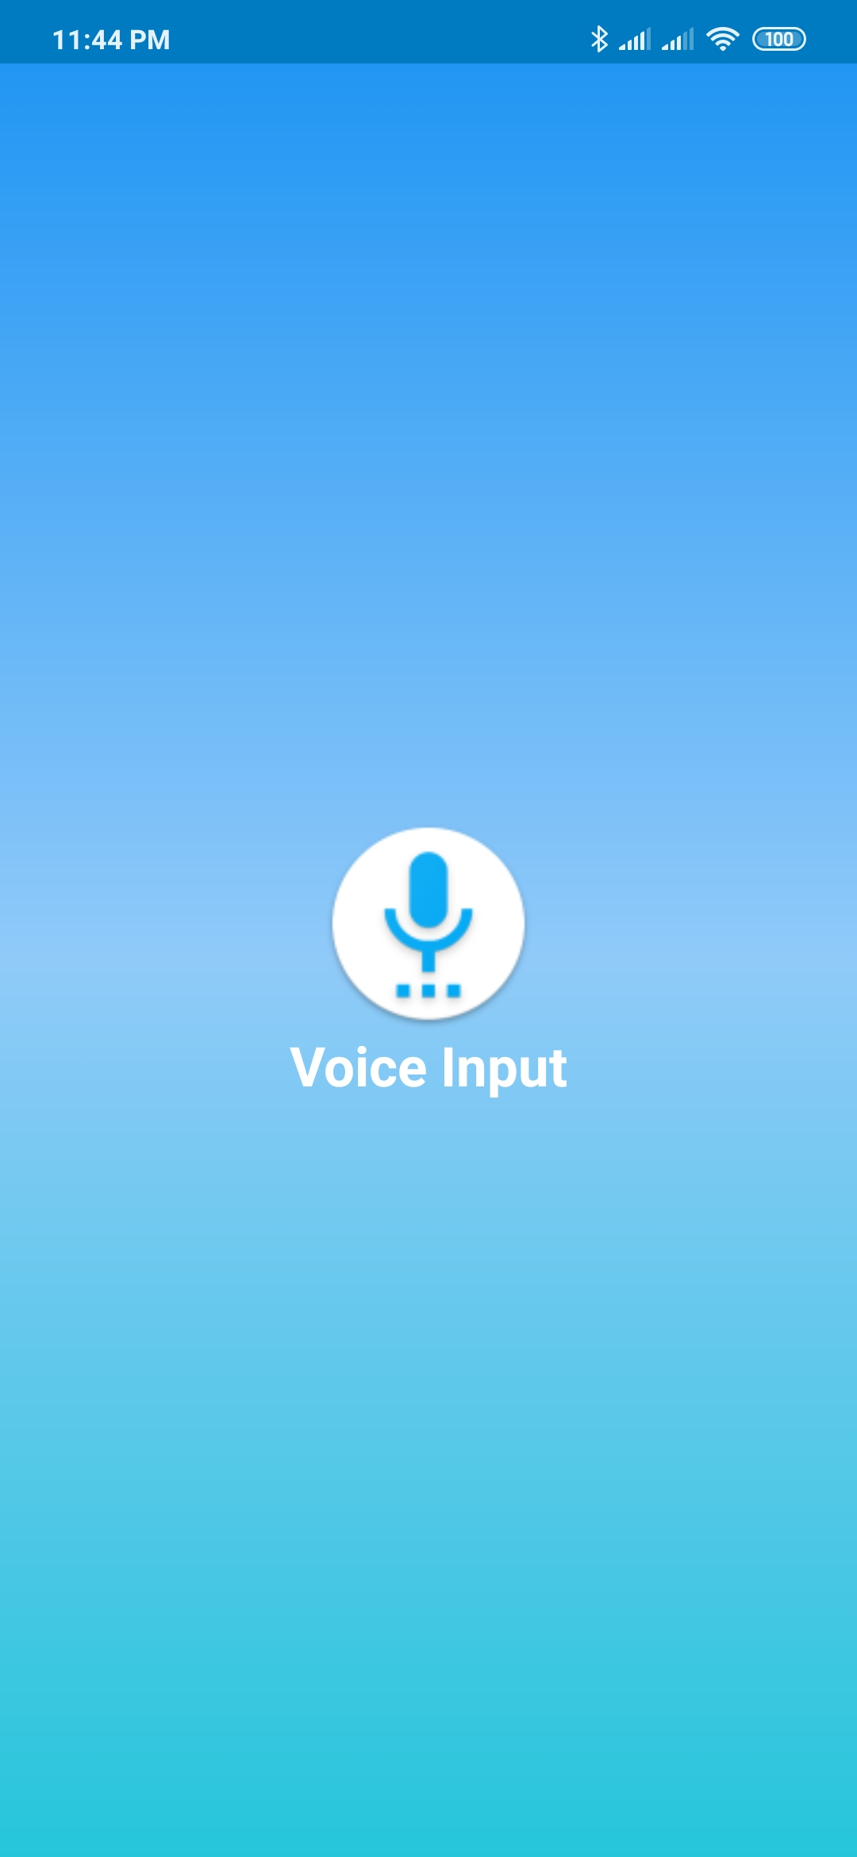
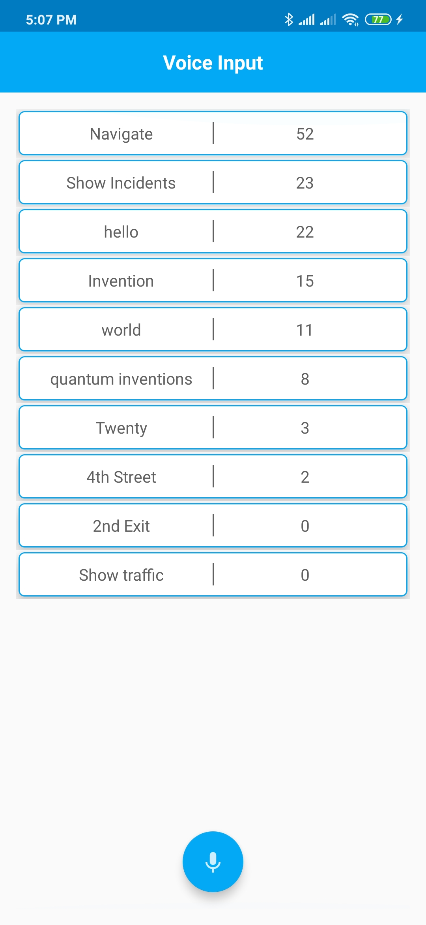
1. Splash Screen
2. Home Screen

3. Voice Popup Screen
4. Phrase Match Screen

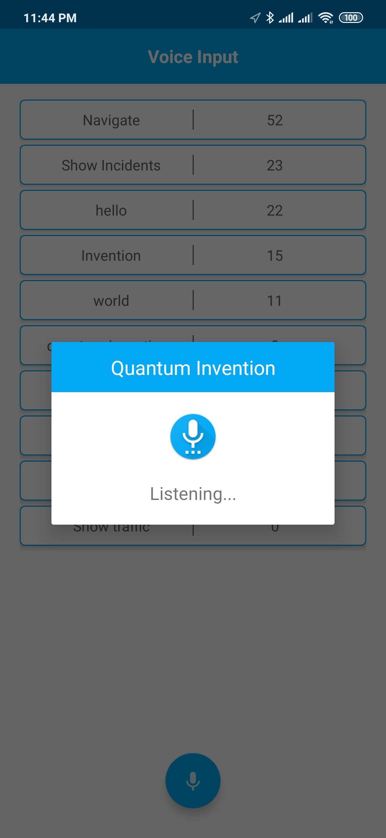
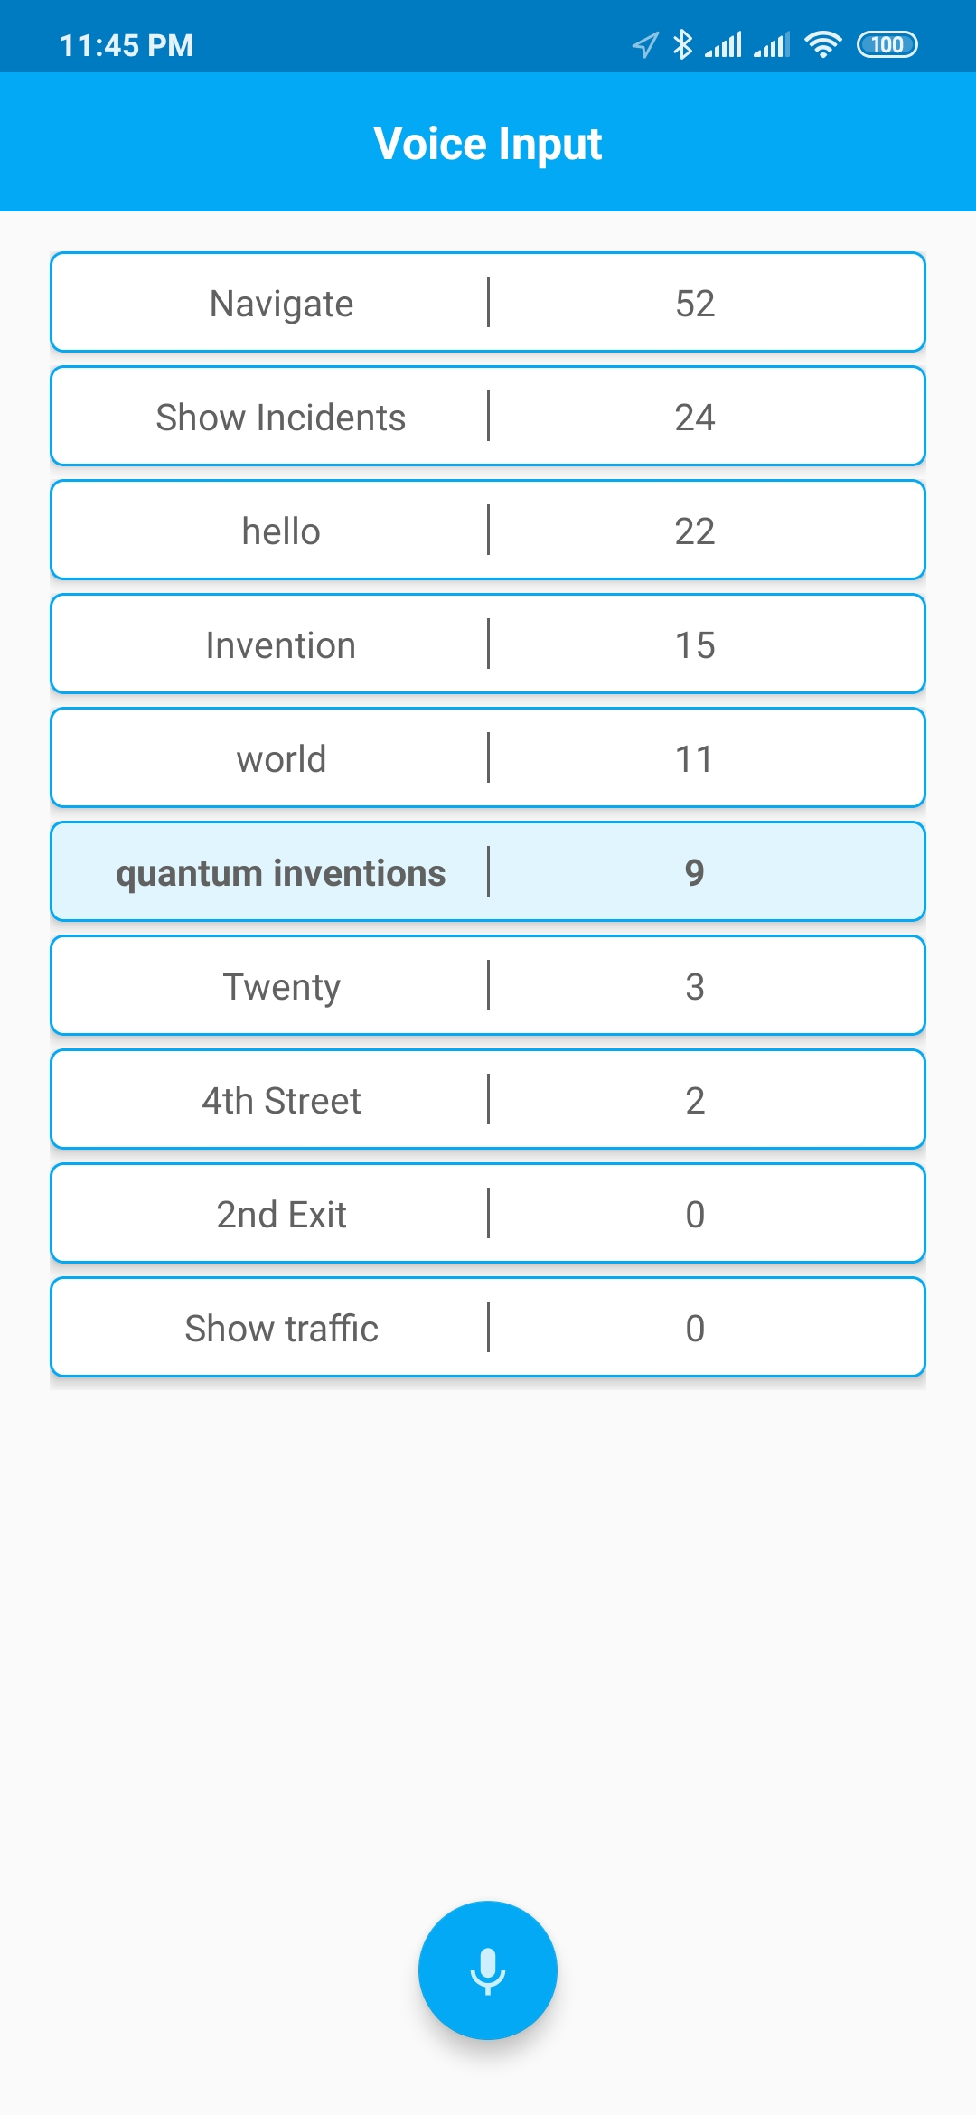

:Project Flow:
Display Dictionary List From Server
Click On Mic
Click App Icon
Permission
Listen User Voice Input
Search and Highlight the Matching Phrase in Dictionary
Allow
Deny
Start App

:Project Summary:

Library Used:

1. 'com.android.support:design:29.0.0' (For Support Design)

2. 'com.android.support:recyclerview-v7:29.0.0' (For Showing Dictionary list)

3. androidx.cardview:cardview:1.0.0' (For Looking dictionary items in card)

4. 'com.squareup.retrofit2:retrofit:2.3.0' (For Api Calling)

5. 'com.squareup.retrofit2:converter-gson:2.3.0' (Convert Request body to Java Object)

