EC413 Lab 7 – Pipelined CPUs: Forwarding
Report: what was done for each task, test results, and the modified datapath.

Task 1 – Pre-lab: baseline simulation
The unmodified project was simulated with the provided discussion_tb.v (the 10-instruction sequence). Because the pipeline has no forwarding, every instruction that reads a register written 1 or 2 instructions earlier reads a stale value. Final register values:
Register | Expected | Baseline (no fwd) | Fixed design
R5 (add R1,R4) | 569 | 423 | 569
R6 (slt R3,R5) | 1 | 0 | 1
R7 (sub R4,R6) | 145 | 146 | 145
R8 (add R7,R2) | 237 | 92 | 237
Mem[0] (sw R7) | 145 | 0 | 145

The baseline values are exactly the “wrong / no forwarding” values listed in the testbench comments. (Note: the project as supplied needed two declaration fixes to compile in a strict simulator: pipecontrol.v BranchMux is declared [1:0] on the port and [2:0] as a reg, and stallmux.v declared output ex as [6:0] while the reg is [13:0]. Both were made consistent; behaviour is unchanged.)

Tasks 2–4 – Forwarding unit (1 ahead, 2 ahead, arbitration)
A new module forwardingunit.v was added to the EX stage, plus two 3-to-1 muxes (ForwardAMux, ForwardBMux) in CPU.v placed between the ID/EX register and the ALU. The existing wires MuxASelect/MuxBSelect carry the select signals.
- Select encoding: 00 = register-file value (ID/EX), 01 = write-back data (2 ahead), 10 = EX/MEM ALU result (1 ahead).
- Task 2 (1 ahead): if EX/MEM.RegWrite and EX/MEM.Rd == ID/EX.Rs (or Rt), select 10 and forward MemAluOut.
- Task 3 (2 ahead): if MEM/WB.RegWrite and MEM/WB.Rd == ID/EX.Rs (or Rt), select 01 and forward WriteBackData (the output of the MemToReg mux, so it is also correct for a value coming from a load).
- Task 4 (arbitration): when both match, the instruction in EX/MEM is the more recent writer, so 1-ahead takes priority; 2-ahead is selected only if 1-ahead does not match.
The ALU’s A input now comes from ForwardAMux, and the AluSrc mux input 0 comes from ForwardBMux (so immediates still override B). The store-data register EX/MEM_MemData is loaded from the forwarded B value, so sw also receives forwarded data.
assign ForwardA = OneAheadA ? 2'b10 : (TwoAheadA ? 2'b01 : 2'b00);
assign ForwardB = OneAheadB ? 2'b10 : (TwoAheadB ? 2'b01 : 2'b00);

Task 5 – $0 write
Register $0 is hard-wired to zero, but an instruction such as add $0,$1,$2 still has Rd = 0 and RegWrite = 1, so it would otherwise be forwarded. Every forwarding condition therefore also requires Rd != 0. Test: add $0,R10,R10 followed by add R11,$0,R10 gives R11 = 5 (it would be 15 if the $0 result were forwarded).

Task 6 – No write
Instructions such as sw, beq, bne, j and pipeline bubbles have RegWrite = 0 but their instruction fields may still match a later source register (e.g. sw’s Rt, and its ALU output is just the address). Every forwarding condition requires the producer’s RegWrite bit (EXMEM_WBControl[0] and WB_WBControl[0]). Test: sw R2,8($0) followed by add R12,R2,R2 gives 184 (it would give 16 if the sw’s address were forwarded).

Task 7 – Register bypass
A value produced three instructions earlier is being written in WB in the same cycle the consumer reads the register file in ID, so forwarding cannot help; the register file must pass the write data straight through. RegFile.v already had write-through but it ignored RegWrite and RegWrite was not in the sensitivity list, so a non-writing instruction could wrongly bypass. It now bypasses only when RegWrite && WriteRegister == ReadReg && ReadReg != 0, and re-evaluates when RegWrite changes. Test: addi R13,$0,3; nop; nop; add R14,R13,R13 gives 6.

Extra credit – LW followed by SW
A sw that immediately follows the instruction producing its store data (lw or ALU op) reaches the MEM stage while that producer is in WB, so the data is available only as WriteBackData. No stall is needed:
- The Rt field is carried one more stage (new EXMEM_RtReg).
- New module storeforward.v asserts ForwardStore when MemWrite && RegWrite_WB && WB_Rd != 0 && WB_Rd == EX/MEM.Rt.
- New mux StoreDataMux in front of the data-memory write-data port selects WriteBackData instead of the EX/MEM store-data register.
Test: lw R17,8($0); sw R17,20($0) stores 92 (mem[8]) to mem[20]. A lw two instructions ahead of a sw (lw, nop, sw) is handled by the ordinary 2-ahead forward on B and also stores the right value. Limitation: a lw followed by a non-store instruction that uses the loaded value (load-use hazard) still needs a stall; hazardunit.v is a stub in the supplied project and that case was out of scope.

Modified datapath
New hardware is drawn in colour: red = 1-ahead path, green = 2-ahead / write-back paths, blue = forwarding-unit control.
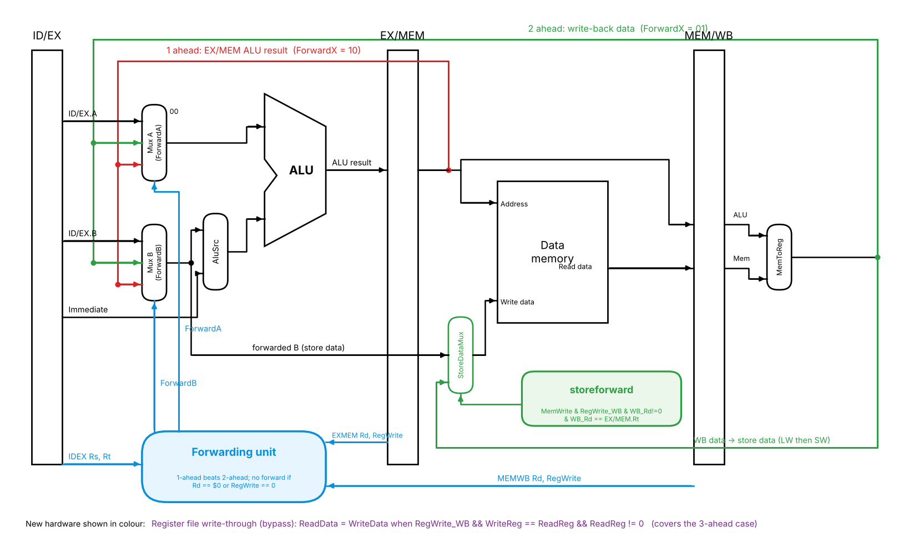

Verification
fwd_tb.v is a self-checking testbench: the lab’s 10 instructions plus the extra tests above. All 14 checks pass (ALL TESTS PASSED). Each feature was also verified to be necessary by deliberately disabling it (removing the $0 guard, the RegWrite guard, the arbitration, the 2-ahead path, the register bypass and the LW→SW forward) and confirming that the testbench then fails.

Files changed / added
- CPU.v: forwarding muxes, forwarding unit instance, store-data mux, EX/MEM Rt register
- forwardingunit.v, storeforward.v: new
- RegFile.v: bypass gated by RegWrite
- pipecontrol.v, stallmux.v: port width declarations made consistent
- fwd_tb.v: new self-checking testbench

