Practical-4
- Password strength (PasswordChecker.java + Driver.java)
(a) In PasswordChecker, check four rules — length ≥ 8, contains an uppercase letter,
contains a digit, contains a special character — using regex (e.g. “.*[A-Z].*”) or
String methods.
(b) Write strength(String pw) that counts how many rules pass and returns “Weak” (0–
1), “Medium” (2–3) or “Strong” (4).
(c) In Driver.main: test several passwords; for each, print which rules passed and the
final label.
Expected output: “abc” → Weak; “Abcd1234!” →

INPUT:
Password.java
public class Password {

public static final String length=".{8,}";
public static final String uppercaseletters=".*[A-Z].*";
public static final String digit=".*[0-9].*";
public static final String specialpattern=".*[^a-zA-Z0-9].*";

public static boolean checkLength(String pass) {
return pass.matches(length);
}

public static boolean checkupercase(String pass) {
return pass.matches(uppercaseletters);
}

public static boolean checkdigit(String pass) {
return pass.matches(digit);
}

public static boolean checkpattern(String pass) {
return pass.matches(specialpattern);
}

public static String strength(String pass) {

int count = 0;

if (checkLength(pass)) {
count++;
}

if (checkupercase(pass)) {
count++;
}

if (checkdigit(pass)) {
count++;
}

if (checkpattern(pass)) {
count++;
}

if (count <= 1) {
return "weak password!";
}
else if (count <= 3) {
return "medium password";
}
else {
return "strong password!";
}
}
}
Driver.java
public class Driver {

public static void main(String args[]) {

String[] password = {
"abc",
"abc1234",
"Abc!123",
"xyzzzzzz1",
"J123@",
"Jeel@12367"
};

for (String pass : password) {

System.out.println("Password: " + pass);

System.out.println("Length >= 8: "
+ Password.checkLength(pass));

System.out.println("Uppercase: "
+ Password.checkupercase(pass));

System.out.println("Digit: "
+ Password.checkdigit(pass));

System.out.println("Special character: "
+ Password.checkpattern(pass));

System.out.println("Strength: "
+ Password.strength(pass));

System.out.println("-------------------------");
}
}
}

OUTPUT:
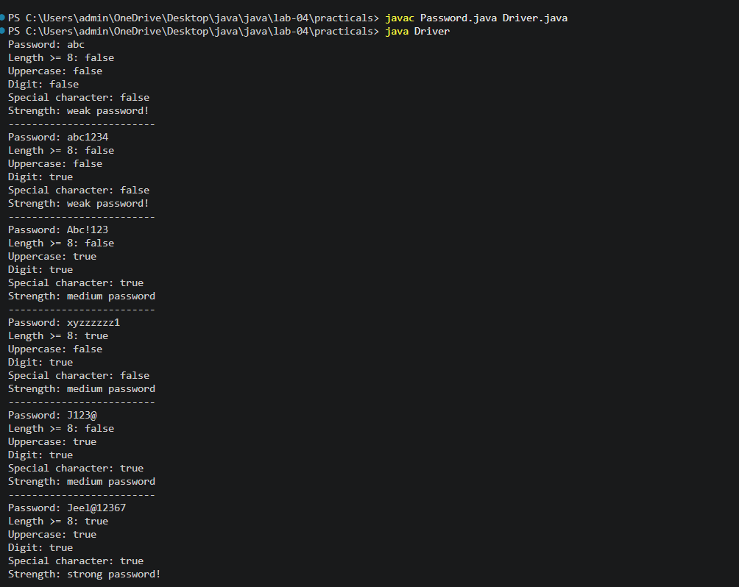

2. Chat-log filter (ChatFilter.java + Driver.java)
(a) In Driver.main, define a String[] of log lines like “10:05 alice Hello there” (include
one malformed line with fewer than 3 parts).
(b) Read a keyword from the user.
(c) For each line, split into time/user/message with split(“ ”, 3); skip lines that do not
have 3 parts.
(d) If the message contains the keyword (case-insensitive), increment a counter and
append “time user: message” to a StringBuilder.
(e) Print “Matches: N” and the built report.
Expected output: keyword “hello” over 3 lines (1 malformed) → “Matches: 1” and
the matching line.
INPUT:
Chat.java

public class Chat {
public static String fill(String[] log,String keyword)
{
int count=0;
StringBuilder word=new StringBuilder();

for (String line: log) {
String[] parts = line.split(" ", 3);

if (parts.length < 3) {
continue;
}
String time=parts[0];
String user=parts[1];
String message=parts[2];

if (message.toLowerCase().contains(keyword.toLowerCase())) {
count++;

word.append(time)
.append(" ")
.append(user)
.append(": ")
.append(message)
.append("\n");
}
}

return "Matches: " + count + "\nword " + word;
}

}

Driver1.java
import java.util.*;

public class Driver1 {
public static void main(String[] args) {
String[] log={
"10:05 alice Hello there",
"01:22 hiii whatsss uppp",
"11:10",
"01:11 ye ye ye"

};
Scanner sc=new Scanner(System.in);

System.out.println("Enter a keyword you wannt to search!:-");
String keyword=sc.nextLine();

String result = Chat.fill(log,keyword);

System.out.println(result);

sc.close();
}

}

OUTPUT:
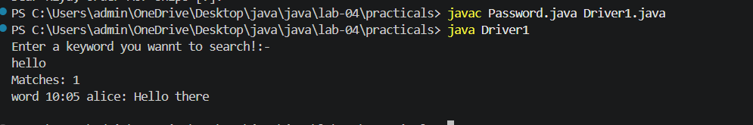
3. (For Advanced Learners – home) Template filler (TemplateFiller.java +
Driver.java)
(a) In Driver.main, define a template like “Dear {name}, order {id} ships {date}.” and
two parallel arrays: names {“name”, “id”} and values {“Riya”, “A07”} (note {date}
is not supplied).
(b) Compile a Pattern for \{(\w+)\} and get a Matcher on the template.
(c) Walk the matches with a StringBuilder: for each {placeholder}, look up its value in
the names array and replace with the value, or with “[?]” if not found.
(d) Print the filled template.
Expected output: the unsupplied {date} becomes [?].

INPUT:
Template.java
import java.util.regex.*;

public class Template {

public static String fillTemplate(String template, String[] names, String[] values) {

Pattern pa = Pattern.compile("\\{(\\w+)\\}");
Matcher match= pa.matcher(template);

StringBuilder result = new StringBuilder();
int lastEnd = 0;

while (match.find()) {

result.append(template, lastEnd, match.start());

String placeholder = match.group(1);
String replacement = "[?]";

for (int i = 0; i < names.length; i++) {
if (names[i].equals(placeholder)) {
replacement = values[i];
break;
}
}

result.append(replacement);
lastEnd = match.end();
}
result.append(template.substring(lastEnd));

return result.toString();
}
}

Driver3.java
public class Driver3 {

public static void main(String[] args) {

String template = "Dear {name}, order {id} ships {date}.";

String[] names = {"name", "id"};
String[] values = {"Riya", "A07"};

String result = Template.fillTemplate(template, names, values);

System.out.println(result);
}
}

OUTPUT:

