Practical-5

1. Shape areas: an abstract Shape with abstract area(); subclasses Circle, Rectangle,
Triangle. Put a mix in a Shape[] and loop once to print each area and the running total,
tracking the largest — one loop handling every shape through polymorphism.
INPUT:-
import java.lang.Math;

abstract class Shape {
abstract double area();
}

class Circle extends Shape {
double r;

Circle(double r) {
this.r = r;
}

double area() {
return Math.PI * r * r;
}
}

class Rectangle extends Shape {
double l;
double w;

Rectangle(double l, double w) {
this.l = l;
this.w = w;
}

double area() {
return l * w;
}
}

class Triangle extends Shape {
double base;
double height;

Triangle(double base, double height) {
this.base = base;
this.height = height;
}

double area() {
return 0.5 * base * height;
}
}

public class Shapemain {
public static void main(String[] args) {

Shape[] s = {
new Circle(5),
new Rectangle(4, 3),
new Triangle(2, 7)
};

double total = 0;
double largest = 0;
String largestShape = "";

for (int i = 0; i < s.length; i++) {

double currentArea = s[i].area();

System.out.println(
"Area of " + s[i].getClass().getSimpleName()
+ " is: " + currentArea
);

total = total + currentArea;

if (currentArea > largest) {
largest = currentArea;
largestShape = s[i].getClass().getSimpleName();
}
}

System.out.println("----------------------");
System.out.println("Total area: " + total);
System.out.println("Largest area: " + largest);
System.out.println("Largest shape: " + largestShape);
}
}

OUTPUT:-
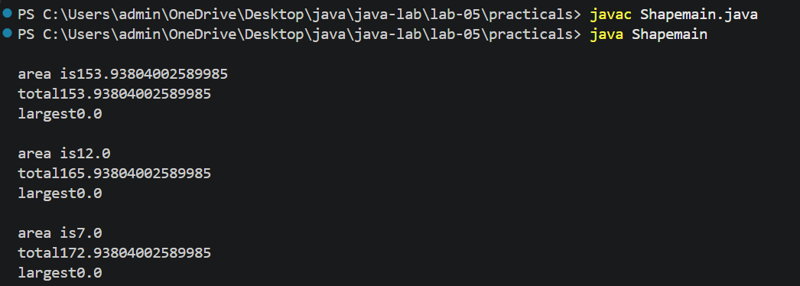

2. Payroll: an abstract Employee with abstract monthlySalary(); FullTime (fixed), PartTime
(hours × rate) and Intern (stipend), each calling super for the shared name/id. Loop a
mixed array to print each salary and the total; use instanceof to add a note only for
interns.
INPUT:-
abstract class Employee{
String name;
int id;
Employee(String name,int id)
{
this.name=name;
this.id=id;
}
abstract double monthlySalary();
}
class Fulltime extends Employee
{
double salary;
Fulltime(String name,int id,double salary)
{
super(name,id);
this.salary=salary;

}
double monthlySalary()
{
return salary;
}
}
class Parttime extends Employee {
int hours;
double rate;

Parttime(String name,int id,int hours,double rate) {
super(name, id);
this.hours = hours;
this.rate = rate;
}

double monthlySalary() {
return hours * rate;
}
}
class Intern extends Employee{
double stipend;
Intern(String name,int id,double stipend)
{
super(name,id);
this.stipend=stipend;
}
double monthlySalary(){
return stipend;
}
}
public class Payroll {
public static void main(String[] args) {

Employee[] employees = {
new Fulltime("Jeel", 1, 70000),
new Parttime("teju", 2, 90, 5000),
new Intern("ruhi", 3, 25000),
new Fulltime("hasti", 4, 60000)
};

double total = 0;

for (Employee e : employees) {

double salary = e.monthlySalary();

System.out.println(
"Name: " + e.name +", ID: " + e.id +", Salary: " + salary
);

if (e instanceof Intern) {
System.out.println("This employee is an Intern.");
}
total = total + salary;
}

System.out.println("-------------------------");
System.out.println("Total Payroll: " + total);
}
}

OUTPUT:-
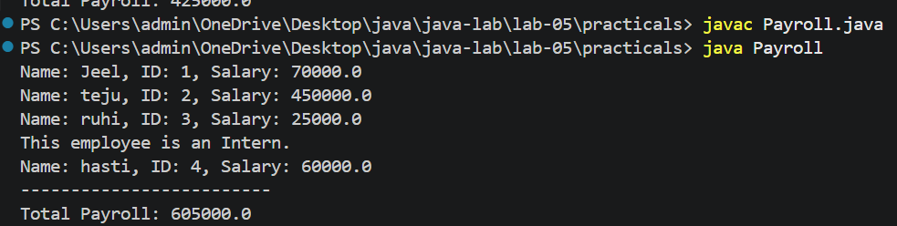

3. (For Advanced Learners – home) Model a few media types that each compute a late fee
differently and total the fees for a returned batch. Design the hierarchy and rules yourself.
INPUT:-
abstract class Media {
String name;

Media(String name) {
this.name = name;
}

abstract double calculateFine(int daysLate);
}

class Novel extends Media {

Novel(String name) {
super(name);
}

@Override
double calculateFine(int daysLate) {
return daysLate*4;
}
}

class Movie extends Media {

Movie(String name) {
super(name);
}

@Override
double calculateFine(int daysLate) {
return daysLate*8;
}
}

class Journal extends Media {

Journal(String name) {
super(name);
}

@Override
double calculateFine(int daysLate) {
return daysLate * 2;
}
}

public class Mediamain {
public static void main(String[] args) {

Media[] it={
new Novel("Housemaid"),
new Movie("Spiderman:Brand New day"),
new Journal("Vogue"),
new Novel("Harry Potter")
};

int[] lateDays = {3, 2, 5, 4};

double totalFine = 0;

for (int i=0;i<it.length;i++) {

double fine = it[i].calculateFine(lateDays[i]);

System.out.println(it[i].name +" \nDays late: " + lateDays[i] +" \nFine: " + fine);
System.out.println("----------------------");
totalFine += fine;
}

System.out.println("----------------------");
System.out.println("Total Fine:" + totalFine);
}
}

OUTPUT:-
