Practical-6
1. Remote control: an interface Switchable with on()/off() and a default toggle(); Fan and
Light implement it. Loop over a Switchable[] toggling each. Then add a functional
interface that decides, given a device and an hour, whether it may switch on, and supply it
once as an anonymous class and once as a lambda.

Input:-
interface Switchable {
void on();
void off();

default void toggle() {
on();
}
}

class Fan implements Switchable {
public void on() {
System.out.println("fan is on");
}

public void off() {
System.out.println("fan is off");
}
}

class Light implements Switchable {
public void on() {
System.out.println("light is on");
}

public void off() {
System.out.println("light is off");
}
}

@FunctionalInterface
interface Permission {
boolean maySwitchOn(Switchable device, int hour);
}

public class Remote {
public static void main(String[] args) {
Switchable[] dev = {
new Fan(),
new Light()
};

for (Switchable d : dev) {
d.toggle();
}

Permission p1 = new Permission() {
public boolean maySwitchOn(Switchable device, int hour) {
return hour >= 6 && hour <= 22;
}
};

Permission p2 = (device, hour) -> hour >= 6 && hour <= 22;

System.out.println("Anonymous class at 10AM: " +
p1.maySwitchOn(dev[0], 10));

System.out.println("Lambda at 12PM: " +
p2.maySwitchOn(dev[1], 24));
}
}

Output:-
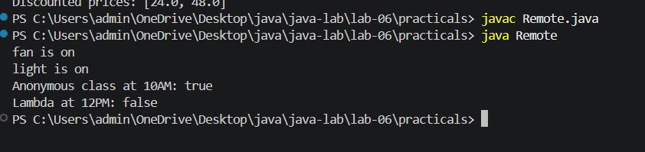

2. Notification senders: a functional interface Notifier with send(String); make email and
SMS senders as lambdas, hold them in an array, and broadcast one message through all.
Add a marker interface Urgent and send twice for senders marked urgent.
Input:-
@FunctionalInterface
interface Notifier{
void send(String msg);
}
interface urgent{

}
public class Notification {

public static void main(String[] args) {

Notifier email = message ->
System.out.println("Email: " + message);

Notifier sms = message ->
System.out.println("SMS: " + message);
Notifier[] sender={
sms,
email
};

String message = "Notification....";

for (Notifier s:sender) {
s.send(message);
}
}
}
Output:-
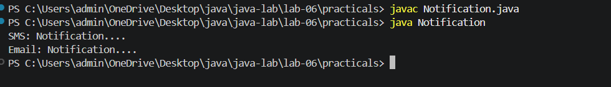

3. (For Advanced Learners – home) Build a small discount engine where each rule is a
lambda the user picks at runtime and applies to a list of prices; organise it into packages
and ship it as a runnable JAR.

Input:-
DiscountEngine.java

package discount;

import java.util.*;

public class DiscountEngine {

public static List<Double> apply(List<Double> prices, DiscountRule rule) {
List<Double> result = new ArrayList<>();

for (double price : prices) {
result.add(rule.apply(price));
}

return result;
}
}

DiscountRule.java
package discount;

@FunctionalInterface
public interface DiscountRule {
double apply(double price);
}

Main.java
package discount;

import java.util.*;

public class Main {
public static void main(String[] args) {
Scanner sc = new Scanner(System.in);

List<Double> prices = new ArrayList<>();

System.out.print("Enter number of prices: ");
int n = sc.nextInt();

for (int i = 0; i < n; i++) {
System.out.print("Enter price: ");
prices.add(sc.nextDouble());
}

System.out.println("1. 10% discount");
System.out.println("2. 20% discount");
System.out.println("3. Flat 50 discount");

System.out.print("Choose rule: ");
int choice = sc.nextInt();

DiscountRule rule;

switch (choice) {
case 1:
rule = price -> price * 0.90;
break;
case 2:
rule = price -> price * 0.80;
break;
case 3:
rule = price -> Math.max(0, price - 50);
break;
default:
System.out.println("Invalid choice");
return;
}

List<Double> result = DiscountEngine.apply(prices, rule);

System.out.println("Original prices: " + prices);
System.out.println("Discounted prices: " + result);
}
}

Output:-
