Practical-8
1. Guarded calculator: read two numbers and an operator; throw a custom
DivideByZeroException and catch invalid-number input separately, printing a clear
Message
INPUT:-
import java.util.Scanner;

class DivideByZeroException extends RuntimeException
{
DivideByZeroException(String msg)
{
super(msg);
}
}
public class Calculator
{
public static double calculate(double a,double b,char op)throws DivideByZeroException
{
switch(op)
{
case '+':
return a+b;
case '-':
return a-b;
case '*':
return a*b;
case '/':
if(b==0){
throw new DivideByZeroException("can not divde by zero");
}
return a/b;
default: throw new IllegalArgumentException("Invalid operator!");
}
}

public static void main(String[] args) {

Scanner sc=new Scanner(System.in);
boolean success=false;

while(!success){

try{

System.out.println("enter a number1:");
double n1=Double.parseDouble(sc.nextLine());

System.out.println("enter a number2:");
double n2=Double.parseDouble(sc.nextLine());

System.out.println("enter a operator(+,-,*,/)");
char o=sc.nextLine().charAt(0);

double res=calculate(n1,n2,o);

System.out.println("result is: "+res);
success=true;
}
catch(NumberFormatException n){
System.out.println("invaild number!!");
}
catch(DivideByZeroException d)
{
System.out.println("divide by zero exception");
}
catch(IllegalArgumentException i)
{
System.out.println("error"+i.getMessage());
}
finally{
System.out.println("calculations complete");
}
}
sc.close();
System.out.println("thank you for using calculator");
}
}
OUTPUT:-
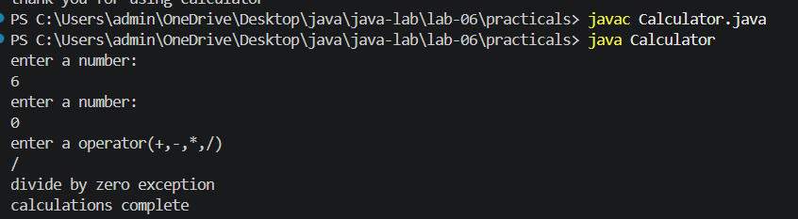
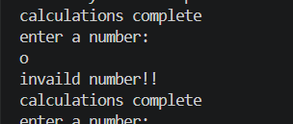

2. Stock issue: a Warehouse where issue(item, qty) throws a custom checked
OutOfStockException carrying the shortfall, and InvalidQuantityException for qty ≤ 0.
Process a list of requests, catching and reporting each failure without stopping the run.
INPUT:-

class OutOfStockException extends Exception{
private int fall;

OutOfStockException(String msg,int fall){
super(msg);
this.fall=fall;
}

public int shortfall(){
return fall;
}
}

class InvalidQuantityException extends Exception{
InvalidQuantityException(String msg){
super(msg);
}
}

class Warehouse{
private int stock;

Warehouse(int stock){
this.stock=stock;
}

public void issue(String item,int qun)throws OutOfStockException,InvalidQuantityException{

if(qun<=0){
throw new InvalidQuantityException("quantity must be greater than 0");
}

if(qun>stock){
int fall=qun-stock;
throw new OutOfStockException("Not enough stock for "+item,fall);
}

stock=stock-qun;

System.out.println("Issued "+qun+" "+item+"Remaining stock: "+stock);
}
}

class Stock{
public static void main(String[] args)
{

Warehouse w=new Warehouse(10);

String[][] req={
{"Laptop","3"},
{"Keyboard","4"},
{"Mouse","6"},
{"Monitor","0"},
{"Printer","2"}
};

for(String[] r:req)
{

String item=r[0];
int q=Integer.parseInt(r[1]);

try{
w.issue(item,q);
}

catch(OutOfStockException e){
System.out.println("Out of stock: "+item+" | Shortfall: "+e.shortfall());
}

catch(InvalidQuantityException e){
System.out.println("Invalid quantity for "+item+": "+e.getMessage());
}
}

System.out.println("All requests processed.");
}
}

OUTPUT:-
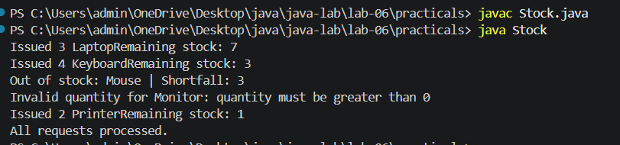

3. (For Advanced Learners – home) Create an AutoCloseable resource and use try-with-
resources to prove it always closes — even when an exception is thrown inside the block
— and that the original error is the one reported. Decide what to model as the resource.
INPUT:-
class FileResource implements AutoCloseable {

public FileResource() {
System.out.println("Resource opened");
}

public void use() {
System.out.println("Using resource");
throw new RuntimeException("Original error inside try block");
}

@Override
public void close() {
System.out.println("Resource closed");
}
}

public class ResourceDemo {

public static void main(String[] args) {

try (FileResource resource = new FileResource()) {
resource.use();
} catch (Exception e) {
System.out.println("Error: " + e.getMessage());
}
}
}

OUTPUT:-
