PRACTICAL – 2
  - Smart thermostat (Thermostat.java, main in this file) (a) Create class Thermostat with private String location, private int temperature, private static final int MIN=16 and MAX=30, and private static int activeCount=0.
(b) Constructor(location, startTemp): store location; set temperature to startTemp if it is within MIN..MAX else 22; increment activeCount. (c) Constructor(location): chain with this(location, 22). (d) raise(): if temperature < MAX add 1, else print “Already at maximum (30)”. (e) lower(): if temperature > MIN subtract 1, else print “Already at minimum (16)”. (f) Add getTemperature() (no setter) and static getActiveCount(). (g) In main: create two thermostats, call raise() 10 times then lower() 20 times in loops (printing the temperature each time), then print getActiveCount(). Expected output: temperature rises to 30 then “Already at maximum”, falls to 16 then “Already at minimum”, count 2.

public class Thermostat {

private String location; private int temperature;
private static final int MIN = 16; private static final int MAX = 30; private static int activeCount = 0;

public Thermostat(String location, int startTemp) { this.location = location;

if (startTemp >= MIN && startTemp <= MAX) {

temperature = startTemp;
} else { temperature = 22;
}

activeCount++;
}

public Thermostat(String location) { this(location, 22);
}

public void raise() {
if (temperature < MAX) { temperature++;
} else {
System.out.println("Already at maximum (30)");
}
}

public void lower() {
if (temperature > MIN) { temperature--;
} else {
System.out.println("Already at minimum (16)");

}
}

public int getTemperature() { return temperature;
}

public static int getActiveCount() { return activeCount;
}

public static void main(String[] args) {

Thermostat t1 = new Thermostat("Living Room"); Thermostat t2 = new Thermostat("Bedroom", 25);

System.out.println("Initial Temperature: " + t1.getTemperature());

for (int i = 0; i < 10; i++) { t1.raise();
System.out.println("Temperature: " + t1.getTemperature());
}

for (int i = 0; i < 20; i++) { t1.lower();

System.out.println("Temperature: " + t1.getTemperature());
}

System.out.println("Active Thermostats: " + Thermostat.getActiveCount());
}
}
OUTPUT:-
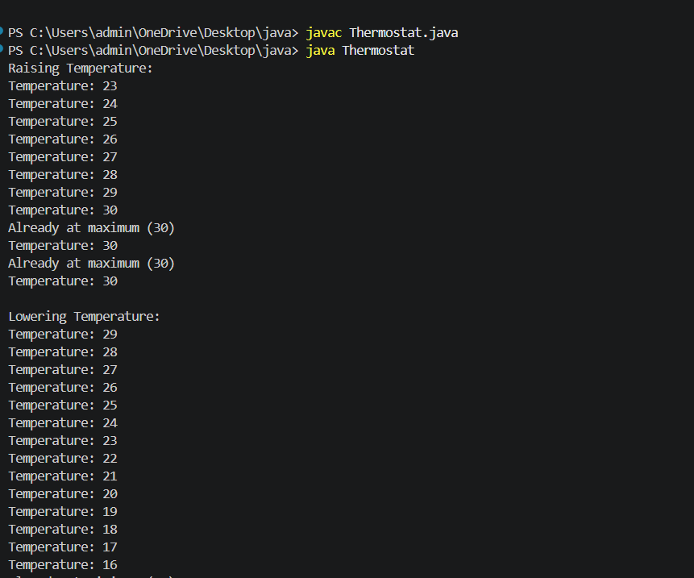

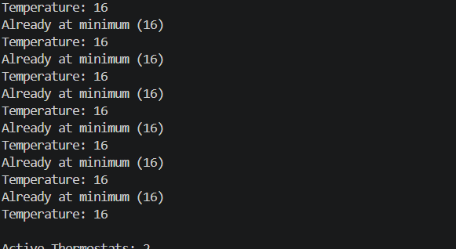

  - Cinema show (CinemaShow.java, main in this file) (a) Create class CinemaShow with private String title, private int seatsAvailable, private final int capacity, and private static int totalBooked=0. (b) Constructor(title, capacity): set both and seatsAvailable = capacity. Constructor(title): chain with this(title, 100). (c) book(int n): if n ≤ seatsAvailable, reduce seatsAvailable by n, add n to totalBooked, return true; else return false unchanged. (d) cancel(int n): increase seatsAvailable by n but never above capacity. (e) Add getSeatsAvailable() and static getTotalBooked(). (f) In main: run a sequence of book and cancel calls, printing the result and seats after each, then print getTotalBooked(). Expected output: booking more than available prints false and leaves seats unchanged; totalBooked equals the successful bookings.

public class CinemaShow {

private String title; private int seatsAvailable;

private final int capacity;
private static int totalBooked = 0;

public CinemaShow(String title, int capacity) { this.title = title;
this.capacity = capacity; this.seatsAvailable = capacity;
}

public CinemaShow(String title) { this(title, 100);
}

public boolean book(int n) { if (n <= seatsAvailable) { seatsAvailable -= n;
totalBooked += n; return true;
}
return false;
}

public void cancel(int n) { seatsAvailable += n;
if (seatsAvailable > capacity) {

seatsAvailable = capacity;
}
}

public int getSeatsAvailable() { return seatsAvailable;
}

public static int getTotalBooked() { return totalBooked;
}

public static void main(String[] args) {

CinemaShow show = new CinemaShow("Avengers", 50);

System.out.println(show.book(20));
System.out.println("Seats Available: " + show.getSeatsAvailable());

System.out.println(show.book(25));
System.out.println("Seats Available: " + show.getSeatsAvailable());

System.out.println(show.book(10));
System.out.println("Seats Available: " + show.getSeatsAvailable());

show.cancel(15);
System.out.println("Seats Available: " + show.getSeatsAvailable());

System.out.println(show.book(10));
System.out.println("Seats Available: " + show.getSeatsAvailable());

System.out.println("Total Booked: " + CinemaShow.getTotalBooked());
}
}
OUTPUT:-
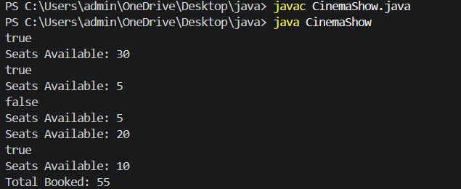

  - (For Advanced Learners – home) Parking lot (ParkingLot.java) (a) Create class ParkingLot with private int twoWheelers and fourWheelers, private final int twoCap and fourCap, and private static long revenue=0. (b) park(String type): for “two”, if twoWheelers < twoCap increment and add 20 to revenue; for “four”, if fourWheelers < fourCap increment and add 40; otherwise print “Full” and reject. (c) leave(String type): decrement the matching count but never below 0. (d) In main: simulate a sequence of park/leave events, printing each outcome, then print final occupancy and revenue. Expected output: parking into a full section is refused; revenue = 20×(two parked) + 40×(four parked).

public class ParkingLot {

private int twoWheelers; private int fourWheelers; private final int twoCap;
private final int fourCap; private static long revenue = 0;

public ParkingLot(int twoCap, int fourCap) { this.twoCap = twoCap;
this.fourCap = fourCap; this.twoWheelers = 0;
this.fourWheelers = 0;
}

public void park(String type) { if (type.equals("two")) {
if (twoWheelers < twoCap) { twoWheelers++;
revenue += 20;
System.out.println("Two-wheeler parked");
} else { System.out.println("Full");
}
} else if (type.equals("four")) { if (fourWheelers < fourCap) {
fourWheelers++; revenue += 40;
System.out.println("Four-wheeler parked");
} else {
System.out.println("Full");
}
}
}

public void leave(String type) { if (type.equals("two")) {
if (twoWheelers > 0) { twoWheelers--;
System.out.println("Two-wheeler left");
}
} else if (type.equals("four")) { if (fourWheelers > 0) {
fourWheelers--; System.out.println("Four-wheeler left");
}
}
}

public int getTwoWheelers() { return twoWheelers;
}

public int getFourWheelers() { return fourWheelers;
}

public static long getRevenue() { return revenue;
}
public static void main(String[] args) { ParkingLot p = new ParkingLot(2, 2);

p.park("two");
p.park("two");
p.park("two");

p.park("four");
p.park("four");
p.park("four");

p.leave("two");
p.leave("four");
p.park("two");
p.park("four");
System.out.println("Two-Wheelers: " + p.getTwoWheelers()); System.out.println("Four-Wheelers: " + p.getFourWheelers()); System.out.println("Revenue: " + ParkingLot.getRevenue());
}
}
OUTPUT:-
