Practical-11
1. Save/load: make a small class Serializable, save an array of its objects to a file with ObjectOutputStream, then read it back into fresh objects and confirm the values survived. Mark one field transient and show it is not saved.

INPUT:-
import java.io.*;

class Student implements Serializable {
private static final long serialVersionUID = 1L;

int id;
String name;
transient String password;

Student(int id, String name, String password) {
this.id = id;
this.name = name;
this.password = password;
}
}

public class SerializationDemo {
public static void main(String[] args) {
Student[] students = {
new Student(1, "Jeel", "abc123"),
new Student(2, "Riya", "xyz456")
};

try {
ObjectOutputStream out = new ObjectOutputStream(
new FileOutputStream("students.dat"));
out.writeObject(students);
out.close();

System.out.println("Objects saved successfully.");

ObjectInputStream in = new ObjectInputStream(
new FileInputStream("students.dat"));
Student[] loaded = (Student[]) in.readObject();
in.close();

for (Student s : loaded) {
System.out.println("ID: " + s.id);
System.out.println("Name: " + s.name);
System.out.println("Password: " + s.password);
System.out.println();
}
} catch (IOException | ClassNotFoundException e) {
System.out.println("Error: " + e.getMessage());
}
}
}
OUTPUT:-
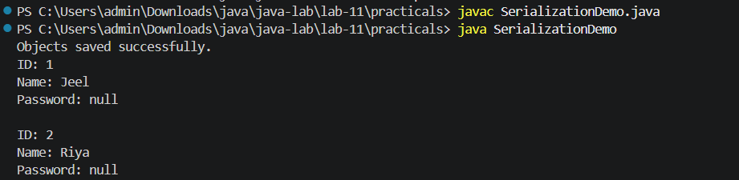
2. Log analyzer: create a few text files, then use Path/Files to read each line by line and count the total lines and how many contain a keyword across all files; also print each file’s size from its attributes.
INPUT:-
import java.io.IOException;
import java.nio.file.*;
import java.nio.file.attribute.BasicFileAttributes;
import java.util.List;

public class LogAnalyzer {
public static void main(String[] args) {
Path[] files = {
Paths.get("app1.txt"),
Paths.get("app2.txt"),
Paths.get("app3.txt")
};

String[][] data = {
{"Application started", "ERROR: Connection failed",
"Application stopped"},
{"User logged in", "ERROR: Invalid input"},
{"System running", "All services active",
"ERROR: File missing"}
};

try {
// Create sample text files
for (int i = 0; i < files.length; i++) {
Files.write(files[i], List.of(data[i]));
}

int totalLines = 0;
int errorLines = 0;

for (Path file : files) {
int fileLines = 0;

// Read and count each line
for (String line : Files.readAllLines(file)) {
fileLines++;
totalLines++;

if (line.contains("ERROR")) {
errorLines++;
}
}

BasicFileAttributes attr = Files.readAttributes(
file, BasicFileAttributes.class);

System.out.println("File: " + file.getFileName());
System.out.println("Lines: " + fileLines);
System.out.println("Size: " + attr.size() + " bytes");
System.out.println();
}

System.out.println("Total lines: " + totalLines);
System.out.println("Lines containing ERROR: " + errorLines);

} catch (IOException e) {
System.out.println("Error: " + e.getMessage());
}
}
}

OUTPUT:-
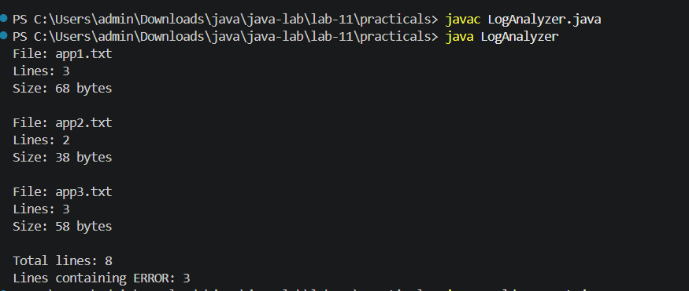
3. (For Advanced Learners – home) Walk a folder tree with NIO and produce a report of the files it contains (name, size, modified time), writing the summary to a file; decide what to include.
INPUT:-
import java.io.IOException;
import java.nio.file.*;
import java.nio.file.attribute.BasicFileAttributes;

public class FolderReport {
public static void main(String[] args) {
Path root = Paths.get(".");
Path report = Paths.get("folder_report.txt");

try {
StringBuilder result = new StringBuilder();
result.append("FOLDER TREE REPORT\n");
result.append("==================\n");

Files.walkFileTree(root, new SimpleFileVisitor<Path>() {
@Override
public FileVisitResult visitFile(
Path file, BasicFileAttributes attrs
) throws IOException {

// Do not include the report file itself
if (!file.toAbsolutePath().normalize().equals(
report.toAbsolutePath().normalize())) {

result.append("Name: ").append(file).append("\n");
result.append("Size: ").append(attrs.size())
.append(" bytes\n");
result.append("Modified: ")
.append(attrs.lastModifiedTime())
.append("\n\n");
}
return FileVisitResult.CONTINUE;
}
});

Files.writeString(report, result.toString());
System.out.println("Report created successfully.");
System.out.println("Saved to: " +
report.toAbsolutePath());

} catch (IOException e) {
System.out.println("Error: " + e.getMessage());
}
}
}
OUTPUT:-
