Practical-12
1. Word frequency: split a paragraph into words, count each in a HashMap, and print the words sorted by frequency (highest first) using a Comparator.
INPUT:-
import java.util.*;

public class WordFrequency {
public static void main(String[] args) {
String paragraph = "Java is easy and Java is powerful";
String[] words = paragraph.toLowerCase().split("\\W+");

Map<String, Integer> frequency = new HashMap<>();

for (String word : words) {
frequency.put(word, frequency.getOrDefault(word, 0) + 1);
}

List<Map.Entry<String, Integer>> list =
new ArrayList<>(frequency.entrySet());

list.sort((a, b) -> {
int byFrequency = b.getValue().compareTo(a.getValue());
if (byFrequency != 0) {
return byFrequency;
}
return a.getKey().compareTo(b.getKey());
});

System.out.println("Word frequencies:");
for (Map.Entry<String, Integer> entry : list) {
System.out.println(entry.getKey() + " : " + entry.getValue());
}
}
}
OUTPUT:-
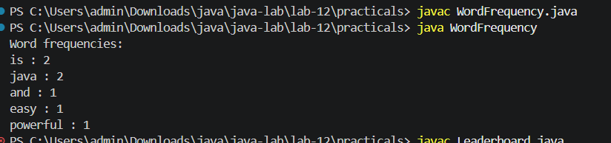
2. Unique visitors: from a list of login names with repeats, use a HashSet to count unique users and a LinkedHashSet to keep first-seen order; print the unique count and the first three distinct names.

INPUT:-
import java.util.*;

public class UniqueVisitors {
public static void main(String[] args) {
List<String> logins = Arrays.asList(
"jeel", "riya", "aman", "jeel",
"priya", "riya", "karan", "aman"
);

Set<String> uniqueUsers = new HashSet<>(logins);
Set<String> firstSeenOrder = new LinkedHashSet<>(logins);

System.out.println("Unique user count: " + uniqueUsers.size());
System.out.println("First three distinct names:");

int count = 0;
for (String name : firstSeenOrder) {
if (count == 3) {
break;
}
System.out.println(name);
count++;
}
}
}

OUTPUT:-
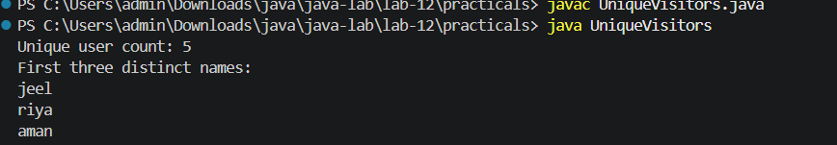

3. (For Advanced Learners – home) Build a leaderboard from player scores held in a Map and print the top-N sorted by score (ties broken by name); choose the data and sorting details.

INPUT:-
import java.util.*;

public class Leaderboard {
public static void main(String[] args) {
Map<String, Integer> scores = new HashMap<>();
scores.put("Riya", 95);
scores.put("Jeel", 88);
scores.put("Aman", 95);
scores.put("Priya", 78);
scores.put("Karan", 88);

int topN = 3;

List<Map.Entry<String, Integer>> players =
new ArrayList<>(scores.entrySet());

players.sort((a, b) -> {
int byScore = b.getValue().compareTo(a.getValue());
if (byScore != 0) {
return byScore;
}
return a.getKey().compareToIgnoreCase(b.getKey());
});

System.out.println("Top " + topN + " players:");
for (int i = 0; i < Math.min(topN, players.size()); i++) {
Map.Entry<String, Integer> player = players.get(i);
System.out.println(player.getKey() + " - " + player.getValue());
}
}
}
OUTPUT:-
