Practical-13
1. Generic containers: a generic Box<T> with get/set and a Pair<A,B>; use them with different types to show type safety without casts, and write a generic method that returns the first element of any array.
INPUT:-
class Box<T> {
private T value;

public void set(T value) {
this.value = value;
}

public T get() {
return value;
}
}

class Pair<A, B> {
private A first;
private B second;

Pair(A first, B second) {
this.first = first;
this.second = second;
}

public void display() {
System.out.println(first + " - " + second);
}
}

public class GenericContainers {
public static <T> T first(T[] array) {
if (array == null || array.length == 0) {
throw new IllegalArgumentException("Array is empty");
}
return array[0];
}

public static void main(String[] args) {
Box<Integer> intBox = new Box<>();
intBox.set(100);
System.out.println("Box value: " + intBox.get());

Box<String> strBox = new Box<>();
strBox.set("Java Generics");
System.out.println("Box value: " + strBox.get());

Pair<String, Integer> pair = new Pair<>("Jeel", 20);
pair.display();

String[] names = {"Jeel", "Riya", "Aman"};
System.out.println("First element: " + first(names));

Integer[] numbers = {10, 20, 30};
System.out.println("First number: " + first(numbers));
}
}
OUTPUT:-
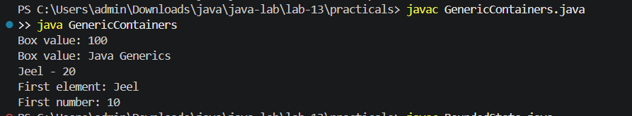
2. Bounded stats: a generic method <N extends Number> double average(N[] values) that works for Integer[], Double[] and Long[]; note why it refuses non-Number types.
INPUT:-
public class BoundedStats {
public static <N extends Number> double average(N[] values) {
if (values == null || values.length == 0) {
throw new IllegalArgumentException("Array must not be empty");
}

double sum = 0;
for (N value : values) {
sum += value.doubleValue();
}

return sum / values.length;
}

public static void main(String[] args) {
Integer[] integers = {10, 20, 30};
Double[] doubles = {2.5, 5.5, 7.0};
Long[] longs = {100L, 200L, 300L};

System.out.println("Integer average: " + average(integers));
System.out.println("Double average: " + average(doubles));
System.out.println("Long average: " + average(longs));
}
}
OUTPUT:-
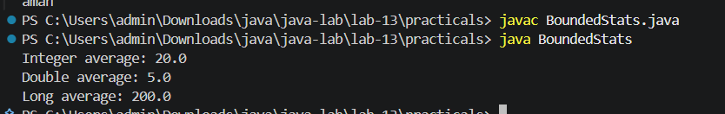

3. (For Advanced Learners – home) Implement a small generic container of your choice (e.g. a stack) backed by an array, reuse it for two different types, and handle the empty case sensibly.

INPUT:-
import java.util.NoSuchElementException;

class Stack<T> {
private Object[] elements;
private int top;

Stack(int capacity) {
elements = new Object[capacity];
top = -1;
}

public void push(T value) {
if (top == elements.length - 1) {
throw new IllegalStateException("Stack is full");
}
elements[++top] = value;
}

@SuppressWarnings("unchecked")
public T pop() {
if (top == -1) {
throw new NoSuchElementException("Stack is empty");
}
T value = (T) elements[top];
elements[top--] = null;
return value;
}

@SuppressWarnings("unchecked")
public T peek() {
if (top == -1) {
throw new NoSuchElementException("Stack is empty");
}
return (T) elements[top];
}

public boolean isEmpty() {
return top == -1;
}
}

public class GenericStack {
public static void main(String[] args) {
Stack<Integer> numbers = new Stack<>(5);
numbers.push(10);
numbers.push(20);

System.out.println("Integer top: " + numbers.peek());
System.out.println("Popped: " + numbers.pop());

Stack<String> names = new Stack<>(5);
names.push("Jeel");
names.push("Riya");

System.out.println("String top: " + names.peek());
System.out.println("Popped: " + names.pop());

System.out.println("Stack empty: " + names.isEmpty());
}
}
OUTPUT:-
