Practical-7

1. Form validator: define @NotBlank and @MaxLength(int) for fields and annotate a SignupForm. Write a checker that uses reflection to read each field’s annotations and returns the list of validation errors for a given object.
INPUT:-
import java.lang.annotation.*;
import java.lang.reflect.Field;

@Retention(RetentionPolicy.RUNTIME)
@Target(ElementType.FIELD)
@interface NotBlank { }

@Retention(RetentionPolicy.RUNTIME)
@Target(ElementType.FIELD)
@interface MaxLength {
int value();
}

class SignupForm {
@NotBlank @MaxLength(20) String username;
@NotBlank @MaxLength(30) String email;
@NotBlank @MaxLength(15) String password;

SignupForm(String username, String email, String password) {
this.username = username;
this.email = email;
this.password = password;
}
}

class Validator {
public static boolean validate(Object obj) {
boolean isValid = true;
Field[] fields = obj.getClass().getDeclaredFields();

for (Field field : fields) {
field.setAccessible(true);
try {
String value = (String) field.get(obj);

if (field.isAnnotationPresent(NotBlank.class)) {
if (value == null || value.trim().isEmpty()) {
System.out.println(field.getName() + " cannot be blank");
isValid = false;
}
}

if (field.isAnnotationPresent(MaxLength.class)) {
MaxLength max = field.getAnnotation(MaxLength.class);
if (value != null && value.length() > max.value()) {
System.out.println(field.getName() + " must be at most " + max.value() + " characters");
isValid = false;
}
}
} catch (Exception e) {
System.out.println("Error checking " + field.getName());
isValid = false;
}
}
return isValid;
}
}

public class ValidatorMain {
public static void main(String[] args) {
SignupForm form = new SignupForm(
"jeel",
"jkjk@gmail.com",
"123063qaad"
);

boolean isValid = Validator.validate(form);

if (isValid) {
System.out.println("Form is valid");
}
}
}

OUTPUT:-
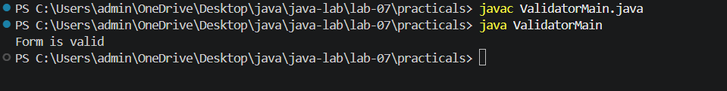
2. Mini test runner: define a @Run annotation and mark some no-arg methods of a class with it. Use reflection to find and invoke only the @Run methods and report how many ran — the idea behind how JUnit finds @Test methods.
INPUT:-
import java.lang.annotation.*;
import java.lang.reflect.Method;

@Retention(RetentionPolicy.RUNTIME)
@Target(ElementType.METHOD)
@interface Run { }

class MyTestSuite {
@Run
public void testLogin() {
System.out.println("Running: testLogin -> SUCCESS");
}

public void regularUtilityMethod() {
System.out.println("This is a regular method, it should NOT run.");
}

@Run
public void testDashboard() {
System.out.println("Running: testDashboard -> SUCCESS");
}

@Run
void testProfile() {
System.out.println("Running: testProfile (package-private) -> SUCCESS");
}
}

class TestRunner {
public static void runTests(Class<?> clazz) {
int runCount = 0;
Method[] methods = clazz.getDeclaredMethods();

try {
Object testInstance = clazz.getDeclaredConstructor().newInstance();

for (Method method : methods) {
if (method.isAnnotationPresent(Run.class)) {
method.setAccessible(true);
method.invoke(testInstance);
runCount++;
}
}
} catch (Exception e) {
System.out.println("Error initializing or running tests: " + e.getMessage());
}

System.out.println("\nTotal methods executed: " + runCount);
}
}

public class TestMain {
public static void main(String[] args) {
TestRunner.runTests(MyTestSuite.class);
}
}

OUTPUT:-
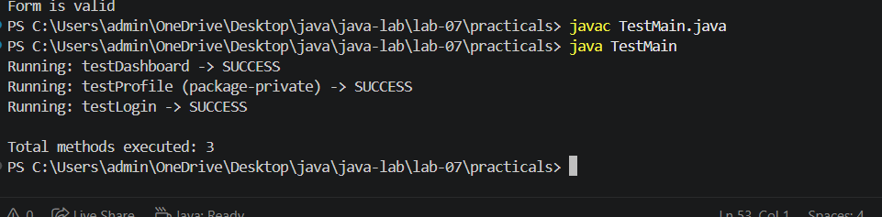

3. (For Advanced Learners – home) Define a @Column(name) annotation and, by reflection, populate an object’s fields from a header row and a data row by matching column names; decide how to handle a missing column.
INPUT:-
import java.lang.annotation.*;
import java.lang.reflect.*;

@Retention(RetentionPolicy.RUNTIME)
@Target(ElementType.FIELD)
@interface Column {
String name();
}

class Student {
@Column(name = "name")
String name;

@Column(name = "age")
int age;

@Column(name = "city")
String city;

public String toString() {
return name + " " + age + " " + city;
}
}

public class StudentMain {
public static void main(String[] args) throws Exception {
String[] header = {"name", "age", "city"};
String[] data = {"Jeel", "18", "Ahmedabad"};

Student student = new Student();

for (Field field : Student.class.getDeclaredFields()) {
Column column = field.getAnnotation(Column.class);

if (column != null) {
String columnName = column.name();
int index = -1;

for (int i = 0; i < header.length; i++) {
if (header[i].equals(columnName)) {
index = i;
break;
}
}

if (index == -1) {
System.out.println("Missing column: " + columnName);
continue;
}

field.setAccessible(true);

if (field.getType() == int.class) {
field.set(student, Integer.parseInt(data[index]));
} else {
field.set(student, data[index]);
}
}
}

System.out.println(student);
}
}
OUTPUT:-
