Practical-10
1. Thread-pool runner: with a fixed pool of 3 (ExecutorService), submit about 10 Runnable
tasks that print their id and sleep briefly; shut down and await completion, observing the
few threads being reused.
INPUT:-
import java.util.concurrent.*;

public class ExecutorServiceExample {
public static void main(String[] args) throws InterruptedException {

ExecutorService service = Executors.newFixedThreadPool(3);

for (int i = 1; i <= 10; i++) {
final int id = i;

service.execute(() -> {
System.out.println("Task " + id + " executed by "
+ Thread.currentThread().getName());
System.out.println("Task " + id + " finished");
});
}

service.shutdown();
service.awaitTermination(1, TimeUnit.MINUTES);

System.out.println("All tasks completed.");
}
}

OUTPUT:-
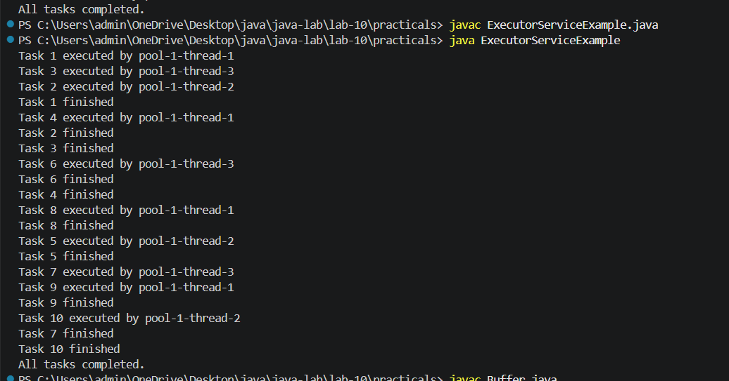

2. Producer–consumer: one thread adds numbers to a small shared buffer and another
removes them, coordinated with wait()/notify(); produce and consume a fixed number of
items in order with none lost.
INPUT:-
class Buffer {
int item;
boolean available = false;

synchronized void produce(int value) throws InterruptedException {
while (available) {
wait();
}

item = value;
available = true;
System.out.println("Produced: " + item);

notify();
}

synchronized int consume() throws InterruptedException {
while (!available) {
wait();
}

int value = item;
available = false;
System.out.println("Consumed: " + value);

notify();
return value;
}
}

public class ProducerConsumer {
public static void main(String[] args) throws InterruptedException {
Buffer buffer = new Buffer();

Thread producer = new Thread(() -> {
for (int i = 1; i <= 5; i++) {
try {
buffer.produce(i);
} catch (InterruptedException e) {
Thread.currentThread().interrupt();
return;
}
}
});

Thread consumer = new Thread(() -> {
for (int i = 1; i <= 5; i++) {
try {
buffer.consume();
} catch (InterruptedException e) {
Thread.currentThread().interrupt();
return;
}
}
});

producer.start();
consumer.start();

producer.join();
consumer.join();

System.out.println("All items produced and consumed.");
}
}
OUTPUT:-
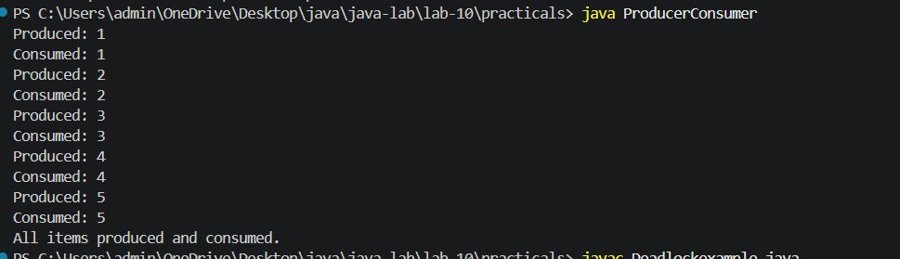

3. (For Advanced Learners – home) Reproduce a deadlock between two threads that lock
two objects in opposite order, then remove it with a consistent lock order. Choose the
scenario yourself.
INPUT:-
public class Deadlockexample {
static Object pen = new Object();
static Object notebook = new Object();

public static void main(String[] args) throws InterruptedException {

// Non-fixed version: Deadlock
Thread t1 = new Thread(() -> {
synchronized (pen) {
System.out.println("T1 locked Pen");

try {
Thread.sleep(100);
} catch (InterruptedException e) {
Thread.currentThread().interrupt();
return;
}

synchronized (notebook) {
System.out.println("T1 locked Notebook");
}
}
});

Thread t2 = new Thread(() -> {
synchronized (notebook) {
System.out.println("T2 locked Notebook");

try {
Thread.sleep(100);
} catch (InterruptedException e) {
Thread.currentThread().interrupt();
return;
}

synchronized (pen) {
System.out.println("T2 locked Pen");
}
}
});

t1.start();
t2.start();

t1.join();
t2.join();

// Fixed version: Consistent lock order
Thread t3 = new Thread(() -> {
synchronized (pen) {
System.out.println("T3 locked Pen");

synchronized (notebook) {
System.out.println("T3 locked Notebook");
}
}
System.out.println("T3 finished");
});

Thread t4 = new Thread(() -> {
synchronized (pen) {
System.out.println("T4 locked Pen");

synchronized (notebook) {
System.out.println("T4 locked Notebook");
}
}
System.out.println("T4 finished");
});

t3.start();
t4.start();
}
}

OUTPUT:-
