Practical-9

1. Counter race: several threads each increment a shared counter many times. Run it
without synchronization to watch the total come out too low, then make the increment
synchronized and confirm it is exactly right every run.
INPUT:-
public class Counter {
static int count = 0;

static synchronized void increment() {
count++;
}

public static void main(String args[]) throws InterruptedException {

count = 0;

Thread t1 = new Thread(() -> {
for (int i = 0; i < 10000; i++)
count++;
});

Thread t2 = new Thread(() -> {
for (int i = 0; i < 10000; i++)
count++;
});

t1.start();
t2.start();

t1.join();
t2.join();

System.out.println("Without synchronization: " + count);

count = 0;

Thread t3 = new Thread(() -> {
for (int i = 0; i < 10000; i++)
increment();
});

Thread t4 = new Thread(() -> {
for (int i = 0; i < 10000; i++)
increment();
});

t3.start();
t4.start();

t3.join();
t4.join();

System.out.println("With synchronization: " + count);
}
}

OUTPUT:-
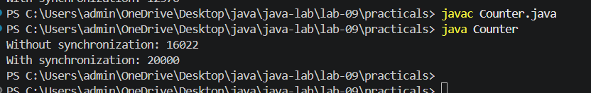

2. Seat booking race: a shared seatsLeft of 5 with about 10 threads each trying to book one
seat. Without synchronization show that more than 5 can succeed (oversell); with a
synchronized book() exactly 5 do.
INPUT:-
public class Ticket {
static int seatsleft = 5;
static int booked = 0;

static void book() {
if (seatsleft > 0) {
try {
Thread.sleep(1);
} catch (Exception e) {
}

seatsleft--;
booked++;

System.out.println("seats left: " + seatsleft);
}
}

static synchronized void syncBook() {
if (seatsleft > 0) {
seatsleft--;
booked++;

System.out.println("Seat booked successfully, seats left: " + seatsleft);
}
}

public static void main(String args[]) throws InterruptedException {

Thread[] t = new Thread[10];

seatsleft = 5;
booked = 0;

System.out.println("Without synchronization:");

for (int i = 0; i < 10; i++) {
t[i] = new Thread(() -> book());
t[i].start();
}

for (int i = 0; i < 10; i++)
t[i].join();

System.out.println("Total booked: " + booked);
System.out.println("Seats left: " + seatsleft);

seatsleft = 5;
booked = 0;

System.out.println("\nWith synchronization:");

for (int i = 0; i < 10; i++) {
t[i] = new Thread(() -> syncBook());
t[i].start();
}

for (int i = 0; i < 10; i++)
t[i].join();

System.out.println("Total booked: " + booked);
System.out.println("Seats left: " + seatsleft);
}
}
OUTPUT:-
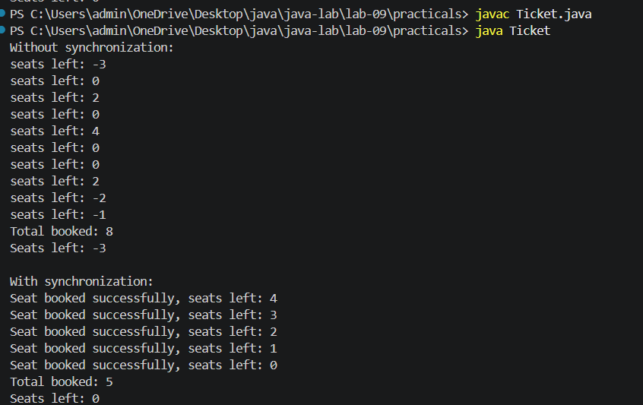

3. (For Advanced Learners – home) Split a large array of numbers across several threads
that add into one shared total, show the wrong result, then fix it two ways and compare;
decide how to measure the difference.
INPUT:-
import java.util.concurrent.atomic.AtomicLong;

public class ArrayTotal {
static long total = 0;

static void add(long value) {
total += value;
}

static synchronized void syncAdd(long value) {
total += value;
}

public static void main(String[] args) throws Exception {

int[] arr = new int[1000000];

for (int i = 0; i < arr.length; i++)
arr[i] = 1;

Thread[] threads = new Thread[4];

// Without synchronization
total = 0;
long start = System.nanoTime();

for (int i = 0; i < 4; i++) {
int startIndex = i * 250000;
int endIndex = startIndex + 250000;

threads[i] = new Thread(() -> {
for (int j = startIndex; j < endIndex; j++)
add(arr[j]);
});

threads[i].start();
}

for (Thread t : threads)
t.join();

long time1 = System.nanoTime() - start;

System.out.println("Without synchronization: " + total);
System.out.println("Time: " + time1 + " ns");

// With synchronized
total = 0;
start = System.nanoTime();

for (int i = 0; i < 4; i++) {
int startIndex = i * 250000;
int endIndex = startIndex + 250000;

threads[i] = new Thread(() -> {
for (int j = startIndex; j < endIndex; j++)
syncAdd(arr[j]);
});

threads[i].start();
}

for (Thread t : threads)
t.join();

long time2 = System.nanoTime() - start;

System.out.println("With synchronized: " + total);
System.out.println("Time: " + time2 + " ns");

// With AtomicLong
AtomicLong atomicTotal = new AtomicLong(0);
start = System.nanoTime();

for (int i = 0; i < 4; i++) {
int startIndex = i * 250000;
int endIndex = startIndex + 250000;

threads[i] = new Thread(() -> {
for (int j = startIndex; j < endIndex; j++)
atomicTotal.addAndGet(arr[j]);
});

threads[i].start();
}

for (Thread t : threads)
t.join();

long time3 = System.nanoTime() - start;

System.out.println("With AtomicLong: " + atomicTotal);
System.out.println("Time: " + time3 + " ns");
}
}
OUTPUT:-
