PRACTICAL – 1

1. Vending machine (VendingMachine.java, main in this file)
(a) Define an enum Coin with constants ONE, TWO, FIVE, TEN.
(b) In main, set a snack price of 15 and a running total of 0; create a Scanner.
(c) Loop: read a coin name, use a switch expression to convert the Coin to its value
(ONE→1, TWO→2, FIVE→5, TEN→10), add it to the total, and print the total so
far.
(d) Stop the loop once the total reaches 15 or more.
(e) Print the change to return .

import java.util.Scanner;
public class Vendingmachine
{
enum coin
{
One,Two,Five,Ten
}
public static void main(String args[])
{
int price=15;
int total=0;
Scanner sc=new Scanner(System.in);
while(total<price)
{
System.out.println("Enter a coin-\n One,Two,Five,Ten");
String input=sc.next();
coin c=coin.valueOf(input);
int value=switch(c)
{
case One->1;
case Two->2;
case Five->5;
case Ten->10;

};
total+=value;
System.out.println("total in vendingmachine:"+total);
}
int paid=total-price;
System.out.println("paid change:"+paid);
sc.close();

}
}
OUTPUT:
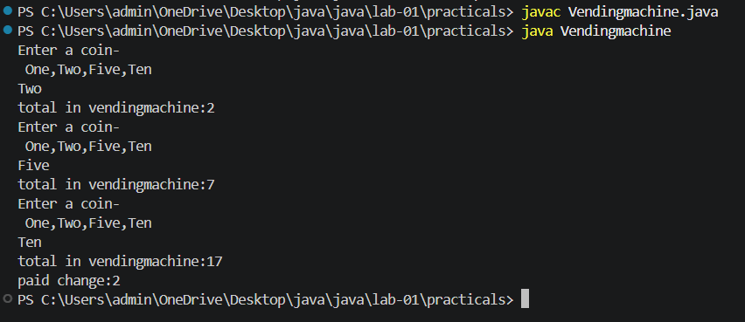

2. Toll booth (TollBooth.java, main in this file)
(a) Define a record Vehicle(String number, String type).
(b) In main, keep a running toll total and three counters (bike, car, truck).
(c) Loop until the user types “done” for the number: build a Vehicle, use a switch
expression on its type for the toll (bike→20, car→50, truck→150), add to the total,
and increment that type’s counter.
(d) After the loop, print the total toll and the type with the highest count.
Expected output: two cars + one bike → “Total toll: 120”, “Most frequent: car”.
import java.util.Scanner;
public class TollBooth {
record Vehicle(String number, String type)
{}
public static void main(String args[])
{
Scanner sc=new Scanner(System.in);
int total=0;
int bike=0;
int car=0;
int truck=0;
String mostFrequent="";
while (true)
{
System.out.print("Enter vehicle number (or done): ");
String num= sc.next();
if(num.equals("done"))
break;
System.out.print("Enter vehicle type (bike/car/truck): ");
String type = sc.next();
Vehicle va = new Vehicle(num, type);
int value=switch(va.type())
{
case "bike"->20;
case "car"->50;
case "truck"->150;
default->0;
};
total+=value;
bike++;
car++;
truck++;
if (bike>=car && bike>=truck)
{
mostFrequent= "bike";
}
else if(car>=bike && car>=truck)
{
mostFrequent="car";
}
else
{
mostFrequent="truck";
}
}
System.out.println("total toll-"+total);
System.out.println("mostFrequent used vehicle:-"+ mostFrequent);
sc.close();
}
}
OUTPUT:
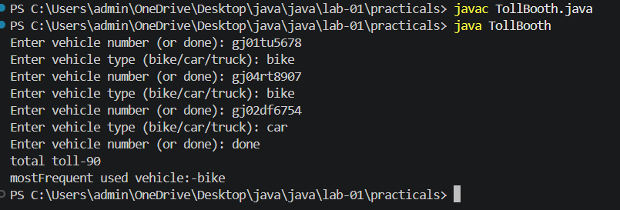

3. (For Advanced Learners – home) Rock-Paper-Scissors-Lizard-Spock (RPSLS.java)
(a) Define an enum Move with ROCK, PAPER, SCISSORS, LIZARD, SPOCK.
(b) Write winner(Move a, Move b) returning 1 if a beats b, -1 if b beats a, 0 for a tie —
use a switch expression listing what each move beats (Scissors cut Paper, Paper
covers Rock, Rock crushes Lizard, Lizard poisons Spock, Spock smashes Scissors,
and the five mirror cases).
(c) In main, play 5 rounds: pick a random computer Move, read the player’s Move, call
winner(), print the round result and keep score.
(d) After 5 rounds, print the overall winner.
Expected output: each round prints both moves and the round winner; ends with a
“You win 3–2” summary.
import java.util.*;
public class RPSLS
{
enum Move {
ROCK, PAPER, SCISSORS, LIZARD, SPOCK
}
public static int winner(Move a, Move b)
{
if (a == b)
return 0;
return switch (a)
{
case ROCK ->
(b == Move.SCISSORS || b == Move.LIZARD) ? 1 : -1;
case PAPER ->
(b == Move.ROCK || b == Move.SPOCK) ? 1 : -1;

case SCISSORS ->
(b == Move.PAPER || b == Move.LIZARD) ? 1 : -1;
case LIZARD ->
(b == Move.SPOCK || b == Move.PAPER) ? 1 : -1;
case SPOCK ->
(b == Move.SCISSORS || b == Move.ROCK) ? 1 : -1;
};
}

public static void main(String[] args)
{
Scanner sc = new Scanner(System.in);
Random random = new Random();
int playerScore = 0;
int computerScore = 0;
System.out.println("Moves: ROCK, PAPER, SCISSORS, LIZARD, SPOCK");
for (int round = 1; round <= 5; round++)
{
System.out.println("\nRound " + round);
Move computer = Move.values()[random.nextInt(5)];
System.out.print("Enter your move: ");
Move player = Move.valueOf(sc.next().toUpperCase());
int result = winner(player, computer);
System.out.println("You: " + player);
System.out.println("Computer: " + computer);
if (result == 1) {
System.out.println("You win this round!");
playerScore++;
} else if (result == -1) {
System.out.println("Computer wins this round!");
computerScore++;
} else {
System.out.println("Round is a tie!");
}
}
System.out.println("\n===== FINAL RESULT =====");
System.out.println("Your Score: " + playerScore);
System.out.println("Computer Score: " + computerScore);
if (playerScore > computerScore) {
System.out.println("You win " + playerScore + "-" + computerScore + "!");
} else if (computerScore > playerScore) {
System.out.println("Computer wins " + computerScore + "-" + playerScore + "!");
} else {
System.out.println("Match Draw!");
}
sc.close();
}
}
OUTPUT:
