Practical-3
1. Distinct points (Point.java + Driver.java with main)
(a) Create class Point with private int x, y and a constructor.
(b) Override toString() to return “(x, y)”.
(c) Override equals(Object) to be true when both x and y match, and hashCode() to agree
(e.g. Objects.hash(x, y)).
(d) In Driver.main: build a Point[] with some repeated coordinates.
(e) Count distinct points: for each point, use equals() to check whether it already
appeared earlier; count those that did not.
(f) Print “Distinct: N”.
Expected output: 5 points with 2 repeats → “Distinct: 3”.
INPUT:-
import java.util.Objects;

public class Point {
private int x;
private int y;

public Point(int var1, int var2) {
this.x = var1;
this.y = var2;
}

public String toString() {
return "x:" + this.x + "and y:" + this.y;
}

public boolean equals(Object var1) {
if (this == var1) {
return true;
} else if (!(var1 instanceof Point)) {
return false;
} else {
Point var2 = (Point)var1;
return this.x == var2.x && this.y == var2.y;
}
}

public int hashCode() {
return Objects.hash(new Object[]{this.x, this.y});
}
}

OUTPUT:
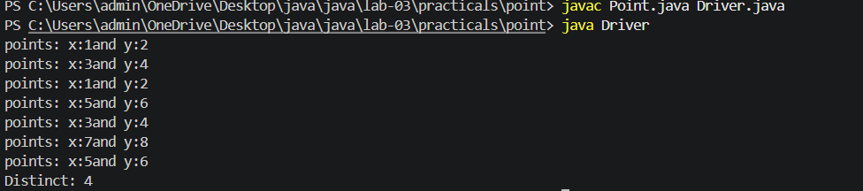
2. Duplicate card check (Card.java + Driver.java)
(a) Create class Card with private String rank, suit and a constructor.
(b) Override toString() to return rank + “ of ” + suit (e.g. “Queen of Hearts”).
(c) Override equals()/hashCode() by rank + suit.
(d) In Driver.main: add cards to a Card[] one at a time; before adding each, use equals()
to check it against the earlier cards.
(e) Print “Duplicate found: <card>” the first time a repeat appears.
Expected output: a second “Ace of Spades” → “Duplicate found: Ace of Spades”.
INPUT:-
import java.util.*;
public class Card
{
private String rank;
private String suit;
public Card(String rank,String suit)
{
this.rank=rank;
this.suit=suit;
}
@Override
public String toString() {
return rank+ " of "+suit;
}

public boolean equals(Object o)
{
if(this==o)
return true;
if (!(o instanceof Card))
return false;
Card c=(Card) o;
return rank.equals(c.rank) && suit.equals(c.suit);
}

public int hashCode()
{
return Objects.hash(rank,suit);
}

}

OUTPUT:-
3. (For Advanced Learners – home) Fractions (Fraction.java + Driver.java)
(a) Create class Fraction with private int num, den.
(b) In the constructor, reduce to lowest terms: compute g = gcd(num, den) and divide
both by g.
(c) Override toString() to return num + “/” + den.
(d) Override equals()/hashCode() using the reduced num and den.
(e) In Driver.main: create several equivalent fractions (1/2, 2/4, 3/6) and confirm they
are all equal and print the same.
Expected output: new Fraction(2,4) prints “1/2” and equals new Fraction(1,2).

INPUT:-
import java.util.*;

public class Fraction {
private int num;
private int den;

public Fraction(int num, int den) {
int g=gcd(num, den);
this.num=num / g;
this.den=den / g;
}

private int gcd(int a, int b) {
while (b != 0) {
int temp=b;
b=a%b;
a=temp;
}
return Math.abs(a);
}

@Override
public String toString() {
return num + "/" + den;
}

@Override
public boolean equals(Object o) {
if (this==o)
return true;

if (!(o instanceof Fraction))
return false;

Fraction f=(Fraction) o;
return num==f.num && den==f.den;
}

@Override
public int hashCode() {
return Objects.hash(num,den);
}
}
OUTPUT:-
