# Booted! Process Documentation

Table of Contents

Introduction

Ideation

Problems Discussed

Brainstorming

Initial Game Ideas

In-Class Playtest

Observations

Suggestions

Gameplay

Starting Number

Target and Death Number

Materials

Excluding Noobs

First Iteration

Problems Discussed

Ruleset

Results

Suggestions

Second Iteration

Problems Discussed

Brainstorming

Ruleset

Results

Third Iteration

Problems Discussed

Brainstorming

Ruleset

Results

Fourth Iteration

Problems Discussed

Brainstorming

Ruleset

Results

Fifth Iteration

Problems Discussed

Brainstorming

Ruleset

Results

Sixth Iteration

Problems Discussed

Brainstorming

Ruleset

Results

Seventh Iteration

Problems Discussed

Brainstorming

Ruleset

Eighth Iteration

Problems Discussed

Ruleset

Ninth Iteration

Problems Discussed

Ruleset

Final Iteration

Problems Discussed

Brainstorming

Collaboration

# 

# 

# Introduction

# Ideation

## Problems Discussed

We first met on November 7, 2014 to discuss our two themes (“Players need permission from parents,” and “Players exclude noobs”). Instead of brainstorming, we first elaborated on what these themes would mean in the context of a game idea (below are notes from the meeting):

1. Challenge that our players have: They need permission from their parents.

* Why would they need permission from their parents?
  + They are underage and are not legally able to participate without an adult’s permission.
    - Involves mature content (ex. violence)
    - Parents are culturally or personally opposed to it, think that games are a waste of time
    - Parents need their children to work and provide for the family
      * Could be a game that kids could play while doing housework or chores
    - Parents need to provide some resource for children (ex. money)
  + The game involves their parents (therefore, as an outside party, the parents need to give their consent)

2. Player's cultural preference: Exclude noobs from their game. How do we achieve this?

* Creating a negative feedback loop for losing (ex. Item shop in League of Legends).
* Not explaining the rules to discourage new players.
* Team based situations where experts will dislike having noobs on their team.
* Possibly the parents themselves are noobs?
* The expert wants to feel “powerful”
  + Provides a way for the child to “fight back” against parent.
* Experts have some sort of advantage over other players
  + Better skills, strategy?
  + Better equipment from playing so long ?

**Our audience:** Parents disapprove of player playing game, player between 8 - 18 years of age and living with parent(s)

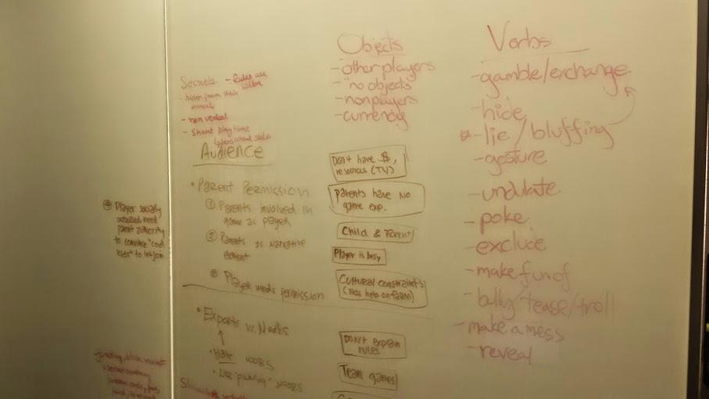

## Brainstorming

We then decided to brainstorm game features, which could be combined into a game that would satisfy our goals. First we brainstormed together, coming up with shared concepts that explored the constraints in different ways. After this, everyone individually brainstormed either full game concepts or game rule snippets for 10 minutes on post-it notes, then shared them. We grouped together like post-it notes on a board and repeat this process as necessary. We especially looked into the areas of a game that players could play anywhere and in secret, hidden from parents. Our final game took some elements from that but did deviate in some areas. Below are notes taken during the meet:

* A game goes against the parent’s wishes:
  + Can be played in secret?
    - Hidden from parents
    - Non-verbal, gestures
    - Could have a situation where children are playing right in front of parents, but the parents don’t know
      * A sibling (noob) might try to intervene and join the game, but doesn’t know rules so can’t play
    - Short play time / pick up and go games (ex: Ninja)
      * Have persistent states (so more experts are created)
    - ex: Fight club / Secret clubs
      * First rule is you don’t talk about fight club
      * A sign to show you’re part of the club
      * Filtering for new members (b/c new members might ruin the game for others)?
* Vandalism as a game?
  + **Of mischief**
    - Not following their schedule (staying up late, sleeping in)
    - Hiding things from parents (drawing on the wall and covering it with furniture) (trying to leave a symbol?)
      * Hiding evidence of the game that parents don’t like
  + Trolling as a game (w/ code of conduct)
    - Trolling in ‘wrong context’, against code of conduct = noob

Vote people out if they aren’t good enough trolls or ‘fake’ trolls

* Elite, expert groups
* When is the game played? In school, in class?
* Game played in inappropriate context (i.e. when other people are playtesting?) Jessica Hammer as the parent
* Physical game might not work (hiding dice would be weird)
* Game played throughout days
* Hidden signals

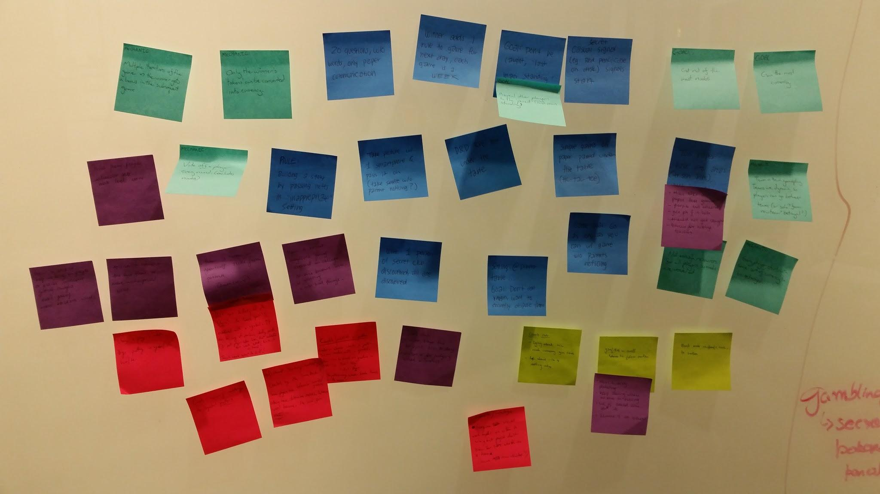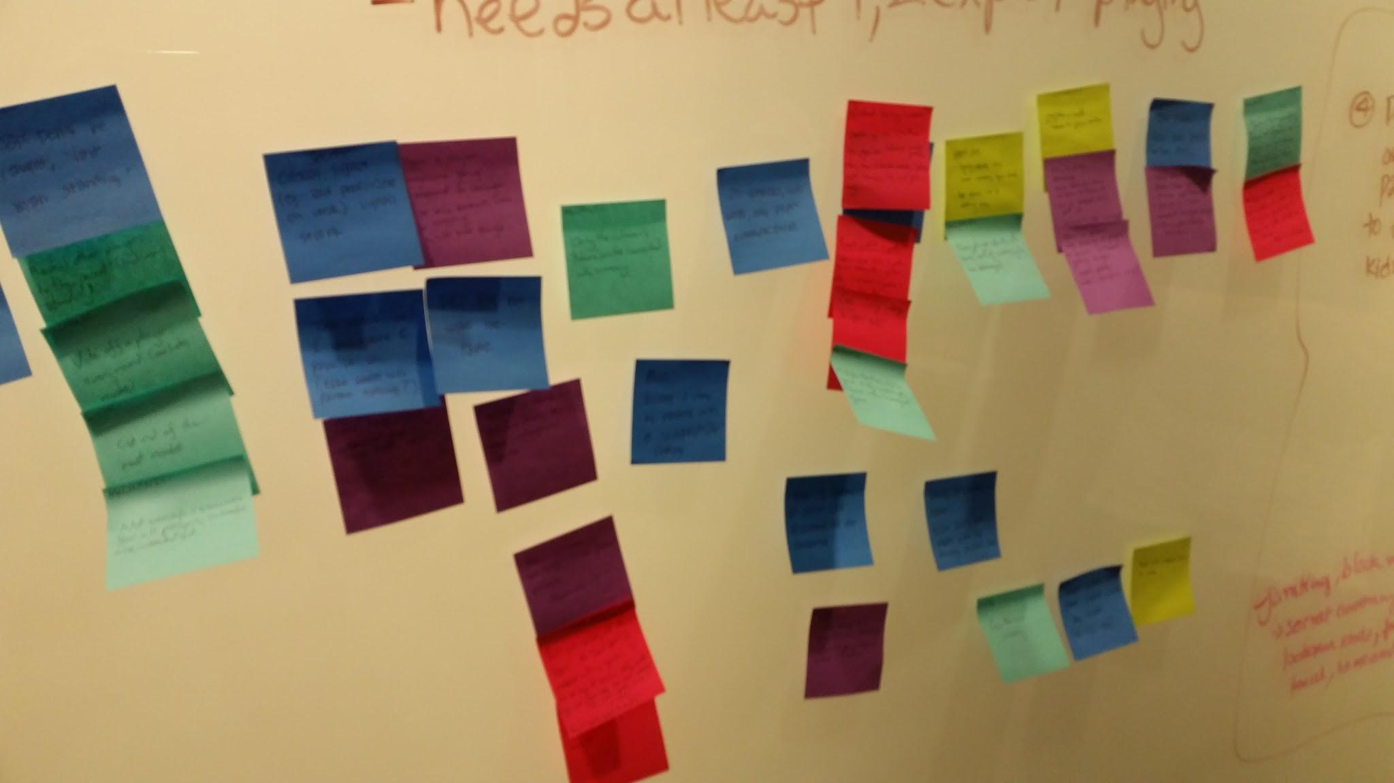

Post-it notes:

* Goal: Don't be caught, "last man standing"
* Goal: Reveal other players to the "parent" (last man standing)
* Mechanic: Vote off a player every round (excludes noobs)
* Mechanic: Not enough resources for all players, so noobs are weeded out
* Goal: Go as long as you can with the game without parents noticing
* Goal: Get rid of the most noobs.
* Casual secret signal signals start of game
* Take picture with a smartphone and pass it on (take selfie without parent noticing?)
* Steal from people; whoever gets max loot wins
* Spread a rumor; the one that is most widespread wins
* D&D rpg but under the table
* Mechanic: Only the winner's "tokens" can be converted into currency
* Rule: Building a story by passing notes in "inappropriate" setting
* 20 questions without words, only paper communication
* When 1 person of secret club is discovered, all are discovered
* Liar's Club: who says the biggest lie today; criteria for judging what is worse
* Winner adds 1 rule to game for next day, each game is a WEEK
* Complete/establish a pattern: leader or whoever starts a pattern. This can be done with a symbol. Pattern can be based on gesture or verbal: i.e. "cat" "dog"; pass the pattern along. whoever breaks the rule loses the wager
* Create currency matching the symbol pattern
* Mechanic: multiple iterations of the game => the winner gets a bonus in the subsequent game
* Mechanic: Every player starts with some sort of currency to be exchanged
* Liar's Club: lying about how much currency you have; lying about who is dating who
* Setting: at dinner table; Goal: don't want to eat veggies, want to secretly dispose them
* Change a player's state by putting a symbol on him/her
* Secret Assassins: Don't get killed, kill other "players". The "weak spot" is established with a symbol. It can be any of various body parts. OR each player hides a "token" that indicates their weak spot. Write it on board? Touch weak spot to kill!
* Have a tattoo on yourself. Hide from parents (Death Eaters)
* Have a sticker. Keep sticking on people or places without getting caught. Take pictures as proof. More stickers wins.
* Start a dirty drawing; Keep doing when no one is seeing; lie if asked who did it; blame it on others
* Goal: Gain the most currency.
* Simple games on paper passed under the table (tic-tac-toe)
* Flash mobs -> specific task -> twitter
* Have a paper toss game; people hit others; get points if it hits; should not get caught; bonus for hitting teacher
* Toss paper balls into areas (trash bins), most is goal
* Collaborative/sabotage: everyone should work together on a team to win, but people don't know for sure who is on a team (how are teams decided?)
* Mechanic: Team vs team gameplay. Teams are dynamic, so players can go between teams (or solo? form new team? betrayal?)

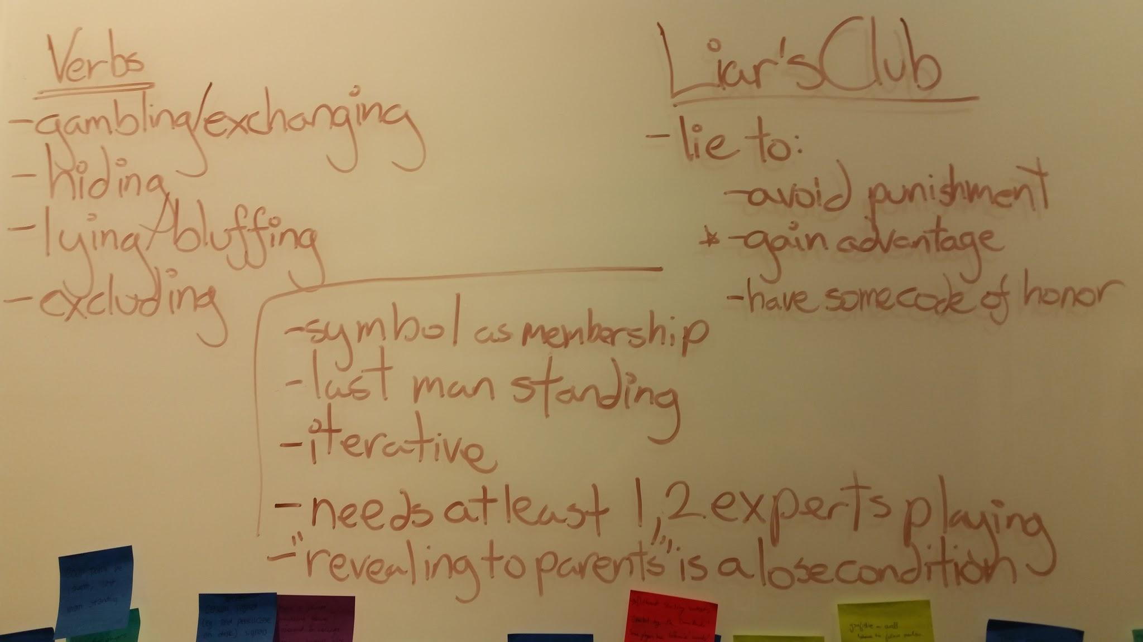

## Initial Game Ideas

We then met again on November 10, 2014 with ideas prepared from the previous meeting. The goal of this meeting was to come up with a set of game rules and playtest many different ideas. The games we played barely resemble the final game - however, elements from these early ideas did transfer. At the end of this meeting, we came up with the bare bones structure of the math game that was seen during the inclass playtest. Below are the game concepts that we came up with and playtested:

**Ninja Signs Duel**

Ninja’s duel without sound. Form hand signs to assassinate your opponents. The last one standing wins. Needs 2 players, and no components.

**Rules:** If players remember who won the most recent game, that player goes first. Otherwise, the oldest player takes the first turn. On a player’s turn, he/she faces an opponent and ‘makes a sign’:

* Shows between 1 and 5 fingers on a single hand.
* The player receiving the sign must respond by either:
  + Showing a sign of the same ‘element’ (e.g. the same number of fingers but in a different format), either to attacking player, or another opponent
  + Or showing a counter sign (e.g. a different number of fingers, but in a format that uses a component of the previous sign)
* If a player repeats a sign or takes too long, then they are eliminated
* The last player standing wins

**What do we like:**

* Playable anywhere
* Many gestures
* Stealthy game (can hide from other people easily)
* Excludes noobs well

**What is an expert?**

* Increase the odds for more experienced players.
* Increase more strategic decisions players are able to make.
* High learning curve
* Game that requires practice
* A game where experts have fun playing against experts

**Collaboration and Auction Game**

Players: 4 or more

Materials: deck of cards (King of Spades placed aside)

Instructions:

Each player is dealt 2 cards face down. If there was a winner in the previous round, they are also given the King of Spades. Otherwise, the dealer receives the King of Spades, for a total of 3 cards in their hand.

There is now a Collaboration Period (can take any length of time, including all day). Players can do whatever they want with this time, including negotiating with other players, swapping cards, or abstaining from any activity.

After the Collaboration Period is the Auction Period. The King flips a card from the top of the deck, and the rest of the players can bid on the card using whatever cards they own. Thus, a player can combine a 2 and a 6 for a total of 8 points to use to bid on a card.

(In the case of a tie in bid points, the high card of the bid wins. In the case of another tie, the higher suit wins.)

The Auction Period lasts 3 rounds.

After the Auction Period, each player chooses one of their cards to become their Rank card. All players reveal their Ranks, as well as the remainder of their possession cards. The top two ranked players can each choose a possession card from the remaining players that will be discarded.

After cards have been discarded, each player adds their possession cards to their total score. The player with the highest score from this round becomes the king in the next round.

**Paparazzi**



Start with teams of two, up to 4 teams.

Game played in context of inappropriate situation (i.e. at a family dining table)

Game played over a week

Each player has a smartphone capable of taking pictures

If you take a frontal picture of an enemy player (and they are not looking at you), this counts as a point (if picture is blurry, it does not count).

If you take a picture and the enemy player is taking a picture of you, then it counts as shooting each other.

We playtested all three games but were not satisfied with the experience. For instance, while the ‘Paparazzi’ game was fun, it required too much setup and didn’t really help players who needed to get permission from their parents (they needed a smart phone). In addition, gameplay was too chaotic and it didn’t seem that players could feasibly become experts. Meanwhile, the ninja signs game was fun but not complex enough. Stated above, we enjoyed the fact it could be played anywhere and the gestures were interesting. We decided to push further on this ninja gesture game more, eventually reaching the the ruleset for the earliest version of the math game:

**The Math Game**

Start sum at zero.

Each player has a public death number, and a private target number. Death numbers are randomly selected, and numbers range from 100-300. Private target numbers are chosen, and also must be between 100-300.

To win, either be the last person standing (killed everyone else) or hit the target number. You must call out when your target number is hit, otherwise it doesn’t count.

You can’t do the opposite operation of the previous turn (i.e. someone multiplied by 5, and now I divided by 5).

Your target number cannot be someone else’s death number.

You play with hand signals. One is a number, the other is the modifier. One hand is a number from 1 - 5 (1 - 5 fingers). The other hand is the modifier.

* Fist: Add
* Index pointing in: Subtract
* Divide: Diagonal hand
* Crossed index and middle: Multiply

Gameplay:

Oldest person goes first. Go in clockwise order.

You show your hands, and say out loud the result.

On each person's’ turn, all other players hold up fingers from 10, going down one finger per second. Once reach zero, make the throat slitting motion and that player who didn’t say anything is now dead.

Being eliminated:

If your death number is hit, then you are dead and elimination.

If you don’t say anything in the time limit when its your turn, you are also dead.

If you miscalculated, you are dead.

If you make a number above the limit (300) you are dead.

We found that this game was compelling, and players felt like a ‘noob’ when messing up on the deceivingly simple calculations. Skill was involved through mathematical calculations. Materials required were extremely simple - anyone could get their hands on pen and paper, and exceptionally skilled players could memorize all numbers and play with nothing at all. Though there were areas we needed to tighten for the game, overall we felt more satisfied with this idea than others.

# 

# 

# In-Class Playtest

We presented the prototype for Math Game developed as described above in the in-class playtesting session. We played a total of three rounds with several variations each round.

In the first round, we played with three players, and left out the rule where players must count down on each player’s turn as a time constraint. The first round was completed in 3 turns, where players chose very low, easy to reach target numbers.

In the second round, we introduced two more players for a total of five players (so that there would be two ‘newcomers’ to the game), and altered the rules slightly. We introduced a timer rule, which forced players to work faster, or face elimination. This game was slightly longer, but a player did manage to win within the first few turns due to a low target number.

In the third round, we kept the same set of five players, but provided an additional rule that the target number must be above 100. This game was longer than the previous rounds, and was a knockout round where a winner was determined by knocking out all other players due to fumbles or hitting death numbers.

From the playtest session, we gathered the following crucial observations and suggestions from the players and audience members.

## Observations

Gameplay

* When given the option of saying the operation out loud or not in addition to hand gestures, people favored saying the operations out loud
* People began having a go-to strategy
* If the target number is low, easy to get. If high, the game becomes more competitive
* Time pressure increased stress levels and made it easier to mess up
* There were corrections of mistakes (such as initially calculating the total wrong, and then immediately fixing it)
* Lack of clear rules if correction of mistakes within time limit

Target and Death Numbers

* Additional rule of above 100 target number was really good (low target numbers were too fast)
* Drastically different target numbers forced a back and forth between different ranges of numbers
* It would be nice if death numbers were on table, somewhere central, where all people could see it
* Concern: Once you’re good, you reach target number. Solely depends on other players actions because numbers can drastically change in two turns
* The more people that play, the harder it is to get a number
* If a number is low, its easy to hit; if number is high, there’s more competition
* There should be some sort of balance between death and target numbers

Information Overload

* Time pressure was exciting
* A lot of numbers to think about (target, avoid death, while also targeting others, while also thinking about symbol)
* Down to two people, became more competitive because players could sense what each others number could be
* First round had a much more relaxed atmosphere compared to the second round when we introduced the time pressure
* Hand gestures were confusing

Excluded Noobs?

* Coordinating hands AND mental math made sense with excluding noobs
* Ben: When someone messed up, I said noob under my breath because people were fumbling and ran out of time
* People who won or made mistake got excluded from game
* When a player messed up, she felt really dumb that she couldn’t do minus 2
* Did a good job at making you feel like a noob when you mess up

Feasibility for Players Needing Parental Permission

* Parents are ok with this because their kids are “going to do math”
* Thought it was nice that there were no game materials, which added to the easy playability

Emotional Response

* Emotional engagement behind performing mathematical tasks
* The game is math based, but it seems more like a number fighting game
* Players seemed challenged and engaged in the game
* Simple mathematical operations became quite dramatic

## Suggestions

### Gameplay

* Make the time limit visual rather than oral
* Next person has to say the number of your operation
* To combat back and forth gameplay, prevent players from performing the same operation twice in a row
* Implement a point system to support points and penalties (for fumbles)
* Would be interesting if increased a time limit with a visual clock to encourage people to multiply higher numbers

### Starting Number

* Felt like game lagged in beginning since you start at 0
* Randomly generate a starting number
* Randomly get starting number AFTER target numbers have been chosen so there’s an emotional reaction

### Target and Death Number

* Target numbers are under player control currently, so maybe swap death numbers and target numbers
* randomize death number after people choose target numbers
* Prime numbers are really interesting
* separate ranges for target numbers and death numbers
* Create a ‘defensive’ number territory (target range) and an ‘offensive’ territory (death range)
* Instead of target number, a target sequence

### Materials

* Liked the lack of game materials, didn’t like the writing number down and the random number generator
* Minimize game materials even further
* Is there a way to generate numbers randomly without materials?

### Excluding Noobs

* Current boundaries are too fuzzy, create stricter rules
* Making a single mistake gets you out of the game (makes the game more exclusionary)
* Maybe have a moderator for the game to highlight people’s screw ups

# 

# 

# First Iteration

After reviewing the notes from the playtests, we came up a list of possible changes for the game and worked through them by adding them as additional rules per playtest. We kept track of each iterations added rules and after play, discussed the modified experience and suggested more possible changes as a result.

For the playtests done on November 11, we used sticky notes attached to paper to keep track of death and target numbers.

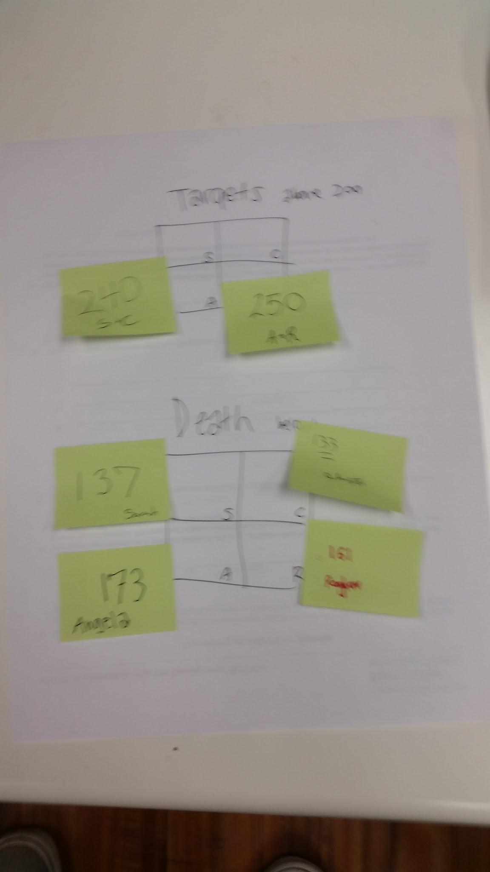

## Problems Discussed

* **Minimizing Materials:** We noted that a general consensus from the class showed that our game was successful in being playable without parental permission due to the clear lack of materials needed to play. To push this further, we sought to minimize the materials needed to play, particularly the random number generator. To combat this, we got rid of random number generation entirely, and let players choose both their target and death numbers.
* **Starting Number:** As we did in the third round of the playtest, we started the game at 150 instead of 0.
* **Zoning:** To match with our starting number which was now in the middle of the gameplay range, we specified the Death Below and Target Above zones. This meant that players could only choose death numbers in the Death Below zone (1-100), and target numbers in the Target Above zone (200-300).

## Ruleset

* Starting at middle (150)
* Public Death and Target Numbers
* No Randomization, choose both numbers
* Zoning: Death Below (100), Target Above (200)

## Results

With this set of rules, we found that gameplay went extremely quickly. Specifically, we discovered that once a player entered the Death Below zone, players weren’t eager to leave it, and focused on killing other players. In this game, the dominant strategy for everyone seemed to be to eliminate other players, rather than reaching their own target number. We also found that due to two players picking the same target number, there was an incentive for two players to work together, which gave us the idea for teamplay.

* Once we hit the Death Below zone, people died very quickly
* Christian and Sarah both picked 240 as targets
* We didn’t really play with timer but it was still stressful
* First turn defined beginning play. Started very defensively, suddenly switched to offense
* Raghav deliberately got close to Christian’s death number so Sarah knocked Christian out
* Christian and Sarah formed an informal agreement of teamwork, though Sarah killed Christian later
* Raghav killed himself by not knowing symbols and calculations quickly enough
* Playing with sticky notes so people secretly choose death, then stick to playing area, then secretly choose target

## Suggestions

* Call out noob when you think someone is taking too much time or they mess up (signs or numbers)
* Try switching zones to death (100-200) and targets (201 - 300). Starting at 0

# Second Iteration

## Problems Discussed

* In the previous iteration we observed that the gap between death zone and target zone was quite large. So if players entered the death zone then they tended to stay in the death zone. Similarly, once the players entered the target zone, they tended to stay in the target zone.
* Should we make death numbers and target numbers public? In the previous iteration, only death numbers were public. We wanted to try out an iteration where both numbers were made public. We were trying to find the right game balance.
* Team play: We noticed that Christian and Sarah were helping each other during the previous iteration. So we decided to introduce the concept of teamplay.

## Brainstorming

* **Starting the game at 0, death zone 100-200, target zone 201-300:** The idea here was to enable quicker switching between the death zone and target zone.
* **Public death and target number:** Every player’s death number and target number is written down on a sheet of paper and is visible to everyone at all times.
* **Players choose both numbers**: Since we made both the death numbers and target numbers public, we wanted to give the users a choice to pick their own numbers.
* **Team play:** There are two teams with two players each. To form a team, players have to be sitting adjacent to each other. Once the teams are formed, they have a few minutes to discuss strategy.

## Ruleset

* Starting at 0
* Public Death and Target Numbers
* No Randomization, choose both numbers
* Zoning: Death Below (100-200), Target Above (201-300)
* Teams: Shared target, different death numbers (everyone secretly picks own death number)
  + Adjacent teams (Sarah and Christian, Raghav and Angela)
  + Starting the game: First player is of one team, the next player is the other
  + Gave some time in beginning to strategize within teams

## Results

* Raghav and Angela collectively decided to hit Sarah first since she is the one who will be hit by our moves
  + Decided to play offensively and stay within the death zone
* Game ended earlier because after one player in any team got killed, it was easy to kill the other person.
* Sarah and Christian chose target numbers that were close to each other. If one person won, it was easy for the other person to win as well.
* Two people on a team is a lot of power - one person can set up and other person seals a victory.
* The original death zone (1-100) and target zone (200-300) was better because the game lasted longer.

# Third Iteration

## Problems Discussed

* **The game ended way too early**. Since we introduced team play, one team chose target numbers that were too close to each other. Moreover, when one player in the team was killed, it was very difficult for the remaining player to play against two opponents.
* **Teams gave too much power to players**. As discussed in the previous point, team play allowed players in a team to kill one person in the opponent team quickly. Then the odds were stacked against the single surviving opponent.
* **Find the right balance between who chooses the target and death numbers:** We allowed players to pick both their target and death numbers. This gave the players too much power. They was no element of chance or fate.

## Brainstorming

* **Start at 150 to make the game last longer**: We reverted back to the first iteration where the game started at 150.
* **Public death and target numbers**: We kept this rule from the second iteration. Players can see everyone’s death and target numbers.
* **Player chooses death number, opponent chooses your target number**: This rule allows opponents to decide your “fate”.
* **Prime play:** If the player hits a prime number, he can choose to reverse the direction of play. This rule adds complexity to the game.

## Ruleset

* Starting at 150
* Zoning: Death Below (0-100), Target Above (200-300)
* Public Death and target Numbers
* No randomization
* Opponent chooses your target number
* No teams
* Prime play - Push hand gesture when you hit a prime number, this reverses the order or turns.
  + If the player who says a number which is prime and doesn’t push motion, the order is not reversed.
  + If the number isn’t actually a prime, others can call out on this and if the number isn’t a prime then the person who attempted to push is out

## Results

* Really short game.
* Angela was able to hit a prime number to avoid Sarah’s turn, which then allowed Christian to kill Sarah
* Prime play allowed more control over the numbers
* Since both target and death People focus heavily on the numbers at the center of the table while thinking of their next move.

# 

# Fourth Iteration

## Problems Discussed

* How do we create a player community for this game? One of the main concerns during the in-class playtest was that we were not pushing the “building a community” aspect of the game.
* Adding more “expert” play to the game? Can we add more complexity and stress to the game so that only the experts feel comfortable playing it?

## Brainstorming

* **Timer rule:** If a player is taking too long, other players can tap their wrist. If everyone taps their wrists then the player is kicked out of the game.
* **Yelling “noob**”: When a player makes a mistake, other players yell “noob” and kick the player out of the game. We did not implement this rule for this iteration.

## Ruleset

* Starting at 150
* Zoning: Death Below (0-100), Target Above (200-300)
* Choose your own Death, Opponents choose Target
* Public Death and Target Numbers
* Prime play, reverses turn order
* Timer Rule: When you think someone’s taking too long, tap your wrist. Once everyone taps their wrist, you lose.
* Informal Rule: You can say the operation and the number.

## Results

* Angela was knocked out before her turn. A player hit Angela’s death number even before she a had a chance to play.
* Christian got stressed out when people started tapping their ‘watches’. He made simple math operations like add 1.
* No one used prime play this time. They were too stressed because of the timer rule.

# 

# Fifth Iteration

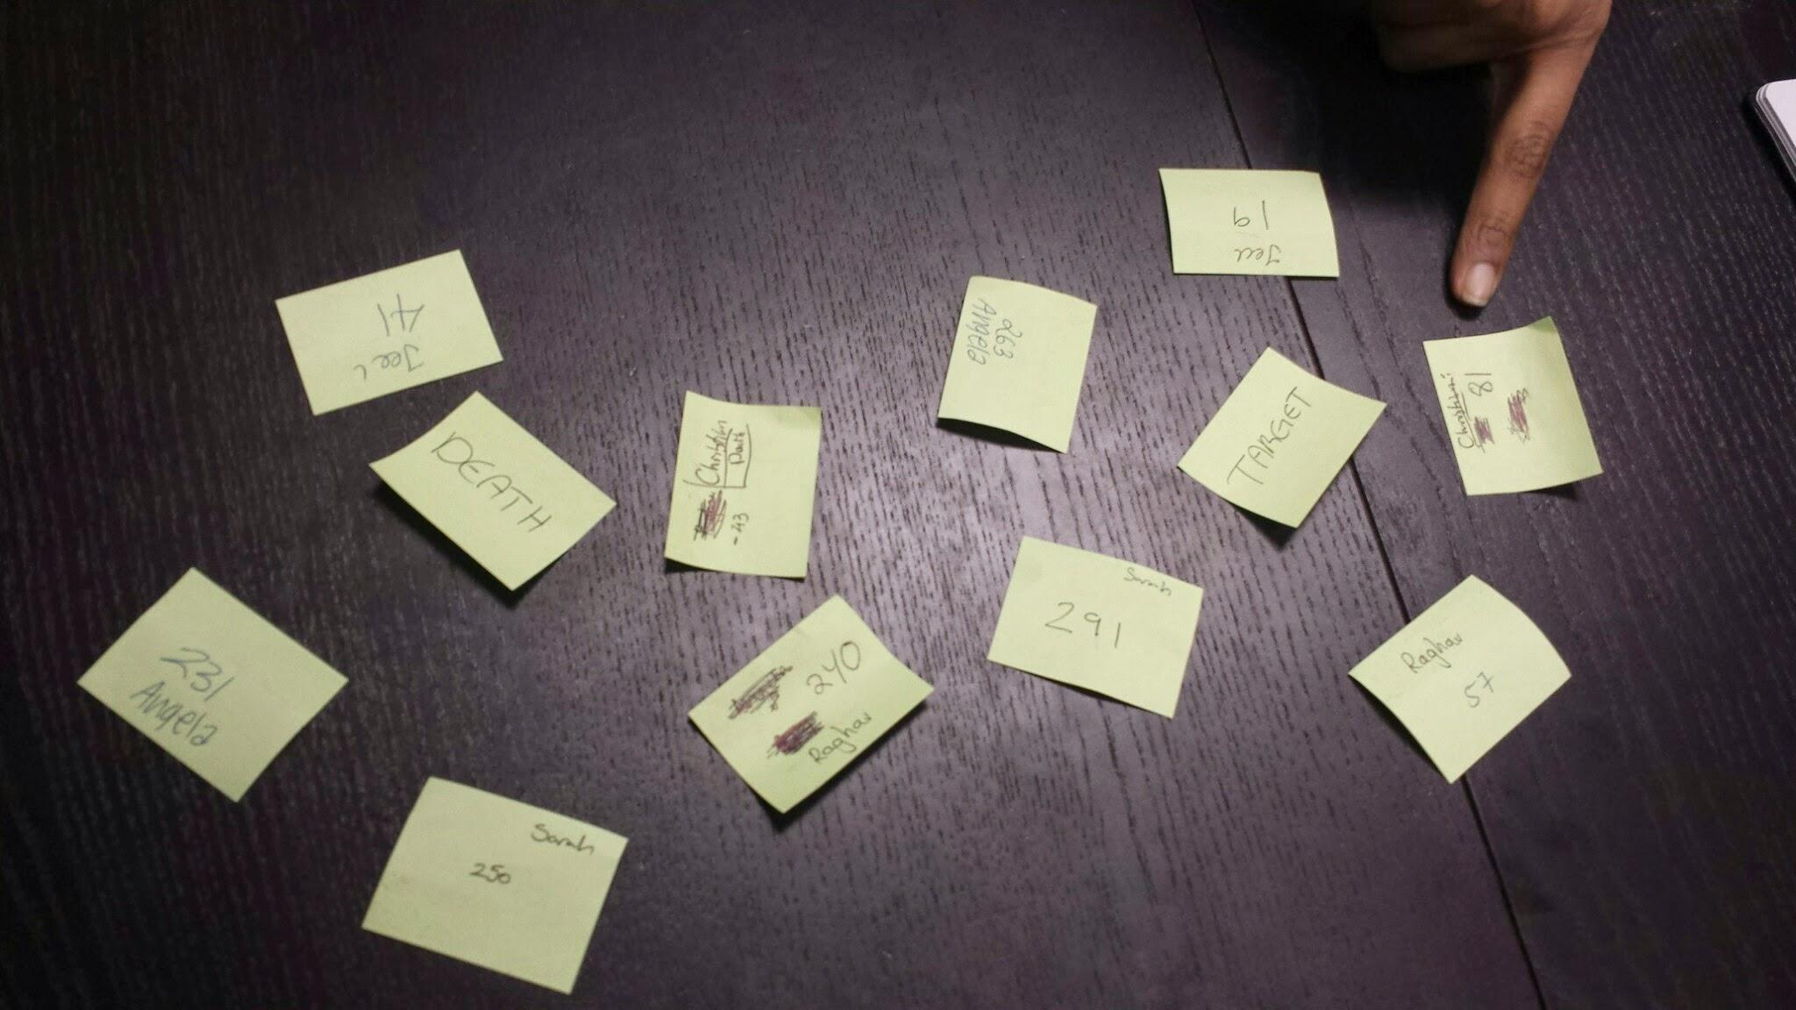

## Problems Discussed

* Current range of numbers results in some players being very quickly eliminated, the flow of the game takes some large swings. The short game length is not an explicit issue, however we want to adjust the game to keep players in-game for a longer duration to see how this affects play.
  + Related to this, while the most skilled player seems to generally win, sometimes players seem to be eliminated by chance, and we want to avoid this.

## Brainstorming

* When contemplating ways to adjust game length, we gravitated towards adjusting the number ranges for players. The ‘location’ of players ‘death’ and ‘target’ numbers has a big impact on their remaining in the game, so we felt that tweaking the assignment of these could give us the variation we wanted to test.

## Ruleset

We retained the rules from the previous iteration with the exception of number selection:

Death and Target Number Selection

* Selection of death and target numbers now has an element of randomness:
  + Each person writes two numbers, one below 100 and one above 200:
  + The numbers are then shuffled in the center of the table
  + Everyone chooses one number for death
  + Then everyone chooses a target

(If you get same death and target number, you choose again)

## Results

* Raghav was the first person ever to be booted
* Jeel got it close to her own target but not quite, Christian tried to boot himself out, and then made Jeel win
  + Christian was panicking
* When it’s spread out, people were confused and couldn’t remember targets and deaths
* Most people try to set people up to kill other people
* Longer game
* No one did prime play

# Sixth Iteration

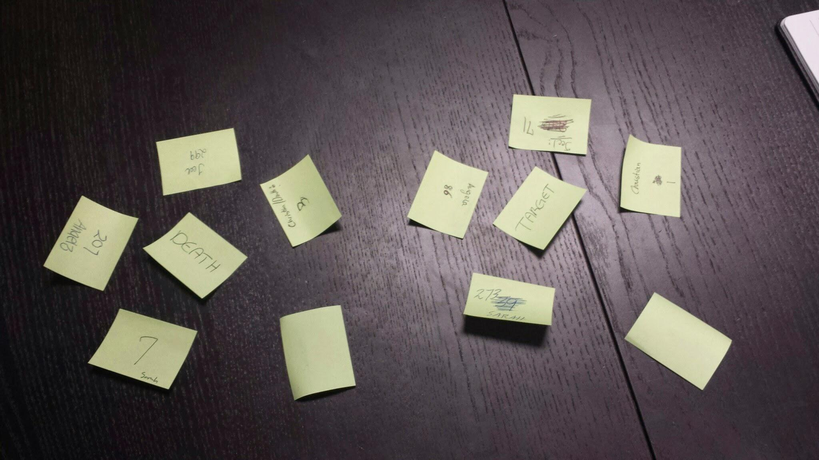

## Problems Discussed

* Adjusting the number ranges did not have the intended effect. The length of the game remained roughly the same, and giving players less control over their number selection also felt counter to having a skill based game that players could master.
* Increasing the cognitive load was another interesting problem that arose from randomizing the numbers.
* We felt that rather than going towards longer play time, we should examine further means for having a community of experienced players, and giving them ways to eliminate new players.

## Brainstorming

* We felt that the feeling of control from selecting numbers tied stronger into our intended design direction.
* We discussed the implications of game length, and felt that a game with sudden eliminations felt good as long elimination stemmed from skilled moves by players, which seemed to be the case. As such , we wanted to revert to the two zones:
  + death: 0-100, target: 200 - 300
* We discussed the effects of the pressure that players felt when they were counted down (such as when Angela did it in the in-class playtest). We decided to formalize this rule further.

## Ruleset

* Play starts at the middle of the general range (150)
* Public Death and Target Numbers
* No Randomization, players select their own death number, and the target number for the player to their right
  + A number can be selected within the following ranges: 1-100, 200-300
* Prime play
* 4 calculations (add, subtract, multiply, and divide)
* After taking your turn, begin keeping count for the person who is going next

## Results

* This time Raghav choose 1 for Christian’s target number, which set a tone
  + Christian, Sarah, and Raghav then choose numbers below 10 for death
* Raghav got himself out on as the first person
* People kept forgetting to do the timer
  + Timer does not start until the previous person initiates the countdown?.
* Angela messed up with symbols but since Christian didn’t say boot, then the game continued on as usual
* Jeel won by ‘profiting’ off of Angela and Christian’s nooby moves

# Seventh Iteration

We brought on outsiders to test our game this time to see how their experiences with the game would differ from ours. We had experts from our team mixed in with newcomers, and we did this so that we could see if our game truly established a culture that was unfriendly towards ‘noobs.’ We still used sticky notes to keep track of the numbers, but simply pasted them into a central area for gameplay. The next few iterations are based on the outsider’s playtest experiences.

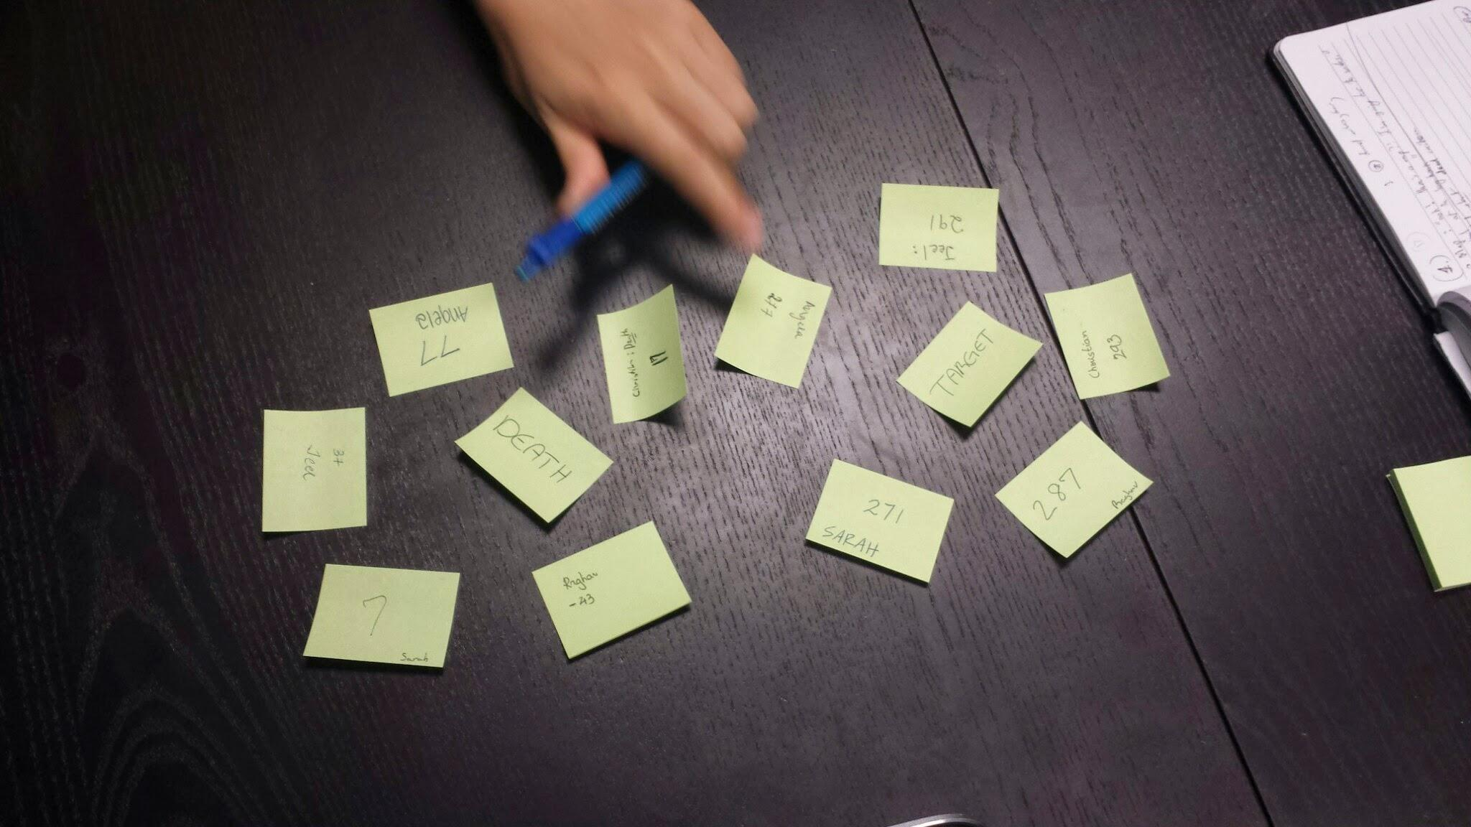

## Problems Discussed

We realized from the previous playtest that people kept forgetting to initiate the countdown. We felt the reason for that was that each of us had playtested the game way too many times without the countdown and hence it was difficult to remember to initiate it. At this point we were confident of the game prototype we had and so we decided to have others playtest our game and give us feedback.

## Brainstorming

Since we were playtesting with others we decided to leave the countdown rule in to see how they deal with it.

## Ruleset

The rules for this round were very similar to our previous playtest.

* The first player starts at 150.
* 100-200 is now just a safe zone.
* First, choose a target number for the person on your right from the following range - (1-99, 201-300)
* Choose your own death number from the following range - (1-99, 201 - 300)
  + You cannot choose a death number similar to one of the already picked target numbers
  + In case of duplicates, the people with duplicates choose their numbers again.
* All calculations must lead to a number between 1-300.
* The countdown from 10 to 1 can be started by any person.
* Any person can shout ‘Boot’ to kick someone out for mixing up the symbols
* Talking during other people’s turns is allowed, but you cannot say anything that might help them (i.e. one cannot say “Oh you’re close to Angela’s death number kill her” or “the answer is 150”)

**Results**

* People were talking to each other and collaborating in a friendly way (Saba, who had seen our in-class playtest, was helping a new player understand the game better)
* Saba got out immediately as someone reached her death number.
* Jaydev had second thoughts about one of his moves and said ‘Oh I’m stupid’.
* Jeel won this round as well.

# Eighth Iteration

## Problems Discussed

The game ended pretty quickly and the new players barely got a chance to understand the game so we decided to have another go at the game so they get a sense of it. One of the things we realized was that there were many simple rules and we needed to frame them in a better way for people to grasp them easily and also that some rules that were implicit to us were not implicit to other players and we decided to add them to the ruleset.

## Ruleset

We played with the same ruleset as the previous playtest.

**Results**

* Interestingly, three people chose 1 for the other player’s target number. We had them re-select.
* Jay chose a very easy target number for Leticia, even a noob could win with that number. (75)
* Coincidentally, Leticia’s target number was the highest and she was the first person to start. She just divided by 2 and won in the first turn.

# Ninth Iteration

## Problems Discussed

Since the previous round also got over really soon, we played one more round without really brainstorming.

## Ruleset

We played with the same ruleset as the previous playtest.

**Results**

* Jaydev unknowingly killed himself.
* Saba did an incorrect hand gesture.
* Leticia forgot what number she got and asked the previous person for help
* Jeel won again.
* No one is doing the countdown as everyone is trying to figure out what to do next

**Feedback**

* Saba suggested that we could have a timer or one of those windy toys that buzz when they release to measure time taken by each person before they say their operation.
* Another suggestion was to call out ‘boot’ when a death number is hit.
* Saba wanted a way to prevent herself from dying, like a blocking mechanism.
* Have more sticky notes with more properties to give more power or constraints.
* What if you could change your death or target numbers suddenly in the game.
* Have a safe card (Decide a safe card/switch that you can use to replace one number as your turn)

# Final Iteration

# **Problems Discussed**

Based on the preceding two playtests, we on two general issues and one specific mechanical issue:

1. Difficulty with accessibility
   1. While we are designing a game that is meant to engender a culture unfriendly to neophyte players, the current level of complexity feels slightly too high. The fact that the core mechanics of the game are mathematically based and require additional concentration factors into this. It hasn’t been a factor with every group of players, but the last two playtests indicated there is room for improvement
2. Need for a stronger community
   1. Fostering a strong sense of community for regular players can carry with it the possibility that incoming players may feel like outsiders. This depends on the community itself and a number of other factors, but this ‘in-crowd’ effect aligns with our design goals.
3. In the preceding playtests, the player designated to keep time for the calculating player consistently failed to do so. Keeping time, when properly executed, contributed to succinct elimination of players and differentiation between skill levels, so we wanted to address this.

## Brainstorming

* Keeping time:
  + Players were felt relief of tension after taking their turn and successfully completing their calculation. This relief also causes their concentration to lapse so they forget to keep count for the next player.
  + More experienced/skilled players recover their focus from this relief more quickly, so they would be better candidates for keeping count. Ostensibly, they would also be the players motivated to eliminate noobs.
    - The rule seemed to function well when it was open to any player keeping the count for the reasons mentioned above. In this situation, experienced players are able to pick up the count, and they can more aggressively eliminate easy targets.
* Community
  + We had discussed the house rules of Monopoly in class a number of times. The house rules of Monopoly typically soften penalties, however we discussed how house rules could be employed to increase complexity for players that desired it , and also contribute to fostering a sense of community. To this end, we thought of some additional, less common mathematical operations that we had wanted to include as means for directing the flow of play (e.g. perfect square) but had shied away from due to the overly daunting level of complexity.

# Collaboration

Our team collaborated closely through each phase of ideation. At the beginning of our process, we alternated between group brainstorming around central constraints, and focused individual ideation, which would then be brought back into the group setting as focus points for further ideation. During the internal playtests, everyone’s feedback was taken seriously and suggestions for the next iteration were listened to, tested, and integrated. In total, we had five meetings in which we collaborated to ideate, playtest, and iterate over our designs and to finalize our product.

During the first two meetings in which we ideated over what sort of game would suit our prompts, we worked in conjunction and bounced ideas off of one another. Using a whiteboard, we recorded all of our thoughts on the prompts. In addition, once we all came up with game ideas separately and presented them to each other, we worked together to refine these ideas further. We also used post-its to create affinity diagrams, grouping our ideas together to see where the common themes lay among us.

During our following three meetings, we went through series of observations, playtests, and revisions of our game together, with all of us playing the games as experts ourselves. In these phases, communication was crucial, as all of us found ourselves having varying experiences with the game. With the combined effort of our iterations, we produced a feasible final product for an audience lacking parental permission, which also effectively excluded newbie players as well.

We handled group communication primarily through the use of the GroupMe messenger mobile application, and established meeting times using the When2Meet web application. We utilized Google Drive for managing rules, notes, and process documentation.