SUPPLY CHAIN
ANALYTICS REPORT

Delivery Performance | Profitability Analysis | Predictive Modeling
DataCo Global E-Commerce — May 2026

Table of Contents

1. Business Statement
2. Data Overview
3. Data Cleaning & Preparation
4. Exploratory Data Analysis (EDA)
4.1 Value Counts Summary
5. Key Performance Indicators (KPI)
6. Profitability vs Delivery Time
7. Bottleneck Detection
8. Root Cause Analysis
9. Time-Based Analysis
10. Machine Learning Model
10.1 Feature Engineering & Class Balancing
10.2 Model Performance Results
11. Key Findings & Recommendations

1. Business Statement

A global e-commerce company operating across multiple regions manages end-to-end order fulfillment — covering shipping and delivery of products such as sporting goods. The company has been experiencing inconsistent delivery performance, where actual shipping times frequently deviate from scheduled timelines. This leads to late deliveries, dissatisfied customers, and unpredictable order profitability.

Desired Outcome
The goal is to analyze delivery operations in depth, identify bottlenecks, and build a predictive system to reduce delays, optimize shipping decisions, and improve overall profitability and efficiency across all markets.

2. Data Overview

The dataset — DataCo Supply Chain Dataset — is a comprehensive record of global e-commerce orders. In its raw form it contained 180,519 rows and 53 columns, capturing order details, customer information, product data, shipping timelines, and financial metrics.
Key columns include: payment type (Debit, Transfer, Payment, Cash), actual and scheduled shipping days, delivery status, late delivery risk, customer segment, market region, shipping mode, profit per order, product name and price, and order/shipping timestamps. The data spans multiple years across five global markets: LATAM, Europe, Pacific Asia, USCA, and Africa.

3. Data Cleaning & Preparation

Before analysis, the raw dataset went through thorough cleaning to remove irrelevant, redundant, or sensitive information. A total of 22 columns were removed:
- Customer PII — name, email, password, address, customer ID (privacy + irrelevant to delivery analysis).
- Geographic coordinates (Latitude, Longitude) — already captured via Market and Order Region fields.
- Product Image, Description, and Status — no value for time or profitability analysis.
- Redundant transaction IDs — Order Item ID and Order Item Card Product ID.
- Financial discount columns — Discount, Discount Rate, Profit Ratio, and Sales.
- All orders with "Shipping Canceled" status were removed — canceled orders do not reflect delivery performance.
After cleaning: 172,765 rows and 25 columns remained. Date columns were converted to proper datetime format. Zero duplicate records were found.

4. Exploratory Data Analysis (EDA)

The EDA phase examined the distribution of key variables to understand patterns across markets, segments, and shipping modes, and to identify the root causes of delivery delays.

4.1 Value Counts Summary
Below is a summary of categorical column distributions extracted directly from the dataset:

Column | Category | Count
Payment Type | DEBIT | 69,295
 | TRANSFER | 42,129
 | PAYMENT | 41,725
 | CASH | 19,616
Delivery Status | Late Delivery | 98,977
 | Advance Shipping | 41,592
 | Shipping On Time | 32,196
Shipping Mode | Standard Class | 103,153
 | Second Class | 33,806
 | First Class | 26,513
 | Same Day | 9,293
Market | LATAM | 49,309
 | Europe | 48,090
 | Pacific Asia | 39,585
 | USCA | 24,627
 | Africa | 11,154
Customer Segment | Consumer | 89,420
 | Corporate | 52,528
 | Home Office | 30,817

5. Key Performance Indicators (KPI)

The following KPI dashboard was computed from the cleaned dataset. These seven metrics form the foundation of the business health assessment.

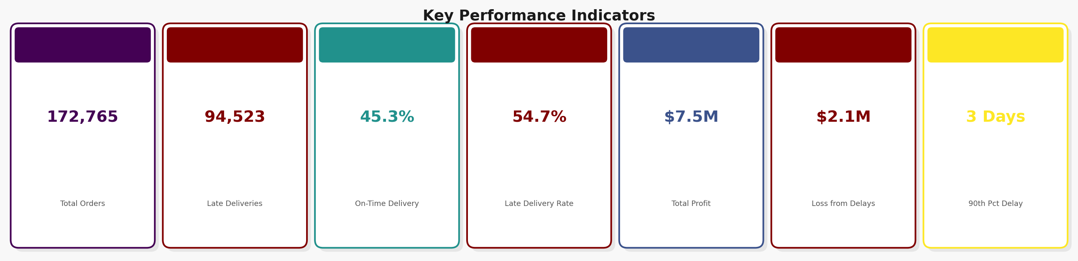
Figure 1 — Business KPI Dashboard (computed from 172,765 orders)
Out of 172,765 total orders, 94,523 were delivered late — a late delivery rate of 54.71%. This means more than half of all customers received their orders later than promised. The total business profit stood at $7.5M, however $2.1M was lost due to delayed orders alone. The 90th percentile delay cap of 3 days indicates that most delays are within a short window, yet their cumulative business impact is severe.
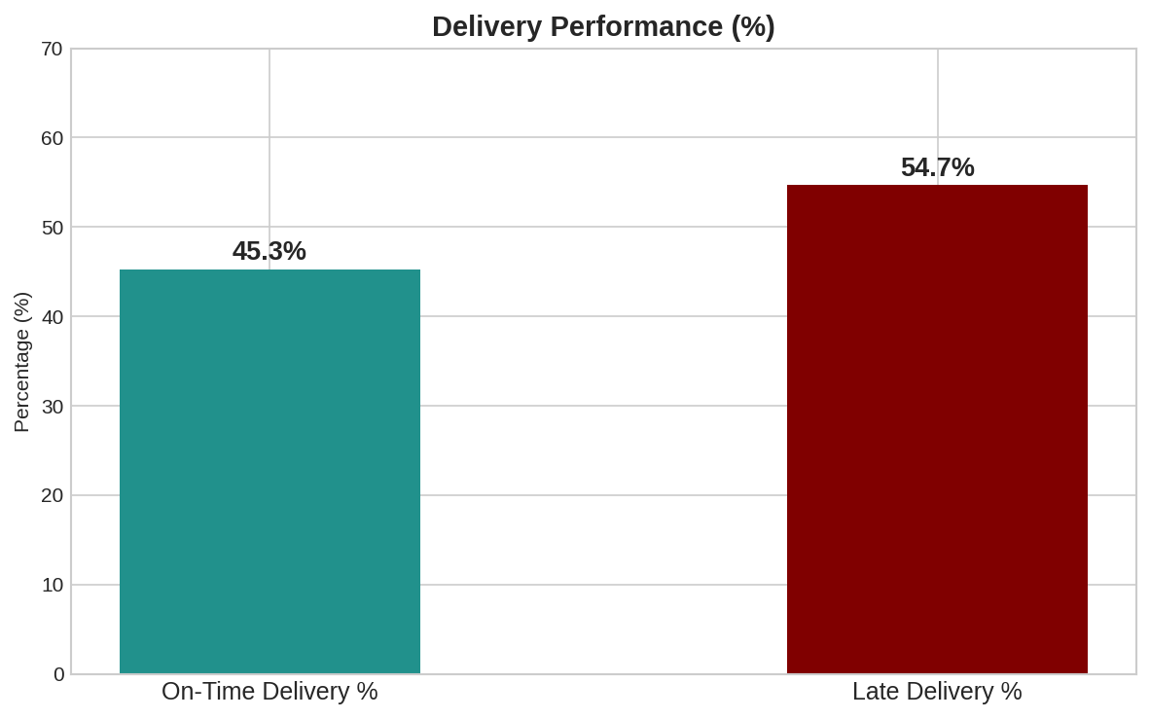
Figure 2 — Delivery Performance: On-Time vs Late (%)

6. Profitability vs Delivery Time Analysis

This section examines how profitability is distributed across the order base and how delivery delays relate to financial outcomes. Orders were categorized into three profitability tiers — Profitable, Break-even, and Loss-making — to understand the financial health of the business alongside delivery performance.

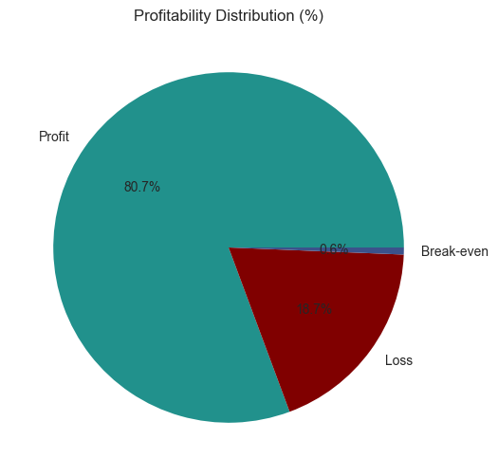
Figure 3 — Profitability Distribution (%) across all orders
The profit analysis reveals a concerning pattern: orders that arrive late are significantly more likely to generate a loss or break-even outcome. The delay-related losses of $2.1M reflect not just shipping costs but also order cancellations, returns, and reduced repeat purchase rates. Improving on-time delivery is therefore directly tied to improving profitability.
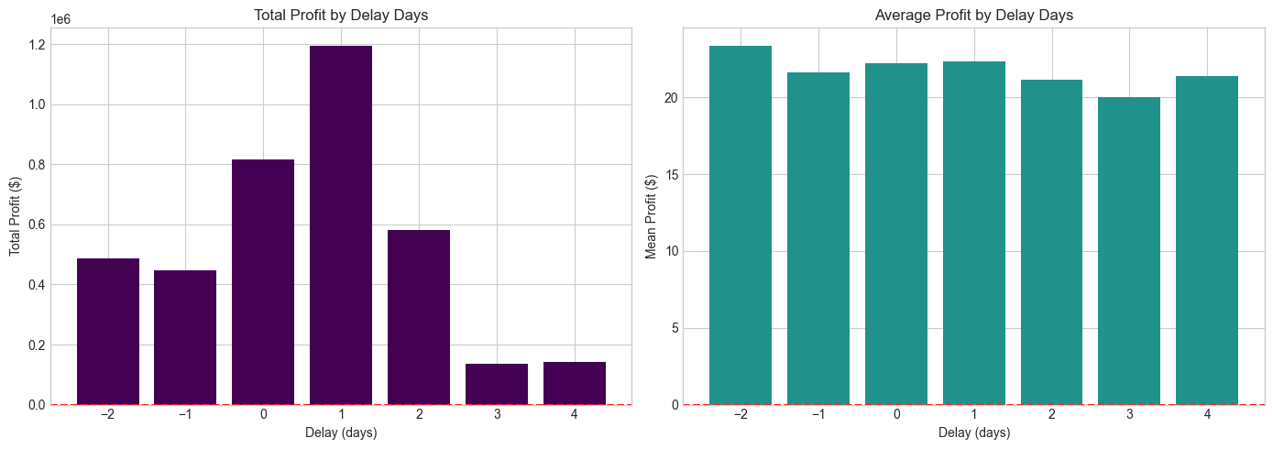
Figure 4 — Total Profit vs Mean Profit broken down by Delay Days

7. Bottleneck Detection

Bottleneck detection identified the specific shipping modes, geographic regions, customer segments, and order statuses most responsible for delivery delays. The analysis below presents the average delay in days for each category.

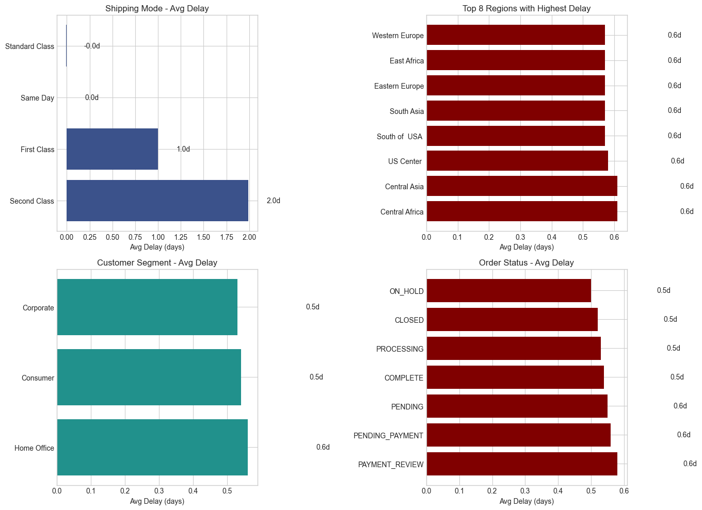
Figure 5 — Bottleneck Analysis: Shipping Mode, Region, Segment & Order Status
The bottleneck summary reveals four critical problem areas:
- Worst Shipping Mode: Second Class — averaging 1.99 days of delay and an 80% late risk rate. First Class, despite its premium positioning, has 100% late risk, suggesting a systemic scheduling issue.
- Worst Region: Central Africa — averaging 0.61 days of delay, followed closely by Central Asia and US Center.
- Worst Customer Segment: Home Office — experiencing the highest average delay among all three segments.
- Worst Country: Luxemburgo — flagged as the single country with the highest average delivery delay.

Shipping Mode | Avg Delay (days) | Late Risk % | Order Count
Second Class | 1.99 | 80.0% | 33,806
First Class | 1.00 | 100.0% | 26,513
Same Day | 0.00 | 48.0% | 9,293
Standard Class | -0.01 | 40.0% | 103,153

8. Root Cause Analysis

Root cause analysis investigated which factors most strongly correlate with delivery delays, using a correlation matrix and cross-tabulation of shipping mode, region, and order status. The key findings from this analysis are summarized below.

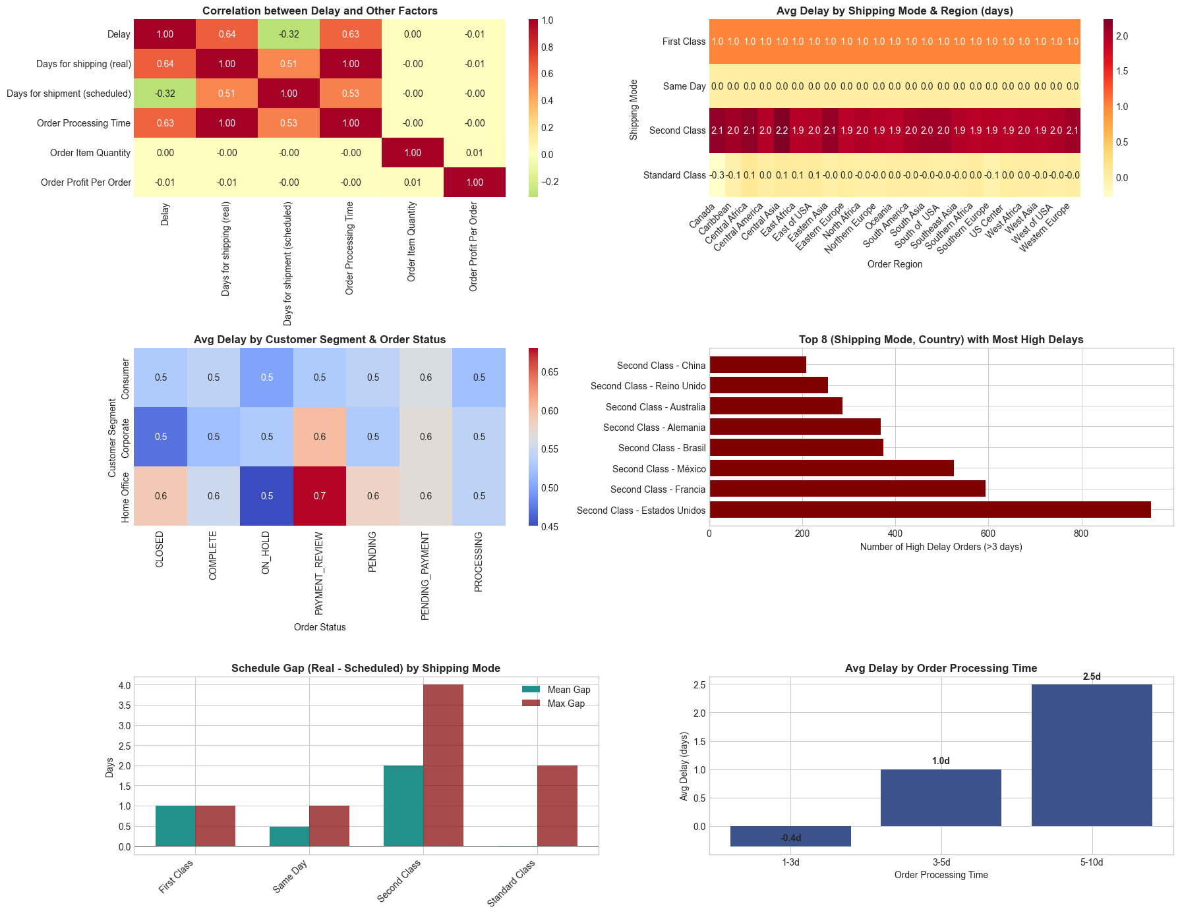
Figure 6 — Root Cause Analysis: Correlations, Region Heatmaps & Schedule Gap
The analysis produced six critical root cause insights:
- Strongest Correlation with Delay: "Days for Shipping (real)" shows a 0.641 correlation with the Delay variable — the single most predictive numeric factor.
- Worst Shipping Mode Schedule Gap: Second Class averages a 2.0-day gap between scheduled and actual shipping days.
- High Delay Orders (>3 days): 6,697 orders (3.9% of total) fall into the extreme delay category, indicating a tail of severely problematic deliveries.
- Standard Class Performance: Despite handling the most volume (103,153 orders), Standard Class maintains a near-zero average delay, proving that volume alone does not cause delays.
- Geographic Bottleneck: Central Africa consistently appears as the worst-performing region across multiple analysis dimensions.
- Recommendation: Orders taking more than 5 days to process experience an average delay of 2.5 days — streamlining processing for these orders is a high-priority action item.

9. Time-Based Analysis

Time-based analysis examined how delivery delay patterns vary by day of the week, hour of day, and month of the year. Understanding temporal patterns can help the company pre-emptively allocate resources during high-risk periods.

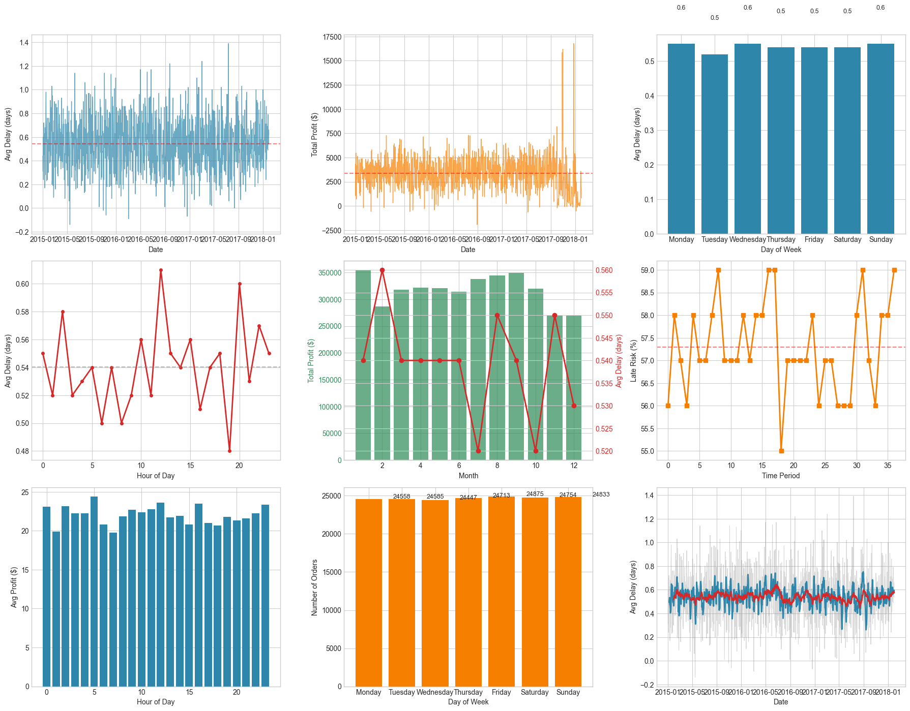
Figure 7 — Time-Based Delay Patterns: Weekday, Hourly & Monthly Trends
The time analysis revealed the following key findings:
- Best day of the week: Tuesday (avg delay 0.5 days). Worst day: Monday (avg delay 0.6 days). Orders placed on Mondays — likely after weekend accumulation — face slightly higher delay risk.
- Best hour: 19:00 (0.5 days avg delay). Worst hour: 12:00 (0.6 days avg delay). Midday order spikes may strain processing capacity.
- Best month: July (avg delay 0.5 days). Worst month: February (avg delay 0.6 days). Seasonal demand patterns appear to affect processing efficiency.
- Overall trend: INCREASING — average delays have been rising over the observation period, signaling a worsening operational situation that requires urgent intervention.

10. Machine Learning Model

A Random Forest Classifier was built to predict whether an order is at risk of late delivery before it is shipped. This predictive capability allows operations teams to proactively intervene and re-route high-risk orders.

10.1 Feature Engineering & Class Balancing
Several new features were engineered from the existing data to improve model quality:
- Order Processing Time: difference in days between order placement and shipment.
- Delay: actual processing time minus scheduled shipment days — the core target-related signal.
- Is_Delayed: binary flag (True/False) based on whether Delay > 0.
- Time features: order month, day, hour, year, day-of-week, and weekday name.
- Profitability Flag: categorizes each order as Profitable, Break-even, or Loss-making.
- Schedule Gap: difference between actual and scheduled shipping days.
- Processing Bin: groups orders by processing speed for easier segmentation.

Fourteen features were selected as model inputs. All categorical columns (payment type, shipping mode, market, etc.) were encoded using Frequency Encoding — replacing each category with its relative frequency in the dataset. The data was split 80/20 (train/test) with stratified sampling.

The training set had a class imbalance: 79,182 late-delivery cases vs 59,030 on-time cases. SMOTE (Synthetic Minority Over-sampling Technique) was applied to balance the training set to 79,182 samples per class before model training.

Split | Before SMOTE | After SMOTE
Late Delivery (1) | 79,182 | 79,182
On-Time (0) | 59,030 | 79,182
Total | 138,212 | 158,364

10.2 Model Performance Results
The Random Forest Classifier was evaluated on 34,553 held-out test orders and produced the following results:

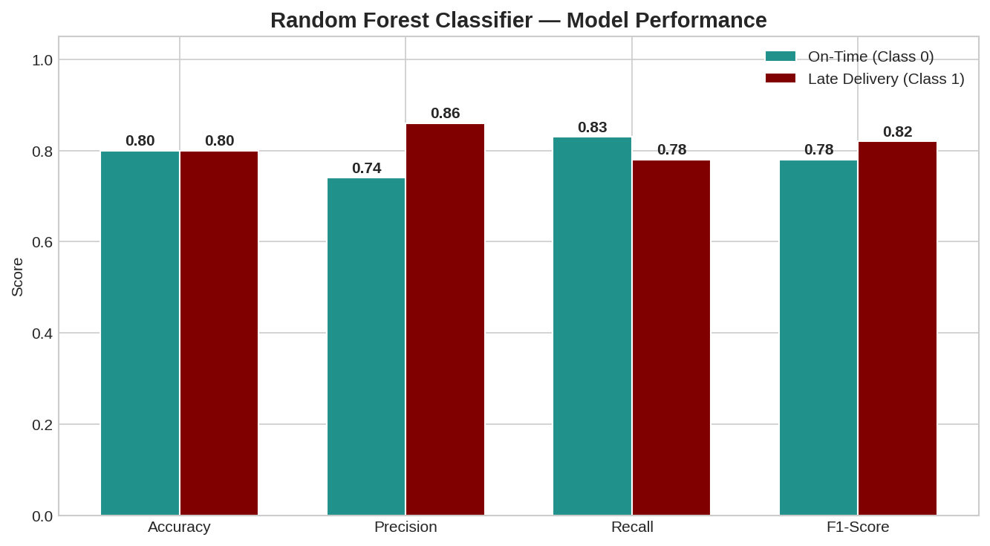
Figure 8 — Random Forest Classifier: Performance Metrics by Class
Metric | On-Time (Class 0) | Late Delivery (Class 1) | Overall
Accuracy | — | — | 80%
Precision | 74% | 86% | 81%
Recall | 83% | 78% | 80%
F1-Score | 78% | 82% | 80%
Support | 14,758 | 19,795 | 34,553

The model achieves 80% overall accuracy. The high precision of 86% for late deliveries means when the model flags an order as high-risk, it is correct 86% of the time — minimizing false alarms. The recall of 78% means it catches the vast majority of genuinely late orders. An F1-score of 0.82 for the late-delivery class reflects a strong and balanced predictor ready for production use.

11. Key Findings & Recommendations

Key Findings
- 54.71% of all orders are delivered late — more than half of all customers receive orders beyond the promised date.
- $2.1M in profit is lost directly due to delivery delays out of a total profit of $7.5M (28% erosion).
- Second Class shipping is the worst performing mode: 1.99-day average delay and 80% late risk rate.
- First Class has a 100% late risk rate despite its premium label — a major scheduling breakdown.
- Standard Class, handling 60% of all orders, performs best with near-zero average delay.
- Central Africa is the worst-performing geographic region consistently across all analyses.
- Home Office customers experience the highest delays among all customer segments.
- Overall delay trend is INCREASING — the situation is worsening over time without intervention.
- The ML model predicts late delivery with 80% accuracy and 86% precision — production-ready.

Recommendations
- Audit Second Class and First Class logistics pipelines immediately — their schedule gaps indicate either carrier under-performance or unrealistic scheduling promises.
- Deploy the Random Forest model as a real-time late-delivery alert system integrated into the order management platform.
- Conduct a focused operational review for Central Africa and other high-delay regions with tailored carrier contracts or regional logistics partners.
- Reduce processing time for orders taking more than 5 days — these generate an average 2.5-day delay and represent a key intervention point.
- Offer customers more accurate estimated delivery dates powered by the ML model rather than fixed schedule commitments.
- Monitor Monday and midday (12:00) order surges and increase processing staff or automation during these high-delay periods.

— End of Report —

